E-Pew News
For the Parish of Burton Joyce with Bulcote and Stoke Bardolph
In the Benefice of Burton Joyce, Bulcote and Stoke Bardolph with Lowdham, Caythorpe and Gunthorpe
The Parish Office, The Carnarvon Rooms, Chestnut Grove Burton Joyce. NG14 5DP
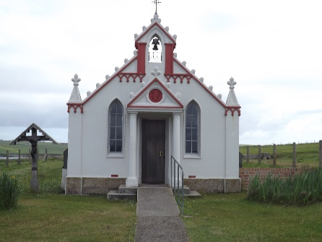
T. 0115 9523943 E. bjbsboffice@gmail.com
W.: www.bjbsb.co.uk

How to be Church in Strange Times

The final service we held in our church buildings was on March 15th, the gospel reading was John 4:5-42 in which Jesus meets the Samaritan woman at the well, during the course of the conversation between the woman and Jesus (verse 21-24) he says to her

“Woman, believe me, a time is coming when you will worship the Father neither on this mountain nor in Jerusalem. You Samaritans worship what you do not know; we worship what we do know, for salvation is from the Jews. Yet a time is coming and has now come when the true worshipers will worship the Father in the Spirit and in truth, for they are the kind of worshipers the Father seeks. God is spirit, and his worshipers must worship in the Spirit and in truth.”

When we read that less than a fortnight ago we couldn’t imagine that there might be a time when we could not worship together, we imagined that some might stay away and that some might even get sick, but it was beyond our comprehension to believe that church building might be shut and the people in lock down.

It’s disconcerting to be separate and kept apart from one another, not able to gather in the church building, the place we call our spiritual home. As I’ve reflected on my own feelings and considered how to be a priest who ministers somewhat remotely I’m reminded of a prayer I often use in the Funeral service

“Father, the death of ……………..brings an emptiness into our lives.
We are separated from them and feel broken and disturbed.
Give us confidence that they are safe and their life complete with you,
and bring us together at the last
to the wholeness and fullness of your presence in heaven,
where you saints and angels enjoy you forever and ever. Amen”

The first few lines of that prayer sum up for me how it feels, we are separated from one another, we do feel broken and disturbed, we feel worried and anxious, it’s a grief of sorts.

But the prayer takes us on a journey from brokenness to wholeness.

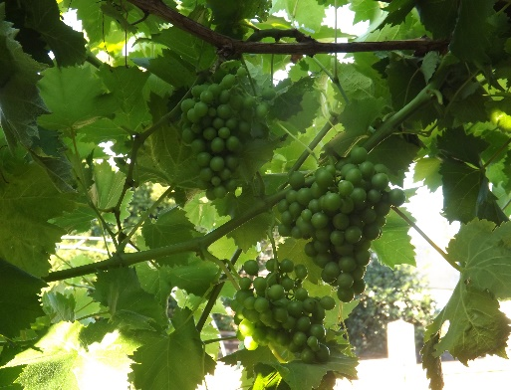
The bible reading from John reminds us that we do not need a church building to be the church, we are people who have faith in the risen Christ, and are filled with the Holy Spirit given at Pentecost. We do not need a building or a mountain, the time did indeed come when we would worship in Spirit and in truth, in our gardens, in our homes, as we take our daily exercise, as we meet our families and friends virtually via the wonders of the internet and telephone.
It might feel like a grief, we might feel broken, but we are the people of God who continue our journey together, bound together by the Spirit.

As such we continue to pray together and for each other, we can still read our bibles and reflect on God’s word for us during troubled times, we can and must, keep building our community, ringing, texting, emailing our neighbours.
For a time we will be church in a strange way but I pray this experience will make us stronger, God is with is, of this we are confident, we are daily renewed by His Spirit of this we are sure.

So now as ever “
We go in peace to love and serve the Lord
In the name of Christ
Amen”

Stay safe, wash your hands, love one another.

Love Anna
Vicar of United Benefice of Burton Joyce, Bulcote and Stoke Bardolph with Lowdham, Caythorpe and Gunthorpe.
reverend.anna.alls@gmail.com
07535017591

