BELSTEAD ST MARY THE VIRGIN
330633099
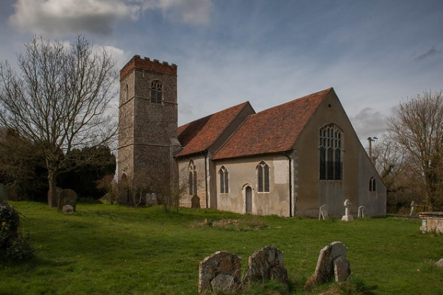
DIOCESE OF ST EDMUNDSBURY
& IPSWICH
Use the QR code below to access online giving to make a regular or one-off gift


The PGS also has a friendly telephone service to set up your regular gift. Call 0333 002 1271 with your details. Find out more at https://parishgiving.org.uk

