The Rector's Ramblings
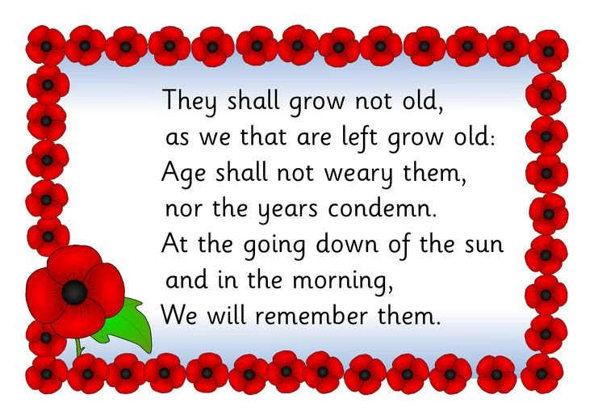
This week, after our Evensong service in St Olav’s, I gave a talk on the history of the symbols, for want of a better word, of Remembrance. The Poppy, The Cenotaph, Remembrance Sunday, and The Tomb of the Unknown Warrior in Westminster Abbey. I have to admit that, as I read the story of the Unknown Warrior and his journey from France, I got quite emotional. It was a journey that reminded me of the scenes from Royal Wootton Bassett where the people of that town, and thousands from outside, would line the streets in honour of the fallen from the war in Afghanistan.
The body now buried in Westminster Abbey was one of four exhumed from the four major battle fields in Northern France and Flanders. It was chosen at random and placed in a simple wooden coffin. The other three men were reburied with full military honours in France. The journey of the coffin was marked at every stage by respect, dignity, and love. It was escorted by senior Military figures from France until it was handed over to the warship HMS Verdun for its journey across the channel, escorted by 6 destroyers. As it stood on deck it had an Able Seaman standing at each corner, and was covered by the Union Flag, a flag that had been used as an Altar covering during the war. When it arrived in Dover it received a 19-gun salute, and was placed on a special train for its journey to London. It arrived on 10th November 1920 and on the morning of 11th November was placed on a guncarriage pulled by 6 black horses from the Royal Horse Artillery and taken through the streets to Whitehall, where it stood, at 11am, for the Two Minutes Silence after King George V had unveiled the newly erected permanent Cenotaph. As it headed off to Westminster Abbey, the chief mourner, walking behind it, was the King, with senior military figures and politians following behind. For 7 days the Abbey remained open and over one million people slowly filed past. They were, predominantly, the mothers, sisters, daughters, and children, of the over 800,000 men who died during the war and who have no known grave.
The Tomb of the Unknown Warrior is the only gravestone in the Abbey that the public cannot walk on. It is permanently surrounded by flowers, and since the then Princess Elizabeth placed her wedding bouquet on it as she left after the service, every royal bride, and I suspect many non-royal brides, have done the same. A mark of gratitude and respect.
Who is buried in the Tomb of the Unknown Warrior will never be known. It could be an 18-year-old, or a man of 45. It could be a farm labourer or a high-powered lawyer. It could be an only son, or a father of many, and that was the point. The Tomb of the Unknown Warrior, and the Cenotaph, were, and still are, a memorial, a remembrance, for all those who have no known grave, whose families have nowhere to go to remember and to grieve. It is an embodiment of the message that we are all equal in the sight of God, all equally loved, and all equally valued.
This Sunday millions of people around the world will stop for two minutes, in churches, at War Memorials, in Military Cemeteries, to remember all who have died in war, and all who still carry the physical and mental scars of conflicts past and present. On Wednesday in shops, offices, schools, on High Streets, up and down the country, many will stop again; to remember the moment the guns fell silent. This year a wreath will be laid at the Cenotaph that has made the journey from France, retracing the journey of the Unknown Warrior, with 3 other wreaths being laid at memorials in Scotland, Wales and Northern Ireland.
Remembrance Sunday, the Poppy, the Cenotaph and the Tomb of the Unknown Warrior don’t, and never have, glorified war. They are symbols of hope, a reminder of past and present sacrifices, and a prayer for peace. It is only in remembering the past, and praying that the world can learn from it, can we hope for a better future, a future that honours the sacrifices made, the lives lost, to give us a future.
“When you go home, tell them of us and say: For your tomorrow, we gave our today.”
Kohima Epitaph
Rev Sarah
You are warmly welcomed to worship in the Valley Parish

8th November  Remembrance Sunday  Holy Communion  with Act of Remembrance  10am  West Dean | 8th November  Act of Remembrance  3pm  Singleton War Memorial  Singleton Churchyard

Rev Sarah Manouch
07468 854864 priestvalleyparish@gmail.com
Please note that I am part-time. My principal working days are Friday and Saturday as well as Sunday. I am not available on a Thursday.

