Saint Hilda’s Parish Church
St. Hilda’s Church Contact list
Parish Priest: Father Simon Sayer CMP
Telephone: 07356 028 581
Email: priest.sthildaprestwich@gmail.com
PCC Secretary: Mrs Carole East
Telephone: 07951 192 728
Email: sthildaprestwich@gmail.com
PCC Treasurer: Mrs Andrea Smethurst
Email: treasurersthildaprestwich@gmail.com
PSO: Mrs Shirley Diver
Telephone: 07922 330069
Email: hildasafeg@gmail.com

Follow us on the following platforms
https://www.facebook.com/Sthildaprestwich
https://www.achurchnearyou.com/church/16091/

Parish Priest: Father Simon Sayer CMP

18th October 2026
Feast of the Dedication of
St Hilda’s Church
11.00am: Parish Mass

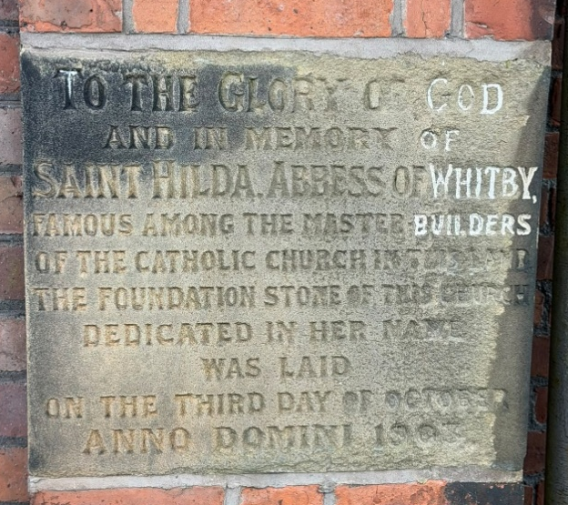
Coffee served after Mass in the Church Hall
The Foundation Stone
Welcoming team: Abi & Joyce
Reader First Lesson & Responsorial Psalm:
Margaret
Reader Second Lesson: Melanie
Intercessor: Carole
Sunday Coffee Rota Rachel & Melanie
Hymns
Entrance: 362 Glorious things of thee are spoken
Offertory: 205 Christ is made the sure foundation
Communion: 307 Sweet Sacrament divine
Angelus:
Recessional: 413 Now thank we all our God

The Sanctuary Lamp

The Sanctuary Lamp indicates and honours the presence of Christ in the Blessed Sacrament, and burns this week for the welfare of animals.
Thank you to all who have already sponsored this lamp. Nearly all the slots for this year are filled, but you can now sign up for any of the Sundays next year, 2027 – the lists are on the clipboard at the back of church.


Life & Mission at St Hilda’s
You can now donate at any time to the life of the parish by scanning the QR Code. Thank you
This week in church
Tuesday 20 October: 10am Votive Mass for Vocations to the Priesthood & Religious Life. Healing Ministries will be offered at this Mass.
Next Sunday: 25 October: 30th in Ordinary Time.
11am Parish Mass.
This week in the hall
Tuesday:
9.00am Coffee Morning open from 9am
and Craft at the Croft
Friday: 9am -10.30am Slimming World

Welcoming Team

The name badges we used at the Heritage Open Days worked well, so we will continue to use them on Sundays and for all events in church. When you are on the Sunday welcoming team, please find your badge (in the basket on the table at the back of church) and wear it.
Thank you.

Father Simon’s Christmas Card Challenge
Three simple ways for you take part in this challenge:
1. Decide to send religious cards that show the story of the reason for the season - the Birth of Our Lord and Saviour Jesus Christ.
2. Visit the Croft Hall, and choose from the Christmas cards on display. The cards are
in packs of 5, and the cost is £3.50 a pack.

3. Buy your cards: the sale of every pack supports our ministry and mission at St Hilda’s.

Thank you for taking part in the challenge.
Repairs to the west wall: work expected to start on Monday 19th October
The main door to Church and the church building and the Croft Hall remain in
use throughout the works. Church life will continue as usual!

The total cost of this essential work (including architect’s fees) is expected to be £50,000. We are grateful for grants from Manchester Diocese of £19,500 and £5,000 from the National Churches Trust. The balance of the cost is being found from allocated funds from the PCC’s reserves. We are fortunate to have the resources to invest in the building. After this work is paid for, the PCC reserves will, however, be
very depleted!

INCOME SURVEY & ATTENDANCE SURVEY

Please make sure you fill a form in ASAP
Every October, the Church of England carry out a “census” of data collections, featuring an anonymous survey of income for regular members only, and an attendance survey of services. Please make sure you are counted and please complete an “anonymous” income form ensuring the appropriate section is shaded not just ticked and drop it in the box. Thank you
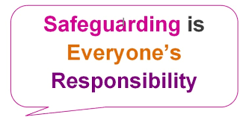
We take the safeguarding of children and vulnerable adults very seriously here at St Hilda’s. Therefore, if you have any concerns please speak to the Parish Safeguarding Officer:
Mrs Shirley Diver: 07922 330069
Or the Diocesan Safeguarding Advisor
Abbey Clephane-Wilson: 0161 828 1465

We are now collecting for the WINTER Fair; please can you help make the Fair a success by donating the following items for the stalls. Bottles/Chocolates/raffle prizes/Tombola prizes. These can be brought to church at any time.

Confessions:

Fr Simon is available to guide you in your prayer life, or to hear confessions, after any Mass. Don’t worry if you’ve never made your confession, or if it’s been a while since you did. The priest will gently guide you in making your confession. Confession is a wonderful opportunity to experience the reconciling love of God
We remember with love and prayers all on our prayer list here at St Hilda’s


Peter Maltby, Harvey Wood,
Trevor & Juanita, Vikki & Vasilli,
Elaine Chaloner, Joanna Maciulskas,
Maryrose & Walter, Cath & Derek,
Andrew Davidson, Angela, Pearl, John Southern, Angela Millington, Peter Holland, Keith Bentley, Jane, Susan Lees, Renée Lukes,
Fr Croft, James Lucas, Francesca Boothman, Jenny Mulholland, Paul & Michael Lees.


We remember before God all those who have died specially those who have passed in the night with no-one to comfort them.

We remember also with love and prayers those whose anniversaries fall during this week
18th October 2006 Kenneth Crowley
18th October 2013 Joyce Greenwood
18th October 2019 Arthur Hickie
20th October 1995 Clifford Finch
20th October 2007 Ronald Gilmore
21st October 1917 Sgt William Wright
22nd October 1942 George Fitton
22nd October 1984 George Schofield
22nd October 2010 George Bohanna
24th October 1959 George Horigan
24th October 2002 Roland Berry

School News


Hello Yellow – Spreading a Little Happiness
Last week, the children at St Hilda’s celebrated Hello Yellow for World Mental Health Day. As part of our activities, the children wrote positive and uplifting messages on postcards and delivered them to members of our local community, including our church family. It has been lovely to receive some beautiful letters and cards in return. Thank you to everyone who took the time to write back! It has been a wonderful reminder that even a small act of kindness can brighten someone’s day.

