SUNDAY 11th October 2026.



Loving God and Loving our Neighbour

Although we are currently without a permanent Rector, services in the Benefice continue with the assistance of visiting clergy. Please do join us – you will be made very Welcome!! The post will continue to be advertised and further updates will be featured in the newsletter

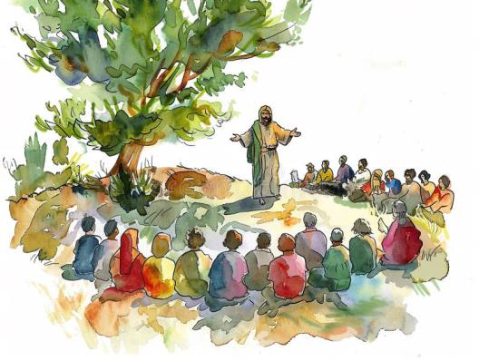
Sunday 11th October. Trinity 19.
9.30am Watton Holy Communion
11.00am Watton TAC Contemporary service
11.00am Aston Harvest Family service
11.15am Bramfield Holy Communion
11.1m Stapleford Prayer and Praise

Sunday 18th October. Trinity 20.
11.00am Watton TAC Contemporary service
11.00am Aston Holy Communion
11.15am Stapleford Harvest Festival Holy Communion
11.1m Waterford Morning Prayer Sermon on the Mount.

Interested in exploring the Christian Faith? Why not join Alpha.
We all have questions we have wanted to ask, about life, faith…what’s going on… But there’s never been the right time or place…Could this be your time?
Come and join us… A choice of options:
We will be running a Daytime Alpha Course starting Monday 21st September at 10am with tea and biscuits.
We will also be running an Evening Alpha Course starting Wednesday 23rd September at 6.30pm with a light supper. We will be providing soup and a roll with beverages.
If you are interested, please contact us to reserve your place… Please give us a ring 07780 452478 Or email Richard@Takeawaychurch.com Details available from Alpha – Alpha: uk@alpha.org

Youth Alpha. Year 6 to Year 11. For further information and to book your place please contact:07780 452478

MIDWEEK

NIGHT PRAYER Fortnightly at 7.30pm on ZOOM. Next meeting Wednesday 14th October. All welcome. Contact Tim Alexander for link tim_alexander3@hotmail.com


Wednesday 21st October. 2.30pm Stapleford village Tea afternoon in Church. All are welcome for tea, coffee cake and chat.

Waterford Quizzle Night Saturday 17th October,6.30pm for 7pm start. £10 per person. www.waterfordvillagehall.co.uk

Aston Village society Coffee morning Friday 30th October, Aston Village Hall, New Park Lane, SG2 7ED. £5.00 on the door.

Sunday November 1st Waterford Bonfire night. From early evening. Licensed Bar, Hot drinks. Adults £10, Age 2-12 £8 www.waterfordvillagehall.co.uk

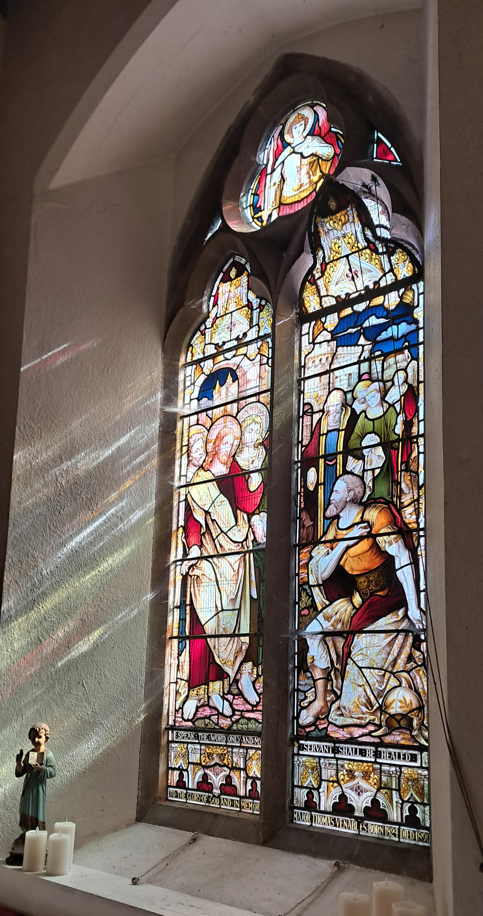
Collect Prayer for Sunday 11th October Trinity 19. O God, forasmuch as without you we are not able to please you; mercifully grant that your Holy Spirit may in all things direct and rule our hearts; through Jesus Christ your Son our Lord, who is alive and reigns with you, in the unity of the Holy Spirit, one God, now and for ever. Amen
One of the east facing windows in St Mary’s Aston. The window shows Jesus healing the Centurion’s servant. “Speak the word only and my servant shall be healed” Matthew 8.5-13

Hymn: All my hope on God is founded. 336 HAM. Author: Joachim Neander was born at Bremen, in 1650.
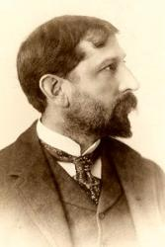
Translator: Robert Bridges (b. Walmer, Kent, England, 1844; d. Boar's Hill, Abingdon, Berkshire, England, 1930) In a modern listing of important poets Bridges' name is often omitted, but in his generation he was considered a great poet and fine scholar. He studied medicine and practised as a physician until 1881, when he moved to the village of Yattendon.
1 All my hope on God is founded;  he doth still my trust renew.  Me through change and chance he guideth,  only good and only true.  God unknown,  he alone  calls my heart to be his own.  2 Human pride and earthly glory,  sword and crown betray his trust;  what with care and toil he buildeth,  tower and temple, fall to dust.  But God's power,  hour by hour,  is my temple and my tower. | 4 Daily doth th' Almighty giver  bounteous gifts on us bestow;  his desire our soul delighteth,  pleasure leads us where we go.  Love doth stand  at his hand;  joy doth wait on his command.  5 Still from earth to God eternal  sacrifice of praise be done,  high above all praises praising  for the gift of Christ his Son.  Christ doth call  one and all:  ye who follow shall not fall.

PRAY for PEACE in The Middle East, UKRAINE and all areas of conflict


Lord God, though peace seems humanly impossible,

We continue to pray for an end to violence and bloodshed. We pray your comfort for the fearful and broken – hearted.


Change the hearts of those set on revenge and destruction.

Give wisdom to world leaders as they respond to aggression.

Bless all who work for understanding, reconciliation and justice which alone bring lasting peace. Amen.

‘God give us peace that lasts, not through the fear of might, but through the force of love, and love of life and right’. Amen

We believe that responding to the climate crisis is an essential part of our responsibility to safeguard God's creation and achieve a just world. Climate change hits hardest the poorest countries and poorest people of the world. Meantime, the widespread destruction of the natural world is a crisis for creation.

Our Environment Programme exists to enable the whole Church to address this — in faith, practice and mission. This includes tackling our own carbon emissions (aiming for Net Zero Carbon by 2030) and our wider work. More information can be found using the following web-link: http://www.churchofengland.org/about/church-england-environment-programme#na

Energy Hub Funded by UK Government: Find out how to:

1. Save energy

2. Save money. Reduce energy bills

3. Reduce carbon. Improve energy footprint

4.Increase comfort

For useful resources and guidance on where to get started visit: linktr.ee/energy_hub


https://app.ecochurch.org/user/21703/summary

EcoChurch – EcoTip for September. Please consider serving Fairtrade coffee and tea.
Fairtrade tea, coffee, chocolate and sugar help growers receive fairer prices and support communities with essentials such as clean water, clinics and classrooms. As Christians, we seek to "do justice and love mercy" (Micah 6:8). Please look out for Fairtrade choices in Costcutter, Co-op, Sainsbury's, M&S and Tesco — every purchase helps.

NEW RECTOR RECRUITMENT UPDATE – Beane Valley Benefice Vacancy has been advertised again on the Diocese of St Albans website. Closing date 2nd November.

https://www.stalbansdiocese.org/vacancies/rector-for-the-beane-valley-benefice/

Good news. Rt Revd Dr Andrew Rumsey, currently Bishop of Ramsbury in the Diocese of Salisbury, is to be the next Bishop of St Albans. Bishop Andrew returns to the Diocese in which he was born and baptised, describing the appointment as “a homecoming” and saying he is thrilled to be joining a “fine team”. He has been installed as the 11th Bishop of St Albans.
The Rt Reverend Richard Atkinson Bishop of Bedford has announced that he will retire at the end of the year.
CARING for our CHURCHYARDS
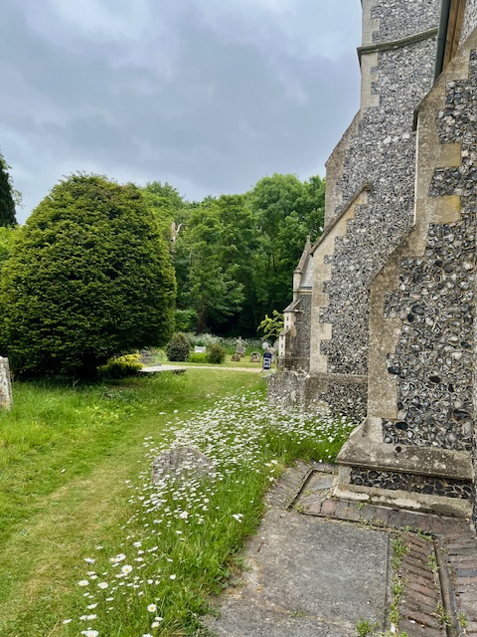
TUESDAYS Waterford Working Parties – Contact Churchwarden Malcolm Wandrag to offer help m.t.wandrag@gmail.com
To help in Stapleford or Watton or Bramfield please contact the Churchwardens.ASTON church open Sundays 12.00-16.00 and Wednesdays 10.00 -17.00 Church and churchyard working parties first Tuesday of month 10am to 12 noon. Contact Churchwarden Sara wardenstmarys@gmail.com
All our churchyards are cared for by volunteers.
Donations and offers of help are welcomed.
To include a loved one in the Book of Remembrance contact the churchwardens

Prayer for Growth for Aston, Bramfield, Stapleford, Waterford and Watton at Stone
Jesus teaches us to pray for our churches to grow. Jesus says: ‘Ask the Lord of the harvest, therefore, to send out workers into his harvest field’ (Matthew 9:38). In ways we don’t understand, God uses all our prayers.

Heavenly Father, you call us to sow seeds of faith in our communities. We ask you to fill us with your Holy Spirit that our lives may show the joy and new life we have in you. Guide our speaking and actions that others may be drawn to know your love. Lord Jesus, bless our churches that we may grow in numbers, love and service. We ask this in your name. Amen.
We pray for others to know God’s love. Tie 5 knots in a piece of string - let each knot represent a friend or family member. Keep the string in your pocket and, as you feel the string, pray for those people to know God’s love. Set an alert on your phone to remind you to pray for those 5 people every day.
A prayer for those who seek to know God.
Lord Jesus, when your followers walked the Emmaus road wondering what was true and what was not, you came alongside them and revealed yourself in Scripture and in broken bread. Come alongside those we know and love who may wonder or seek at this time. Reveal yourself in your love and make us ready to walk alongside them too, until they see your face and know your presence. Amen.
Heavenly father we pray for guidance for our Beane valley benefice churches during the vacancy. Amen.
In Touch Age UK Hertfordshire offer confidential, non-judgemental emotional and practical support on bereavement, physical & mental health issues, cancer, end of life, a partner with dementia or any other problem. Call 01992 634964/630623 or email intouch@ageukherts.org.uk Web page Age UK Hertfordshire | Our Services











Bereavement Support You can access online help at griefshare.org thebereavementjourney.org cruse.org.uk teardropgrief.co.uk ataloss.org
’s
afternoon
Tea

rty
at 64 Rivershill
Sunday 24th July 2.00-5.oopm

Bring & Buy <> Raffle <> Jams
Proceeds to Both

TAKE AWAY AVAILABLE


Why not try Bellringing at Watton or Aston.

We have teachers ready to get you ringing

You don’t have to attend church

We have a wide range of ages in our bands

Everyone is friendly and welcoming

It’s a skills part of Duke of Edinburgh award

It’s good exercise for body and mind

Email: bellringing111@gmail.com for more information.

Aston Practice Thursdays 19.58-21.00 (but not in August)

Aston Ringing Times Sundays 10.30-11.00

Watton Bell ringers meet on Monday evenings at 7pm. Contact: Keith Carpenter 01920 830479

Thank you for reading this week's Newsletter. If you have any questions or feedback on what you would like to see in the Newsletter, please email Tim Alexander at tim_alexander3@hotmail.com. Thank you for your help.

The Diocese of St Albans are currently advertising the following roles. Please circulate details to anyone you think may be interested in applying.

- PA to the Archdeacon of Hertford –Part Time (based in Hertingfordbury)
- Giving Communications Assistant –Part Time (would suit uni/college leaver)
- Property and Trust Adviser – Full Time
Further details on our website on the links below:

https://www.stalbansdiocese.org/vacancies/pa-to-the-archdeacon-of-Hertford-2026/
https://www.stalbansdiocese.org/vacancies/giving-communications-assistant/
https://www.stalbansdiocese.org/vacancies/property-and-trusts-adviser/

Ruth Carl Governance and HR Operations Manager

