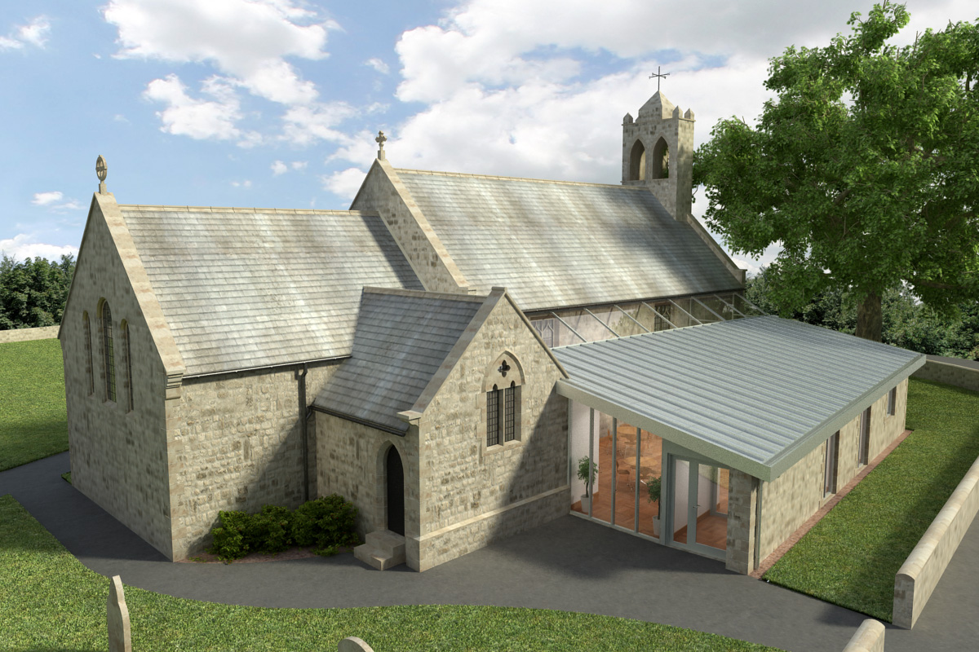
St Mary’s Parish Church, Longframlington

Welcome to our Sunday Morning Prayer. On Sunday 25th October, which is Bible Sunday (Last Sunday after Trinity), when our Officiant will be Rev Philip Bourne, and Veronica, leading the music. Next week, All Saints Day, the Officiant will be Rev Ann Peters and Steve playing the organ. There will be an All Souls Service on First Sunday in November at 6 pm led by Rev Rich. There will be a book available for anyone to enter names to be remembered at the service.
Coming up at St Mary’s and our sister parishes – Morning Prayer in St Mary’s – and on Zoom – usually every Wednesday morning at 9.30 am followed by coffee in the Community Room. The Link can be made using Meeting ID889 6133 2870, Password 093043. New people always welcome either on screen or in church.
Growth Groups – pilgrim – coming this Autumn Our new Growth Group will have begun now, offering a chance to grow together in faith, ask questions, pray with others and explore more deeply the worship we have week by week.

Church Hymn Books – A new edition of Anglican Hymns Old and New have been received and put in Church for worship on Sundays and other Holy Days. If you wish to purchase a copy and have your name inscribed, the price of the hymn book is £10 and your name will be included in the new hymn book. Please give donation to Audrey or Veronica.

Pilgrims across Newcastle Diocese are gearing up for final stage of St Aidan’s Way, part of Year of Sharing in 2026. The final is on 31st October when pilgrims will walk from Tynemouth to Newcastle Cathedral. The Dean of Newcastle Cathedral, Lee Baston, is hoping people can join in the final leg of the journey. The pilgrimage has offered opportunities for friendship, fellowship, prayer and reflection while exploring the beauty of our coastal and urban landscapes. More details from Audrey or Rev Rich.

Many thanks to Sandra and Terry for the wonderful church clean recently and how much as a congregation we appreciate all they do.

A gentle reminder – Please check the coffee rota list for coffee after the services and perhaps put your name down to fill one of the spaces. With thanks.

Thank you for your giving to the life and work of our church. Our offering is taken during the third hymn, and there is a collection giving point at the back of the church for use after the service if you prefer. Regular giving by Standing Order with Gift Aid is particularly valuable to the church – speak to Audrey (01665 570 922) for more information and blank forms.
All our news and much more available on our Facebook page https:www.facebook.com/SMCLongfram/?ti=as and You Tube channel https:www.youtube.com/@stmichaelsfeltonstmaryslon.
Priest in Charge: Rev Rich Townend Phone 01670 719470 Email:revrichtea@gmail.com Regular day off is Monday.
For St Mary’s information contact Veronica Thomson (01665 570 807) or Audrey Truman (01665 570922).

