The Rector's Ramblings
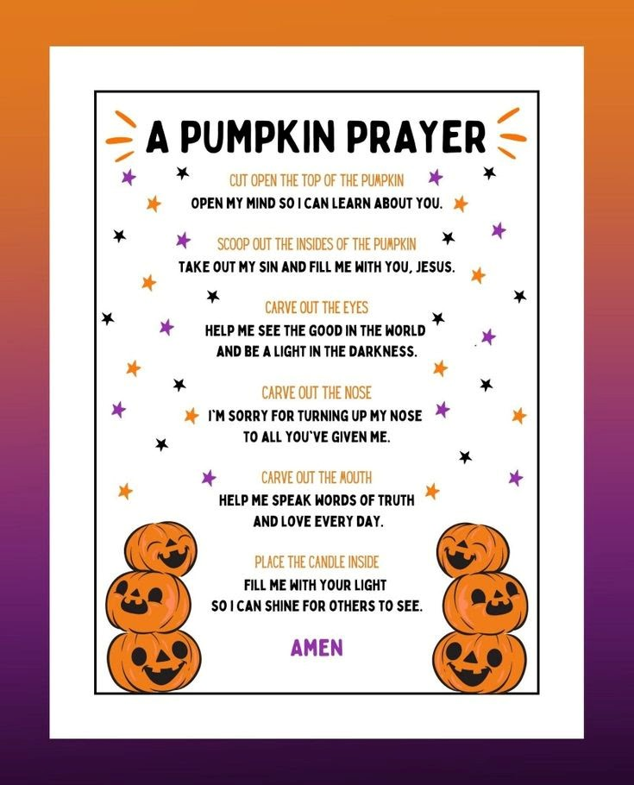
This weekend the church celebrates All Saints’ Day, or to give it it’s Old English name – All Hallows Day (Hallowed meaning holy or sanctified). From that name we get the day that precedes it – All Hallows Eve, or as it is more commonly known today - Hallowe’en. All Hallows Eve, from the Middle Ages, was the day to prepare for All Saints’ Day, when people would fast and prayer ready for the next day’s celebrations, without a witch’s costume or pumpkin in sight. It was only during the late 20th Century that the idea of ‘Trick or Treat’, pumpkin carving, and fancy-dress costumes were imported from America and it became the big event it is today.
Before I Ramble a bit more about Hallowe’en, I have been reflecting on the day that follows it - All Saints Day. Many people, including many Christians, think that All Saints Day is a day dedicated to all the named Saints who don’t have a special Feast Day, but it isn’t. All Saints Day is a day to remember, to give thanks for, and celebrate, the lives of all the departed. It is a day to think of all the people we have known and loved who have died. A day to give thanks for all the people who have helped shape us into the people we are, be it parents, siblings, children, friends, or teachers. St Peter said ‘you are a chosen people, a royal priesthood, a holy nation, God’s own people’ (1 Peter 2: 9). All Saints Day is not about remembering a certain group of people, The Saints, but about remembering that we are all equal in the sight of God, and that we have all been called to be his people, with no favouritism and no hierarchy, and that everyone who has died is worthy of our thanks, and our acknowledgement as to how important they were, and still are, to us, and to God.
But back to Hallowe’en. For those of us of a certain age, and older, who didn’t experience Hallowe’en as children, it is easy to dismiss it as a commercial enterprise, promoted by shops and businesses as a way to make a bit more money (or a lot more money) as the run up to Christmas begins. But as I was reminded last Sunday, at Children’s Church, even the carving of a pumpkin, probably to most obvious sign of modern-day Hallowe’en, is an opportunity to remember the roots of the day, and to offer God our prayers and thanks. The picture at the top of the Ramble is a Pumpkin Prayer, where each element of the carving is an opportunity to remember God and to ask for his blessings and gifts. (I should say at this point, the carving was done by an adult, because you need a really, really sharp knife to get through pumpkin skin).
My favourite part in the prayer is the carving of the mouth and the eyes – ‘help me speak words of truth and love every day’, and ‘help me to see the good in the world and to be a light in the darkness’. They are prayers that we could all do with remembering every day, because it is so easy to fall into the trap of criticism and judgment. It is easy to watch the news, or read the papers, and think that there is nothing good, nothing positive, happening. That there is nothing for us to give thanks for, nothing for us to celebrate, but there is – it’s just that the good, the positive, the small acts of kindness, the small sacrifices people make for the good of others, don’t make the headlines. The people in Spain who rushed to the blood banks to donate after the horrific train crash they are the good in the world. The staff of Medecins Sans Frontieres, who fly into areas of natural, and man-made, disasters – they are the good in the world. The people who donate to food banks, sometimes giving food that they desperately need themselves because they know others needs are greater – they are the good of the world speaking, and showing, love every day.
But we don’t need to make grand gestures, or sacrifices, to speak love, and see good. We can do it by simply smiling at someone as we pass them in the street. We can say hello to the person who serves us in a shop, and thank you as we leave. We can offer a cup of tea to a neighbour. We can remember all the things that people did for us, and as we remember them this All Saints Day, we can commit ourselves to living as they lived, and to be a light in the darkness.
Rev Sarah
You are warmly welcomed to worship in the Valley Parish

1st November
All Saints' Day
Holy Communion
10am
East Dean

Rev Sarah Manouch
07468 854864 priestvalleyparish@gmail.com
Please note that I am part-time. My principal working days are Friday and Saturday as well as Sunday. I am not available on a Thursday.

