

St John’s Review
September 2026

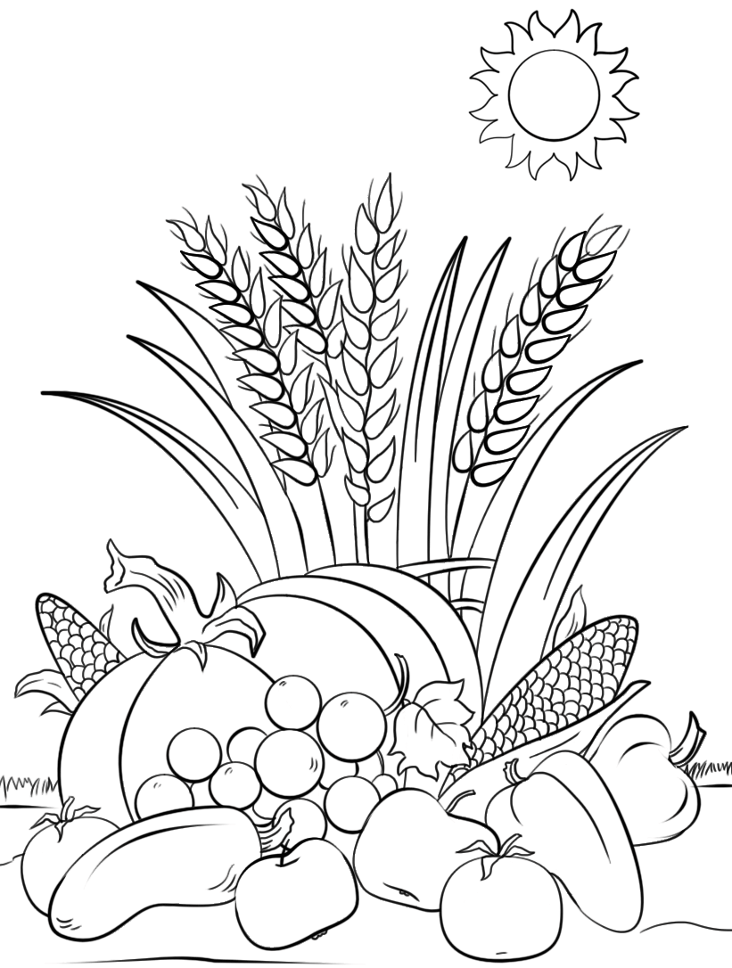

Serving the villages of
Hadston, Red Row and North and South Broomhill

Services September 2026

SUNDAY | 6th Sept | 9.00am | Holy Communion
SUNDAY | 13th Sept | 9.00am | Holy Communion
SUNDAY | 13th Sept | 4.00pm | Café Church  Coquet Tea Rooms  Amble
THURSDAY | 17th Sept | 2.00pm | Third Thursday
SUNDAY | 20th Sept | 9.00am | Holy Communion
SUNDAY | 27th Sept | 9.00am | Holy Communion  Harvest Festival



Dear friends,

September: the start of the new school year, a time when the Church celebrates Harvest and, a cooling of the weather. As a teacher before I was called to ordained ministry, I always find myself thinking of September as the start of something new. Those classrooms empty on the Summer holiday would soon be filled with inquiring minds, carefully planned activities and, as a Reception teacher for many years, lots of glue and painting activities to help with learning! I always enjoyed the start of a new school year and all the possibilities it held for my students. Perhaps you, or someone you know, is about to start a new school year. They may be a little nervous about moving schools or starting to learn new subjects, or they may be a new teacher going in to their very first year of teaching. I think we all know how it feels to start somewhere new, with all the concerns and excitement. Let us commit to praying for and supporting our children and young people who are starting a new school year. Let’s encourage them with our words and the way in which we are interested in their learning and development as people. Let’s remember everyone who is in a new season of life, whether it is exciting or scary, and let us offer them a listening ear and an open door when it is needed. Together we can be there to support everyone, young or old, with care and compassion and the odd prayer too!

I mentioned earlier Harvest, and we at St John’s have our Harvest Festival service on Sunday 27th September 9am. It will be followed by a Harvest Brunch, the details of which will be shared closer to the day. Do come along. This is a very important day, when we give thanks to God for the harvest but we remember with grateful hearts those who work so very hard for us on land and sea in order that we might be fed with good and nourishing food. With the weather this summer being unusually hot I have been very mindful of the cost the farming community pay during times like these. Not only do crops and livestock suffer but farmers suffer too as they do everything they can to protect what is given into their care, both soil and animals. They are often in my prayers and thoughts and I would encourage you to do the same.

It is interesting that in his life on earth Jesus often spoke in parables about everyday events and recognisable scenarios, including talking about crops and soil, fishing and harvesting. We have an understanding when he talks of seeds being planted in different soils, we can imagine storms brewing on a huge lake and how frightening that might be. Jesus spoke of things we understand because He understands the lives we lead, and he cares for all people and all parts of our lives. Nothing is too big or small to talk to Him about. Prayer is a way of communicating with God and if you would like help with your prayers, my advice is to just speak to God wherever you are and whatever you are doing. God will hear your words, whether they are spoken, whispered or shouted. He will hear you and respond, because he loves you.

This month we pray especially for Anthony Reay as he heads off to start his Ordination Training. We wish him well and look forward to seeing how and where God will lead him in the future.

God bless you all,

Rev Rachael



Wedding guest

A little boy at Sunday School learned about the time Jesus went to a wedding and changed the water into wine. "And what did you learn from that story?" asked his father afterward.

The boy thought for a moment and answered, "If you're having a wedding, make sure Jesus is there."


You are invited to Making Space – our craft club

Our next meeting will be on Thursday 10th September at 7pm in St John’s church kitchen.

Everyone is welcome, bring anything you are making with you and we will have time to plan what we might like to do together as we meet each month.

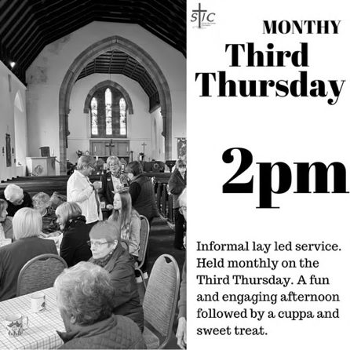
Everyone is welcome to Third Thursday, 17th September, at 2 pm in Church.
A short informal service enjoyed by all, led by Cynthia or Sheila.
Refreshments are served afterwards.

And after our August break …..



Wednesday 9th September in Druridge Bay Community Centre.
Everyone welcome!

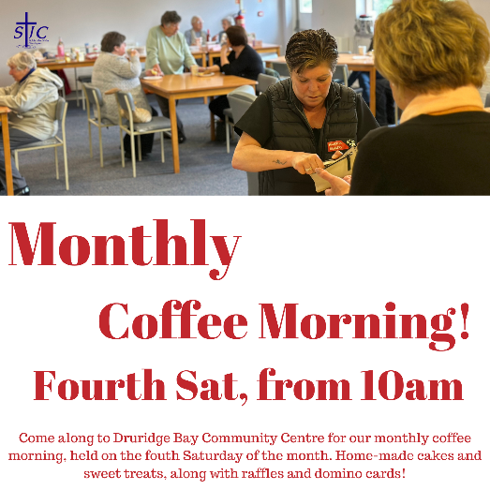

Saturday 26th September from 10 am
in Druridge Bay Community Centre.
What’s happening at our sister church,
St Cuthbert’s in Amble?
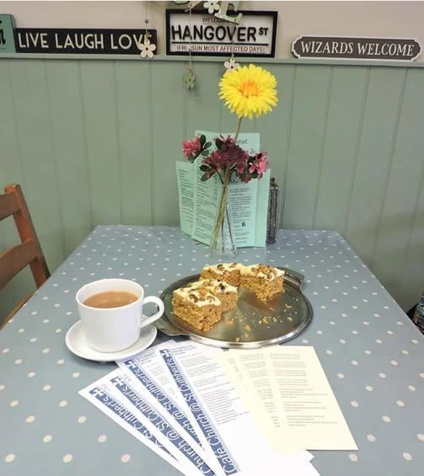
Café Church
Every month St Cuthbert’s hosts Café Church in the Coquet Tea Rooms – a lovely time with
familiar faces and holiday visitors. Why not pop along sometime?

Sunday 13th September at 4pm.

Coffee mornings
Held on the first and third Saturdays of each month, from 10am in St Cuthbert’s church.

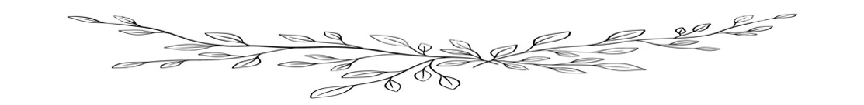

Freezer labels
Jane had a system for labelling homemade freezer meals. She would carefully note in large clear letters, ‘Lasagne’, ‘Beef stew’, ‘Chicken casserole’, etc. But every day when she asked her husband what he wanted for dinner, he never asked for any of those meals.
So finally, she decided to stock up with his various requests. Nowadays her freezer is full of dinners with neat little tags that say: ‘Whatever’, ‘Anything’, ‘I Don't Know’, ‘I Don't Care’, ‘Something Good’, or ‘Food’.
No more frustration for Jane, because no matter what her husband wants for dinner, she has it!



MEMORIAMS FOR SEPTEMBER
BLACK
Precious memories of a much loved mam and nana Mary died 8th September 1990. Remembering you is easy, we do it every day. It’s the sadness of losing you, it never goes away. Sadly missed but not forgotten by Gordon, Lynn, Kerry, Teresa and families

BLACK
Margaret Black died September 19th 2007. In loving memory of a dear wife, mother, nana and sister. Too dearly loved to be forgotten and always in our thoughts. Gary, Paula and all the family

KNOX
Treasured memories of our dear Dad, Stan, who loved life’s simple pleasures, his family and the community he and Muriel belonged to. Died 20th September 2019, sadly missed and forever in our thoughts and in our hearts. Linda and Hilary.

MILLER
In loving memory of a wonderful, Dad and Grandad Billy Miller died suddenly on 7th September 2021. Loved and missed everyday by wife Joan, daughters Mandy and Kirsty, son in law Bryan and grandsons Austin and Rowan. Always in our hearts.

*** Missing a memoriam? ***
We are trying to identify the family members requesting memoriams and are only including those we have been asked to retain. Please email stjohnchevington@gmail.com if your memoriam is omitted and confirm the name of your loved one, the words you would like to use and your contact details. (There is no charge for including a memoriam).
Crossword
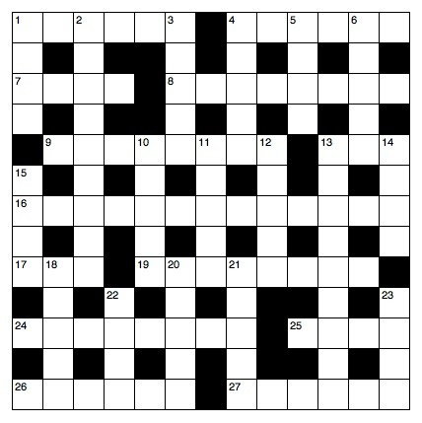
Crossword Clues

Across
1 ‘Unless the Lord builds the house, its builders — in vain’ (Psalm 127:1) (6)
4 Season of the year (Psalm 84:6) (6)
7 ‘My soul is overwhelmed with sorrow to the point of death. — here and keep watch with me’ (Matthew 26:38) (4)
8 It came over the whole land from the sixth to the ninth hour on the first Good Friday (Luke 23:44) (8)
9 Paul invariably did this in the synagogues he visited on his missionary journeys (Acts 17:2) (8)
13 ‘It is God who works in you to will and to — according to his good purpose’ (Philippians 2:13) (3)
16 Members of the Church of Scotland (13)
17 ‘Now when he saw the crowds, he went up on a mountain side and — down’ (Matthew 5:1) (3)
19 Mock(Luke14:29)(8)
24 Disgrace(Psalm44:13)(8)
25 First month of the Hebrew calendar (Exodus13:4)(4)
26 Christianity of the Britons before Augustine arrived from Rome(6)
27 Mean (Numbers 35:23)(6)

Down
1 ‘Whoever finds his life will — it’ (Matthew 10:39) (4)
2 ‘My lord the king, let the — — on me and on my father’s family, and let the king and his throne be without guilt’ (2 Samuel 14:9) (5,4)
3 O raid (anag.) (5)
4 ‘If two of you on earth — about anything you ask for, it will be done for you by my Father in heaven’ (Matthew 18:19) (5)
5 Take care of (1 Samuel 17:15) (4)
6 What the older son heard as he came near the house the day his prodigal brother came home (Luke 15:25) (5)
10 ‘Do not think of yourself more highly than you ought,but rather think of yourself with — judgment’ (Romans 12:3) (5)
11 Do ten(anag.)(5)
12 Architectural style first used in Greek temples in the sixth century BC (5)
13 Capable of being used(1Kings7:36)(9)
14 ‘Each one should — his own actions’(Galatians6:4)(4)
15 Among the items imported by Solomon’s fleet of trading ships (1 Kings 10:22) (4)
18 ‘But I am afraid that just —— was deceived by the serpent’s cunning, your minds may somehow be led astray’ (2 Corinthians 11:3) (2,3)
20 Outstanding 18th-century hymn writer, — Watts(5)
21 One of the four sons of Asher(Genesis46:17)(5)
22 Be distressed(Proverbs24:19)(4)
23 He was the father of Gaal, who threatened rebellion against Abimelech (Judges 9:28) (4)

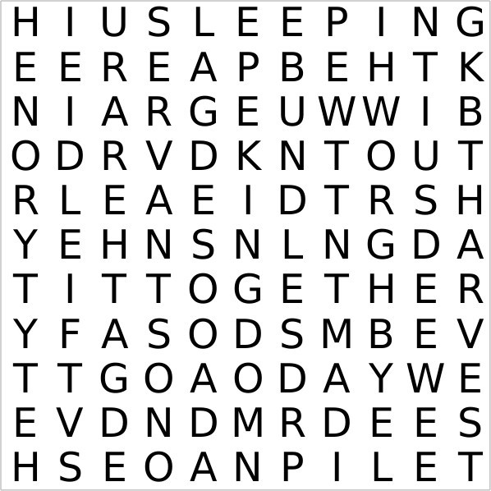

Wordsearch – The Parable of the Weeds (Matthew 13.24-30)

Ever wonder why there is both good and evil allowed in this world? Jesus told a parable that touched on this subject – it is called the Parable of the Weeds. It runs like this: Consider the world as if it were a field where a Farmer has sown good seed. But then an enemy came and sowed weeds among the wheat. So, when the wheat came up, so did the weeds. What to do? Instead of destroying the weeds, and thereby risking the wheat, the Farmer tells his reapers to wait and let both wheat and weeds grow together until the harvest. At the harvest he will instruct the reapers to gather up the wheat, but to discard the weeds. So do not despair when evil seems to thrive in this world – there is a reckoning still to come, and justice will be done.

Kingdom, Heaven, Good, Seed, Field, Sleeping, Grain, Weeds, Enemy, Servants, Master, Sow, Gather, Reap, Root, Let, Grow, Together, Harvest,
Bundles, Barn, Burned.
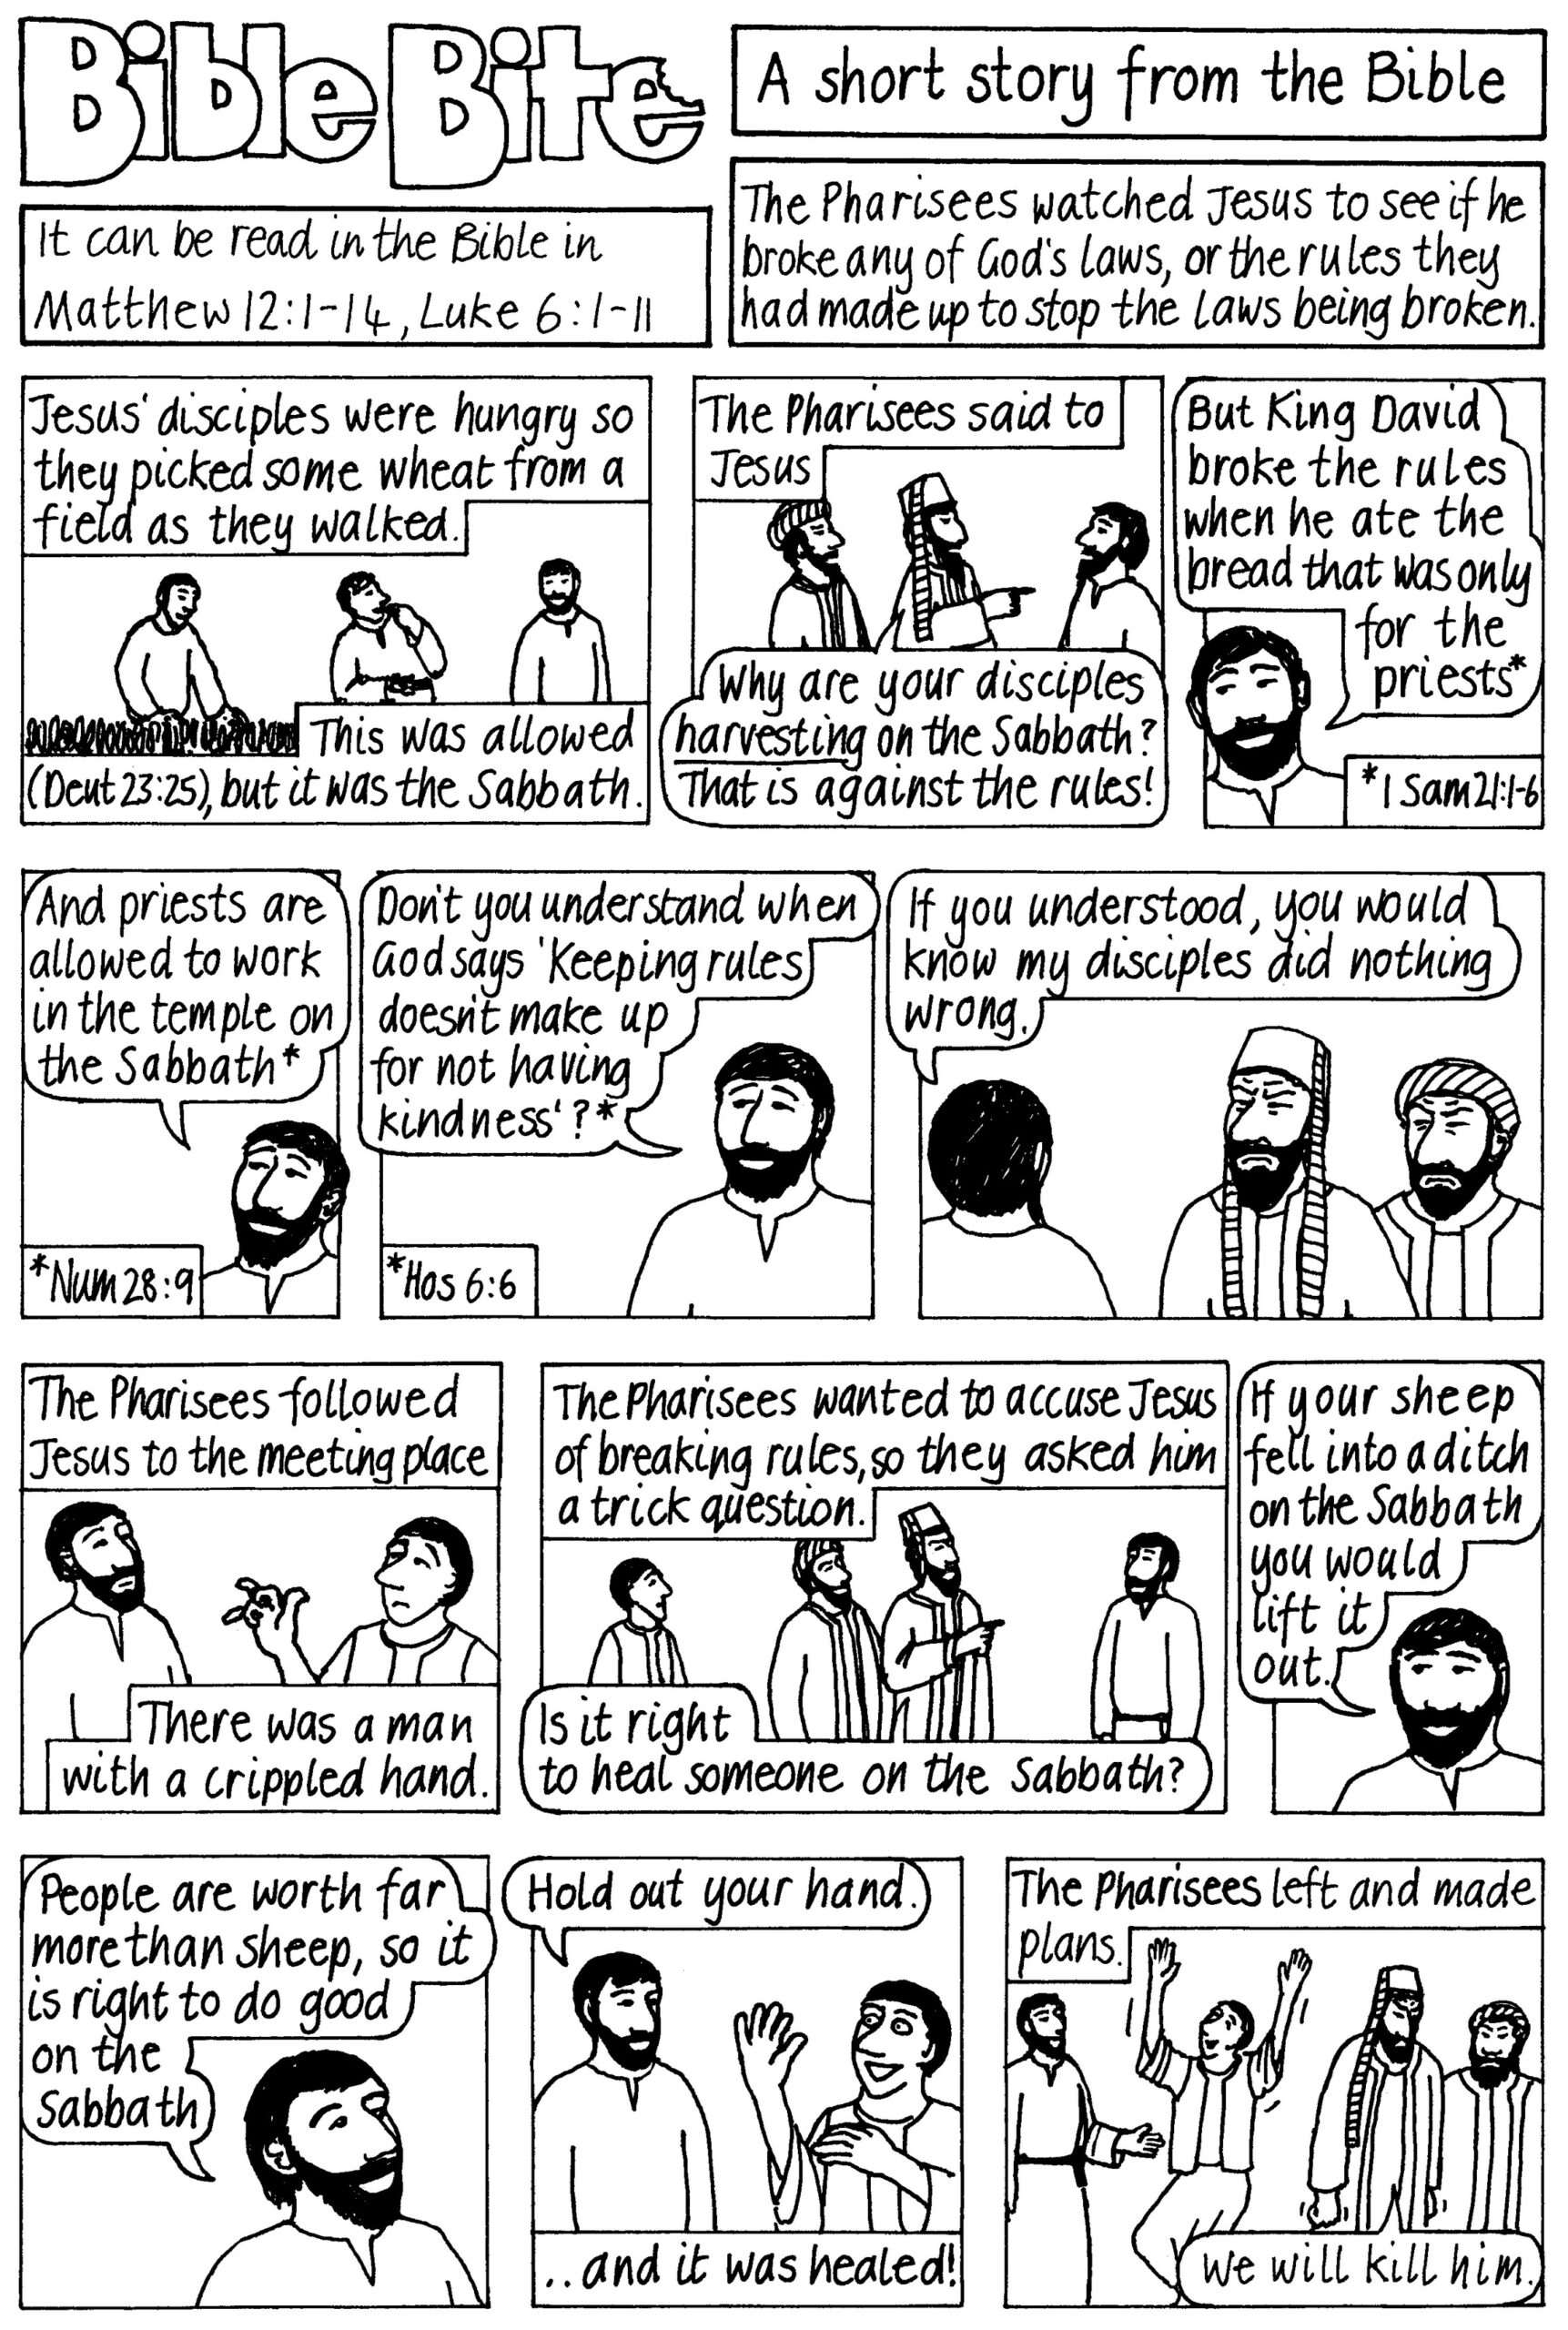

Poets Corner

The Picket Hut

Huddled n bundled tigither tight,
A nee room, night shift pittance plight.
Polythene, n owld timmer props,
Paraffin stove on full, n non-stop.

Eyes blink as yon fire does flicker n dance,
Quickly changing to a picket hut 5 second, trance.
As the Whittle pit cohort, strike ridden souls,
Sit bent ower, elbows on knees, like sickened ghouls.

There’s a slow rhythm to the night shift as they shuffle,
In nd oot, like Lowry stick men, plenty of groans n gruffle
The pyet of tha fyeces, hingin like wor mother’s owld dish cloot
Sucking on tha tabs, future nd fear, there is nee doot!

The plastic doorway flaps nd flutters in the shore road wind,
These Whittle men, a look aroond, tha the very best ya cud find.
Tha curse nd criticise, argue and debate, the 3 day week,
This hut, these men, their strength within, there is nee meek.

Wor mutha nd other wives turn up, with flasks of broth,
Ya can tell, men, bairns and wives, wa aall cut from the same mining
cloth.
Just 15, a bairn really, still growing up. Yit these nights, good education,
To sit nd listen, watch and learn, as these fillers, these hardy hewers,
Grappled with life in the picket hut, on yon Derek Crooch Location.

John Robertson

The September Night Sky

The September equinox occurs at 1.03 am on September 23rd. This event marks the start of astronomical autumn in the northern hemisphere. On this day everyone on Earth experiences roughly 12 hours of daylight and 12 hours of night.

Bright planets

Saturn is currently the only bright planet in the evening sky. You can find rising over the eastern horizon an hour so after dark. Telescopes are required to see the celebrated rings but its largest moon, Titan, can be glimpsed with binoculars. Jupiter and Mars rise in the eastern sky after midnight; they are both continuing to brighten as they approach Earth over the coming months.

Phases of the moon


Sep 4 Sep 11 Sep 18 Sep 26

Harvest Moon
Of all the Full Moons of the year, few have acquired such a romantic reputation as the Harvest Moon. The name sounds ancient, and indeed it is closely tied to the farming year, but there is nothing mysterious about the Moon itself. The Harvest Moon is simply the Full Moon occurring nearest to the autumn equinox.
What makes it special is the way the Moon rises on successive evenings at this time of year. Normally the Moon rises roughly 50 minutes later each night, but around the autumn equinox the delay can be considerably smaller, especially from northern latitudes. For several evenings in succession a bright Moon may therefore appear soon after sunset.
Before electric lighting, this was genuinely useful. Farmers gathering crops at the end of the day could continue working by moonlight, and it is from this connection that the familiar name probably arose.
The effect is caused by geometry. The Moon moves eastwards against the background stars each day, but in September the path it follows – the ecliptic – meets the eastern horizon at a rather shallow angle during the evening. Much of the Moon's nightly movement is therefore sideways along the horizon rather than upwards away from it. The result is a succession of relatively early moonrises.
There is also a persistent story that the Harvest Moon looks unusually large or orange. It is not actually larger than other Full Moons merely because it is the Harvest Moon. However, when seen low in the sky it often appears enormous because of the familiar Moon illusion. Its orange or reddish colour is quite real: near the horizon, moonlight has to pass through a much greater thickness of atmosphere, which scatters away more of the blue light.
So the Harvest Moon needs no exotic astronomical explanation. It is an ordinary Full Moon placed, by a fortunate combination of season and celestial geometry, in exactly the right part of the sky to have become one of the most celebrated Moons of the year.
If you’d like to learn more about astronomy, then consider contacting your local astronomy club – the Northumberland Astronomical Society (NASTRO) - see www.nastro.org.uk for further details.

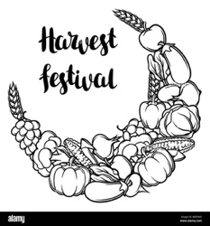
Dr Adrian Jannetta MSc CMath FRAS

Our Harvest Festival will be on Sunday September 27th at 10.00am.
Gifts of non-perishable food items will be collected and given to our local food bank.
If you would like to contribute, items can be brought to church for the Harvest Festival service or can be left in church at any time during the week before (remember church is open daily between 10am and 4pm).
Afterwards there will be pastries, fruit and croissants served with tea, coffee or juice. All are welcome to stay.
All in the month of September

It was:

250 years ago, on 9th September that the Second Continental Congress adopted the name United States, which replaced United Colonies.

200 years ago, on 5th September 1826 that John Wisden, British cricketer was born. Founder of Wisden’s Cricketers’ Almanac. Launched with 112 pages in 1864, it now runs to 1500 pages and is the bible of cricket.

175 years ago, on 19th September 1851, Wiliam Lever, 1st Viscount Leverhulme, was born. Co-founder of Lever Brothers with his brother James. Now called Unilever, this global consumer goods company operates in more than 190 countries.

125 years ago, on 29th September 1901 that Enrico Fermi, Italian-born American physicist was born. Creator of the first nuclear reactor, he became known as the ‘architect of the nuclear bomb.’

90 years ago, on 7th September 1936 that Buddy Holly, the American rock and roll singer and hits was born. Killed in a plane crash in 1959.

Also 90 years ago, on 21st September 1936 that Frank Hornby, British inventor, died. Remembered for Meccano, Hornby Model Railways and Dinky Toys.

Also 90 years ago, on 30th September 1936 that Pinewood Studios in Buckinghamshire were officially opened.

80 years ago, on 5th September 1946 that Freddie Mercury, Zanzibar-born British rock singer and songwriter was born. As lead singer of Queen, he sold more than 250 million records worldwide. Died of bronchial pneumonia resulting from AIDS in 1991.

70 years ago, on 25th September 1956 that the world’s first transatlantic cable, TAT-1, went into service. It could carry 36 simultaneous calls, later increased to 72. It was retired in 1978.

65 years ago, on 11th September 1961, that the World Wildlife Fund (now the World Wide Fund for Nature) was founded in Switzerland. Nowadays it is the world's largest conservation organisation, operating in nearly 100 countries with over 35 million supporters.

60 years ago, on 8th September 1966 that the Severn Bridge was officially opened. Linking Wales and England over the rivers Severn and Wye, it carries about 32,000 vehicles a day.

50 years ago, on 5th September 1976 that the first episode of the Muppet Show was broadcast on ITV in the UK. It attracted 15 million viewers and ran for five series until March 1981.

40 years ago, on 7th September 1986 that Desmond Tutu became the first black Archbishop of Cape Town. Retired in 1996.

30 years ago, on 27th September 1996 that the Taliban seized control of Kabul, the capital of Afghanistan. Mullah Omar was installed as Head of the Supreme Council and ruled until 2001.

25 years ago, on 11th September 2001 that the terrorist attacks on America took place. Al-Qaeda terrorists hijacked four planes and crashed them into the World Trade Centre’s Twin Towers in New York, into the Pentagon, and into a field in Pennsylvania (following a passenger revolt – the intended target was Washington DC). 2,973 people were killed.

20 years ago, on 3rd September 2006 that Andre Agassi announced his retirement due to back problems. He was 36, a former world number one in tennis, and the 1996 Olympic champion.

Back to School - facing that first Day

No matter how old we are, we can probably remember our first day at school – being left at the door, meeting children we did not know, separated from the adults we did know and had trusted since the day we were born. But on the other hand, there was the excitement: a big step along the road of life, new friends to make, another adult to become important in our lives. Yes, quite a lot to handle when you’re rising five!
And that’s what hundreds of thousands of children are going to experience this month. Parents may have prepared them for it, and they may in a slightly apprehensive way be looking forward to it, but it must feel to the five-year-old like a massive step into the unknown.
Not much less is the anxiety of mum, who leaves her precious child, proudly resplendent in their new school uniform, in the Reception class-room. Will he or she suddenly panic, and cry for that familiar parental cuddle? Will they feel abandoned in an alien setting? Will they like the teacher?
Of course we’ll be praying for them, and we know that like millions of others before them they will very probably eventually decide that their schooldays were among the best of their lives. But end of class can’t come soon enough for mum on that first day! How wonderful when they come running out, laughing and excited, clutching a piece of paper with some obscure crayon marks on it – written evidence of their first day’s education.

Crossword Answer Wordsearch Answer
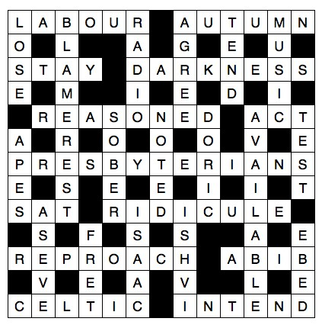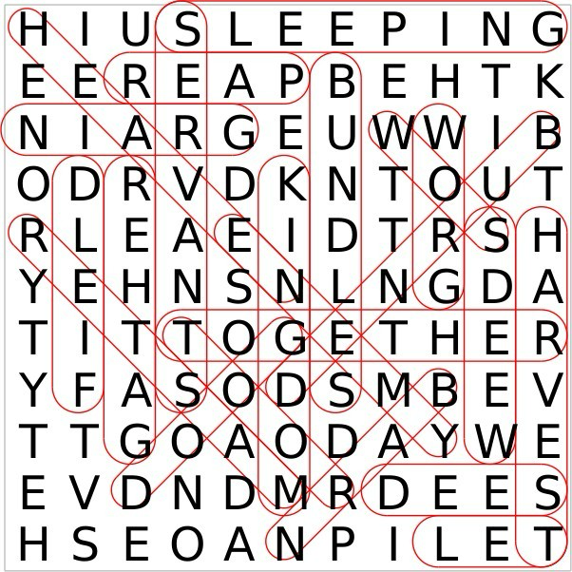



Gift Shop, Home Interiors, Painted Furniture, Furniture painting commissions & Frenchic Paint stockist.


10 The Precinct. Hadston. NE65 9YF

Facebook The Furniture Painter

Email keith.brooks2@btconnect.com Mobile 07437853665.

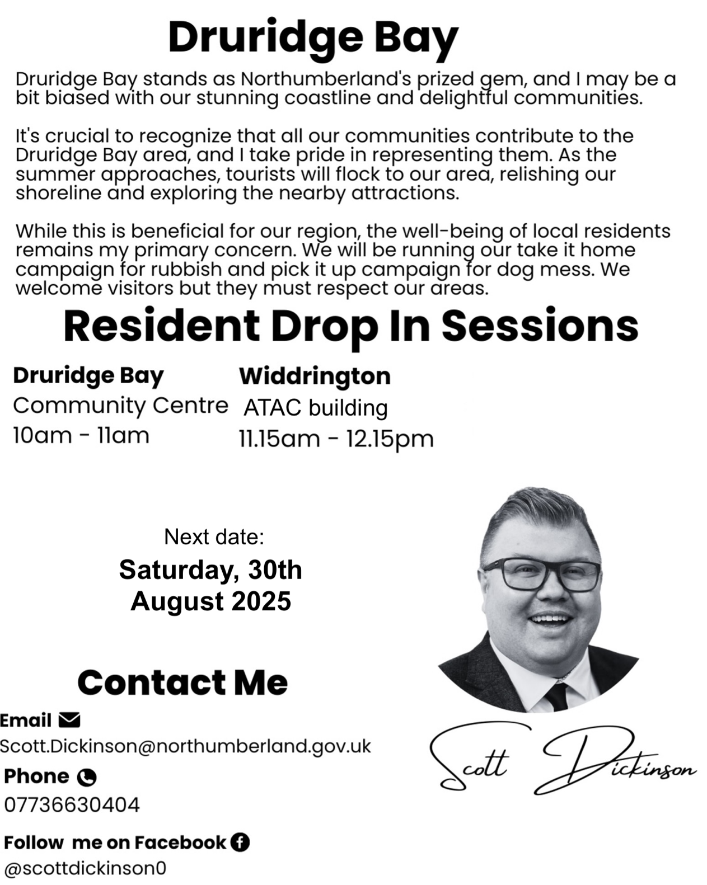



ADVERTISE HERE!

If you would like to advertise your business, please contact the editors via stjohnchevington@gmail.com for more

HADSTON NEWSAGENCY

PROPRIETOR – Stephen Paton

HADSTON SHOPPING CENTRE

Tel: 760233

Post Office Now in Shop
Newspapers Magazines
Stationery Cigarettes
Tobacco Alcohol
Pet Corner Household Goods
Groceries





T. DAWSON Ltd

ELECTRICAL CONTRACTOR

- Renewables
- EICR
- Domestic, Commercial, Industrial

T. Dawson Ltd
Bradley House
23 Togston Road
North Broomhill
NE65 9UZ

Tel: 01670 761921 / 07955 911720 Email: trevortoggy@icloud.com




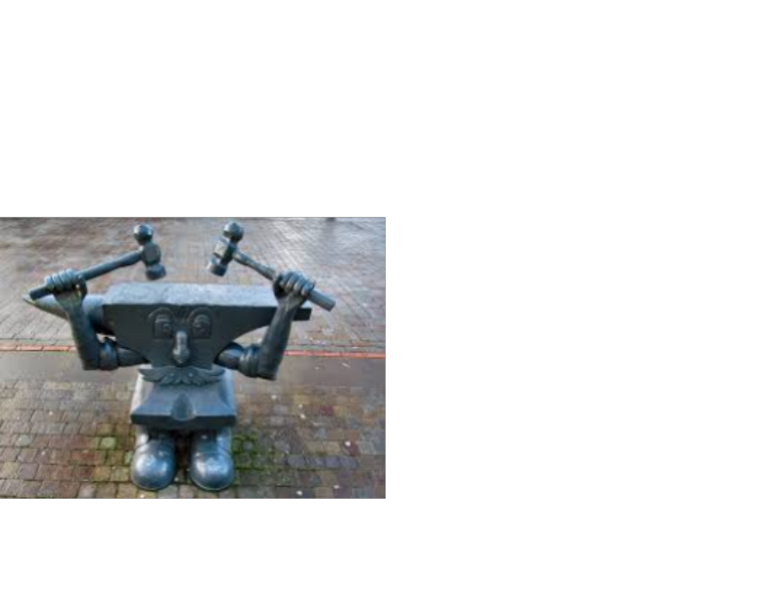
John S Lunn & Sons
Artsmith, Blacksmith
Stephen Lunn
Est 1921
Tel: Red Row 01670 760246

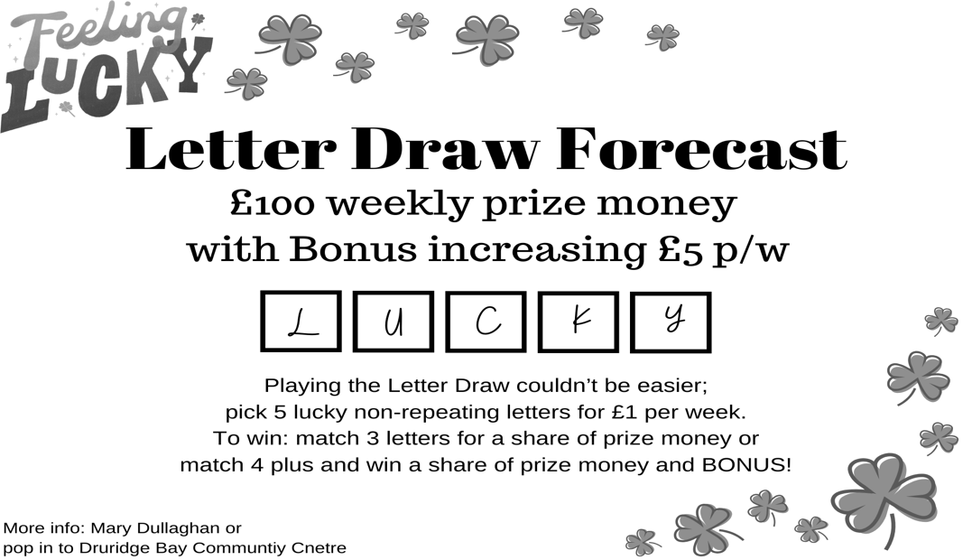
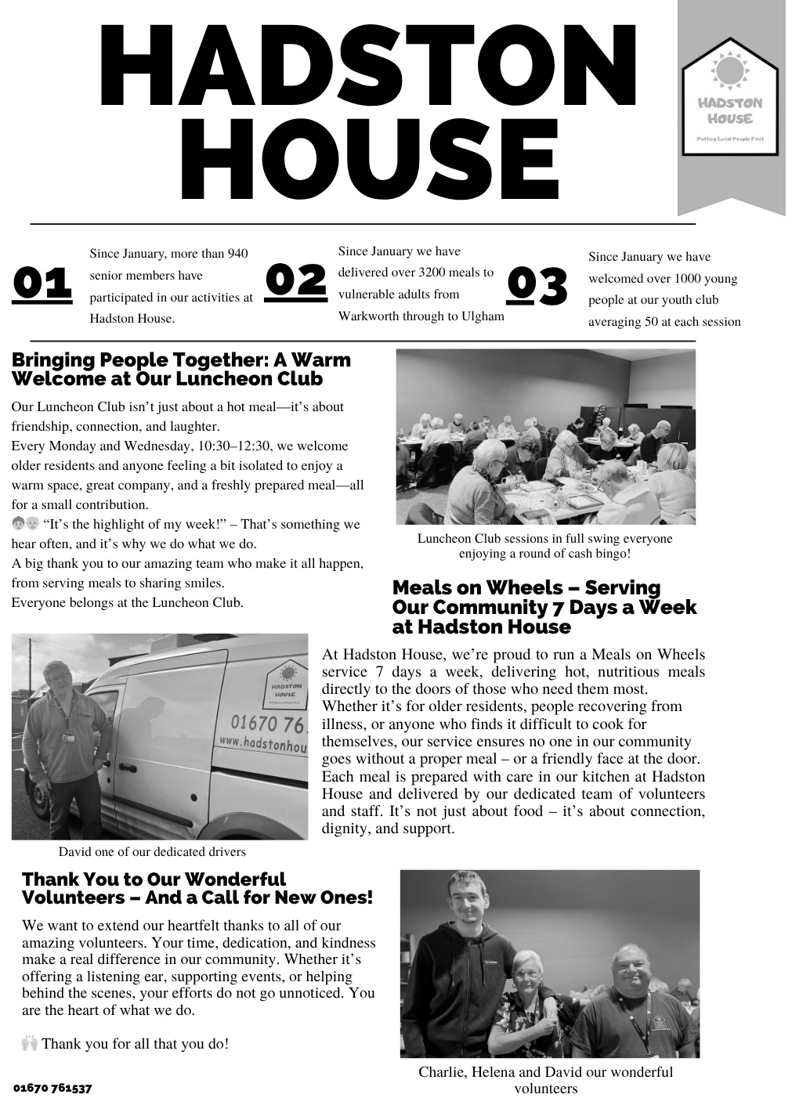
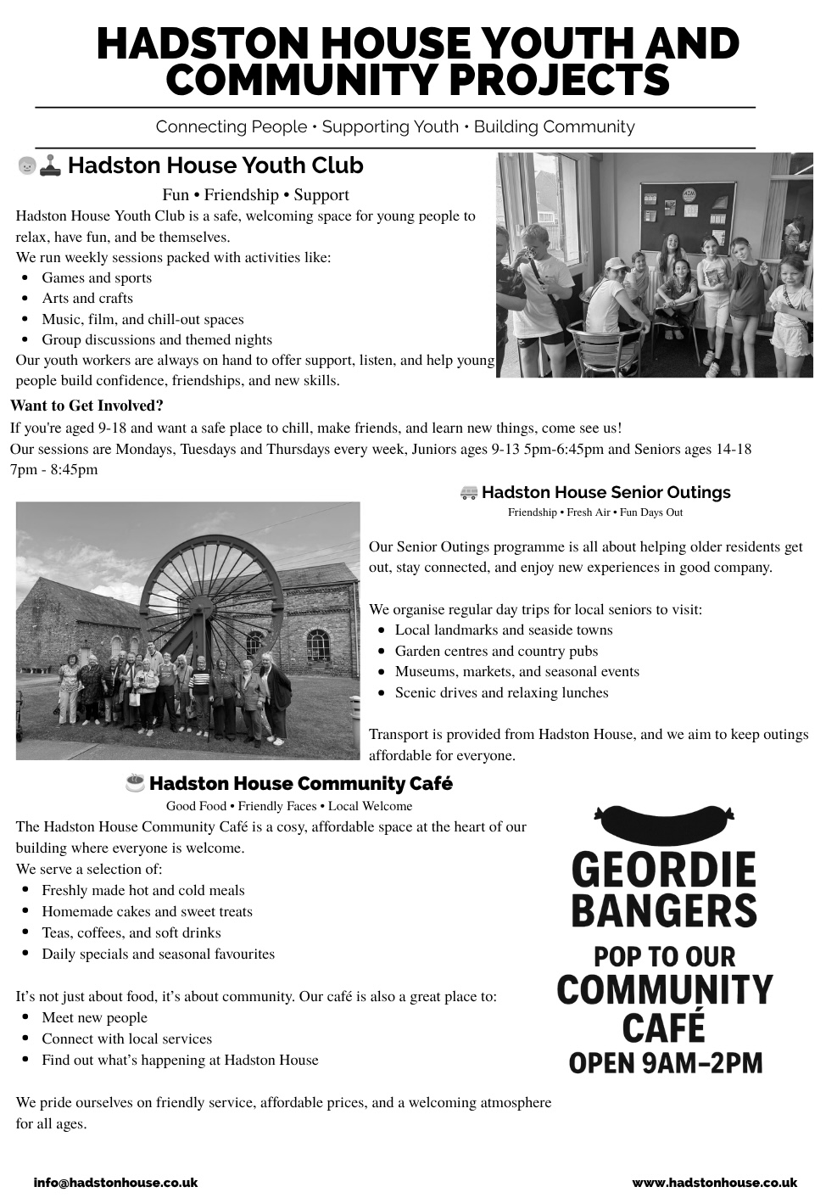

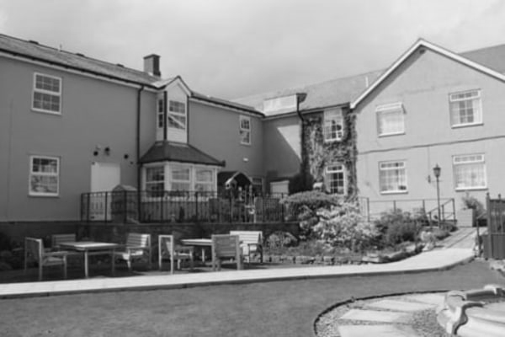
HEATHERDALE RESIDENTIAL
CARE HOME
Broomhill, Morpeth
HEATHERDALE RESIDENTIAL
CARE HOME
Broomhill, Morpeth

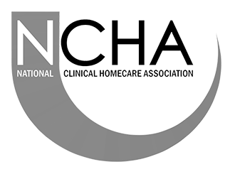
01670 760796

Our aim is simply ‘Care Without Compromise’, which fundamentally means
we believe in Privacy, Dignity, Independence, Choice, Rights and Fulfilment
for the client. High standards of comfort, providing ‘First Class Quality Care’

Our home has:
- Ambience – “Truly a Hom, in the warmest sense.”
- Social Activities and Outings – “Daily with various outings”
- A Tip-top team – “Warm, cheerful, reassuring and caring”
- Virtually all single rooms, the majority of which are en-suite.
- Lovely Gardens, which have won Britain in Bloom Competitions
- Excellent Home Cooking - Great choice – 5 Star”
- Qualified Staff – “Training from day one”
Call any time for a brochure!
Helpline | Phone | Cost
Samaritans | 116 123  Open 24/7  jo@samaritans.org | Free
Mind Mental health support | 0300 123 3393 Open 9am-6pm except bank holidays.  Text 86463  info@mind.org.uk | Local rates from landline  Mobile charges vary
FRANK  Need advice about drugs – talk to Frank | 0300 123 6600 Open 24/7  Text 82111  frank@talktofrank.com | Local rates from landline  Mobile charges vary
Alcoholics Anonymous | 0800 9177 650  help@aamail.org | Free
Rape Crisis | 0808 802 9999  12noon-2.30 & 7-9.30 daily | Free
Switchboard LGBT+ helpline | 0300 330 0630  10am-10pm daily  chris@switchboard.lgbt | Local rates from landline  Mobile charges vary
National Domestic Violence  Run by Women’s Aid and refuge | 0808 2000 247 Open 24/7  0808 801 0327 Male advice & enquiry  0808 802 4040 Helpline for men worried they may be harming someone else | Free
ManKind Initiative domestic abuse helpline for men | 01823 334244 weekdays 10am to 4pm | Local rates from landline  Mobile charges vary
Farming Community Network | 03000 111 999  7am-11pm every day of the year  chris@fon.org.uk | Local rates from landline  Mobile charges vary
Dementia Helpline | 0800 888 6678  Open 9am-9pm Mon-Fri  helpline@dimentiauk | Free
Silver Line  Helpline for older people | 0800 470 80 90  Open 24/7 | Free
Action for Elder Abuse | 0808 808 8141  Open 9am-5pm Mon-Fri | Free
Childline | 0800 1111 open 24/7 | Free

PARISH CONTACTS
Priest in Charge: Rev’d Rachael Dines
Churchwarden: Sheila Orgill
Safeguarding Officer Sheila Orgill
Editor: stjohnchevington@gmail.com

Please contact Rev’d Rachael Dines, 07763 211901 with any enquiries about baptisms, weddings and funerals or if there is anything St John’s can do to help you.

Find us on Facebook  - St John the Divine, Chevington
Also: A Church Near You website https:/www.achurchnearyou
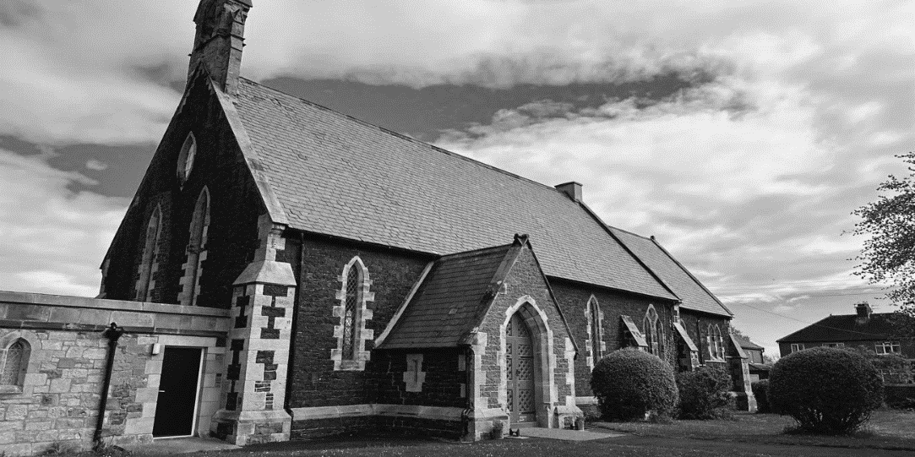

Dates and times are correct at the time of going to press.
Copies of this magazine can be obtained from St John’s Church or by contacting the magazine editor

The magazine committee is not responsible for the content of articles submitted and also reserves the right to exercise editorial discretion.

