The Rector's Ramblings
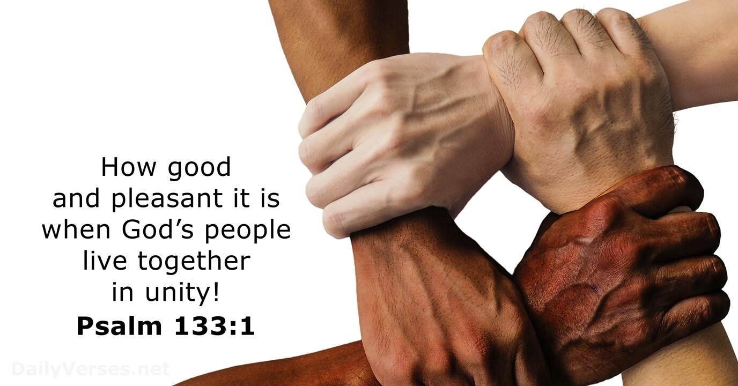
It may only be the middle of October, but packs of Christmas cards are flying off the shelves in St Olav’s or, more accurately, are flying off the tables. Although some customers first reaction is ‘No, it’s too early’, many of them still end up buying a few packs because there is no guarantee that their favourite design will still be in stock when they come back. We have over 100 different designs on display, and when one sells out, a new design replaces it.
What I find fascinating is the process of people picking the cards they want, which can sometimes take up to half an hour, or longer. Some cards are dismissed immediately, the image on the front is wrong. It may be a photo rather than a painting. It may be that it has too many words, or not enough. It may be that they prefer a nativity scene rather than a robin. And then it is what is written inside, what biblical text is quoted, whether it says Happy Christmas or Christmas Blessings. There is so much choice that it can seem overwhelming, but we are all different, and we all want the cards we send to say a little bit about us, as well as telling the person we send them to how much they mean to us.
Thinking about the choices people make reminded me of the famous quote from the film Forrest Gump – ‘Life is like a box of chocolates. You never know what you’re gonna to get’. Now picking a chocolate can be just as personal as picking a Christmas Card. Do you prefer milk or dark, toffee or coconut, fudge or nut? It’s easy to get your favourite if you can see the list of contents, but if you are offered an open box and the list is on the bottom, it is easier, and politer, to just take the one that looks the right shape for your favourite, and smile (sometimes through gritted teeth) when you realise it’s the coffee cream!
Now unlike Christmas Cards we send, and chocolates we choose from a list, life is more like the cards we receive, and the random pick we make from an open box. We don’t know what we’re going to get. We don’t know what gifts, skills, blessings, life will give us, but we can choose to embrace the gifts, to use them for the good of others, just like we can choose to display the cards that don’t match our preferences, to eat the random chocolate, or we can choose to only use our gifts for our own benefit, to only display cards we like, to spit out the coffee cream because it’s not the nut or coconut we prefer.
Many years ago, before ordination, I visited a friend on Boxing Day and was surprised that she only had half a dozen Christmas cards, and when I looked, I thought she hadn’t received mine. So, I began to apologise that mine hadn’t arrived and she said, ‘oh, it came, thank you, but I only like cards with renaissance paintings on them, and don’t display any others’. Now I love putting up all the Christmas, birthday, thank you cards I get because not only does it give me a boost, but the person who sent it went to the trouble of buying it, writing it, and sometimes the expense of posting it, and they deserve my gratitude, and for me to acknowledge their time and effort by displaying the card. My friend, I believe, missed out on some of the joy of Christmas, and maybe the joy of life, because she wanted it to be right for her, to fit her ideas, her preferences, and she couldn’t see the joy, the blessing, of diversity and different ways of doing things.
We are all different, thank God, we all have different tastes, different skills and different gifts, and they should be all recognised, valued, and respected, and if we work together, sharing what we have, using our skills to help others, embracing our differences as well as our similarities, who knows what a wonderful world this could be.
“There are different kinds of gifts, but the same Spirit distributes them. There are different kinds of service, but the same Lord. There are different kinds of working, but in all of them and in everyone, it is the same God at work.” – 1 Corinthians 12:4-6
Rev Sarah

You are warmly welcomed to worship in the Valley Parish
18th October  Holy Communion  10am  West Dean | 25th October  Holy Communion  10am  West Dean  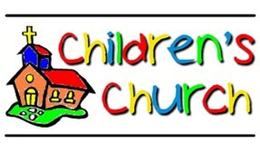  11am  West Dean

. Rev Sarah Manouch
07468 854864 priestvalleyparish@gmail.com
Please note that I am part-time. My principal working days are Friday and Saturday as well as Sunday. I am not available on a Thursday.

