VISITING
St Mary’s Church
Belstead
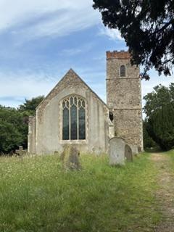

A social story

You might visit the Church for a special occasion like a wedding or at Christmas. You might come to have a look around or attend a service on a Sunday.
This is the door you will walk through
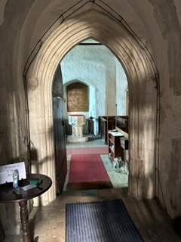

You can sit on one of these seats called a pew
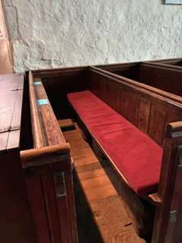
During the service there will be music played on the organ and singing. It might sound very loud
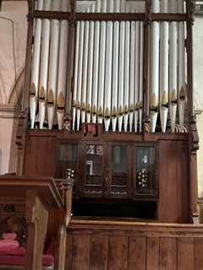
If you need to have a break you can sit in a quieter part of the Church or go for a walk outside.
At the end of the service, you might be able to have a drink and a cake or biscuit

There is a sensory box in the bookcase as you enter the Church please borrow and use the items during your visit.

