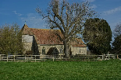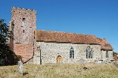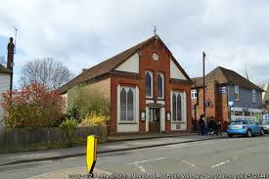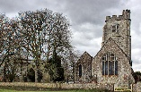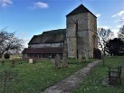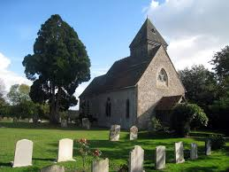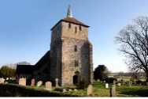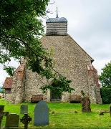

Saxon Shoreline Benefice Newsletter
  - October 2026
Sharing worship and events across Aldington, Bilsington, Bonnington, Hamstreet, Kenardington, Ruckinge and Warehorne.
Welcome!
We continue during October to celebrate Harvest. Officially, the season of Creationtide finishes on 4th October, the festival of St. Francis of Assisi. This year marks the 800th Anniversary of his death in 1226. St. Francis saw the love of God reflected in all aspects of creation and thus is seen as the patron saint of ecology.
List of services and events - October 2026
Thursday 1st October –
St. Matthew’s, Warehorne, Morning, visiting team of bell ringers from Bodiam
Friday 2nd October —
7.00pm, Beginning of Flower Folk Festival - Concert with ‘Ashford Folk’ - St. Mary Magdalene, Ruckinge
Saturday 3 October —
10.00am – 4.00pm, Flower Folk Festival, St. Mary Magdalene, Ruckinge, church open with Lunches and Teas;
11.00am – 12noon, St. Mary Magdalene, Ruckinge, live music with The Coltons

Sunday 4 October — Trinity 18 (St. Francis of Assisi – 800th anniversary of his death)
9.00am, Holy Communion (CW), St. Rumwold’s, Bonnington
9.45am for 10.00am start, Family Fun Service, Village Hall, Aldington
10.00am, Pet Service, St. Matthew’s, Warehorne
10.00am, Harvest Festival Service, St. Mary Magdalene, Ruckinge
10.30am, Methodist Harvest Communion Service, Church of the Good Shepherd, Hamstreet
St. Mary Magdalene, Ruckinge: church open after Harvest Festival for Lunches and Teas until 6.00pm
2.00pm-3.00pm. St. Mary Magdalene, Ruckinge: Live music by ‘Cantwara’
6.00pm St. Mary Magdalene, Ruckinge: Concert by ‘Lydia Laughing’
Tuesday 6th October -
7.00pm - Alpha Course, Mountfield Farm, Warehorne
Wednesday 7 October —
12.00 noon, Mid-week Holy Communion (BCP), St. Mary’s, Orlestone
7.30pm, Bible Study at St. Martin’s Church, Aldington – ‘Rogues, Scoundrels and Scallywags in the Bible’
Sunday 11 October — Trinity 19
9.00am, BCP Holy Communion, St. Peter & St. Paul, Bilsington
10.30am, BCP Matins, St. Mary Magdalene, Ruckinge
10.30am, Morning Worship, Church of the Good Shepherd, Hamstreet
10.45am, Holy Communion (CW), St. Martin’s, Aldington

Monday 12 October -
10:00am-12noon, Study the book of Mark, Church of the Good Shepherd, Hamstreet
Tuesday 13th October —
10.00am -11.30am, Tuesday Together, St. Mary Magdalene, Ruckinge
7.00pm - Alpha Course, Mountfield Farm, Warehorne
Wednesday 14 October —
12.00 noon, Mid-week Holy Communion (Celtic), St. Mary’s, Orlestone
7.30pm, Bible Study at St. Martin’s Church, Aldington – ‘Rogues, Scoundrels and Scallywags in the Bible’
Sunday 18 October — Trinity 20 (Luke the Evangelist)
9.00am, Holy Communion Service (CW), St. Mary’s, Orlestone
9.00am, Holy Communion Service (CW), St. Rumwold’s, Bonnington;
9.30am, Morning Worship, St. Mary’s, Kenardington
10.00am, Family Service, St. Mary Magdalene, Ruckinge
10.30am, Anglican Holy Communion Service (CW), Church of the Good Shepherd, Hamstreet
10.45am, Worship Service, St. Martin’s, Aldington
6.00pm, Harvest Festival Evensong with the Jump Singers, St. Matthew’s, Warehorne
Monday 19th October –
10:00am-12noon, Study the book of Mark, Church of the Good Shepherd, Hamstreet
Tuesday 20 October —
10.00am -11.30am, Tuesday Together, St. Mary Magdalene, Ruckinge
7.00pm - Alpha Course, Mountfield Farm, Warehorne
Wednesday 21 October —
12.00 noon, Mid-week Holy Communion (CW), St. Mary’s, Orlestone
7.30pm, Bible Study at St. Martin’s Church, Aldington - Rogues, Scoundrels and Scallywags in the Bible
Sunday 25 October — The Last Sunday after Trinity (BCP – Trinity 21)
9.00am, BCP Holy Communion, St. Peter & St. Paul, Bilsington
10.30am, Morning Worship, Church of the Good Shepherd, Hamstreet
10.30am, BCP Holy Communion, St. Mary Magdalene, Ruckinge
10.45, Holy Communion, St. Martin’s, Aldington
6.30pm, BCP Evensong, St. Matthew’s, Warehorne

Monday 26th October –
10:00am-12noon, Study the book of Mark, Church of the Good Shepherd, Hamstreet
Tuesday 27th October —
10.00am -11.30am, Tuesday Together, St. Mary Magdalene, Ruckinge
7.00pm - Alpha Course, Mountfield Farm, Warehorne

Wednesday 28 October —
12.00 noon, Mid-week Holy Communion (BCP), St. Mary’s, Orlestone
7.30pm, Bible Study at St. Martin’s Church, Aldington – ‘Rogues, Scoundrels and Scallywags in the Bible’
Saturday 31st October –
12.45pm Visiting team of bellringers from Upchurch, St. Matthews, Warehorne
Prayer
Most High and loving God, we praise you with Brother Sun, Sister Moon, the wind, the water and the earth. Teach us to receive creation as your gift, to care for it with humility, and to live in peace with all your creatures; through Jesus Christ our Lord. Amen.
Contacts and Submissions
Rector: Revd. Geoff Abasolo-Munnery, revgeoff.saxonshorelinebenefice@gmail.com; 07743 598896
Assistant Curate: Revd. Anne Loat, anne.loat@outlook.com, 07745 918629
Assistant Priest with PTO: Revd. Canon John Saunders, canonjohnsaunders@aol.com
Newsletter editor: please send to Revd. Geoff
Safeguarding contact: Mrs. Pauline Williams, wpauline@btinternet.com
Deadline for October newsletter items: Fri 16th October

