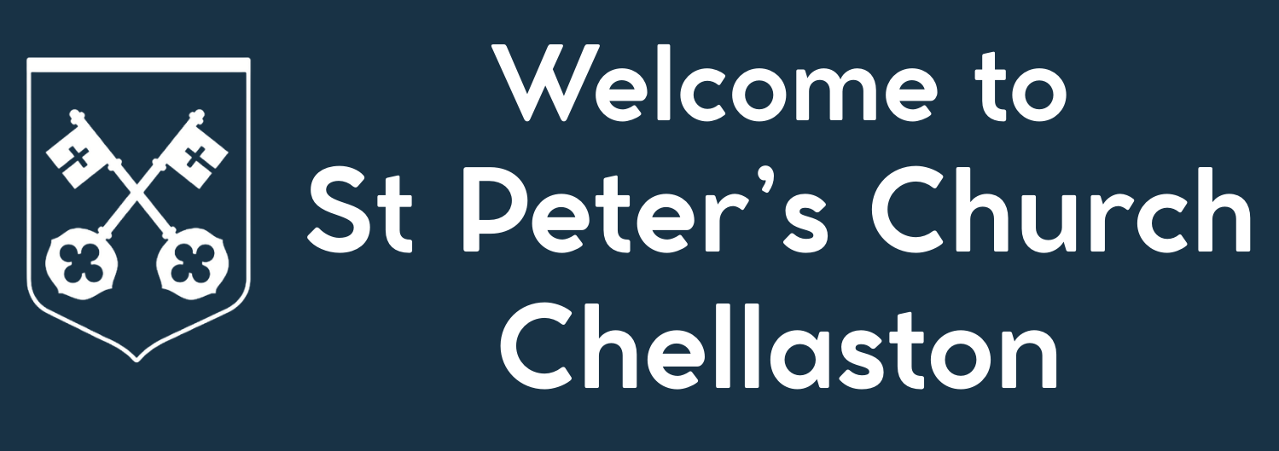
Notices
Sunday 18th October 2026


Readings: Exodus 32:1-14, Matthew 22:1-14

Vicar: Revd. Simon Drew Tel: 07342 280758. Simon.stpcchellaston@gmail.com

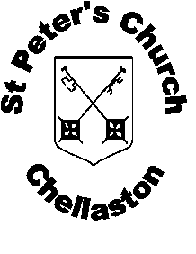
Church website: www.achurchnearyou.co.uk
Church email: stpeterschurchchellaston@gmail.com
Church Hall: stpeterschurchhallchellaston@hotmail.co.uk
Safeguarding: 07713 254931

Find us on Facebook:










For more information on the accessibility symbols visit https://accessiblechurch.net

PARTICULAR NOTICES

THIS WEEK AT ST PETERS
Sun 18th Oct | 10.00 am | Morning Worship
Mon 19th Oct | 7.00 pm | Alpha Course (Youth Room)
Weds 21st Oct | 9.15 am | Communion
Weds 21st Oct | 10.30 am | Coffee Morning

(Note: Sunday service will be live streamed on YouTube this week)

Readings: Exodus 33:12-23, 1 Thessalonians 1:1-10

NOTICES & EVENTS


Please note that the morning service on Remembrance Sunday (8th November 2026) will be at the later time of 10:50 am. As the scouts and guides will be with us for this, we suggest you get there by 10:45 am!


Advance notice of additional Christmas events
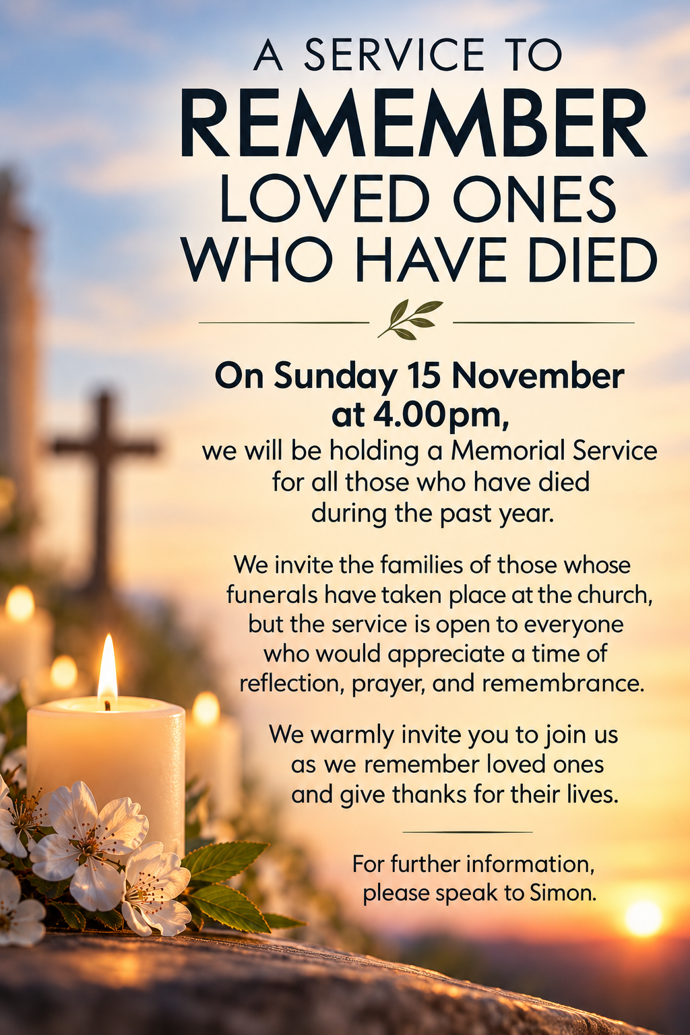

PRAYER


Praying for Chellaston Street by Street:
Tuphall Close, Chase Close, Lows Court

Please pray for:
Liz and Terry Spencer, Gordon Robison, Audrey Haward,
Beryl Ratcliffe, Richard Hubball.

We pray for the families of those who have died:

Iris Burke, Michael Swann.

Prayer Wheel:

See notice board for details or begin by contacting

Simon on

07342 280758
Pray with us: Hold in prayer those places where conflict and suffering continue, and all who have been forced from their homes or are experiencing hardship. Remember everyone who is struggling, those who care for them, and people in our own parish who are sick, grieving, lonely, or carrying heavy burdens.

Prayer of the Week

Loving God, you promised Moses, “My presence will go with you.” Help us to walk closely with you each day, trusting in your guidance and peace. Fill us with the faith, hope, and love shown by the Thessalonian church, that our lives may bear witness to your goodness. May we be aware of your presence in all we do; through Jesus Christ our Lord. Amen.

NEXT SUNDAY
Sunday 25th October 2026
10.00 am Communion
Readings: Deuteronomy 34:1-12, Matthew 22:34-46

