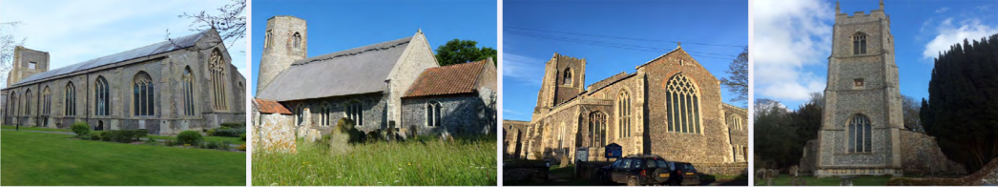
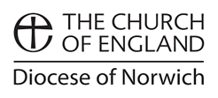


Happy Christmas from
North Walsham, Edingthorpe,
Worstead and Westwick

Come just as you are to take the life-changing Christmas journey.
Wherever you are this Christmas, you are invited to receive comfort and joy and to be with Jesus.
You are welcome. You are deeply known and truly loved.

St Nicholas’ Advent and Christmas Wreath Festival
open daily throughout December

SUNDAY 29th NOVEMBER – ADVENT SUNDAY
8am Holy Communion (BCP) St Nicholas
10.30am Holy Communion *St Nicholas
5pm Advent Carol Service St Nicholas

SUNDAY 6th DECEMBER – ADVENT 2 / St NICHOLAS
8am Holy Communion (BCP) St Nicholas
10.30am Patronal Festival *St Nicholas
5pm Choral Evensong St Nicholas

SUNDAY 13th DECEMBER – ADVENT 3
8am Holy Communion (BCP) St Nicholas
9.15am Holy Communion All Saints
10.30 am Holy Communion *St Nicholas
5pm Choral Evensong St Nicholas

MONDAY 14th DECEMBER
11am Carol service – Norfolk Women’s Institute St Nicholas

TUESDAY 15th DECEMBER
7pm NW High School Christmas Concert St Nicholas

WEDNESDAY 16th DECEMBER
7pm Candles and Carols – remembering loved ones *St Nicholas
in association with Gordon Haynes Funerals & Murrell Cork Funerals

THURSDAY 17th DECEMBER
7.30pm Candlelit carol service *St Nicholas

SATURDAY 19th DECEMBER
4pm Carol Service St Botolph’s

SUNDAY 20th DECEMBER – ADVENT 4
8am Holy Communion (BCP) St Nicholas
10.30am Holy Communion *St Nicholas
3pm Carol Service St Mary’s
4.30pm Carol Service All Saints

THURSDAY 24th DECEMBER – CHRISTMAS EVE
4pm Crib & Christingle St Mary’s
4pm Christingle *St Nicholas
Please bring along your donation to the Children’s Society.
Come in your Christmas Jumper or as a Nativity Character
9pm Bethlehem Midnight Mass with blessing of the crib St Mary’s
11pm Midnight Mass with blessing of the crib *St Nicholas
11.15pm Midnight Mass with blessing of the crib All Saints

FRIDAY 25th DECEMBER – CHRISTMAS DAY
8am Holy Communion (BCP) St Nicholas
10.30am Family Communion *St Nicholas

*Live-streamed on YouTube – St Nicholas North Walsham

All Saints Edingthorpe NR28 9TN, St Mary Worstead NR28 9AL
St Nicholas North Walsham NR28 9BT, St Botolph Westwick NR10 5BW

Please pass this leaflet onto someone who may like
to attend some or all of these services

We wish you a Merry Christmas
and a blessed and peaceful
New Year

We would love to welcome you at any of our services

St Nicholas, North Walsham
Sundays
8am Holy Communion from the Book of Common Prayer
10.30am *Holy Communion
5pm Choral Evensong / Evening Prayer
Sunday Kids meet on the 1st and 3rd Sunday of the Month
Monday – Friday each week
9am *Morning Prayer
Thursdays
9am Coffee morning in the church halls (supporting various groups)
10.30am Market Day Holy Communion
Fridays
9.30am Cuddles and Catch-up Toddler group (0-2.5years) St Benet Hall

All Saints, Edingthorpe, Sundays
9.15am Holy Communion 2nd Sunday of the month
9.15am Morning Prayer 4th Sunday of the month

St Mary, Worstead, Sundays
9.15am Morning Prayer 1st Sunday of the month
9.15am Holy Communion 3rd Sunday of the month

St Botolph, Westwick
as advertised in the Benefice Magazine

Facebook @stnicksnorthwalsham Instagram @northwalshambenef
saint-nicholas.org.uk 01692 408971
