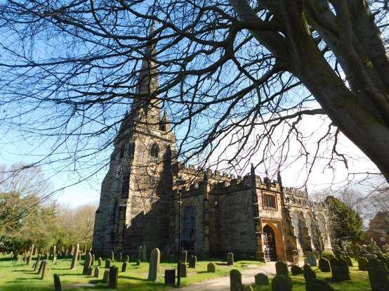
Did you know that at Sefton Church -

Our average monthly payments - just for our parish share, utilities and insurance is:
£5,000
Our average monthly receipts are:
£2,000
Each month we are losing approximately:
£3,000
Obviously, this is very worrying and the cost of the upkeep of our Grade One listed building is extremely expensive.
If you feel you can help in any way please do so or speak to John (Treasurer).

