Saint Hilda’s Parish Church
St. Hilda’s Church Contact list
Parish Priest: Father Simon Sayer CMP
Telephone: 07356 028 581
Email: priest.sthildaprestwich@gmail.com
PCC Secretary: Mrs Carole East
Telephone: 07951 192 728
Email: sthildaprestwich@gmail.com
PCC Treasurer: Mrs Andrea Smethurst
Email: treasurersthildaprestwich@gmail.com
PSO: Mrs Shirley Diver
Telephone: 07922 330069
Email: hildasafeg@gmail.com

Follow us on the following platforms
https://www.facebook.com/Sthildaprestwich
https://www.achurchnearyou.com/church/16091/

Parish Priest: Father Simon Sayer CMP

6th September 2026
23rd Sunday in Ordinary Time
11.00am: Parish Mass

Coffee served after Mass in the church hall

Welcoming team: Melanie & Rachel
Reader First Lesson & Responsorial Psalm:
Margaret
Reader Second Lesson: Pat A
Intercessor: Carole
Sunday Coffee Rota Melanie & Rachel
Hymns
Entrance: SHB 4 As the deer pants for the water
Offertory: 333 All my hope on God is founded omit v5
Communion: 63 All ye who seek a comfort sure
Angelus
Recessional: 334 All people that on earth do dwell

This week at St Hilda’s
Tuesday:
9.00am Coffee Morning open from 9am
and Craft at the Croft
10.00am Mass with Healing Ministries
1pm We welcome the Society Clergy Chapter to St Hilda's: please pray for them, their parishes and places of ministry.
7.00pm Heaton Park WI
Second year anniversary
Friday:
9am -10.30am Slimming World


Saturday: Heritage Open day
Church open from 10am to 2pm
Next Sunday:
11.00am Parish Mass
Heritage Open Day
church open until 4pm
24th Sunday in Ordinary Time
Heritage Posters and flyers are available
Harvest Thanksgiving
Sunday 27 September:

11.00am Parish Mass and blessing of items donated for the Heaton Park Pantry, and for donations to Christian Aid's Harvest Appeal for the people of Sudan
After Mass: bring and share Harvest Lunch
There is a list at the back of church for suggested items.

Back to School Sunday
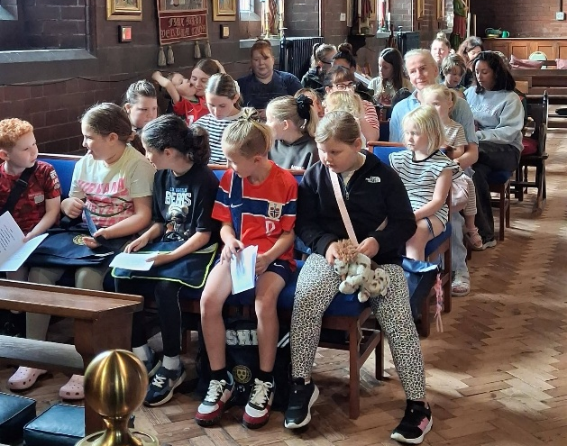
We were blessed last Sunday at Family Church for Fr Simon to bless twenty of our young children’s Backpacks in readiness of their return to school.

SCHOOL NEWS
It has been wonderful to welcome everyone back, and we are looking forward to an exciting new school year.
A very warm welcome to all our new children and families joining the St Hilda’s family. We are so pleased to have you with us! Here’s to a happy, successful and exciting year ahead!
We remember with love and prayers all on our prayer list here at St Hilda’s


Harvey Wood, Trevor & Juanita, Vikki & Vasilli,
Elaine Chaloner, Joanna Maciulskas,
Maryrose & Walter, Cath & Derek,
Andrew Davidson, Angela, Pearl, John Southern, Angela Millington, Peter Holland, Keith Bentley, Jane, Susan Lees, Renée Lukes,
Fr Croft, James Lucas, Francesca Boothman, Jenny Mulholland, Paul & Michael Lees.

We remember before God all those who have died specially those who have passed in the night with no-one to comfort them.
Christine Brockley

We remember also with love and prayers those whose anniversaries fall during this week
6th September
Kathleen Collier 1996
7th September
Gill Haydock 2012
9th September
Ian Boothman 2024
10th September
Archibald Wallace 1974
11th September
Robert Boardman 2017
Irene Thornton 2022
Derek Cooper 2022



We take the safeguarding of children and vulnerable adults very seriously here at St Hilda’s. Therefore, if you have any concerns please speak to the Parish Safeguarding Officer:
Mrs Shirley Diver: 07922 330069
Or the Diocesan Safeguarding Advisor
Abbey Clephane-Wilson: 0161 828 1465


Life & Mission at St Hilda’s
You can now donate at any time to the life of the parish by scanning the QR Code.
Thank you

Future dates for your diary
September
16th Adam Partridge Auctioneers 10am -1pm
17th Lunchtime Community Drop In
20th 25th in Ordinary Time
24th 10am Mass Our Lady of Walsingham
10.30am – 2.30pm. MacMillan Coffee morning and meet your NHS neighbourhood team.
26th Walsingham Festival – St Augustine’s Tonge Moor. See poster for details.
27th Harvest Thanksgiving/26th in OT
Donations for the Food pantry and Christian Aid South Sudan appeal
Followed by a Bring and Share Lunch for Harvest
28th Welcome service at Manchester Cathedral
for Archdeacon Canon Simon Cook
30th Society Vocations Group: Launch is at 7pm at the Church of the Holy Family, Failsworth (poster with details is displayed at the back of church).
October
4th PCC meeting
9th Mass St John Henry Newman 11am
13th Heaton Park WI 7pm – 9pm
15th Lunchtime Community Drop In
18th Dedication Sunday
November
2nd Requiem Mass for All Souls
10am and 6pm
10th Heaton Park WI 7pm – 9pm
12th CMP Mass & Chapter meeting 12noon.
14th Patronal Festival 11am followed by a Parish Party in the church hall.
19th Lunchtime Community Drop In
22nd PCC meeting
28th Winter Fair
December
8th Heaton Park WI 7pm – 9pm
20th Nine Lessons and Carols 6pm
24th First mass of Christmas 6pm
January 2027
1st New Years Day Mass
17th PCC meeting
12 noon -1.30pm Society Vocations group meeting
April
4th PCC meeting
25th APCM

