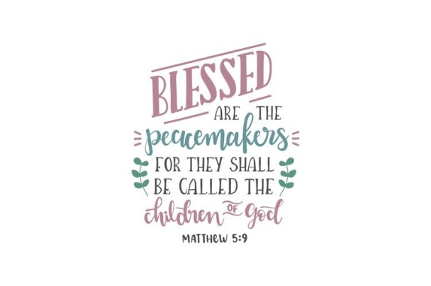
The Rector's Ramblings

Blessed are the peacemakers, for they shall be called Children of God. Matthew 5:9
There are some dates that are so ingrained in our consciousness that you only need to say them and everyone knows what you are talking about – 1066, 11th of the 11th, and today, 11th September, or as the world knows it, 9/11. The day, 25 years ago, that the world stopped and changed forever.
I’m sure many of you, like me, can remember exactly where you were when the news broke of the first plane crashing into the World Trade Center, The Twin Towers. I was at my desk in the Mercer offices in Westgate, Chichester, just back from lunch. It was just a normal day and then Sam, one of my team, suddenly said, or actually shouted, ‘Oh my God!’. Several of us went to see what was wrong, it was so unlike him, and on his screen were the images of the first tower to be hit, smoke coming out of the building, people on the streets stopped in horror at what they had seen, and as we watched, shocked and stunned, we saw the second plane hit. No work was done for the rest of the day as we all, silently, returned to our desks, logged on to the news, and watched in horror and disbelief as the day unfolded. No one cared that no work was done because no phones rang, no emails were received, as the whole world stopped. For those who remember it, I don’t need to describe the horrific events of that day, they are too painful, too real, especially for those who lost family, colleagues and friends, but should we still be remembering, or is it time to move on?
Well, I personally think we should, and we must, remember the people who died that day, in the planes, in the Twin Towers, in the Pentagon. We should remember all the first responders, the firefighters, the ambulance crews, who lost their lives helping others, and those who still live with the scars, and the memories, because if we don’t, we can’t learn from that day and from what followed.
The immediate result of 9/11 was fear, which led to aggression, and the war in Afghanistan. A war that lasted 20 years. But as with 9/11, the victims, the people who suffered most from the war, and the aftermath, were, are, the innocent. Apart from the hijackers, none of the people who died as a result of 9/11 wanted a war. None of the first responders who rushed into the building asked ‘what is your faith?’ before they got people out. None of the hospitals turned away victims because of their skin colour.
And the aftermath of fear and hate is still with us, and it is still being used to ‘justify’ acts of violence and of harassment. We saw that this week in Portsmouth, when social media called on people to converge on a hotel that they said was housing Muslim immigrants. It wasn’t. What it was doing was providing overnight accommodation to the Under 19’s cricket team from Pakistan, invited to this country for a tour. Under 19, away from home, away from family, what must they have felt, feared, as the crowd began to gather?
The quote at the top of this Ramble is from the bible, but I’d like to share another with you ‘“O You who believe! Enter absolutely into peace. Do not follow in the footsteps of Satan. He is an outright enemy to you.” Enter absolutely into peace. That is a quote from the Quran, the Muslim Holy Book.
Muslims worked in the Twin Towers, alongside Christians, Jews, Buddhists, Hindus, and hundreds of people of other faiths. Christians and people of all faiths and none, made up the first responders, the doctors and nurses.
Acts of terrorisms, of violence, perpetrated in the name of God, of Allah, of any other deity, are not in their name. Faith is so often used by people as an excuse. As a way of justifying actions that God, by whatever name He is called, does not condone, does not call for. Our enemy is not someone of a different faith, or a different skin colour, our enemy is Satan and it is up to us if we choose to let him in, or to shut him out.
I’m sorry if anyone who reads this Ramble is offended, or upset, by what I’ve written, that is absolutely not my intention, but we are called to love one another, and that love is irrespective of faith, skin colour, gender, nationality, social or economic status. We have a choice in life, we can feed the ravenous wolves of Satan, feeding it with hate, fear and terror, or we can feed the quiet lamb of God, with love, peace, and hope. Blessed are the peacemakers, because they enter absolutely into peace.
Rev Sarah
Worship in the Valley Parish
13th September
Holy Communion with Baptism
10am
Singleton
Deanery Evensong
Sunday 13th September @ 6pm Christ Church, Forestside
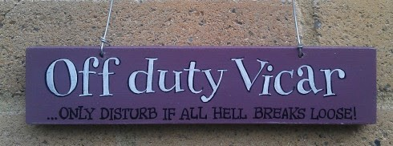The Rector's Ramble will be a day late next week, as I am taking a few days off, but normal service will be resumed on Saturday 19th September.
Rev Sarah Manouch
07468 854864 priestvalleyparish@gmail.com
Please note that I am part-time. My principal working days are Friday and Saturday as well as Sunday. I am not available on a Thursday.

