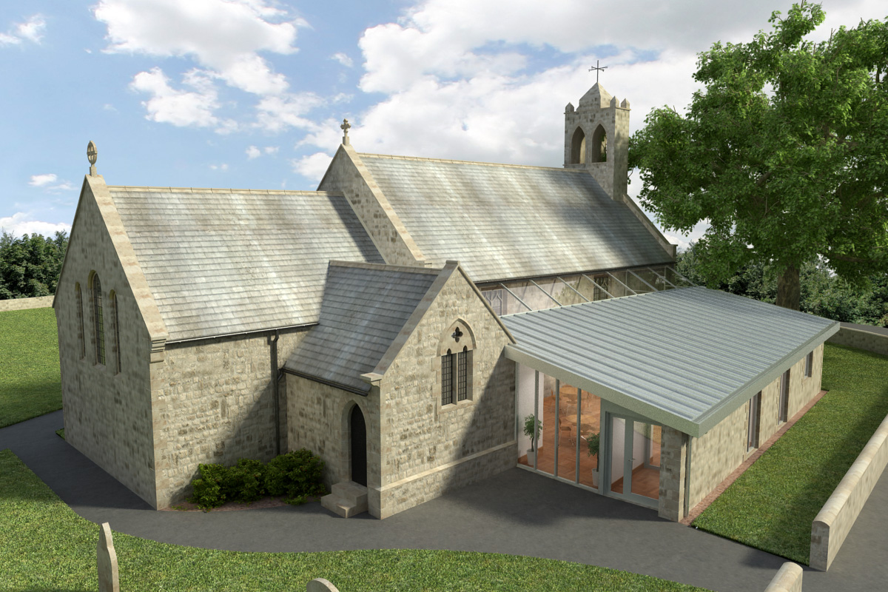
St Mary’s Parish Church, Longframlington

Welcome to our Sunday Morning Prayer. On Sunday 13th September, which is Fifteenth Sunday after Trinity, when our Officiant will be Rev Rich, Tony playing the organ, and Sam, our Reader giving the Homily. Next week, Trinity Sunday 16th, the Officiant will be Rev David Wood and Steve playing the organ.
Coming up at St Mary’s and our sister parishes – Morning Prayer in St Mary’s – and on Zoom – usually every Wednesday morning at 9.30 am followed by coffee in the Community Room. The Link can be made using Meeting ID889 6133 2870, Password 093043. New people always welcome either on screen or in church.
Growth Groups – Pilgrim - coming this Autumn Our new Growth Group will begin the first week of October, offering a chance to grow together in faith, ask questions, pray with others and explore more deeply the worship we have week by week. Six sessions on the Lord’s Prayer. Wednesday evenings in Longfram, led by Rev Michael and Jan McCuin. Sign up begins now, so please do think and pray about whether a Growth Group might be for you. Other dates available. Booking form at back of church.

Please note Church Street, Longframlington, closed from A697 for its entire length from 21st to 25th September for work to clear a water blockage.

The Bereavement Journey booking is now open for the seven-session Bereavement Journey course Saturday 3 October 10 am – 12 noon, at Acklington Village Hall. It is for anyone who has been bereaved at any time, poster available in church.

Choral Evensong, Newcastle Cathedral Choir, Sunday 18 October, 6pm St Bartholomew’s Church, Whittingham.

Coffee following Church Service – Sundays – please add your name to the list which is now housed in the Community Room together with the Calendar of events.

MACMILLAN COFFEE MORNING – hosted by Village Voices in St Mary’s Community Room, Monday 28th September 11.30 – 1 pm. Come along and support this amazing cause – Enjoy a cuppa and a cake.

Thank you for your giving to the life and work of our church. Our offering is taken during the third hymn, and there is a collection giving point at the back of the church for use after the service if you prefer. Regular giving by Standing Order with Gift Aid is particularly valuable to the church – speak to Audrey (01665 570 922) for more information and blank forms. All our news and much more available on our Facebook page https:www.facebook.com/SMCLongfram/?ti=as and You Tube channel https:www.youtube.com/@stmichaelsfeltonstmaryslon.
Priest in Charge: Rev Rich Townend. Phone 01670 719470. Email:revrichtea@gmail.com. Regular day off is Monday.
For St Mary’s information contact Veronica Thomson (01665 570 807) or Audrey Truman (01665 570922).

