God, our strength and our help
in times of trouble,
be with your people now,
in the aftermath of this earthquake.
Move us to come together
offering shelter for the homeless,
rest to the weary
comfort to the injured and distressed
so that although all is unsteady
and faith may be shaken,
the light of your hope shines through.
We ask this through Christ our Lord,
Amen

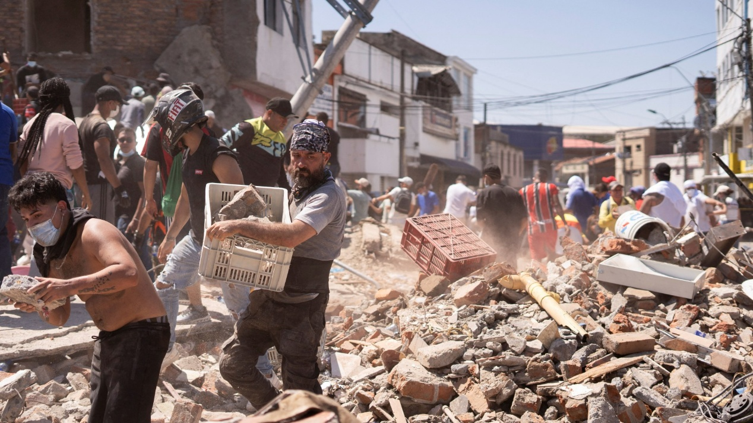

Prayer from Cafod. Image from Al Jazeera news, Colombia

