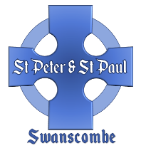
The Church of St Peter and St Paul
Swanscombe

Church marriage with calling of Banns

Statutory:
Calling of Banns £ 39.00
Church Service £566.00 £605.00
Church Fees:
Church costs Nil
Verger £ 30.00 £ 30.00

Basic Total: £635.00

Optional:
Organist £ 75.00
Choir £ 75.00
Bells £160.00
Permission to video* £100.00
Flowers** £ 75.00(minimum)
Candelabras*** £ 30.00
Heating**** £ 50.00

If you would like a soloist to sing in traditional or modern style,
with electronic accompaniment if necessary, a fee of up to £50
is payable.
*Permission to Video. Payment for copyright and performance rights which the church has to pay.
**Flowers. If you would like the church to provide church flowers the minimum contribution is £75. This may increase if you have specific colour/bloom choices.
***Candelabras. If you would like the candelabras to be lit, £30
should cover the cost of the candles.
**** Heating. Most weddings take place when it is warm. If you
think that you may require heating, £50 would help to cover the costs.

NB: If either the bride or groom lives outside the parish of Swanscombe, then Banns will have to be called in their own
parish, and a fee payable to the appropriate incumbent.
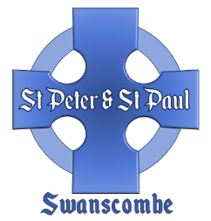
The Church of St Peter and St Paul
Swanscombe

The marriage of:

Groom

Bride

Date Time

Contact number and email

Basic Cost of Marriage: £635.00

Options: (please indicate)

Organist £ 75……………………
Choir £ 75……………………
Bells £160……………………
Permission to video £100……………………
Flowers £ 75……………………
Candelabras £ 30……………………
Heating £ 50…………………
Other

Total Cost £

A £150 deposit is payable in advance (non-refundable).
This is deducted from the overall cost, which is payable
no later than 21 days before the date of the wedding.

Please return this form to the Church Administrator.
January 2026

