Benefice of Saxon Shoreline Consultation: Consolidated Thematic Report
  - Shared parish strengths, common challenges, governance responses and comparison with wider rural Church of England trends

Executive Summary
This report draws together the consultation material from the parishes and churches of the Benefice of Saxon Shoreline. It identifies strong common themes across the responses: deep affection for local churches, appreciation of worship and pastoral ministry, successful community-facing activity, committed volunteers, valued buildings and churchyards, and continuing opportunities through festivals, life events and hospitality. At the same time, the responses show repeated concern about ageing and small congregations, limited volunteer capacity, finance, administration, communication, building maintenance, and engagement with children, young people and families.
Overall, the governance proposals received a broadly favourable but cautious response. On an indicative reading of the consultation summaries, approximately 70% of recorded parish-level responses can be characterised as supportive or supportive in principle; around 20% expressed caution, reservations or a need for further detail before giving firm support; and around 10% preferred alternative or incremental approaches rather than immediate adoption of the proposed two-parish model. These figures should be treated as a thematic estimate rather than a formal ballot result, because the consultation material records qualitative responses rather than a counted vote from every respondent.

1. Shared Strengths Across the Parishes
The most consistent positive theme is that the churches remain deeply valued as places of worship, memory, welcome, fellowship and community identity. Across the Benefice, respondents repeatedly referred to seasonal services, Remembrance, Harvest, Christmas, Carol services, Occasional Offices, coffee mornings, concerts, lectures, flower festivals, pilgrimage and heritage visits as important ways in which church life continues to connect with the wider community.
Several churches reported particular strengths in hospitality and welcome. Coffee mornings, refreshments after worship, Café Church, Toy Services, Fun Club, family days and other informal gatherings were identified as effective points of contact. These activities matter because they allow people to encounter church life relationally, socially and gently, rather than only through regular Sunday worship.
Church buildings and churchyards are also significant assets. Respondents described them as beautiful, peaceful, historic, well maintained, spiritually meaningful and capable of wider community use. In several places, recent or planned improvements to facilities, including kitchens, toilets, access, heating, interpretation and digital giving, were seen as strengthening the potential for welcome and sustainability.
Another major strength is the presence of committed lay people. Churchwardens, PCC members, treasurers, Friends groups, local preachers, licensed and lay ministers, musicians, cleaners, flower arrangers, readers, intercessors and event volunteers all appear repeatedly as the practical foundation of parish life. The consultation demonstrates that, although many teams are small, there remains a substantial reservoir of loyalty, affection and service across the Benefice.
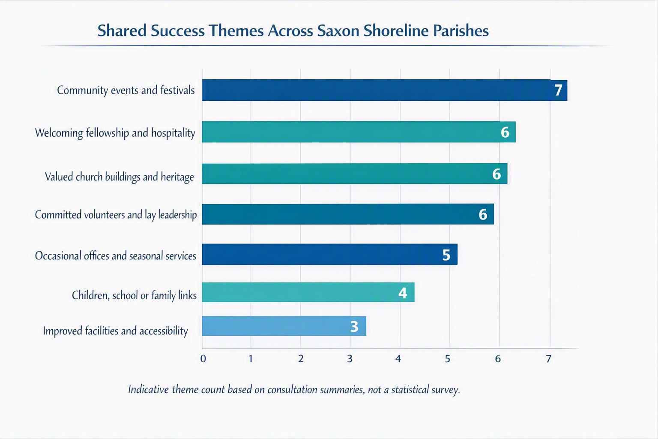
Figure 1. Indicative commonality of positive themes across the parish consultation summaries.

2. Common Challenges Across the Parishes
The most widespread challenge is sustainability. Nearly every parish identified some combination of small or ageing congregations, reduced regular attendance, difficulty attracting younger people, and uncertainty about future volunteer capacity. These concerns are not simply numerical; they affect worship planning, officer recruitment, pastoral care, buildings, finance and confidence about the future.
Children, young people and families are a recurring concern. Some churches have active links with schools, Scouts, Guides, Fun Club or family-oriented activity, but respondents frequently noted that Sunday attendance by children and young families remains limited. The reasons suggested include changed Sunday routines, sport and family commitments, unfamiliarity with Christian worship, service timing, liturgical accessibility, and the difficulty of sustaining children’s work with limited volunteers.
Communication and visibility are also common themes. Respondents mentioned uncertainty about what is happening elsewhere in the Benefice, the loss or absence of the printed Parish magazine, limited online visibility, lack of clarity about service leadership, and the need for better information for visitors. Several responses also pointed to the importance of personal presence and recognisable local leadership in strengthening trust and engagement.
Financial and administrative pressures are closely linked to these issues. Parish Share, low income, restricted giving, ring-fenced funds, debt, building repairs, quinquennial requirements, energy costs, churchyard maintenance and the burden of meetings all appear in the consultation material. Respondents frequently distinguished between support for greater collaboration and anxiety about losing local financial control, local identity or local responsibility.
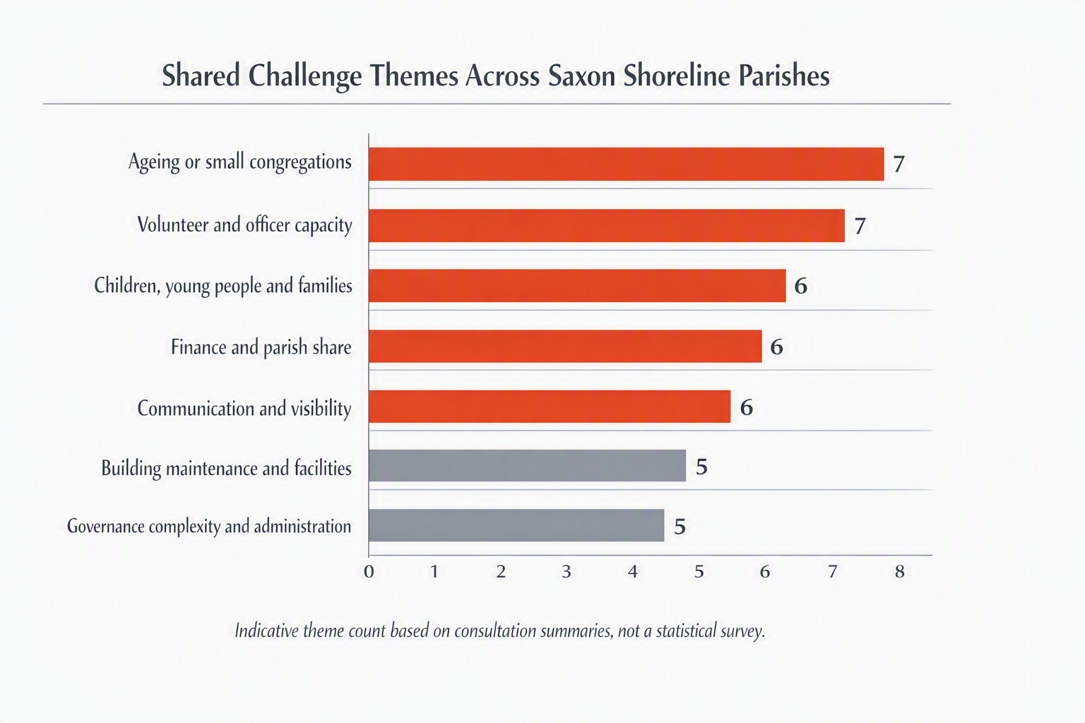
Figure 2. Indicative commonality of challenge themes across the parish consultation summaries.

3. General Response to the Governance Proposals
The proposed move towards a two-parish or clustered model was generally received as a credible response to the pressures identified across the Benefice. Support was strongest where respondents saw the proposal as reducing duplication, easing the burden on churchwardens and PCC officers, simplifying meetings, widening the pool of skills, encouraging collaboration, and releasing clergy time for pastoral and missional work.
The indicative balance of opinion is as follows: approximately 70% supportive or supportive in principle; approximately 20% cautious, undecided or requiring more detail; and approximately 10% preferring alternative or incremental models. This assessment is based on the consultation summaries, not on a formal numerical poll, and should therefore be used to describe the broad direction of opinion rather than as a definitive voting outcome.
Response category | Indicative proportion | Summary interpretation
Supportive or supportive in principle | Approximately 70% | Change is regarded as necessary, and a two-parish or clustered structure is seen as potentially more manageable.
Cautious or requiring further detail | Approximately 20% | Respondents want clarity on finance, representation, local identity, role responsibilities and practical operation before firm support.
Alternative or incremental preference | Approximately 10% | Some respondents prefer parish pairings, trial clusters, improved administration, joint meetings or other steps before structural change.

4. Alternative Models and Supplementary Solutions Raised
- Incremental parish pairings: suggested pairings included Bilsington with Bonnington, Warehorne with Kenardington, and other groupings that respect geography, existing relationships and local identity.
- Trial clusters: some respondents suggested trialling smaller clusters of two to four churches before committing permanently to a two-parish structure.
- Benefice administrator: a paid or voluntary administrator was repeatedly suggested as a practical first step to reduce pressure on the Rector and improve co-ordination.
- Separate or ring-fenced finances: many supportive respondents wanted assurance that parish-specific funds, legacies, restricted gifts and regular giving would remain identifiable and protected.
- Joint PCC or co-ordinated meetings: suggestions included joint meetings, quarterly Benefice meetings, Churchwardens’ meetings, or simultaneous PCC meetings with shared clergy input.
- Improved communication: proposals included a Benefice newsletter, stronger website presence, better social media, printed information for those not online, and clearer service publicity.
- Service pattern review: options included alternating services, Benefice services on a rota, midweek or differently timed services, livestreaming, and more accessible worship formats.
- Mission and engagement initiatives: suggestions included Alpha or similar courses, stronger school links, more family events, better visitor interpretation, use of churches as community hubs, and greater collaboration with local organisations.

5. Comparison with National Rural Church Trends
The experience of Saxon Shoreline aligns closely with wider Church of England rural church trends. National rural mission resources emphasise that rural churches often remain important centres of local identity, heritage, worship, pastoral care and community service, even where regular Sunday congregations are small. The Church of England notes that it has over 10,000 rural churches and that around 40% of people who attend church worship in rural settings, underlining the continuing strategic significance of rural ministry.
National reports also identify recurring rural challenges that mirror the Benefice consultation: ageing congregations, limited volunteer capacity, the demands of historic buildings, dispersed populations, clergy serving multiple churches, financial pressure, and the need for mission to be enabled through lay leadership, local gifts and simplified structures. The Church of England’s rural mission materials stress that mission and growth are more likely to flourish in rural multi-church groups where time and space are created for mission and where lay people are developed and equipped.
The national attendance picture provides both encouragement and realism. Statistics for Mission 2023 reported a third consecutive year of growth, with average weekly attendance rising from 663,000 in 2022 to 693,000 in 2023, and the worshipping community rising above one million for the first time since the pandemic. However, national reporting also makes clear that attendance remains below 2019 levels. Saxon Shoreline therefore reflects a national pattern: signs of renewed opportunity and special-service resilience alongside continuing structural and demographic pressures.
The Benefice also reflects national guidance on how village churches may thrive. National rural church resources commend warm welcome, life events, creative use of buildings, care for churchyards, festivals, heritage, children’s engagement, work with isolated people and effective communication. These themes are already visible in local consultation responses: the Benefice has strong examples of hospitality, heritage, festivals, school links, churchyard care, Friends groups, pastoral presence and occasional offices. The key strategic question is therefore not whether these assets exist, but how they can be better co-ordinated, communicated, resourced and sustained.

6. Conclusions and Recommended Next Steps
The consultation shows that Saxon Shoreline is not beginning from weakness alone. It has valued buildings, strong local affection, faithful worshippers, committed volunteers, significant pastoral and community contacts, and a range of creative activities already taking place. Nevertheless, the present governance and operating model is widely perceived as fragile because it depends on a small number of people carrying a large volume of responsibility across multiple churches.
The next phase should therefore focus on converting cautious support into informed confidence. This will require clear financial modelling, transparent representation arrangements, defined role descriptions, a communication plan, and an agreed process for protecting local identity while strengthening shared governance. A practical early step would be to establish a small Benefice working group to develop detailed options, including the proposed two-parish model and credible incremental alternatives, before final parish decisions are requested.

