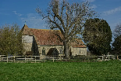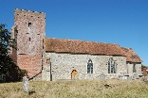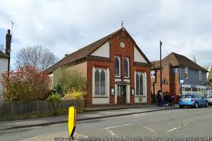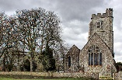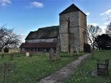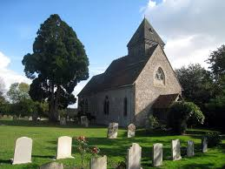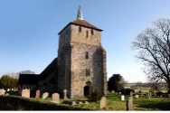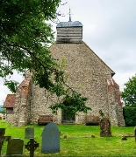

Saxon Shoreline Benefice Newsletter
  - September 2026
Sharing worship and events across Aldington, Bilsington, Bonnington, Hamstreet, Kenardington, Ruckinge and Warehorne.

Welcome
Welcome to our new Benefice newsletter as an attempt to communicate across our parishes. In September we begin the Church season of Creationtide with a newly commissioned Festival of Creation in Christ. Across our parishes we begin our Harvest Festivals thanking God for the harvest and for the hard work of our farming community, as well as reflecting on caring for God’s creation.

List of services and events - September 2026
Wednesday 2 September —
12.00 noon, Mid-week Holy Communion (Celtic), St. Mary’s, Orlestone
Saturday 5 September —
10.00am -11.30am, Coffee Morning, St. Mary Magdalene, Ruckinge
Sunday 6 September — Festival of Creation in Christ (Trinity 14): 9.00am, Holy Communion (CW), St. Rumwold’s, Bonnington;
9.45am for 10.00am start, Family Fun Service, Village Hall, Aldington; 10.00am, BCP Holy Communion, St. Matthew’s, Warehorne;
10.30am, Holy Communion (CW), St. Mary Magdalene, Ruckinge; 10.30am, Methodist Communion Service, Church of the Good Shepherd, Hamstreet
Tuesday 8 September —
10.00am -11.30am, Tuesday Together, St. Mary Magdalene, Ruckinge
Wednesday 9 September —
12.00 noon, Mid-week Holy Communion (CW), St. Mary’s, Orlestone;
7.30pm, Bible Study at the Mission Hall, Forge Hill, Aldington
Saturday 12 September —
10.00am – 6.00pm, Ride and Stride (lunches and teas),
St. Mary Magdalene, Ruckinge;
10.00am – 12.30pm, Coffee Morning and Craft & Tabletop Sale, Village Hall, Aldington;
Ride and Stride events across the Benefice (10.00am-6.00pm)
Sunday 13 September — Trinity 15
9.00am, BCP Holy Communion, St. Peter & St. Paul, Bilsington;
10.30am, BCP Matins, St. Mary Magdalene, Ruckinge;
10.30am, Morning Worship, Church of the Good Shepherd, Hamstreet; 10.45am, Holy Communion (CW), St. Martin’s, Aldington;
12.30pm, RBL Commemoration Service for Battle of Britain, Church of the Good Shepherd, Hamstreet;
3.00pm, Harvest BCP Choral Evensong, St. Augustine’s, Snave;
3.00pm, Tea Party, St. Mary Magdalene, Ruckinge;
5.00pm Harvest BCP Choral Evensong, St. Rumwold’s, Bonnington (in memory of the late Elizabeth Mann) & Friends of St. Rumwold’s AGM with refreshments

Wednesday 16 September —
12.00 noon, Mid-week Holy Communion (BCP), St. Mary’s, Orlestone;
7.30pm, Bible Study at the Mission Hall, Forge Hill, Aldington
Sunday 20 September — Trinity 16:
9.00am, Harvest Festival Service, St. Mary’s, Orlestone;
9.00am, Holy Communion Service (CW), St. Rumwold’s, Bonnington; 9.30 am, Morning Worship, St. Mary’s, Kenardington;
10.00am, Family Service, St. Mary Magdalene, Ruckinge;
10.30am, Anglican Holy Communion Service (CW), Church of the Good Shepherd, Hamstreet;
10.45am, Worship Service, St. Martin’s, Aldington;
3.30pm, Service of Healing, St. Martin’s Aldington;

Tuesday 22 September —
10.00am -11.30am, Tuesday Together, St. Mary Magdalene, Ruckinge; Alpha Course begins, Warehorne
Wednesday 23 September —
12.00 noon, Mid-week Holy Communion (Celtic), St. Mary’s, Orlestone; 7.30pm, Bible Study at the Mission Hall, Forge Hill, Aldington

Thursday 24 September —
7.30pm, Creationtide Taizé Service, St. Rumwold’s, Bonnington

Saturday 26 September —
10.00am – 12.00 noon, Harvest Family Fun Morning, Village Hall, Aldington
Sunday 27 September —
9.00am, BCP Holy Communion, St. Peter & St. Paul, Bilsington;
10.30am, Morning Worship, Church of the Good Shepherd, Hamstreet; 10.30am, BCP Holy Communion, St. Mary Magdalene, Ruckinge;
10.45, Harvest Festival Communion at the Farm, St. Martin’s, Aldington; 6.30pm, BCP Evensong, St. Matthew’s, Warehorne

Wednesday 30 September —
12.00 noon, Mid-week Holy Communion (BCP), St. Mary’s, Orlestone; 7.30pm, Bible Study at the Mission Hall, Forge Hill, Aldington

Prayer
Creator God,
thank you for the gifts of harvest, earth and sky, seedtime and fruitfulness.
Bless those who work the land, feed the hungry, and care for your creation.
Help us to live gratefully, simply and wisely,
through Jesus Christ our Lord.
Amen.

Contacts and Submissions
Rector: Revd. Geoff Abasolo-Munnery, revgeoff.saxonshorelinebenefice@gmail.com; 07743 598896

Assistant Curate: Revd. Anne Loat,
anne.loat@outlook.com, 07745 918629

Assistant Priest with PTO: Revd. Canon John Saunders, canonjohnsaunders@aol.com
Newsletter editor: please send to Revd. Geoff
Safeguarding contact: Mrs. Pauline Williams, wpauline@btinternet.com

Deadline for October newsletter items: Fri 18th September

