Saint Hilda’s Parish Church
St. Hilda’s Church Contact list
Parish Priest: Father Simon Sayer CMP
Telephone: 07356 028 581
Email: priest.sthildaprestwich@gmail.com
PCC Secretary: Mrs Carole East
Telephone: 07951 192 728
Email: sthildaprestwich@gmail.com
PCC Treasurer: Mrs Andrea Smethurst
Email: treasurersthildaprestwich@gmail.com
PSO: Mrs Shirley Diver
Telephone: 07922 330069
Email: hildasafeg@gmail.com

Follow us on the following platforms
https://www.facebook.com/Sthildaprestwich
https://www.achurchnearyou.com/church/16091/

Parish Priest: Father Simon Sayer CMP

2nd August 2026
18th Sunday in Ordinary Time
9.30am Family Church
11.00am: Parish Mass

Welcomers: Melanie & Christiana
Reader First Lesson: Margaret
Reader Second Lesson: Carole
Intercessor: Hazel
Organist: Geoff
Sunday Coffee Rota: Melanie & Carole
Hymns
Entrance: 457 The King of love
Offertory: 271 Alleluia, sing to Jesus
Communion: 306 Strengthen for service
Angelus
Recessional: 408 Love Divine

This week at St Hilda’s
Tuesday:
9.00am Coffee Morning open from 9am
10.00am Mass with Healing Ministries
Thursday:
10.00am The Transfiguration of the Lord
Friday:
9am -10.30am Slimming World
Next Sunday:
11.00am 19th Sunday in Ordinary Time
Parish Mass
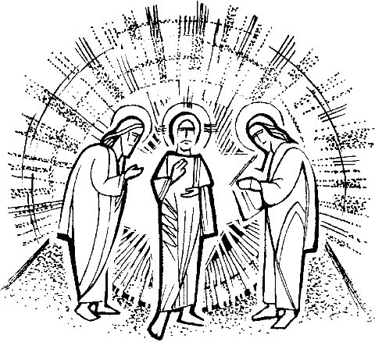

“This is my Son, the Beloved;
he enjoys my favour.
Listen to him.”
Matthew 17: 5

The Transfiguration of the Lord
Thursday 6th August
10.00am Mass

Prayer booklets

On the table at the back of Church, you’ll find a new display of colourful prayer booklets produced by the Prayer Trust. They include photographs as well as the words of prayers. They are free to everyone. Please take them to help you to pray,
or to give to a neighbour or friend.


Saturday 12th September
10am to 2pm

Sunday 13th September
11am Parish Mass
Church open until 4pm

We are taking part in this year’s Heritage Open Days.

The PCC is planning the event, and we will need help over the weekend to welcome visitors, share this beautiful church with them, and provide refreshments.

More details to follow. Meanwhile, please see Fr Simon or Carole if you can help.

Church Flowers - Gifts towards the cost of church flowers in memory of loved ones are always welcome.
We remember with love and prayers all on our prayer list here at St Hilda’s


Trevor & Juanita, Vikki & Vasilli,
Elaine Chaloner, Joanna Maciulskas,
Maryrose & Walter, Cath & Derek,
Andrew Davidson, Angela, Pearl, John Southern, Angela Millington, Peter Holland, Keith Bentley, Jane, Susan Lees, Renée Lukes,
Fr Croft, James Lucas, Francesca Boothman, Jenny Mulholland, Paul & Michael Lees.

We remember before God all those who have died specially those who have passed in the night with no-one to comfort them.
We remember also with love and prayers those whose anniversaries fall during this week
7th August
Emily Robina Kowalczuk 1994
8th August
Bro Ignatius 1985
Felicity Farrell 2008
Dorothy Cameron 2019

Future dates for your diary
August
9th 19th Sunday in Ordinary Time
11th Coffee Morning 9am
Mass with Healing Ministries 10am
Heaton Park WI 7pm - 9pm
13th Standing Committee meeting re: Discussion and Agreement Process for Parish share 2027 / 2028 and 2029
14th Slimming World 9am
16th Assumption of the BVM
20th Lunchtime Community Drop In
23rd 21st Sunday in Ordinary Time
29th Coffee Evening at Margaret’s 7pm
30th 22nd in Ordinary Time Parish Mass 11am
Family Church 9.30am
Back2School Sunday
With Blessing of Backpacks
September
1st Parish School opens 8.50am
Coffee Morning 9am
Mass with Healing Ministries 10am
4th Slimming World 9am
6th 23rd in OT
8th Coffee Morning 9am
Mass with Healing Ministries 10am
CMP Chapter meeting 1pm
Heaton Park WI 7pm – 9pm
9th Deanery Synod meeting at St Mary’s
12th Heritage Open Day 10am to 2pm
12th Lay Leadership Conference – St John’s House
13th 24th in Ordinary Time
Heritage Open Day Parish Mass 11am
Church open till 4pm
16th Adam Partridge Auctioneers 10am -1pm
17th Lunchtime Community Drop In
20th 25th in Ordinary Time
PCC meeting
24th Mass Our Lady of Walsingham 10am
27th Harvest Thanksgiving/26th in OT
28th Welcome service at Manchester Cathedral
for Archdeacon Canon Simon Cooke
October
9th Mass St John Henry Newman 11am
13th Heaton Park WI 7pm – 9pm
15th Lunchtime Community Drop In
November
2nd Requiem Mass for All Souls
10am and 6pm
10th Heaton Park WI 7pm – 9pm
19th Lunchtime Community Drop In
22nd PCC meeting
December
8th Heaton Park WI 7pm – 9pm
17th Lunchtime Community Drop In
January 2027
17th PCC meeting
12 noon -1.30pm Society Vocations group meeting
April

4th PCC meeting
25th APCM

We take the safeguarding of children and vulnerable adults very seriously here at St Hilda’s. Therefore, if you have any concerns please speak to the Parish Safeguarding Officer:
Mrs Shirley Diver: 07922 330069
Or the Diocesan Safeguarding Advisor
Abbey Clephane-Wilson: 0161 828 1465

Life & Mission at St Hilda’s


Hilda’s are always very grateful for any contributions to the Life and Mission of our church.
We are truly grateful for any donation no matter how small. Thank you. Scan the QR code to donate

Heaton Park Food Pantry

Donations are always welcome to help those in our Community. Thank you.

