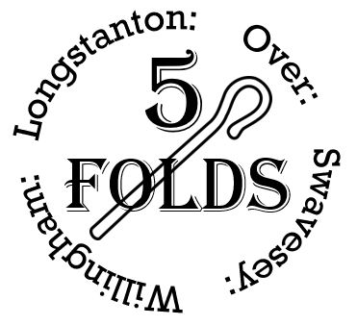
Banns of Marriage Application
PLEASE NOTE: Complete this form for the parish church where you live if you are getting married somewhere else. Please refer to the notes at the end of this form to help you complete it.
 | Groom's Details | Bride's Details
Full Name
Date of Birth
Current Address
Email Address
Telephone Number
Which parish do you live in?
Have you been married before? | Yes / No | Yes / No
If Yes, is your previous partner still living? | Yes / No | Yes / No
Have you ever been in a civil partnership? | Yes / No | Yes / No
Are you a foreign national? | Yes / No | Yes / No
Do you have British Citizenship? | Yes / No | Yes / No
Future Address (if different from above)

Joint Details
Are you related or connected by marriage?
If so, how?
Which church are you getting married at?

On what date and time? | Date:  Time:

Declaration: I hereby certify that to the best of my belief the answers to the above questions are correct. I agree that the information contained in the form may be used as described below.
Groom Signature: __________________________ | Bride Signature: __________________________

Data Protection
For the purposes of data protection law, the data controller is the Minister of the parish and the PCC who will use the information on this form to ensure that the legal requirements relating to the marriage are complied with and to make arrangements for your banns to be called. The Minister and PCC will only share the information with those who need to see it for those purposes.
FOR OFFICE USE ONLY
Dates for Publication of Banns:
1st date:
2nd date:
3rd date:

Contact & Submission Details
Please send this completed form to the 5folds administration office:
Email: admin@5folds.org.uk
Address: St Mary’s Church Hall, Church End OVER, Cambridge CB24 5NH

Notes
- If either of you will not be 18 by the proposed date of the wedding, the vicar will need to know whether the consent of parents or guardians has been obtained.
- If you aren't sure which Church of England parish you live in, enter your postcode into the search box on www.achurchnearyou.com and look for the church flagged “This is the parish church”.
- If either or both of you live in a different parish from the church you are getting married at, you will need to arrange for the banns to be read there, too.
- A least seven days’ notice is required before the first reading of banns.
- The vicar & administrator will liaise to set the dates for your banns to be read. You might want to come to church to hear them read and you’d be very welcome.
Further information: yourchurchwedding.org
Loving God, bless us as we plan our marriage. Amen.

