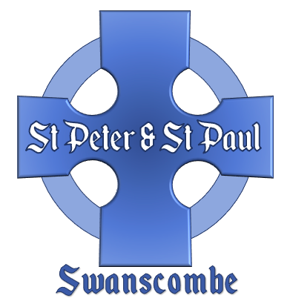
Banns Application
Please complete the form in block capitals and return to admin@swanscombechurch.co.uk
The cost of the Publication of Banns, including providing the Banns Certificate is £59.
Payment can be made by cheque to ‘PCC St Peter and St Paul’ or by BACS payment to:
Account Number 16752961, Sort Code 60 09 10 - PCC St Peter & St Paul, Swanscombe
Once the form and payment is received we will contact you to confirm the dates the Banns will be published. This will usually be the first 3 weeks of the month, during the Sunday morning 10am service. It is hoped that you would be able to attend at least one of these Banns readings.

GROOM’S DETAILS | BRIDE’S DETAILS
Full Name: | Full Name:
Address: | Address:
Phone Number: | Phone Number:
Email: | Email:
Date of Birth: | Date of Birth:
Occupation/Profession: | Occupation/Profession:
Have you been Married Before?   No   Yes  Is previous spouse still living?   No   Yes | Have you been Married Before?   No   Yes  Is previous spouse still living?   No   Yes
Have you been in a Civil Partnership?   No   Yes | Have you been in a Civil Partnership?   No   Yes
Intended Date of Wedding:

Church in which wedding will take place (Church and Parish):

