SUNDAY 30th August 2026.



Loving God and Loving our Neighbour


Although we are currently without a permanent Rector, services in the Benefice continue with the assistance of visiting clergy. Please do join us – you will be made very Welcome!! The post will continue to be advertised and further updates will be featured in the newsletter

Sunday 30th August. Trinity 13.
11.15am Stapleford Benefice Holy Communion
service, No service at Aston, Bramfield,
Watton or Waterford.

Sunday 6^{h} September. Trinity 14.
11.00am Watton Contemporary service
11.00am Aston Prayer and Praise
11.15am Stapleford Prayer and Praise
11.15am Waterford Holy Communion



MIDWEEK
Fortnightly MONDAY 2pm ASTON Bible Study Fellowship 3 Long Ridge Aston with tea and biscuits. All are welcome. Next meeting Monday 7th September Contact Pauline at pauline.manley1966@gmail.com
Aston Bible study fellowship Fortnightly Monday 2pm at 3 Long Ridge Aston with tea and biscuits. All are welcome. Next meeting Monday 7th September Contact Pauline at pauline.manley1966@gmail.com

Alpha Course. Where: 85 Great Innings South, Watton at stone, SG14 3TF. Mondays at 10.00am. If you are interested, please contact us to reserve your
place… Please give us a ring 07780 452478 Or email Richard@Takeawaychurch.com
Details available from Alpha – Alpha:uk@alpha.

NIGHT PRAYER Fortnightly at 7.30pm on ZOOM. Next meeting Wednesday 2nd September. All welcome. Contact Tim Alexander for link tim_alexander3@hotmail.com

Sunday 6th September Waterford village FETE. 1pm – 4pm. Live Music, Bouncy Castle, Bric a Brac, Beer Tent. Entry £1 under 5 free Parking £2


Saturday 12th September Bike n Hike 9am to 5pm in support of Beds and Herts Historic churches trust. Please download Sponsorship forms and list of churches from the website: https://bedshertshct.org.uk/bike-n-hike/


Wednesday 16th September. 2.30pm Stapleford village Tea afternoon in Church. All are welcome for tea, coffee cake and chat.

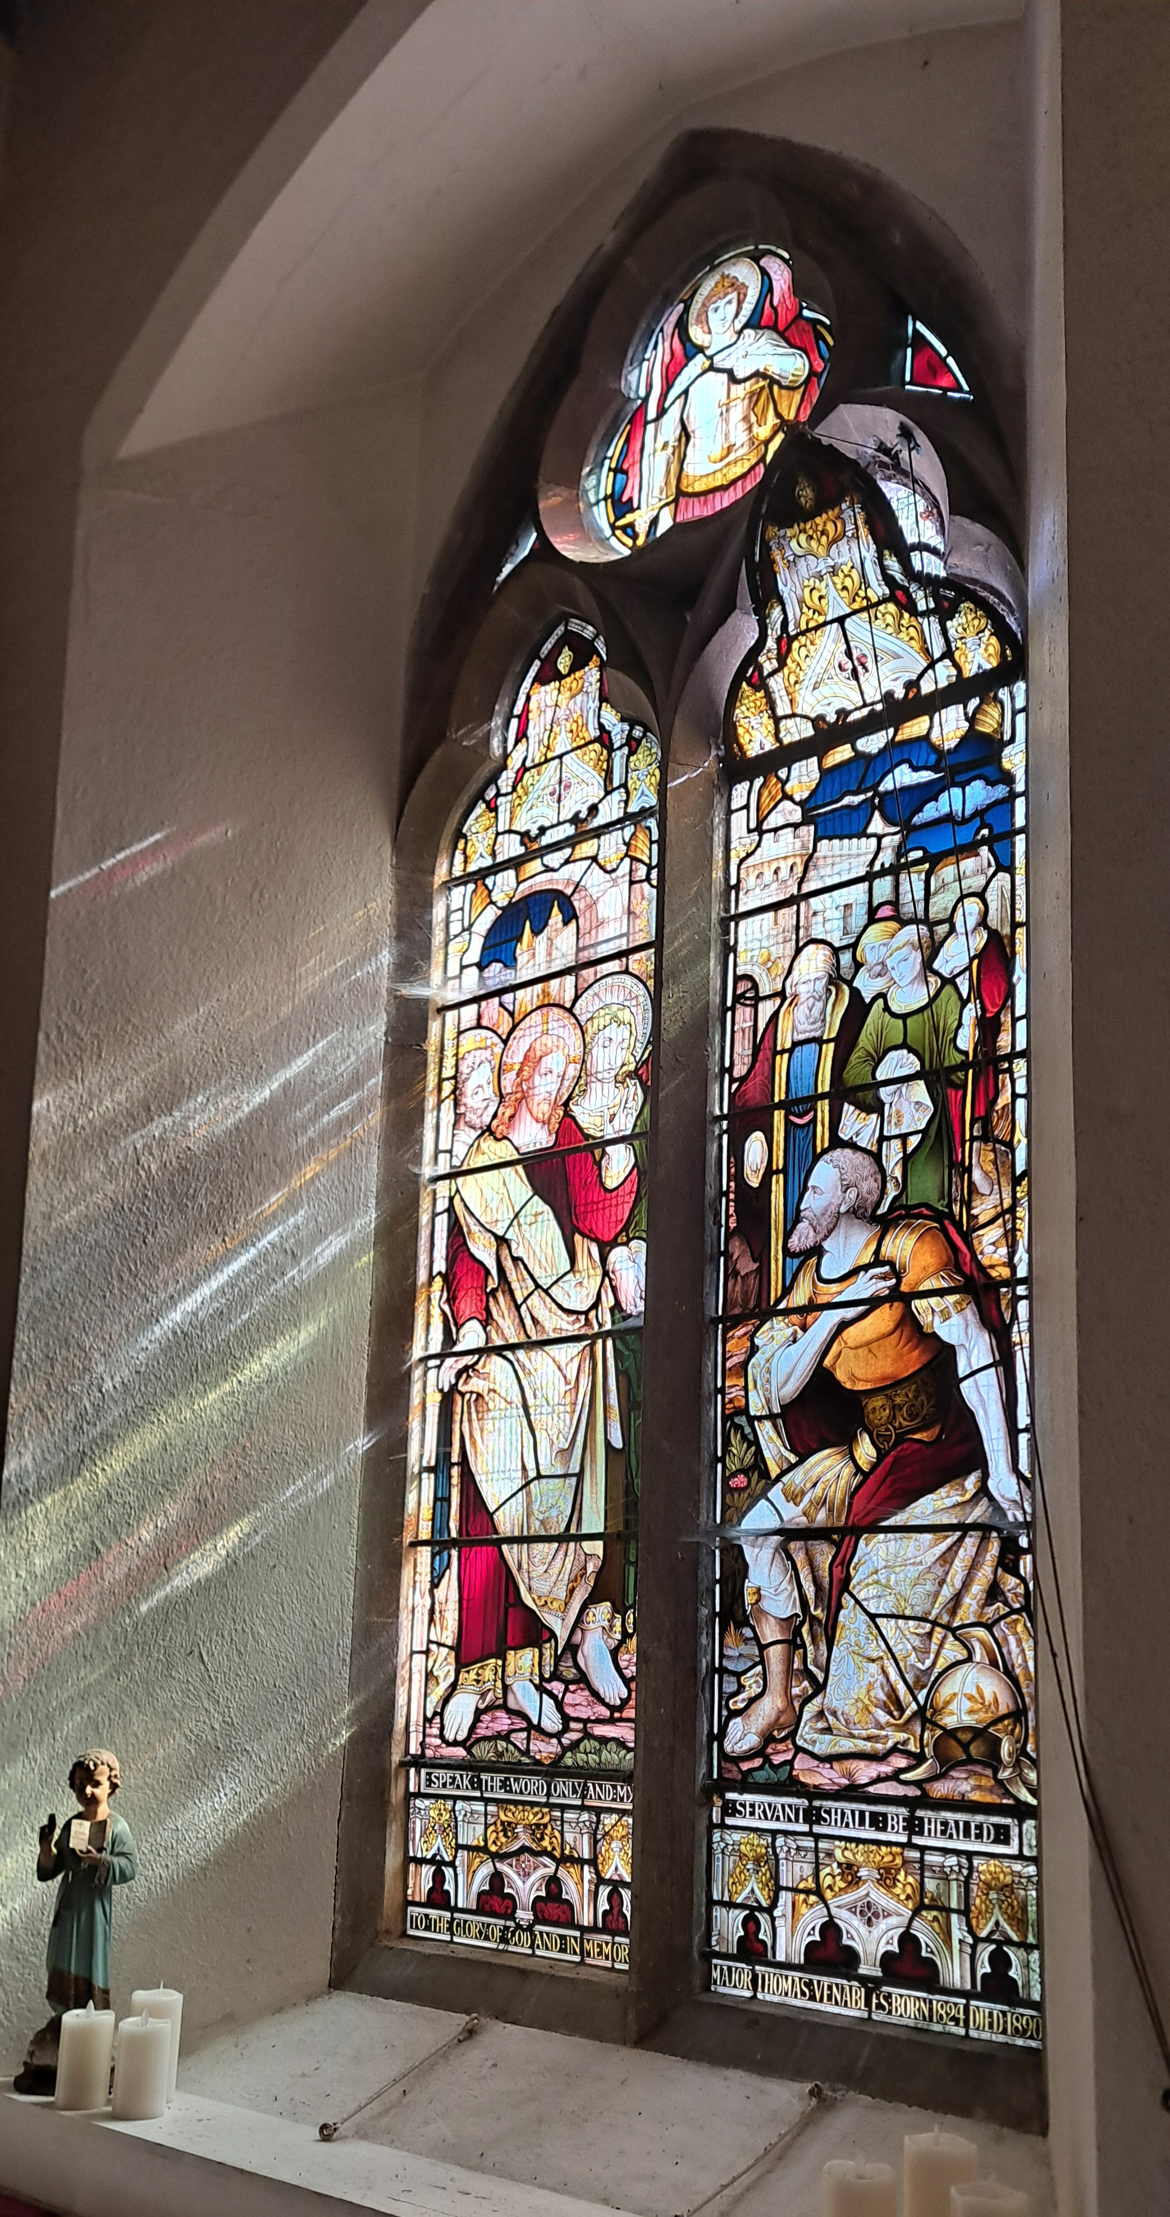
Collect Prayer for Sunday 30th August Trinity 13. Almighty God, who called your Church to bear witness that you were in Christ reconciling the world to yourself: help us to proclaim the good news of your love, that all who hear it may be drawn to you; through him who was lifted up on the cross, and reigns with you in the unity of the Holy Spirit, one God, now and for ever. Amen

One of the east facing windows in St Mary’s Aston. The window shows Jesus healing the Centurion’s servant.

“Speak the word only and my servant shall be healed”

Matthew 8.5-13

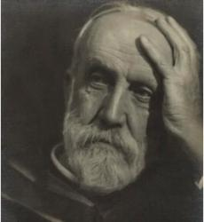
Hymn: All creatures of our God and King. 105 HAM. Author: St. Francis of Assisi

Paraphraser: William Henry Draper, M.A., son of Henry and Lucy Mary Draper, was born at Kenilworth, Dec. 19, 1855, and educated at Keble College, Oxford; B.A. in honours, M.A. 1880. Ordained in 1880, he was Curate of St. Mary's, Shrewsbury; Vicar of Alfreton; of the Abbey Church, Shrewsbury; and since 1899 Rector of Adel, Leeds.
1. All creatures of our God and King,  Lift up your voice and with us sing  Alleluia, alleluia!  Thou burning sun with golden beam,  Thou silver moon with softer gleam,  O praise him, O praise him,  Alleluia, alleluia, alleluia.  2. Thou rushing winds that art so strong,  Ye clouds that sail in Heaven along,  O praise him, alleluia!  Thou rising morn, in praise rejoice,  Ye lights of evening, find a voice.  O praise him, O praise him,  Alleluia, alleluia, alleluia. | 3. And all ye saints of tender heart,  Forgiving others, take your part,  O sing ye, alleluia!  Ye who long pain and sorrow bear,  Praise God and on him cast your care:  O praise him, O praise him,  Alleluia, alleluia, alleluia.  4. Let all things their creator bless,  And worship him in humbleness,  O praise him, alleluia!  Praise, praise the Father, praise the Son,  And praise the Spirit, Three in One:  O praise him, O praise him,  Alleluia, alleluia, alleluia.

PRAY for PEACE in The Middle East, UKRAINE and all areas of conflict


Lord God, though peace seems humanly impossible,

We continue to pray for an end to violence and bloodshed. We pray your comfort for the fearful and broken – hearted.


Change the hearts of those set on revenge and destruction.

Give wisdom to world leaders as they respond to aggression.

Bless all who work for understanding, reconciliation and justice which alone bring lasting peace. Amen.

‘God give us peace that lasts, not through the fear of might, but through the force of love, and love of life and right’. Amen

We believe that responding to the climate crisis is an essential part of our responsibility to safeguard God's creation and achieve a just world. Climate change hits hardest the poorest countries and poorest people of the world. Meantime, the widespread destruction of the natural world is a crisis for creation.

Our Environment Programme exists to enable the whole Church to address this — in faith, practice and mission. This includes tackling our own carbon emissions (aiming for Net Zero Carbon by 2030) and our wider work. More information can be found using the following web-link: http://www.churchofengland.org/about/church-england-environment-programme#na

Energy Hub Funded by UK Government: Find out how to:

1. Save energy

2. Save money. Reduce energy bills

3. Reduce carbon. Improve energy footprint

4.Increase comfort

For useful resources and guidance on where to get started visit: linktr.ee/energy_hub


https://app.ecochurch.org/user/21703/summary
EcoChurch - EcoTip for August
Are fresh cut flowers costing the earth? Flowers are grown using a lot of chemicals, pesticides, fungicides and fertilisers, which leach into waterways and harm pollinators. Flower cultivation uses a lot of water. An imported bouquet has a high carbon footprint from energy intensive greenhouses, international air freight and from refrigeration in transit. Buy local and seasonal - look for British grown, seasonal blooms, which drastically reduces transport impacts.

NEW RECTOR RECRUITMENT UPDATE –

Vacancy re-advertised for the Beane valley Benefice. A huge thank you to Churchwardens, Readers, LLWs, volunteers and visiting clergy for the enormous amount of extra work needed to keep Sunday services and other church business going during the vacancy. The video which Bishop Jane has recently filmed is now available on your vacancy page of the Diocesan website. If you click on the link below, you will be able to view it.

https://www.stalbansdiocese.org/vacancies/rector-for-the-beane-valley-benefice/

Good news. Rt Revd Dr Andrew Rumsey, currently Bishop of Ramsbury in the Diocese of Salisbury, is to be the next Bishop of St Albans. Bishop Andrew returns to the Diocese in which he was born and baptised, describing the appointment as “a homecoming” and saying he is thrilled to be joining a “fine team”. He will be installed as the 11th Bishop of St Albans on Saturday 19th September at 2pm.reThere are two tickets possible per parish/chaplaincy. The service will also be live streamed on the St Albans YouTube channel and the link will be sent out nearer the time. https://www.stalbansdiocese.org/about-us/next-bishop-of-st-albans/
The Rt Reverend Richard Atkinson Bishop of Bedford has announced that he will retire at the end of the year.
CARING for our CHURCHYARDS
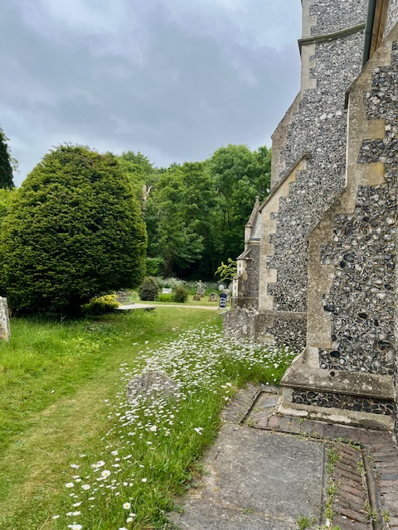
TUESDAYS Waterford Working Parties – Contact Churchwarden Malcolm Wandrag to offer help m.t.wandrag@gmail.com
To help in Stapleford or Watton or Bramfield please contact the Churchwardens.ASTON church open Sundays 12.00-16.00 and Wednesdays 10.00 -17.00 Church and churchyard working parties first Tuesday of month 10am to 12 noon. Contact Churchwarden Sara wardenstmarys@gmail.com
All our churchyards are cared for by volunteers.
Donations and offers of help are welcomed.
To include a loved one in the Book of Remembrance contact the churchwardens

Prayer for Growth for Aston, Bramfield, Stapleford, Waterford and Watton at Stone
Jesus teaches us to pray for our churches to grow. Jesus says: ‘Ask the Lord of the harvest, therefore, to send out workers into his harvest field’ (Matthew 9:38). In ways we don’t understand, God uses all our prayers.

Heavenly Father, you call us to sow seeds of faith in our communities. We ask you to fill us with your Holy Spirit that our lives may show the joy and new life we have in you. Guide our speaking and actions that others may be drawn to know your love. Lord Jesus, bless our churches that we may grow in numbers, love and service. We ask this in your name. Amen.
We pray for others to know God’s love. Tie 5 knots in a piece of string - let each knot represent a friend or family member. Keep the string in your pocket and, as you feel the string, pray for those people to know God’s love. Set an alert on your phone to remind you to pray for those 5 people every day.
A prayer for those who seek to know God.
Lord Jesus, when your followers walked the Emmaus road wondering what was true and what was not, you came alongside them and revealed yourself in Scripture and in broken bread. Come alongside those we know and love who may wonder or seek at this time. Reveal yourself in your love and make us ready to walk alongside them too, until they see your face and know your presence. Amen.
Heavenly father we pray for guidance for our Beane valley benefice churches during the vacancy. Amen.
In Touch Age UK Hertfordshire offer confidential, non-judgemental emotional and practical support on bereavement, physical & mental health issues, cancer, end of life, a partner with dementia or any other problem. Call 01992 634964/630623 or email intouch@ageukherts.org.uk Web page Age UK Hertfordshire | Our Services











Bereavement Support You can access online help at griefshare.org thebereavementjourney.org cruse.org.uk teardropgrief.co.uk ataloss.org
’s
afternoon
Tea

rty
at 64 Rivershill
Sunday 24th July 2.00-5.oopm

Bring & Buy <> Raffle <> Jams
Proceeds to Both

TAKE AWAY AVAILABLE


Why not try Bellringing at Watton or Aston.

We have teachers ready to get you ringing

You don’t have to attend church

We have a wide range of ages in our bands

Everyone is friendly and welcoming

It’s a skills part of Duke of Edinburgh award

It’s good exercise for body and mind

Email: bellringing111@gmail.com for more information.

Aston Practice Thursdays 19.58-21.00 (but not in August)

Aston Ringing Times Sundays 10.30-11.00

Watton Bell ringers meet on Monday evenings at 7pm.

Contact: Keith Carpenter 01920 830479

Thank you for reading this week's Newsletter. If you have any questions or feedback on what you would like to see in the Newsletter, please email Tim Alexander at tim_alexander3@hotmail.com. Thank you for your help.

The Diocese of St Albans are currently advertising the following roles. Please circulate details to anyone you think may be interested in applying.

- PA to the Archdeacon of Hertford –Part Time (based in Hertingfordbury)
- Giving Communications Assistant –Part Time (would suit uni/college leaver)
- Property and Trust Adviser – Full Time
Further details on our website on the links below:

https://www.stalbansdiocese.org/vacancies/pa-to-the-archdeacon-of-Hertford-2026/
https://www.stalbansdiocese.org/vacancies/giving-communications-assistant/
https://www.stalbansdiocese.org/vacancies/property-and-trusts-adviser/

Ruth Carl Governance and HR Operations Manager

