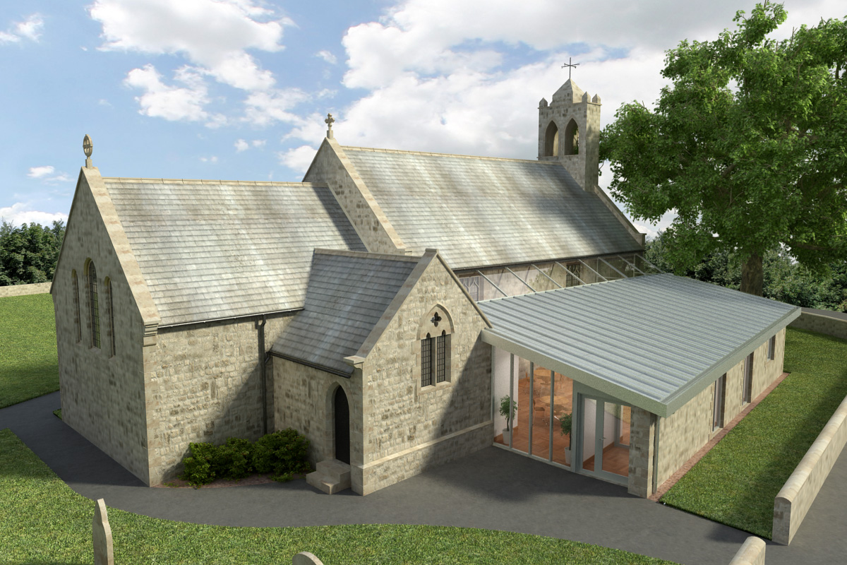
St Mary’s Parish Church, Longframlington

Welcome to our Sunday Morning Prayer. On Sunday 23rd August, which is Twelfth Sunday after Trinity, our Officiant will be Rev Rich, Michael playing the music. Next week, Trinity Sunday 13th, the Officiant will be Rev Rich and Michael playing the music.
Coming up at St Mary’s and our sister parishes – Morning Prayer in St Mary’s – and on Zoom – usually every Wednesday morning at 9.30 am followed by coffee in the Community Room. The Link can be made using Meeting ID889 6133 2870, Password 093043. New people always welcome either on screen or in church.
Starting Rite – A popular course which will run in Felton in the autumn. Beginning on Tuesday 15 September, 10.00 till 11.30 am at St Michael’s, Felton. This is a warm welcoming space for babies under 12 months and their parents or carers to play, sing, wonder and explore faith together, contact Rev Rich or Emma to book a place.
For those of us who visited the Alnwick Playhouse last week the highlight was the Rev Dibley ably played by our own Cath, congrats to all who took part, a stirring performance.
Please make sure there is a complete list for the coffee rota for a Sunday morning as this makes things very easy to organise.

A Forward Notice – Songs of Praise Christmas Concert – BBC Songs of Praise – is recording a Christmas Concert at The Glasshouse, Gateshead on Tuesday 6 October. Doors open at 6 pm and the recording begins at 7 pm. Tickets are free and all ages welcome, though under 18s must be supervised by an adult. Book through Lost in TV or call 020 8530 8154. It would be great if some people from our churches wished to be part of this!

Thank you for your giving to the life and work of our church. Our offering is taken during the third hymn, and there is a collection giving point at the back of the church for use after the service if you prefer. Regular giving by Standing Order with Gift Aid is particularly valuable to the church – speak to Audrey (01665 570 922) for more information and blank forms.
All our news and much more available on our Facebook page https:www.facebook.com/SMCLongfram/?ti=as and You Tube channel https:www.youtube.com/@stmichaelsfeltonstmaryslon.
Priest in Charge: Rev Rich Townend. Phone 01670 719470. Email:revrichtea@gmail.com. Regular day off is Monday.
For St Mary’s information contact Veronica Thomson (01665 570 807) or Audrey Truman (01665 570922).

