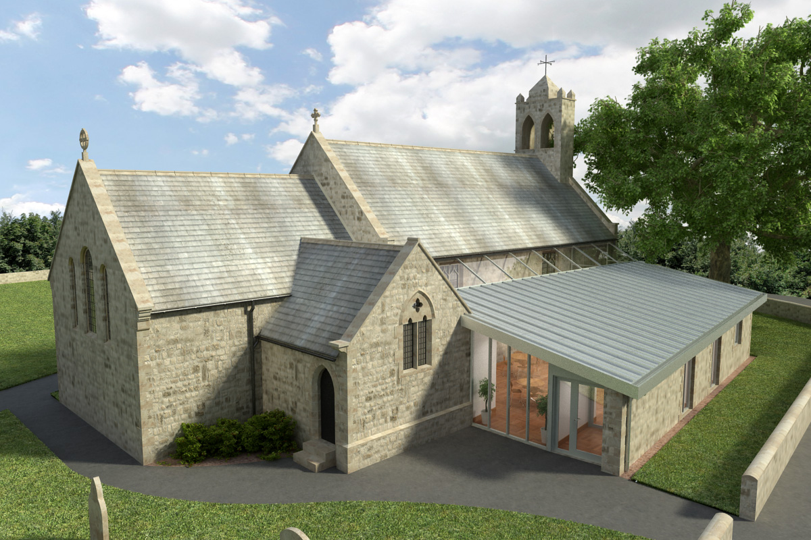
St Mary’s Parish Church, Longframlington

Welcome to our Sunday Morning Prayer. On Sunday 12th July, which is Sixth Sunday after Trinity, when our Officiant will be Rev Rich, and Mary Hipwell giving the Homily, Tony playing the organ. Next week, Trinity Sunday 7 please note separate item.
Coming up at St Mary’s and our sister parishes – Morning Prayer in St Mary’s – and on Zoom – usually every Wednesday morning at 9.30 am followed by coffee in the Community Room. The Link can be made using Meeting ID889 6133 2870, Password 093043. New people always welcome either on screen or in church.
Sunday 19th July will be Ed Butlin, the URC Minister’s last Sunday before his move to Gosforth and the service will be a combined one commencing at 10.30 am. Steve playing the organ. All welcome.
Sunday, 26th July will see the return to Officiate, of the Revd David Wood, who has been recovering from a knee operation and we welcome him back.
Growing in Jesus – A six-week practical workshop course exploring how we love God, follow Jesus and show his love to others today. This course has been most successful and plans are ahead to organize another set of meetings in October.
A huge thank you to Sandra and Terry English for their wonderful job of cleaning the Community Room carpet and various other spaces within the church and to Charlotte who has been keeping clean a lot of the church furniture at the entrance to the Sanctuary.
Thank you for your giving to the life and work of our church. Our offering is taken during the third hymn, and there is a collection giving point at the back of the church for use after the service if you prefer. Regular giving by Standing Order with Gift Aid is particularly valuable to the church – speak to Audrey (01665 570 922) for more information and blank forms.
All our news and much more available on our Facebook page https:www.facebook.com/SMCLongfram/?ti=as and You Tube channel https:www.youtube.com/@stmichaelsfeltonstmaryslon.
Priest in Charge: Rev Rich Townend Phone. 01670 719470. Email:revrichtea@gmail.com. Regular day off is Monday.
For St Mary’s information contact Veronica Thomson (01665 570 807) or Audrey Truman (01665 570922).

