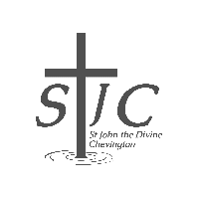
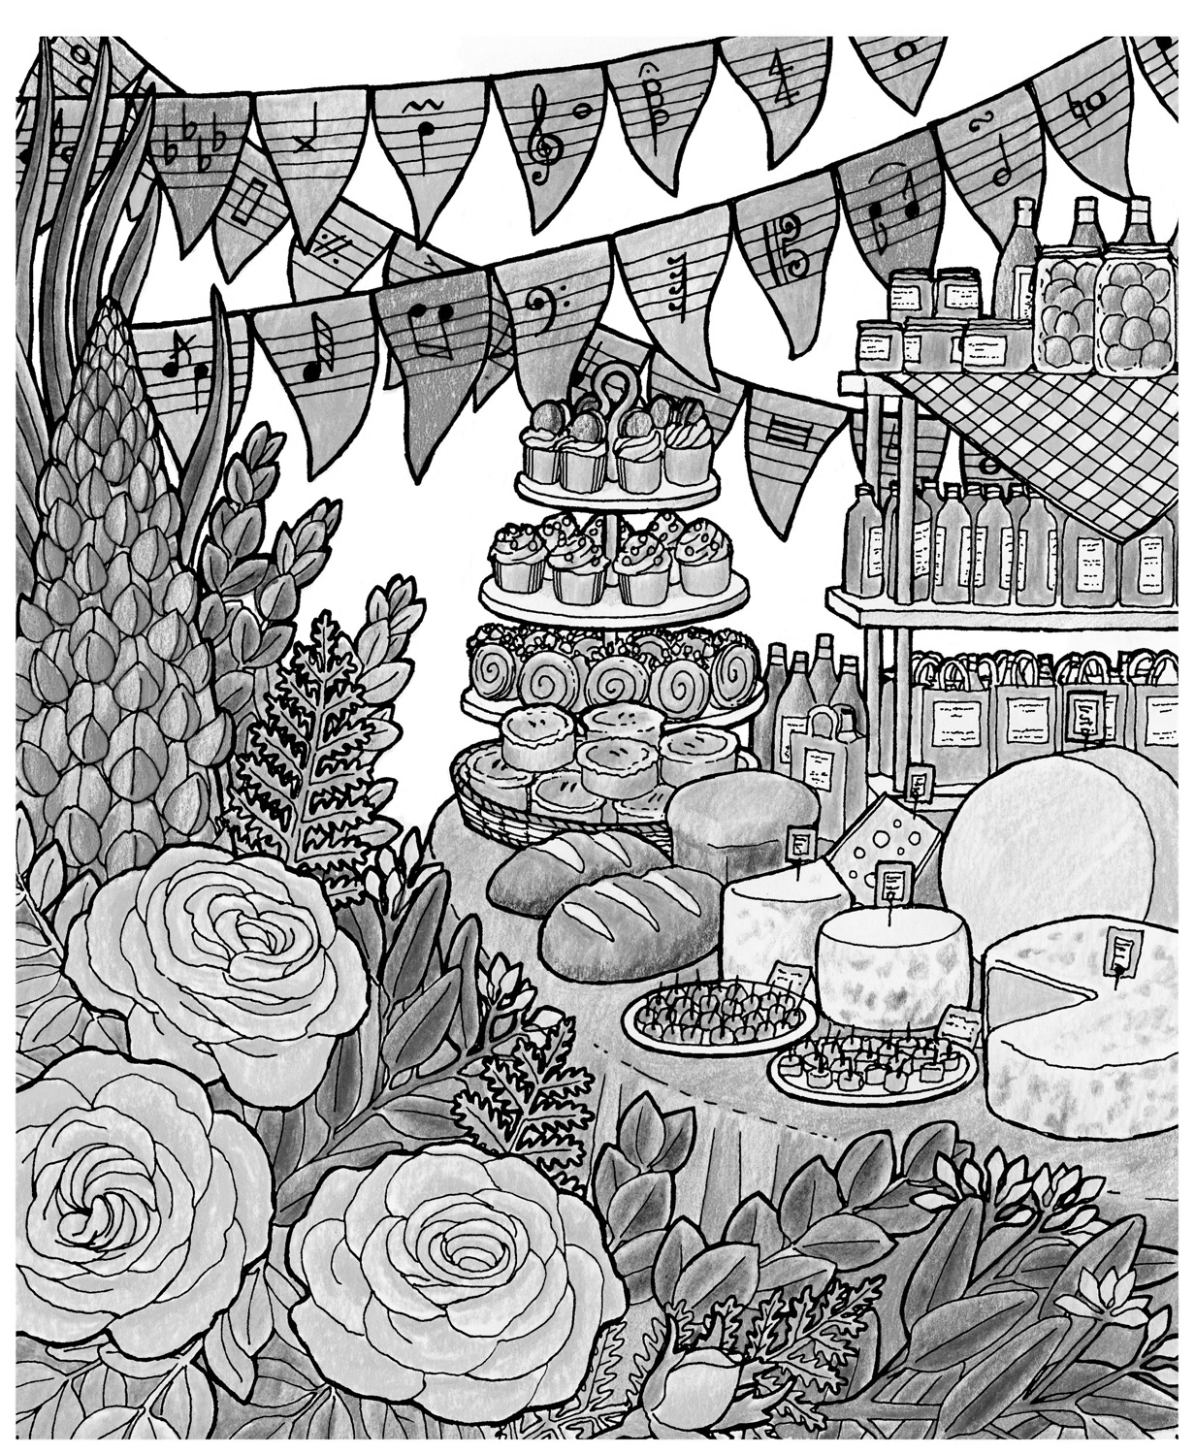

St John’s Review

JUNE 2026

Serving the villages of Hadston, Red Row and North and South Broomhill
Services June 2026

SUNDAY  (PCC following) | 7th June | 10.30am | Holy Communion  Rev Rachael Dines
SUNDAY | 14th June | 10.30am | Holy Communion  Rev Rachael Dines
THURSDAY  SUNDAY  SUNDAY | 18th June  21st June  28th June | 02.00pm  10:30am  10:30am | Third Thursday  Sheila & Cynthia  Holy Communion  Rev Rachael Dines  Holy Communion  Rev Racheal Dines
NOTE:
From July our service times will swap with our sister church St Cuthbert’s, Amble – making Sunday 5th July the first service beginning at 9am.

FUNERALS May 2026
A Prayer to remember those whom we love.

Almighty and eternal God,
we give thanks for all those whom we love but see no longer. Hold them in your everlasting arms of mercy and peace, and grant us grace to cherish their memory with love and thanksgiving. As we remember them in our hearts, comfort us with the hope of your eternal kingdom, where every tear shall be wiped away and all shall be made new in Christ our Lord.
Amen.
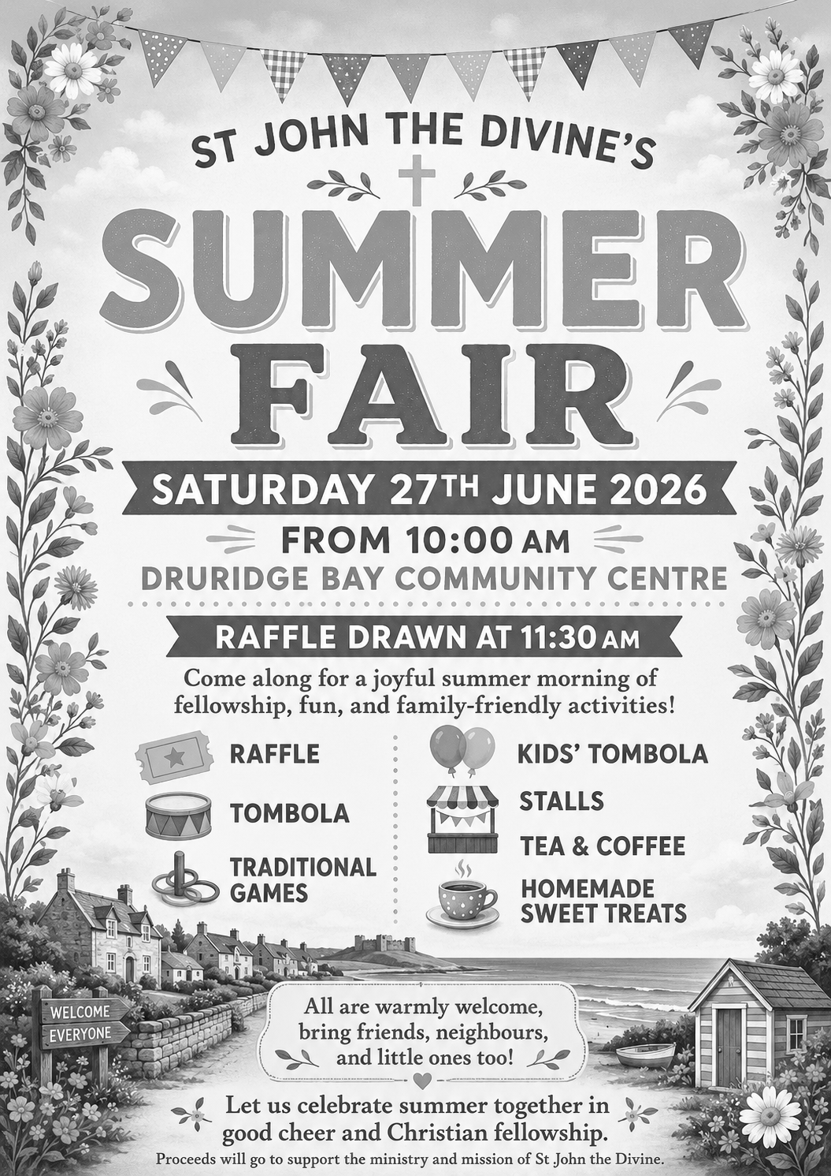
Dear Friends,

It seems that I have been taking quite a few funerals recently, and this is a very special and sensitive time for many. Losing a loved one can be so very tough but one of the things that I enjoy is meeting with families. So many times we plan the funeral and then start to talk about their loved one…it’s then that all the stories come out and there are often tears and laughter mingled together. We talk about someone and the difference they made to our lives, and yet we forget so easily the difference that WE can make. We don’t realise that we are all important and have a special place in our families and communities. We all have a contribution to make to local life and someone else’s life might be so much better because YOU are in it! Our words, actions and simple presence do make a difference and it is good to remember and celebrate this.

In this day and age there are many ways to keep in contact and show care or concern. We have texts, messages, answerphones, email, WhatsApp… the list goes on. However, picking up the phone for a catch up is so precious. Even when visiting in person is impossible the sound of a loved one’s voice can lift our spirits. During my recent holiday time I made the point of catching up with friends and after each call I felt so much better for our chat. Sometimes just a few moments is enough to feel loved and heard. It’s the same with bumping in to a friend in the street. A brief meeting can brighten our day.

This all makes me wonder how we can continue to have a connection that is a little deeper than a magazine article each month… I think it comes down to making a determined effort to stay connected. However, many times have we heard someone say ‘you never call me’ or ‘I don’t hear from my friends or family’… and yet, the phone works both ways! Letters or cards can be written as well as received. On the whole we are privileged to be living in a time where communication can be varied and fast. We ought to make use of all that is at our fingertips in order to stay in contact.

When I think of communication with friends, family and community it makes me reflect on my communication with God. I might feel a little bit upset when my friend doesn’t call me when I expect, but I wonder how God feels when I don’t make the effort to speak with him? We are reminded in the Bible that God knows us and loves us so very much that he even knows the number of hairs on our head. And yet, we give him little thought and only call out to him when we are in desperate need for help. God loves us so much that a conversation with him gives him great joy. He wants that connection with us, when we can tell him exactly how we feel (yes even when we are hopping mad!). He wants to know what is on our hearts, what worries us or brings us happiness, what we need help with and what we are thankful for. A conversation with God can take many forms, but we often refer to this as prayer. Prayer isn’t something that has to be carefully worded, said with a serious voice while dressed in ‘Sunday best’. It is a connection with God at a deep level that sometimes needs no words, sometimes comes when we encounter the beauty of nature or a moving piece of music and sometimes a very few words whispered in the stillness are heard by the God who loves us to the ends of the world and into eternity.

May we all make a choice this month to pick up a phone, write a note or pop round to see a friend, you never know how much the other person may need that contact. It works both ways though, you will often feel more positive after a good old natter too. And don’t forget, a few minutes in prayer will also lift spirits and if you are not sure how to start… try The Lord’s Prayer as a starter, you won’t regret it.

God bless you all,
Rev Rachael
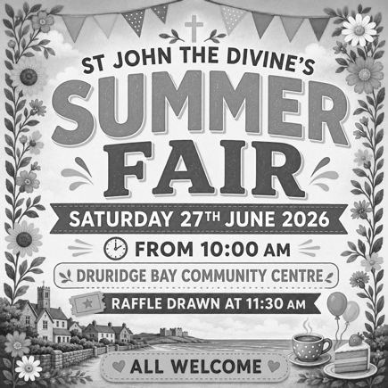
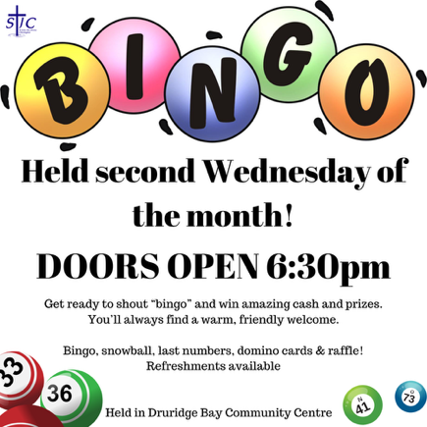
MONTHLY EVENTS

Bingo night – Wed, 10th June SUMMER FAIR – Sat, 27th June

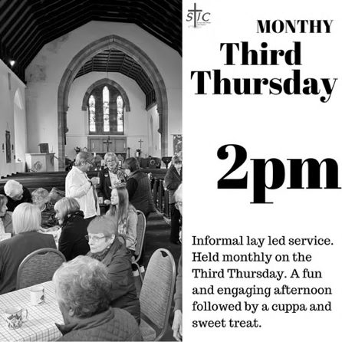
Third Thursday – JUNE
Everyone is welcome to Third Thursday, 18th June at 2 pm in the Church.
A short informal service enjoyed by all, led by Cynthia or Sheila.
Refreshments and sweet treats are served afterwards.


MEMORIAMS FOR JUNE

DUNN
Jack died 12th June 1995. Treasured memories of a dear husband, dad, granddad and great granddad. Sadly missed by all the family.

In loving memories of our dad, granddad and great granddad Jack died 12th June 1995. Loved and remembered always by Elizabeth, Ken and family.

Treasured memories of our dad, granddad Jack died 12th June 1995. Sadly missed; remembered always by Pauline, Roy and family.

HUNT
Ann nee Waugh. In loving memory of a dear mother and sister, died suddenly 7th June 2008. No farewell words were spoken, no time to say goodbye; you were gone before we knew it and only God can tell us why. A million times we’ve needed you, a million times we’ve cried; if our love could have saved you, you never would have died. Sadly missed by loving daughter Joan, sisters Doreen and Jean.

LITTLE
Simon David Little, 14th June 2020
Always in our hearts; gone but never forgotten.
All your loving family.

JOHNSON
In loving memory of a very special dad Don Johnson who died on 20th June 2011. Remembering you is easy, we do it every day, it’s the heartache of losing you that never goes away. We will meet in God’s garden where there is no pain, we’ll put our arms around you and never let go again. Love you always dad, God bless. Until we meet again, your loving daughter Christine, son-in-law Jim and family x

NICHOLLS
Mark Nicholls died 13th June 2022 aged 60 years. A much-loved husband, Dad and Granda who is loved and missed every single day and he will be in our hearts forever, always remembered. Lots of love always Janet, Luke, Lydia, Abigail, Skye, Brody, Adelle and Frankie xxxxxxxx

PATTERSON
In loving memories of my dad, granddad and great granddad Adam Patrick (Jock) died 19th June 2006. Loved and remembered always by Elizabeth, Ken and family.

PATTERSON
In loving memory of a dear dad and granda, Norman died 20th June 1988. Loved and remembered always, Melvyn, Sheila and grandchildren.

RUSSELL
Treasured memories of my twin sister Kathleen died 5th June 2020. Loved and always remembered Ken, Elizabeth and family. God bless.

SIMPSON
Treasured memories of our much loved dad Jim died 19th June 1978. Re-united on 26th April 2003 with our much loved mam Nancy. Never forgotten by daughters Joan, Liz, Lynda, Janet and all the family.

THOMPSON
Precious memories of my husband Jim, a loving husband, step-dad, granda and great granda who peacefully slept away June 23rd 2023 after a long struggle with dementia. You are free from the confusion that haunted you but I know the you are still with me because those who we love, they never die, they stay in our hearts forever. God bless you Jim, sweet dreams, love you always. Your loving wife Christine and family xx

BIRTHDAY MEMORIES

JOHNSON
Special birthday memories on 10th June of my dad Don Johnson. Missing you and love you so much dad and wishing you were here with us to celebrate your birthday like we used to. God bless you always and keep you safe. Your loving daughter Christine, son-in-law Jim and family xx


Please contact Sheila Orgill with Memoriams and
if you would like to put names in our Memoriam Book
or flowers into church in memory of a loved one.
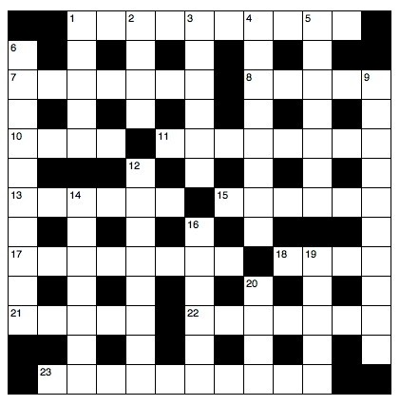
Crossword for JUNE

Across

1 Evil (Genesis 6:5) (10)
7 Musician called for by Elisha when he met the kings of Israel, Judah and Edom (2 Kings 3:15) (7)
8 The request that led to the institution of the Lord’s Prayer: ‘Lord, — us to pray’ (Luke 11:1) (5)
10 ‘We are hard pressed on every—’(2Corinthians4:8)(4)
11 Fraud (2Corinthians6:8)(8)
13 ‘His troops advance in force;they build a siege ramp against me and — around my tent’ (Job 19:12) (6)
15 Where Rachel hid Laban’s household gods when he searched his daughter’s tent (Genesis 31:34) (6)
17 ‘Now about spiritual gifts,brothers,I do not want you to be—’ (1 Corinthians 12:1) (8)
18 Nomadic dwelling(Genesis26:25)(4)
21 ‘As for man,his days are like—,he flourishes like a flower of the field’ (Psalm 103:15) (5)
22 Or I live (anag.)(7)
23 Those guilty of 1 Across(Romans13:4)(10)

Down

1 ‘God so loved the — that he gave his one and only Son’ (John 3:16) (5)
2 ‘Away in a manger, no — for a bed’ (4)
3 Mob ten (anag.) (6)
4 ‘Each — group made its own gods in several towns where they settled’ (2 Kings 17:29) (8)
5 Began (Luke 9:46) (7)
6 Speaking very softly (John 7:32) (10)
9 Workers Ruth joined when she arrived in Bethlehem with her mother-in-law Naomi (Ruth 2:3) (10) 12 Put in jail(Acts22:19)(8)
14 Aceturn(anag.)(7)
16 Discharge(Acts21:3)(6)
19 ‘All these—come from inside and make a man “unclean”’ (Mark 7:23) (5)
20 ‘Let us rejoice and be glad and — him glory!’(Revelation19:7)(4)

Smile Line - Quiet prayers
The little boy was saying his go-to-bed prayers in a very low voice. “I can’t hear you, dear,” his mother whispered.
“Wasn’t talking to you,” said the small one firmly.
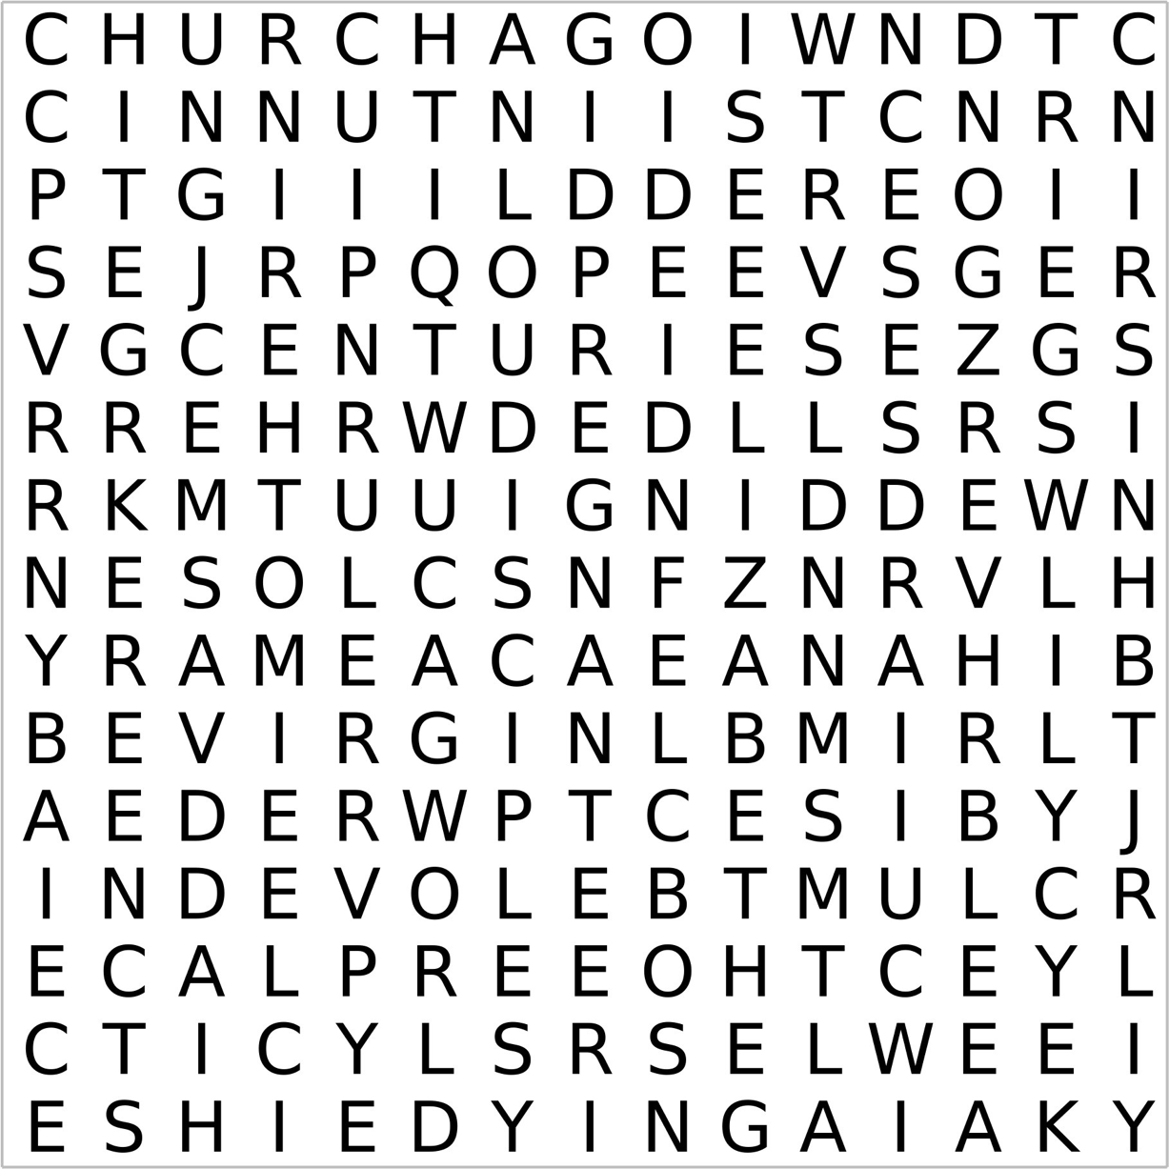
Wordsearch for JUNE

Mary | Ordinary | Family | Beloved | Unique
Virgin | World | Jerusalem | Disciples | Place
Mother | History | Wedding | Dying | Centuries
Elizabeth | Great | Cana | Cross | Church
Pregnant | Event | Wine | Keeping | Blessed
All in the month of JUNE

It was:
250 years ago, on 11th June, that John Constable, British landscape artist, was born.

150 years ago, on 19th June 1876 that Nigel Gresley, railway engineer, was born. He designed some of the best-known steam locomotives in Britain, including the Flying Scotsman.

90 years ago, on 14th June 1936 that G K Chesterton died. Novelist, short story writer, journalist, essayist, poet, social/literary critic and theologian, and remembered for his stories about the priest-detective Father Brown.

80 years ago, on 8th June 1946 that the London Victory Celebrations following WW2 took place. Allied forces paraded through London, cheered by crowds that stretched from Buckingham Palace to Regent’s Park. Countrywide, an estimated 12 million people joined in various celebrations.

65 years ago, from 4th June to 9th November, that the Berlin Crisis of 1961 took place. It led to Berlin being partitioned into East Berlin and West Berlin, and the erection of the Berlin Wall on 13th August.

Also 65 years ago, on 6th June that Carl Jung, Swiss psychiatrist and psychologist, died. Founder of analytical psychology.

40 years ago, on 22nd June 1986 that the ‘Hand of God’ goal took place during the quarter-final of the 1986 FIFA World Cup in Mexico City. Argentine football player Diego Maradona scored a goal against England using his hand, which the referee mistakenly thought was his head, and allowed the goal. England was knocked out of the World Cup as a result, and Argentina won it.

30 years ago, on 4th June 1996 that the Second Severn Crossing was officially opened. The bridge spans the River Severn and links England and Wales via the M4 motorway.

10 years ago, on 23rd June 2016 that the UK European Union (EU) membership referendum was held. 52 per cent of voters voted to leave the EU, and 48 per cent voted to remain. The UK left the EU on 31st January 2020.

Poet’s Corner

The Innocence of a Child.

The innocence of a child, is a precious thing,
An ability to feel joy and passion, mostly within!
Usually accompanied by a genuine smile,
To witness is absolutely more than worthwhile.

A soul that is so sanitized, and incredibly clean,
Untouched by man’s world…in fact its yet to be seen.
Such as to behold… gives a glow to one’s heart,
Knowing that the ‘child’, has yet to play their part.

Their straight forward and unique little answers,
Catch us unaware, but beautifully enhance us!
Their simplicity lies untouched, and definitely not broken
Ready to face to fears and challenges, without any tokens.

And yet as we move from our childhood place,
This innocence leaves us, ‘we think?’ without any trace!
We traverse through our lives, challenges are immense,
Without our innocence, we have no last defence.

And yet with love all around us, unconditionally given,
The child within use can be found; it’s not really that hidden!
Hence, ‘the innocence of a child’, has to be protected,
To lie dormant without any fears, but definitely… not neglected!

The JUNE Night Sky

The June solstice occurs on 21-June at 8.24 UT (9.24 am). This marks the start of summer in the northern hemisphere, as the Sun reaches its furthest point north of the celestial equator. In the UK we have our longest day and shortest night of the year.
Bright planets
You can find three planets in the evening sky this month – although dark skies don’t arrive until nearly 11pm this month. Venus and Jupiter are joined by Mercury over the northwest horizon. Venus and Jupiter will form a striking pair on the evening of June 9th when they are at conjunction and separated by just 1.5°. Jupiter will be gone from the evening sky by the end of the month.

Phases of the moon


Jun 8 Jun 15 Jun 21 Jun 29

The steadying influence of the moon
Each year around June 21st, the Northern Hemisphere experiences the June (summer) solstice – the moment when the Sun reaches its highest point in our sky. It marks the longest day of the year, when daylight lingers well into the evening. The reason lies not in our distance from the Sun, but in the tilt of the Earth.
Earth spins on an axis tilted by about 23.5 degrees relative to its orbit around the Sun. As Earth travels around the Sun, this tilt means that different hemispheres receive more direct sunlight at different times of year. In June, the Northern Hemisphere is tipped toward the Sun, so sunlight arrives more directly and for longer each day – producing warmer temperatures and extended daylight. Six months later, the situation reverses at the December solstice.
Axial tilt is not unique to Earth. Many planets lean over, some dramatically so. Mars, for example, has a tilt similar to Earth’s and experiences seasons – but they are far more extreme and chaotic over long timescales. The key difference? Mars lacks a large stabilising moon.
Earth’s tilt is remarkably steady, and this is where the Moon plays a crucial role. The Moon’s gravitational pull acts like a stabilising hand on a spinning top, preventing Earth’s axis from wobbling wildly. Without the Moon, Earth’s tilt could vary by tens of degrees over millions of years, leading to extreme climate swings that might make long-term habitability far less likely.
The Sun also contributes indirectly. Its gravity governs Earth’s orbit and helps define the overall geometry of the solar system, setting the stage on which these subtle gravitational balances play out. But it is the Moon that provides the fine control, smoothing out Earth’s axial behaviour.
So when we enjoy the long evenings of the June solstice, we are witnessing the combined effects of Earth’s tilt, its graceful orbit around the Sun, and the quiet but crucial influence of the Moon; a cosmic partnership that has shaped our seasons for billions of years.
If you’d like to learn more about astronomy, then consider contacting your local astronomy club – the Northumberland Astronomical Society (NASTRO) - see www.nastro.org.uk for further details.

Dr Adrian Jannetta MSc CMath FRAS

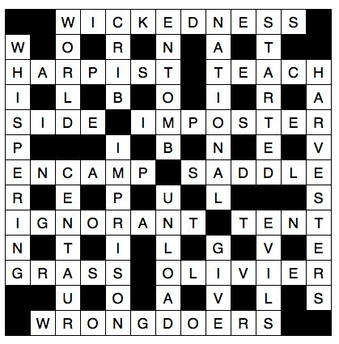
Crossword Answer Wordsearch Answer
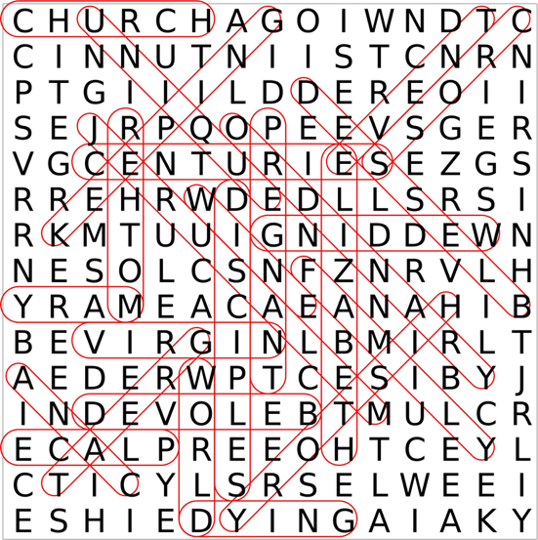

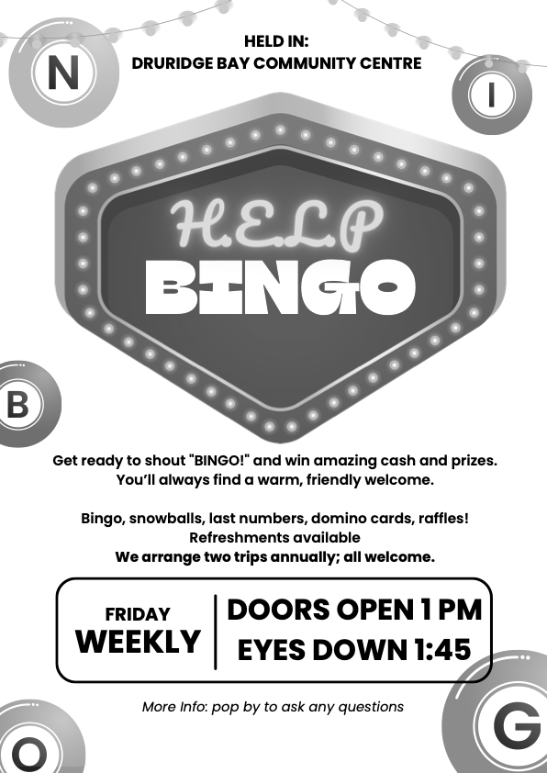

Gift Shop, Home Interiors, Painted Furniture, Furniture painting commissions & Frenchic Paint stockist.


10 The Precinct. Hadston. NE65 9YF

Facebook The Furniture Painter

Email keith.brooks2@btconnect.com Mobile 07437853665.

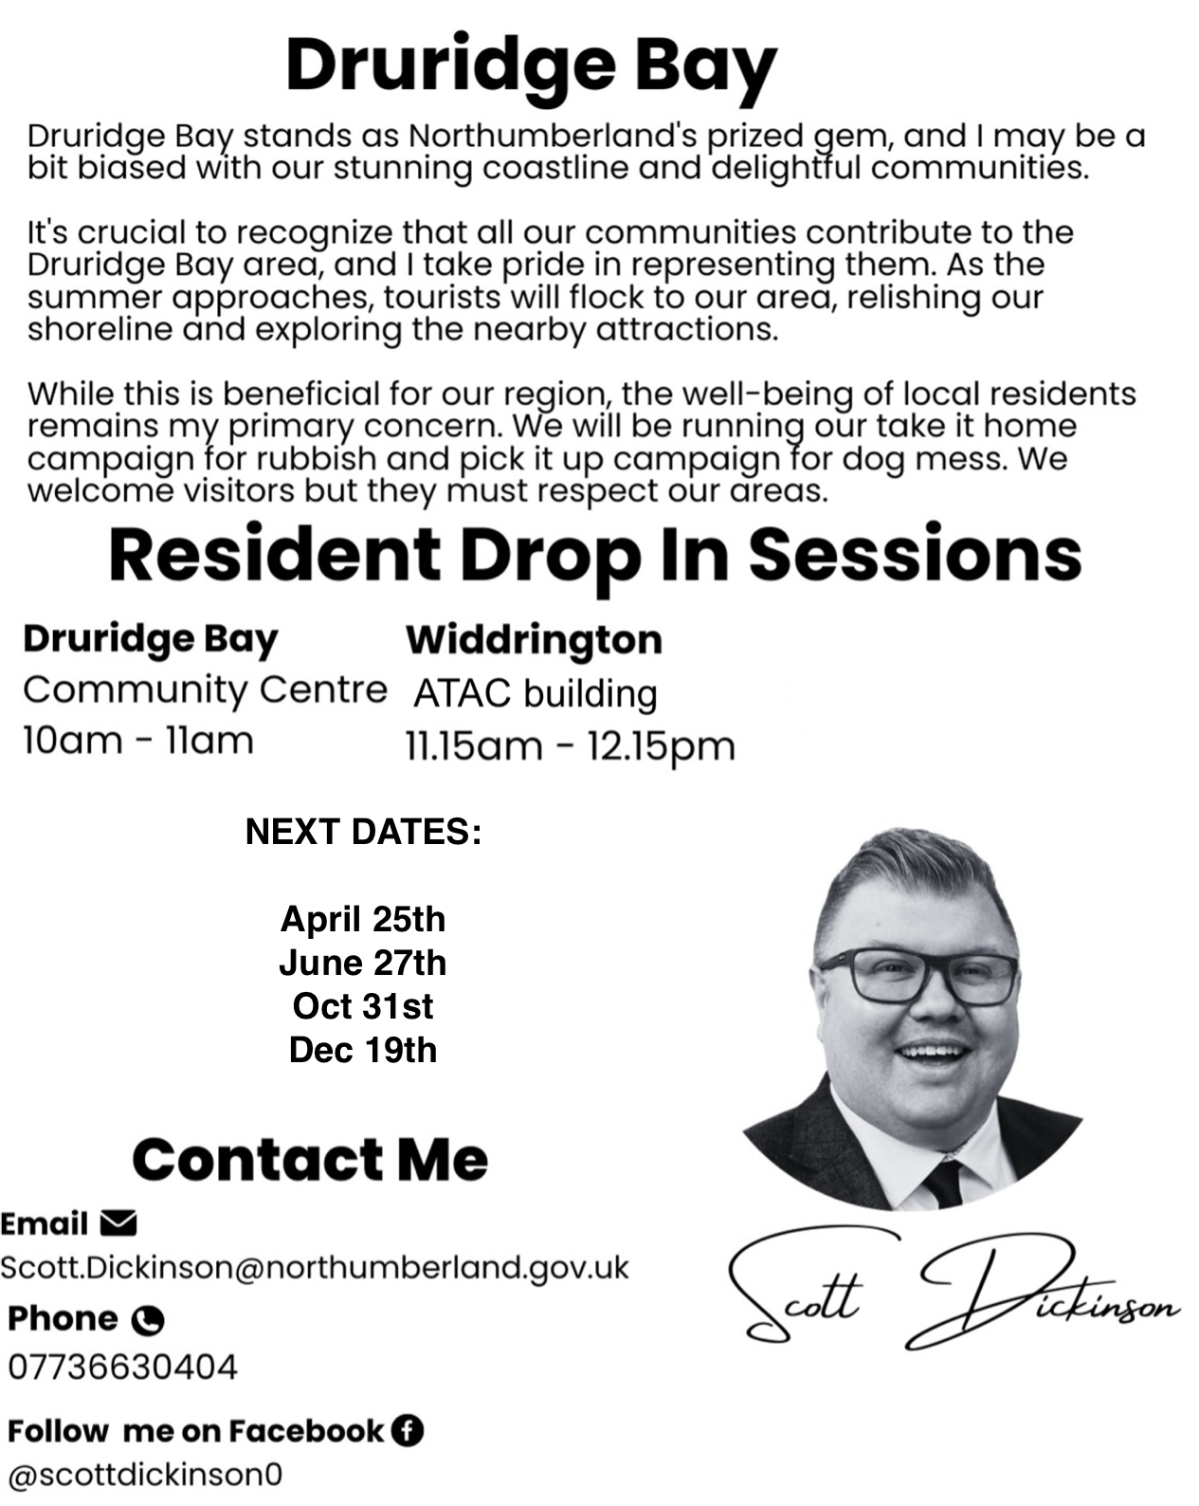


ADVERTISE HERE!

If you would like to advertise your business, please contact the editors via stjohnchevington@gmail.com for more

HADSTON NEWSAGENCY

PROPRIETOR – Stephen Paton

HADSTON SHOPPING CENTRE

Tel: 760233

Post Office Now in Shop
Newspapers Magazines
Stationery Cigarettes
Tobacco Alcohol
Pet Corner Household Goods
Groceries





T. DAWSON Ltd

ELECTRICAL CONTRACTOR

- Renewables
- EICR
- Domestic, Commercial, Industrial

T. Dawson Ltd
Bradley House
23 Togston Road
North Broomhill
NE65 9UZ

Tel: 01670 761921 / 07955 911720 Email: trevortoggy@icloud.com



John S Lunn & Sons
Artsmith, Blacksmith
Stephen Lunn
Est 1921
Tel: Red Row 01670 760246

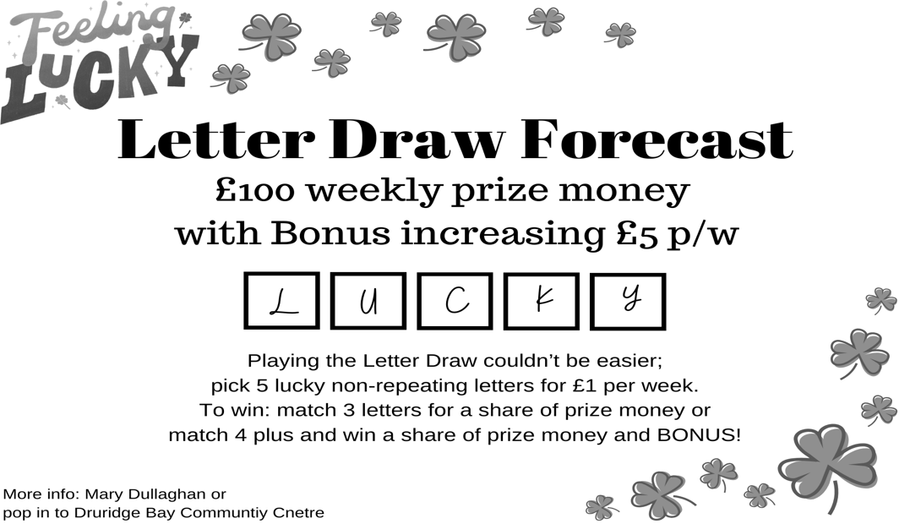

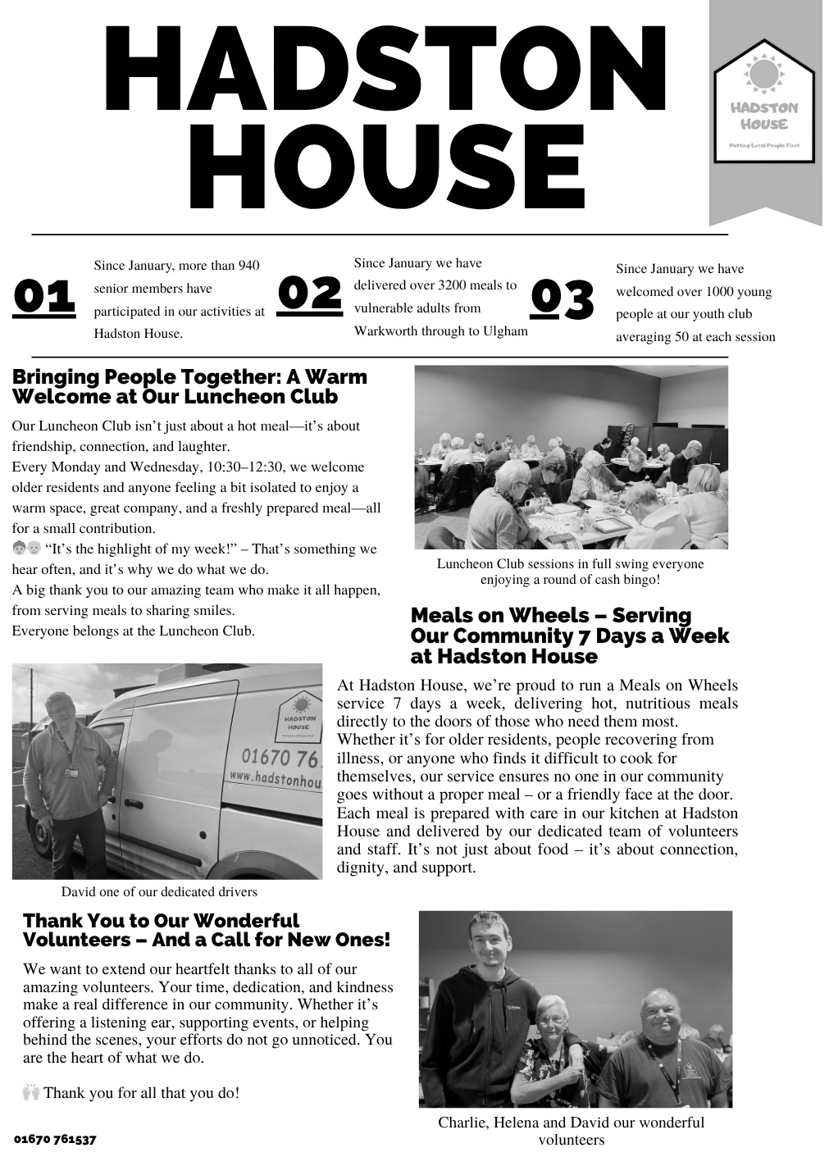

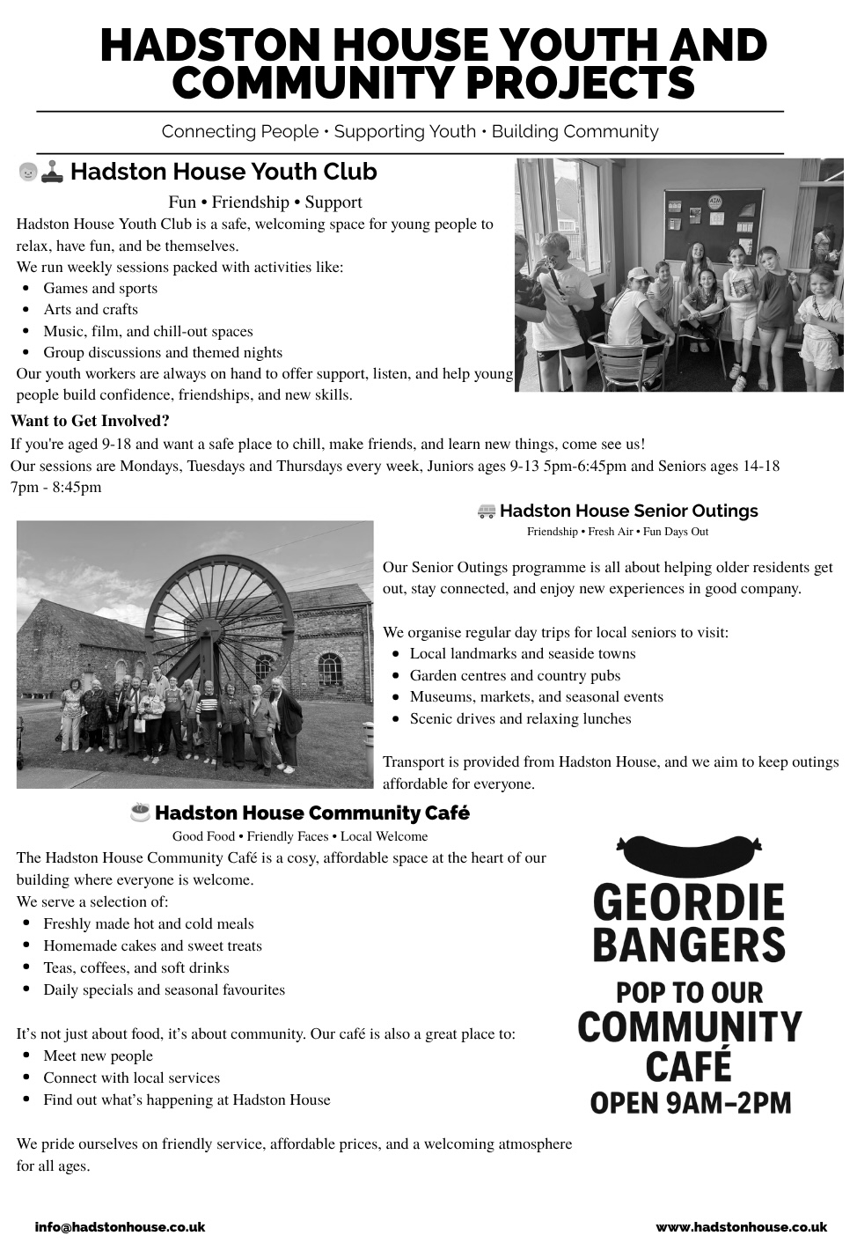

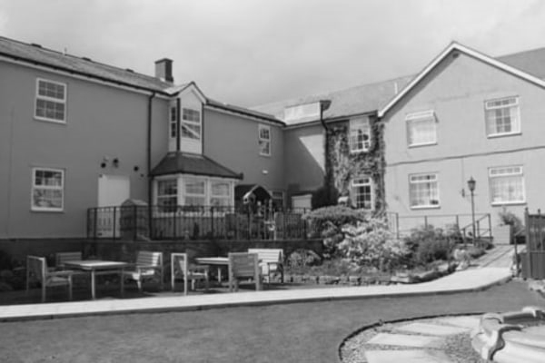
HEATHERDALE RESIDENTIAL
CARE HOME
Broomhill, Morpeth

01670 760796

Our aim is simply ‘Care Without Compromise’, which fundamentally means
we believe in Privacy, Dignity, Independence, Choice, Rights and Fulfilment
for the client. High standards of comfort, providing ‘First Class Quality Care’

Our home has:
- Ambience – “Truly a Hom, in the warmest sense.”
- Social Activities and Outings – “Daily with various outings”
- A Tip-top team – “Warm, cheerful, reassuring and caring”
- Virtually all single rooms, the majority of which are en-suite.
- Lovely Gardens, which have won Britain in Bloom Competitions
- Excellent Home Cooking - Great choice – 5 Star”
- Qualified Staff – “Training from day one”
Call any time for a brochure!

Helpline | Phone | Cost
Samaritans | 116 123  Open 24/7  jo@samaritans.org | Free
Mind Mental health support | 0300 123 3393 Open 9am-6pm except bank holidays.  Text 86463  info@mind.org.uk | Local rates from landline  Mobile charges vary
FRANK  Need advice about drugs – talk to Frank | 0300 123 6600 Open 24/7  Text 82111  frank@talktofrank.com | Local rates from landline  Mobile charges vary
Alcoholics Anonymous | 0800 9177 650  help@aamail.org | Free
Rape Crisis | 0808 802 9999  12noon-2.30 & 7-9.30 daily | Free
Switchboard LGBT+ helpline | 0300 330 0630  10am-10pm daily  chris@switchboard.lgbt | Local rates from landline  Mobile charges vary
National Domestic Violence  Run by Women’s Aid and refuge | 0808 2000 247 Open 24/7  0808 801 0327 Male advice & enquiry  0808 802 4040 Helpline for men worried they may be harming someone else | Free
ManKind Initiative domestic abuse helpline for men | 01823 334244 weekdays 10am to 4pm | Local rates from landline  Mobile charges vary
Farming Community Network | 03000 111 999  7am-11pm every day of the year  chris@fon.org.uk | Local rates from landline  Mobile charges vary
Dementia Helpline | 0800 888 6678  Open 9am-9pm Mon-Fri  helpline@dimentiauk | Free
Silver Line  Helpline for older people | 0800 470 80 90  Open 24/7 | Free
Action for Elder Abuse | 0808 808 8141  Open 9am-5pm Mon-Fri | Free
Childline | 0800 1111 open 24/7 | Free
PARISH CONTACTS
Priest in Charge: Rev’d Rachael Dines
revd.rachael.dines@gmail.com
Churchwardens: Sheila Orgill
Editor: stjohnchevington@gmail.com
Magazine Secretary: contact Sheila or email stjohnchevington@gmail.com
Safeguarding Officer Sheila Orgill

Please contact Rev’d Rachael Dines, 07763 211901 / 01665 497631
or email stjohnchevington@gmail.com with any enquiries about baptisms, weddings and Funerals or if there is anything St John’s can do to help you.

Find us on Facebook  - St John the Divine, Chevington
Also: A Church Near You website https:/www.achurchnearyou
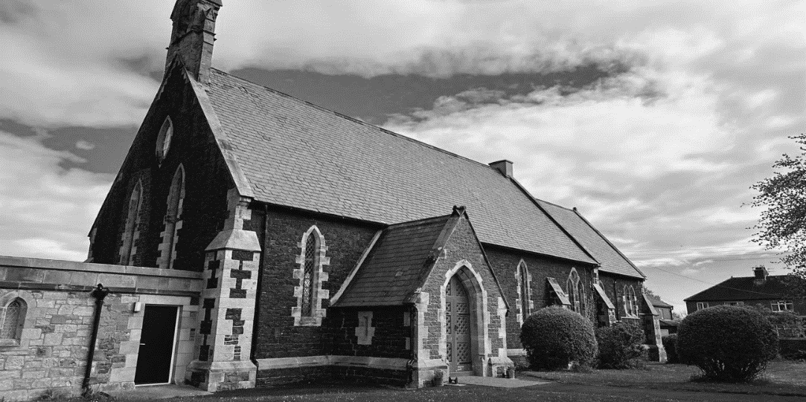

Dates and times are correct at the time of going to press.
Copies of this magazine can be obtained from St John’s Church or by contacting the magazine secretary

The magazine committee is not responsible for the content of articles submitted and also reserves the right to exercise editorial discretion.

