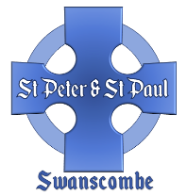
The Church of St Peter and St Paul
Swanscombe

Church marriage with calling of Banns

Statutory:
Calling of Banns £ 39.00
Church Service £566.00 £605.00
Church Fees:
Church costs Nil
Verger £ 30.00 £ 30.00

Basic Total: £635.00

Optional:
Organist £ 75.00
Choir £ 75.00
Bells £160.00
Permission to video* £100.00
Flowers** £ 75.00(minimum)
Candelabras*** £ 30.00
Heating**** £ 50.00

If you would like a soloist to sing in traditional or modern style,
with electronic accompaniment if necessary, a fee of up to £50
is payable.
*Permission to Video. Payment for copyright and performance rights which the church has to pay.
**Flowers. If you would like the church to provide church flowers the minimum contribution is £75. This may increase if you have specific colour/bloom choices.
***Candelabras. If you would like the candelabras to be lit, £30
should cover the cost of the candles.
**** Heating. Most weddings take place when it is warm. If you
think that you may require heating, £50 would help to cover the costs.

NB: If either the bride or groom lives outside the parish of Swanscombe, then Banns will have to be called in their own
parish, and a fee payable to the appropriate incumbent.
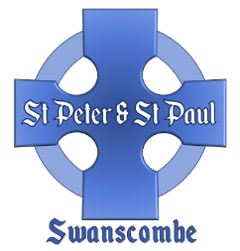
The Church of St Peter and St Paul
Swanscombe

The marriage of:

Groom

Bride

Date Time

Contact number and email

Basic Cost of Marriage: £635.00

Options: (please indicate)

Organist £ 75……………………
Choir £ 75……………………
Bells £160……………………
Permission to video £100……………………
Flowers £ 75……………………
Candelabras £ 30……………………
Heating £ 50…………………
Other

Total Cost £

A £150 deposit is payable in advance (non-refundable).
This is deducted from the overall cost, which is payable
no later than 21 days before the date of the wedding.

Please return this form to the Priest-in-Charge
January 2026

