The Rector's Ramblings
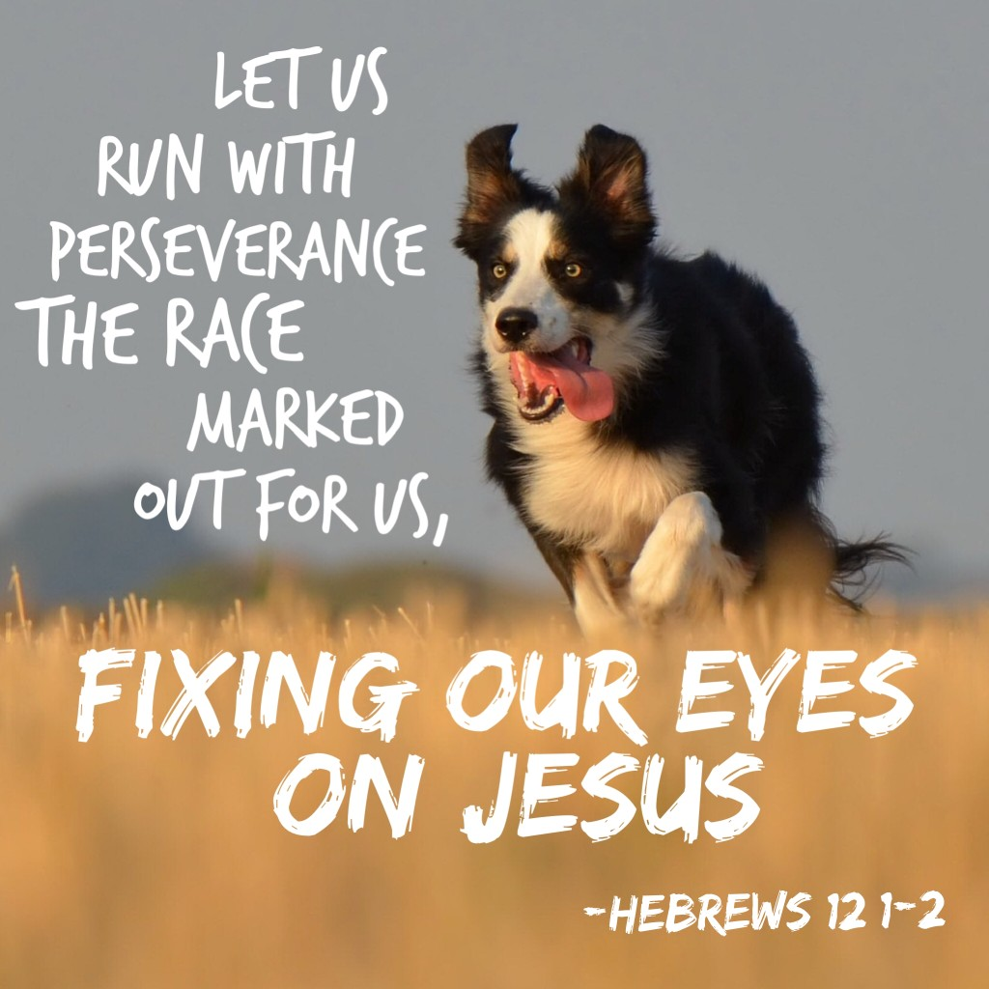
If you’re a sports fan you have been spoilt for choice this summer. The World Cup and Wimbledon may be over, and the Tour de France reaches its conclusion on Sunday, but we now have the Commonwealth Games started in Glasgow. The cricket and motor racing seasons are ongoing, in August we have the European Athletics Championship in Birmingham, then only a few days after that finishes the football season starts again, followed by the rugby. There have also been all the usual events in golf, snooker and darts that have almost happened unnoticed, under the radar, as our TV screens have been full of the big events. Across the country, and around the world, millions have gathered around TVs, at home or in pubs and clubs, travelled to events, or simply enjoyed conversations about the latest triumphs and disappointments. It has truly been a summer of sport, with highs and lows, celebrations and regrets at lost opportunities.
Whether you’re a sports fan or not, it’s hard not to admire the dedication and perseverance of the men and women who have spent years practicing, training, sacrificing so much, to give of their best, and this year having to deal with the unexpected in the form of the weather. The time, energy, and commitment they have shown, and continue to show, reminds us all that success rarely, if ever, comes overnight. Behind every medal, every personal best, every goal, every victory, lies years of practice, resolve and endurance. Sportsmen and women know that there will be setbacks as well as successes. They learn to keep going, even when the finish line, the final whistle, or the last shot, seems a long way off.
And that is the same of life in general, and also of the Christian life, it isn’t a sprint; it's much more like a marathon. We all experience moments when life feels joyful and we’re full of energy, and other times when we wonder if we have the strength to carry on, to get out of bed, to face what the day will bring. Life, and faith, isn't about winning every race or never making mistakes, it’s about trusting that God is with us every step of the journey.
In looking at life as a marathon, with times of joy and also of suffering, St Paul is a good example to us all. Yes, he had a moment of divine revelation on the road to Damascus that changed his life, but he knew that it wasn’t a one-time event that would give him the perfect life, and the perfect faith, for ever. He had moments of incredible joy, but also suffered persecution and oppression, but he kept his faith, and he kept his commitment, and in writing to the people of Rome he looked at his suffering in much the same way an athletic, from whichever sport, looks at their time spent in practice, in training, ‘knowing that suffering produces endurance, and endurance produces character, and character produces hope’. He compared the Christian life to running a race—not against one another, but towards the goal of becoming more like Christ. In the Christian race of life we’re not looking to win, we’re there to encourage each other, to celebrate one another's achievements, and help those who have stumbled to get back on their feet.
So perhaps this summer, as we applaud the dedication of athletes from around the world, it’s a good time for us to reflect on our own journey. Where do we need perseverance? Who has encouraged us along the way? And who might need our encouragement today?
Whether you're a passionate sports fan or someone who couldn't tell a cricket bat from a tennis racket, the values that shine through the best of sport, and the best of sportsmen and women, commitment, teamwork, resilience, humility and respect, are values that echo the Gospel message of Jesus, spread around the world by ordinary people who did, and do, extraordinary things. So whether you have watched, will watch, any of the big events this summer, or whether you are searching for somewhere to go to avoid them, still remember that in life, in God's eyes, the greatest victory is not standing on a podium but learning to love, serve and persevere in faith.
As the Letter to the Hebrews reminds us: "Let us run with perseverance the race that is set before us, looking to Jesus, the pioneer and perfecter of our faith.”
May this summer inspire us all to keep running our own race with hope, courage and joy.
Rev Sarah

Worship in the Valley Parish
26th July


Holy Communion
10am
West Dean

Sunday 26th July @ 11am West Dean

Rev Sarah Manouch
07468 854864 priestvalleyparish@gmail.com
Please note that I am part-time. My principal working days are Friday and Saturday as well as Sunday. I am not available on a Thursday.

