SUNDAY 19th July 2026.



Loving God and Loving our Neighbour


Although we are currently without a permanent Rector, services in the Benefice continue with the assistance of visiting clergy. Please do join us – you will be made very Welcome!! The post will continue to be advertised and further updates will be featured in the newsletter

Sunday 19th July. Trinity 7.
11.00am Watton Contemporary service
11.00am Aston Holy Communion
11.15am Stapleford Prayer and Praise
11.15am Waterford Morning Prayer

Sunday 26th July Trinity 8.
9.30am Watton Prayer and Praise
11.00am Watton Contemporary service
11.15am Bramfield Prayer and Praise
11.15am Stapleford Holy Communion



MIDWEEK
Fortnightly MONDAY 2pm ASTON Bible Study Fellowship 3 Long Ridge Aston with tea and biscuits. All are welcome. Next meeting Monday 20th July Contact Pauline at pauline.manley1966@gmail.com

Alpha Course. Where: 85 Great Innings South, Watton at stone, SG14 3TF. Mondays at 10.00am. Please call Jane:07867016430 or email Richard@Takeawaychurch.com Alpha:uk@alphja.org

NIGHT PRAYER Alternate at 7.30pm on ZOOM. Next meeting Wednesday 22nd July. All welcome. Contact Tim Alexander for link tim_alexander3@hotmail.com


Saturday 25th July 7.30pm Piano Recital St Mary’s Church, Stapleford, SG14 3NB. Tickets £20. Tel: 07963260715. email: musicatstmarys@outlook.com

Friday 7th August Tea and Cakes at Aston Village Hall, New Park Lane, Aston, SG2 7DY. 2pm – 5pm. Raffle. Adults £5.00, Children £3.00. Proceeds to Friends of St Mary’s.

Sunday 6th September Waterford village FETE. Keep the date free.

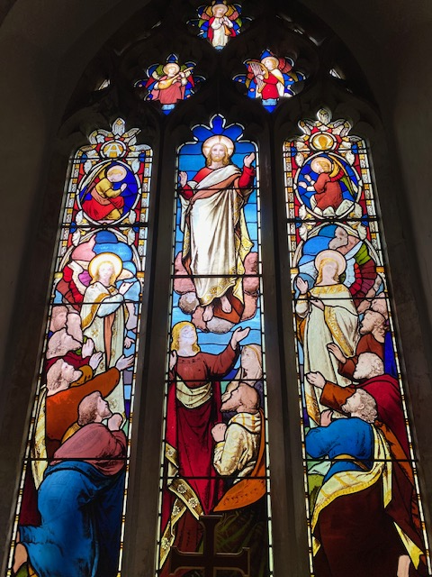
Collect Prayer for Sunday 19th July Trinity 7. Lord of all power and might, the author and giver of all good things: graft in our hearts the love of your name, increase in us true religion, nourish us with all goodness, and of your great mercy keep us in the same; through Jesus Christ your Son our Lord, who is alive and reigns with you, in the unity of the Holy Spirit, one God, now and for ever. Amen

The east window in St Andrew’s Church, Bramfield behind the altar shows Jesus lifted up to heaven, the end of his earthly life, his return to God’s right hand on high

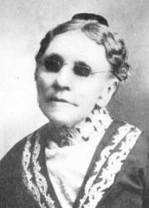
Hymn: To God be the glory. 708 Mission Praise. Pseudonymn: Frances van Alstyne. Author Frances Jane Crosby, the daughter of John and Mercy Crosby, was born in Southeast, Putnam County, N. Y., March 24, 1820. She became blind at the age of six weeks from maltreatment of her eyes during a spell of sickness. When she was eight years old she moved with her parents to Ridgefield, Conn., the family remaining there four years. At the age of fifteen she entered the New York Institution for the Blind, where she received a good education.
1 To God be the glory, great things He hath done,  so loved He the world that He gave us His Son,  who yielded His life an atonement for sin,  and opened the life-gate that all may go in.  Refrain:  Praise the Lord, praise the Lord,  let the earth hear His voice!  Praise the Lord, praise the Lord,  let the people rejoice!  O come to the Father through Jesus the Son,  and give Him the glory, great things He hath done. | 2 O perfect redemption, the purchase of blood,  to every believer the promise of God;  the vilest offender who truly believes,  that moment from Jesus a pardon receives. [Refrain]  3 Great things He hath taught us, great things He hath done,  and great our rejoicing through Jesus the Son;  but purer, and higher, and greater will be  our wonder, our transport, when Jesus we see.

PRAY for PEACE in The Middle East, UKRAINE and all areas of conflict


Lord God, though peace seems humanly impossible,

We continue to pray for an end to violence and bloodshed. We pray your comfort for the fearful and broken – hearted.


Change the hearts of those set on revenge and destruction.

Give wisdom to world leaders as they respond to aggression.

Bless all who work for understanding, reconciliation and justice which alone bring lasting peace. Amen.

‘God give us peace that lasts, not through the fear of might, but through the force of love, and love of life and right’. Amen

We believe that responding to the climate crisis is an essential part of our responsibility to safeguard God's creation and achieve a just world. Climate change hits hardest the poorest countries and poorest people of the world. Meantime, the widespread destruction of the natural world is a crisis for creation.

Our Environment Programme exists to enable the whole Church to address this — in faith, practice and mission. This includes tackling our own carbon emissions (aiming for Net Zero Carbon by 2030) and our wider work. More information can be found using the following web-link: http://www.churchofengland.org/about/church-england-environment-programme#na

Energy Hub Funded by UK Government: Find out how to:

1. Save energy

2. Save money. Reduce energy bills

3. Reduce carbon. Improve energy footprint

4.Increase comfort

For useful resources and guidance on where to get started visit: linktr.ee/energy_hub


https://app.ecochurch.org/user/21703/summary
EcoChurch - EcoTip for July
Could you do something to help the local bees and other pollinators?Try to grow diverse and native plants, in your garden, ideally with a long flowering season. Things like lavender and ivy are good options. Bees need to drink, so put fresh water in a small bowl, or bird bath, with pebbles or twigs to stop them from drowning. Be a little less tidy in your garden. Avoid all pesticides, try to rely on non-chemical controls. Pray that our pollinator populations will increase.

NEW RECTOR RECRUITMENT UPDATE –

Vacancy re-advertised for the Beane valley Benefice. https://www.stalbansdiocese.org/vacancies/rector-for-the-beane-valley-benefice/ A huge thank you to Churchwardens, Readers, LLWs, volunteers and visiting clergy for the enormous amount of extra work needed to keep Sunday services and other church business going during the vacancy.

Good news. Rt Revd Dr Andrew Rumsey, currently Bishop of Ramsbury in the Diocese of Salisbury, is to be the next Bishop of St Albans. Bishop Andrew returns to the Diocese in which he was born and baptised, describing the appointment as “a homecoming” and saying he is thrilled to be joining a “fine team”. He will be installed as the 11th Bishop of St Albans on Saturday 19th September at 2pm.reThere are two tickets possible per parish/chaplaincy. The service will also be live streamed on the St Albans YouTube channel and the link will be sent out nearer the time. https://www.stalbansdiocese.org/about-us/next-bishop-of-st-albans/
The Rt Reverend Richard Atkinson Bishop of Bedford has also announced his retirement.
CARING for our CHURCHYARDS
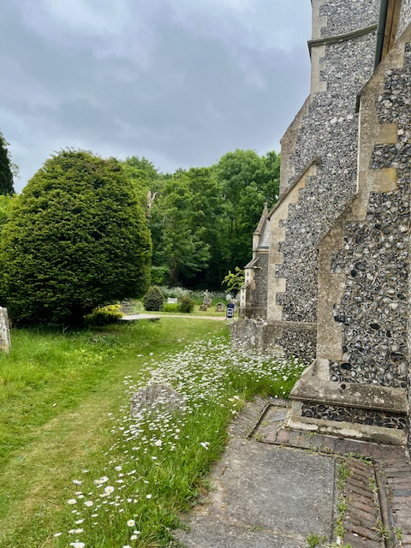
TUESDAYS Waterford Working Parties – Contact Churchwarden Malcolm Wandrag to offer help m.t.wandrag@gmail.com
To help in Stapleford or Watton or Bramfield please contact the Churchwardens.ASTON church open Sundays 12.00-16.00 and Wednesdays 10.00 -17.00 Church and churchyard working parties first Tuesday of month 10am to 12 noon. Contact Churchwarden Sara wardenstmarys@gmail.com
All our churchyards are cared for by volunteers.
Donations and offers of help are welcomed.
To include a loved one in the Book of Remembrance contact the churchwardens

Prayer for Growth for Aston, Bramfield, Stapleford, Waterford and Watton at Stone
Jesus teaches us to pray for our churches to grow. Jesus says: ‘Ask the Lord of the harvest, therefore, to send out workers into his harvest field’ (Matthew 9:38). In ways we don’t understand, God uses all our prayers.

Heavenly Father, you call us to sow seeds of faith in our communities. We ask you to fill us with your Holy Spirit that our lives may show the joy and new life we have in you. Guide our speaking and actions that others may be drawn to know your love. Lord Jesus, bless our churches that we may grow in numbers, love and service. We ask this in your name. Amen.
We pray for others to know God’s love. Tie 5 knots in a piece of string - let each knot represent a friend or family member. Keep the string in your pocket and, as you feel the string, pray for those people to know God’s love. Set an alert on your phone to remind you to pray for those 5 people every day.
A prayer for those who seek to know God.
Lord Jesus, when your followers walked the Emmaus road wondering what was true and what was not, you came alongside them and revealed yourself in Scripture and in broken bread. Come alongside those we know and love who may wonder or seek at this time. Reveal yourself in your love and make us ready to walk alongside them too, until they see your face and know your presence. Amen.
Heavenly father we pray for guidance for our Beane valley benefice churches during the vacancy. Amen.
In Touch Age UK Hertfordshire offer confidential, non-judgemental emotional and practical support on bereavement, physical & mental health issues, cancer, end of life, a partner with dementia or any other problem. Call 01992 634964/630623 or email intouch@ageukherts.org.uk Web page Age UK Hertfordshire | Our Services











Bereavement Support You can access online help at griefshare.org thebereavementjourney.org cruse.org.uk teardropgrief.co.uk ataloss.org
’s
afternoon
Tea

rty
at 64 Rivershill
Sunday 24th July 2.00-5.oopm

Bring & Buy <> Raffle <> Jams
Proceeds to Both

TAKE AWAY AVAILABLE


Why not try Bellringing at Watton or Aston.

We have teachers ready to get you ringing

You don’t have to attend church

We have a wide range of ages in our bands

Everyone is friendly and welcoming

It’s a skills part of Duke of Edinburgh award

It’s good exercise for body and mind

Email: bellringing111@gmail.com for more information.

Aston Practice Thursdays 19.58-21.00 (but not in August)

Aston Ringing Times Sundays 10.30-11.00

Watton Bell ringers meet on Monday evenings at 7pm.

Contact: Keith Carpenter 01920 830479

