Hospitaller/Contact person
Maureen Hiscocks, Rowde Court Road, Rowde 01380 699521
Weblink
www.achurchnearyou.com/church/9690/

Pilgrimage walk between Sandy Lane and Rowde
The map shows the walk from Sandy Lane, via Bromham church to Rowde. It is approximately 5 miles and will take about two hours.
Map for walk – OS Landranger 173 Swindon and Devizes
The walk from Sandy Lane to Bromham is level for most of its duration. There are no stiles.
Walking from Bromham to Rowde includes quite a number of stiles. The gradient is largely flat.

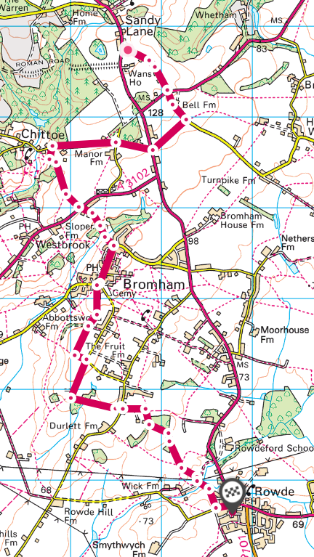

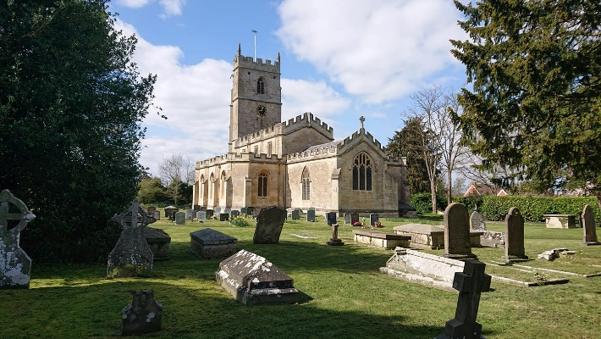
St Matthew’s Church, Rowde

Description
The church is in the centre of the village, but tucked away and out of sight of the road. It is in a tranquil setting, surrounded by a large and peaceful churchyard. There may have been a church here before the compiling of the Doomsday Book, near to running water, essential for baptism, and on a rise in the ground.
A complete list of priests from 1216 is available on the vicar’s board to the right of the main door. The magnificent tower of 1400 still survives. Two of the bells in the bell tower are nearly 300 years old, being cast in 1639.
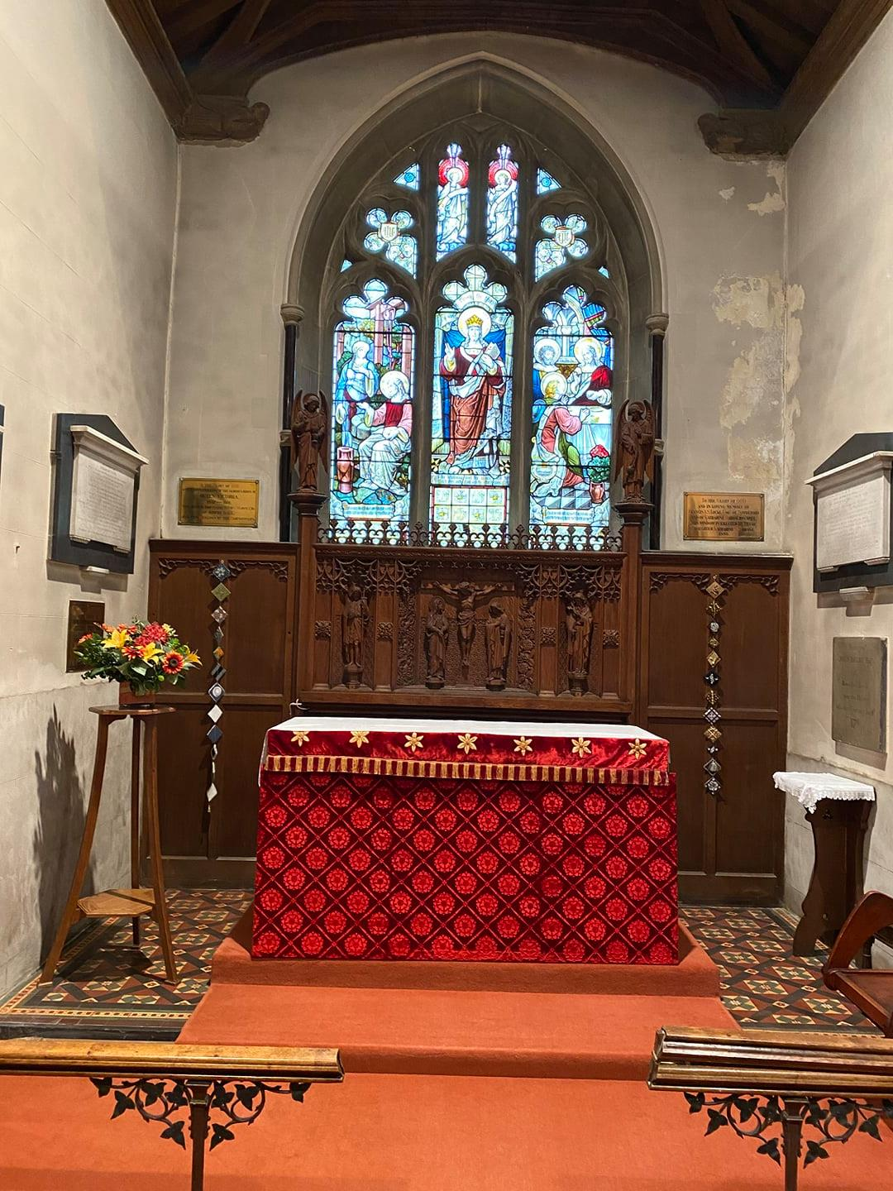
The far chapel is named the Maundrell Chapel, after the martyr John Maundrell, a Rowde man, who was put to death in 1556. He had his own copy of William Tyndale’s New Testament, even though he was unable to read. When he met someone who could read, he produced his bible so it could be read to him. He didn’t agree that the Pope was head of the Church nor that the images of saints in churches should be prayed to and for this he was burnt to death just outside Salisbury.
The font was designed in 1850 by Sir Matthew Digby Wyatt, a notable engineer and architect who lived in Rowde, better known for working with Brunel to build Paddington Station.
You will find materials to aid reflection in the far right corner of the church.
Location
High Street, Rowde, Devizes, Wiltshire SN10 2NB
Directions
Grid reference Grid ref: ST977626
By car: Rowde is 2 miles from Devizes. From Devizes follow the A342 towards Calne. After 2 miles you have reached Rowde. Turn left into Marsh Lane, then right into Rowde Court Road. Continue past St Matthews Close. The back entrance to the churchyard is on your right.
Regular bus service Faresaver 33 Devizes/Calne/Chippenham
Facilities
Level access into the churchyard from the back gate. There is a ramp into the church. Accessible toilet inside the church.
The George and Dragon, and Cross Keys pubs are both adjacent to the church and open for refreshments. There is no shop.
Prayer
Pilgrim God, You are our origin and our destination. Travel with us, we pray, in every pilgrimage of faith, and every journey of the heart. Give us the courage to set off, the nourishment we need to travel well, and the welcome we long for at our journey’s end. So may we grow in grace and love of you and in the service of others. Through Jesus Christ our Lord, Amen

