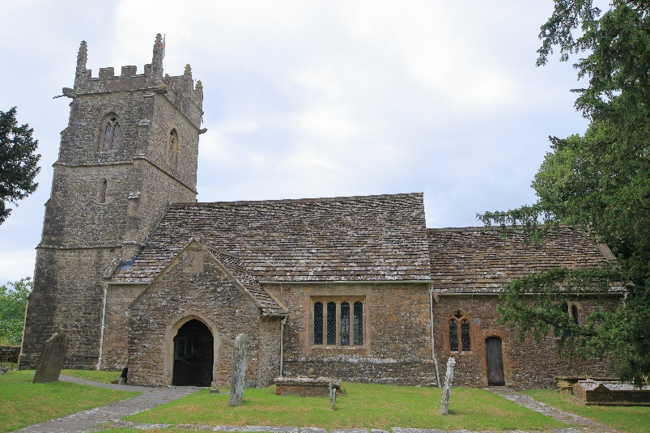

St Stephen’s Church, Charlton Musgrove

Various estimates may be found as to the age of the church. Poyntz-Wright (Church Towers of Somerset) dated the Tower circa 1490. It was not unusual for towers to be added to churches later. There is strong possibility that it happened here.

Earlier records show there was a Rector – Philip de Halstead – appointed 1322 and there is a record of his successors to the present time.

The ecclesiastical parish of Charlton Musgrove existed at the time of the founding of Stavordale Priory (Robert the first prior 1263-1309) and although endowed with lands in Wincanton etc. and deemed to be the Mother Church to Wincanton, it is significant that no connection has been established with Charlton Musgrove.

Wades ‘Somerset’ describes the church as Early Perpendicular in style, (period 1360-1547). The East Window is certainly of the early part of that period though the glass is modern.

The ‘battered’ walls of the Chancel and North Wall of the Nave are a feature of churches built around 1300 and earlier. These walls slope inwards from top to bottom representing the inside of the hull of a ship. The word ‘nave’ comes from the Latin ‘navis’ meaning ship. In the church one was in the Ark of Salvation – a place of safety.

The conclusion that may be drawn is that the original church was built c.1300 but enlarged and the Tower added in the 15th century.

Many alterations were made to the church over the centuries as may be seen from the Churchwarden’s accounts which date back to 1585, and Vestry minutes.

The sundial over the porch is the third one, the first was dated 1606 (G. Sweetman) and was replaced in 1806. In the porch above the door in a niche which once contained a statue of the Virgin. To the right of the door is the remains of a scratch dial vandalised by the electrician who brought the cable through the hole, into which in very early days, the wooden peg was inserted to tell the time. (This was before the porch was built).

Inside the church, records show the East Cover dates from 1606. The Font itself has been retooled. On the wall above the font is the ‘Achievement’ the royal arms painted on wood, dating from which every church was required to display after the Restoration of the Monarchy.

In the Tower the Hatchments commemorate the deaths of John Turner d.1793 (South wall) and Selina (nee Frewen) North wall. The Frewens must have bought them when they moved to Charlton Musgrove House and installed them in the church. The Tower also houses three bells:

- Great Bell (Tenor) diameter 3ft, weight 8 hundredweight; note A flat. Inscribed Thomas Pearce, Edward Lot 1718.

- Middle Bell diameter 2ft 11ins, weight 7 ½ hundredweight; note B flat.

- Smallest Bell diameter 2ft 6ins, weight 6 hundredweight; note C.

From the Churchwardens accounts we learn that the Great Bell was recast in 1718 by Edward Lot, Warminster, and fell broken on the Belfry floor in 1817 where it remained undisturbed for a hundred years. It was recast in 1948, rehung with the other two bells and all three were fixed so that they chime rather than ring. In 1622 ‘Richard Purdy of Warminster exchanged one bell for one old one’.

The church was refloored and repewed in 1756 using a mixture of Norway Oak, deal and ‘ye olde stuff’. At the same time a new pulpit for the Minister and reading desk for the Clerk were provided.

In the wall above the pulpit is the original door which gave access to the Road Screen (long since removed). Steps built to the North wall of the nave at the side of the pulpit led up to this door. On the beam above the Chancel Arch is the dedication of the Church – To God and St Stephen. The chair under the Chancel Arch is Jacobean and another chair in the Sanctuary is a Glastonbury Chair.

The Alter Table has the date 1638 cut in a scroll on the front. The Oak chest bears the date 1761 and the initials of the Churchwardens for that year, who paid three pounds ten shillings (£3.50) for it.

In 1884 a faculty was obtained ‘to alter and improve the Parish Church’. At that time certain memorials were moved from the Nave to the Chancel, so that those of the Leir family are altogether. The Leirs were Rectors of the Parish from 1617 – 1914 and held the Advowson (the right to appointment) from 1677 when Thomas Leir paid Joseph Sawle of Cornwall £237. 5s. 7d. for it until the death of Robert Leir when it was given to the Bishop of Bath & Wells.

Two of the stained-glass windows were given in memory of the Leir family and the third is a memorial by the Frewen family.

The memorials in the church speak for themselves.

