Sunday 16th October 2016 - drains are connected!
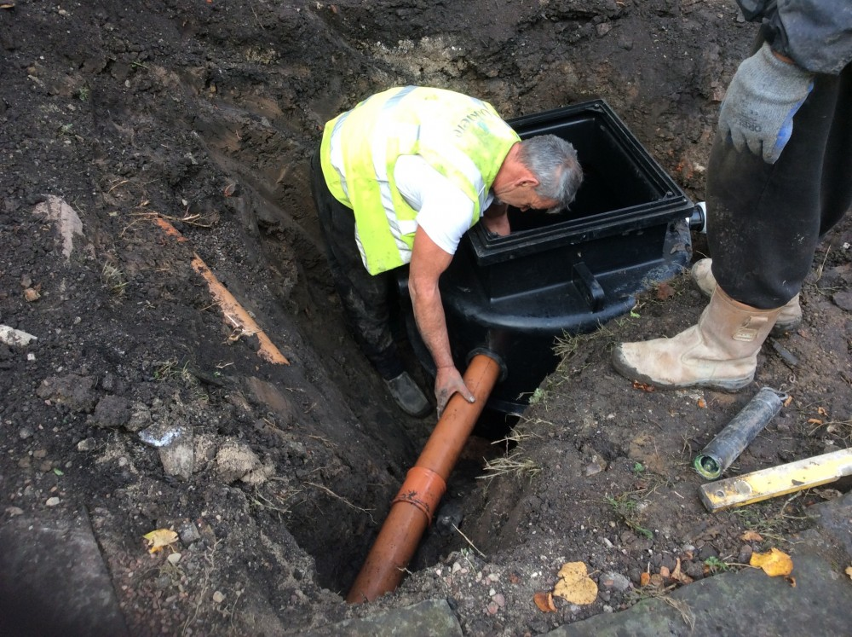
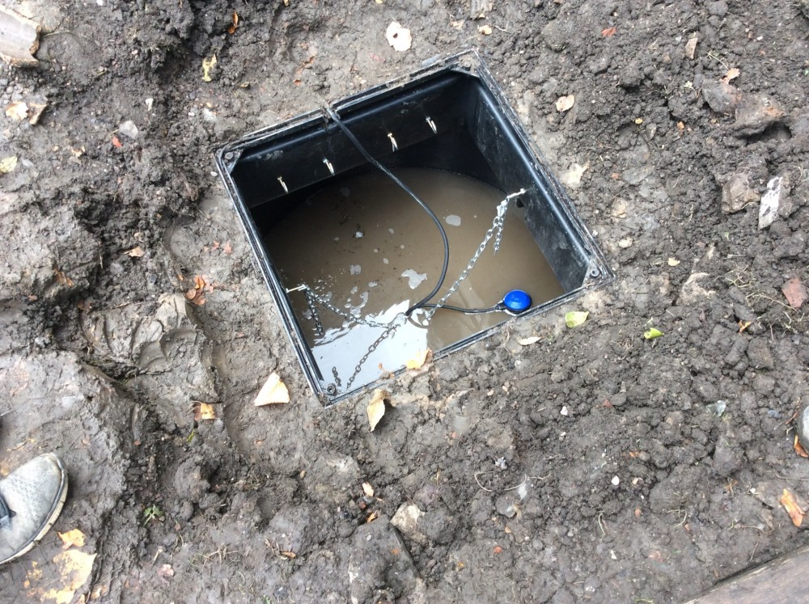
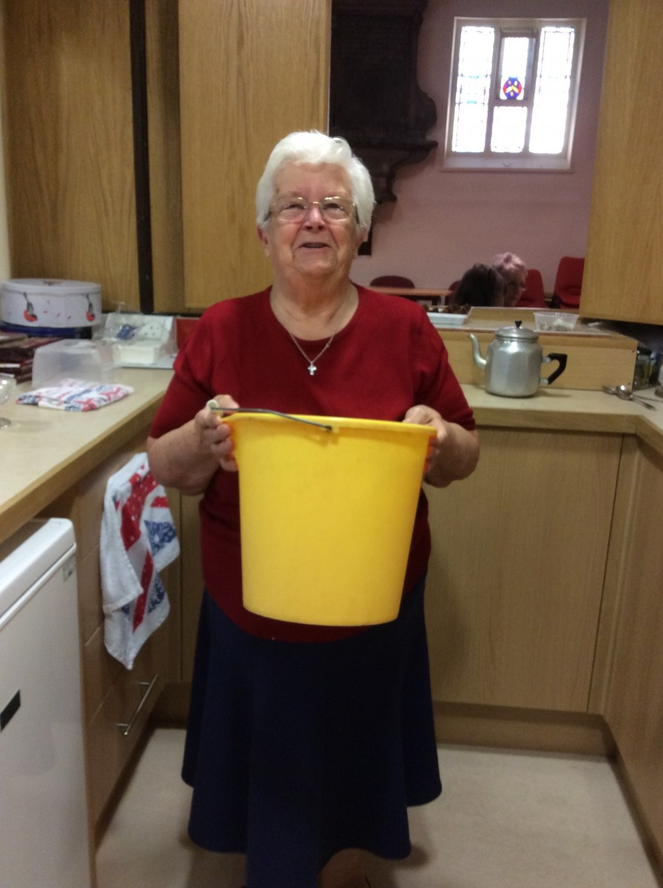
The end of the yellow bucket! Betty's happy!
When we were making a brew in the drinks area we were unable to put water down the sink till the drains were connected.
In the meantime we have been using a yellow bucket to get rid of any water. But not any longer!
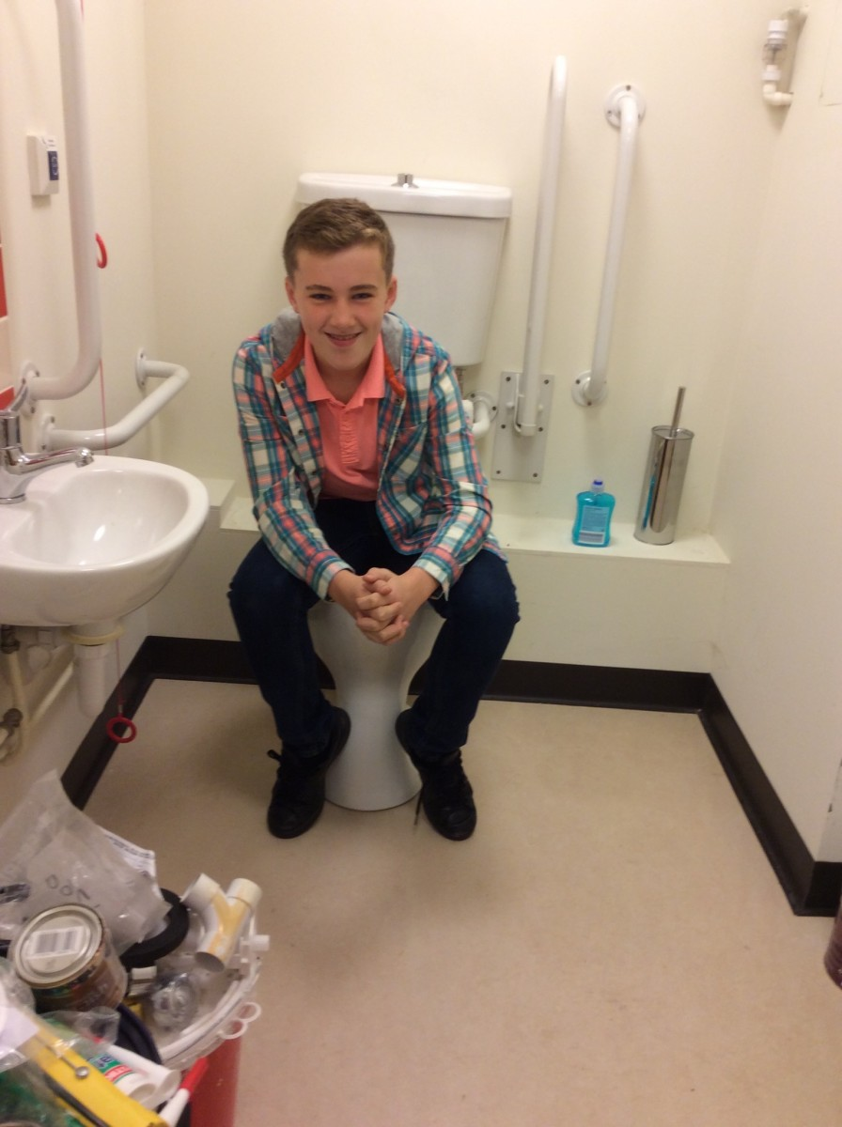
Just testing the facilities! And with kind thanks to the Veolia Envoronmental Trust for a grant of £12,000 towards the drains.

Wednesday 16th July 2014
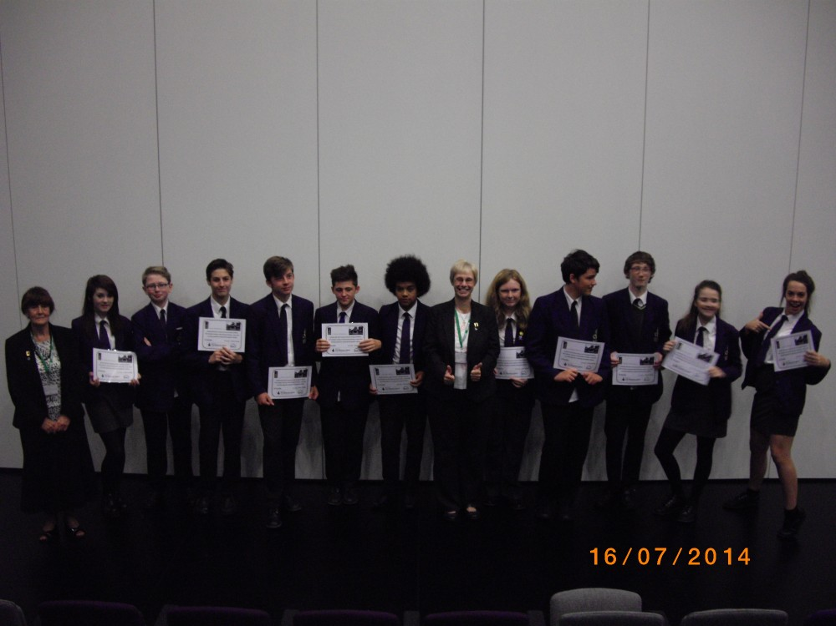
Denton Community College students receive their certificates for interviews and photographic displays for Heritage exhibition.
Sunday 24th November 2013
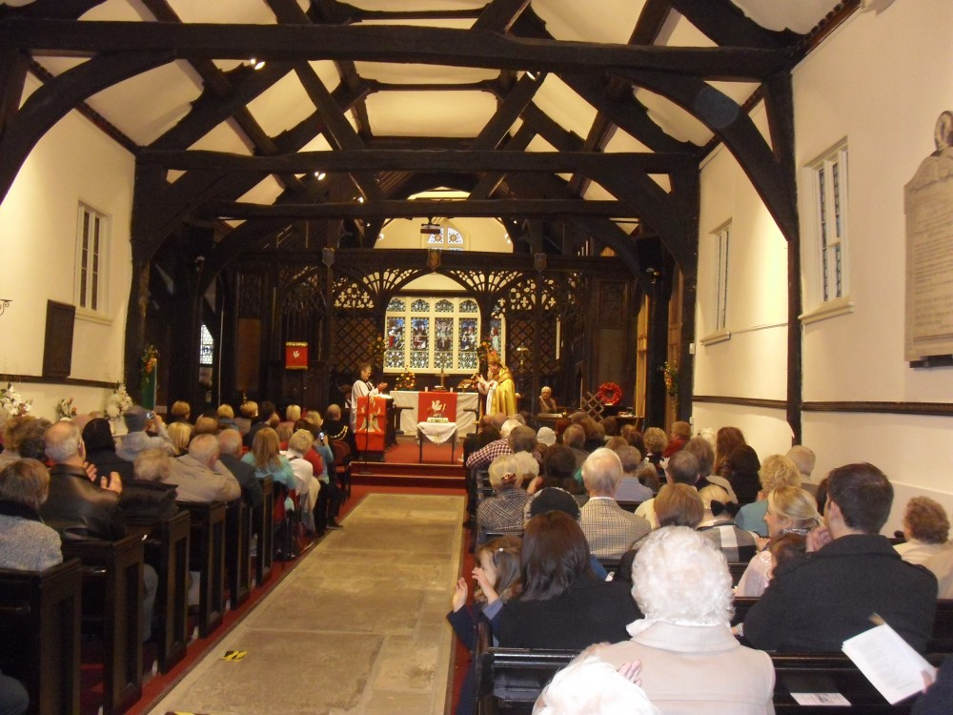
Rededication Service
Friday 15th November 2013
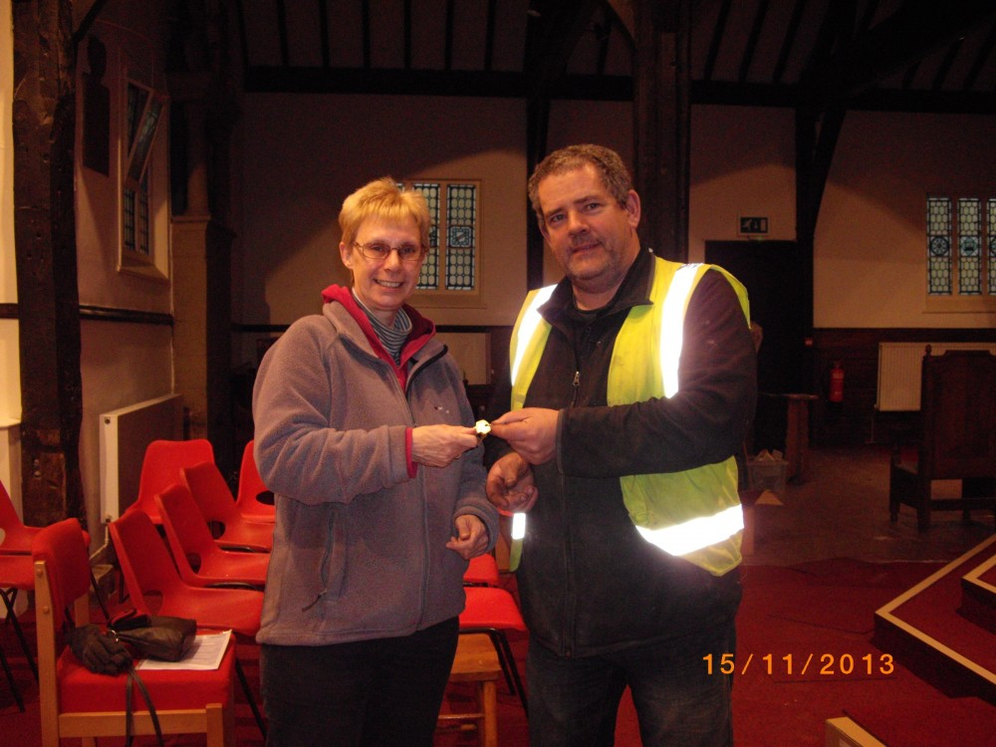
Keys handed over by Contractor
Sunday 3rd November 2013
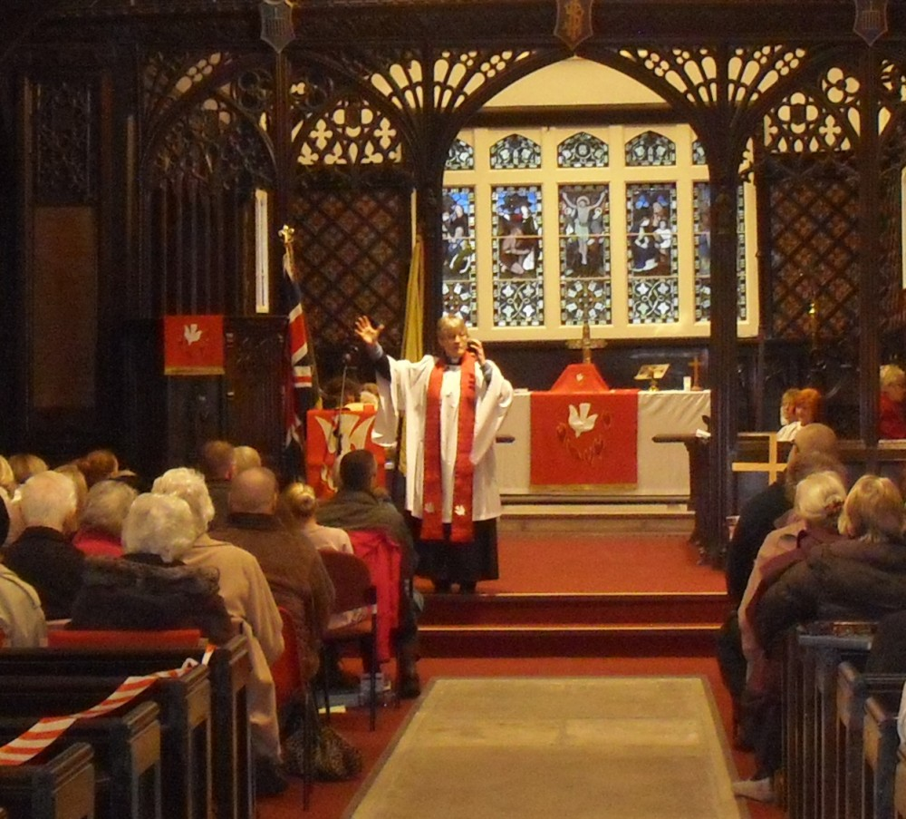
We're back! - The first service back in Church
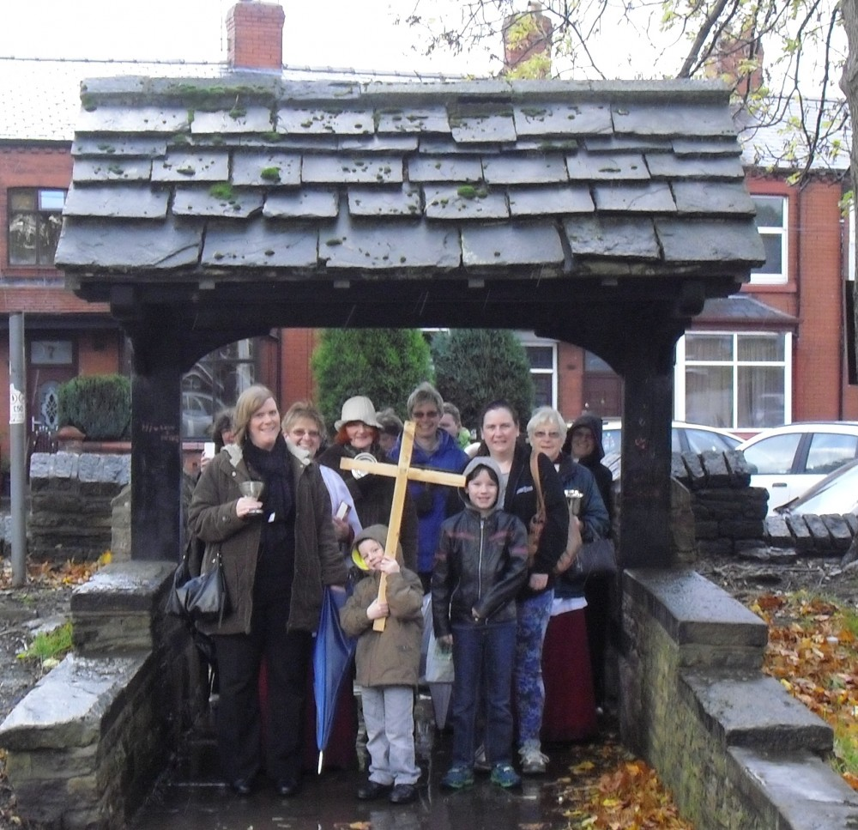
Arriving at the Lych Gate
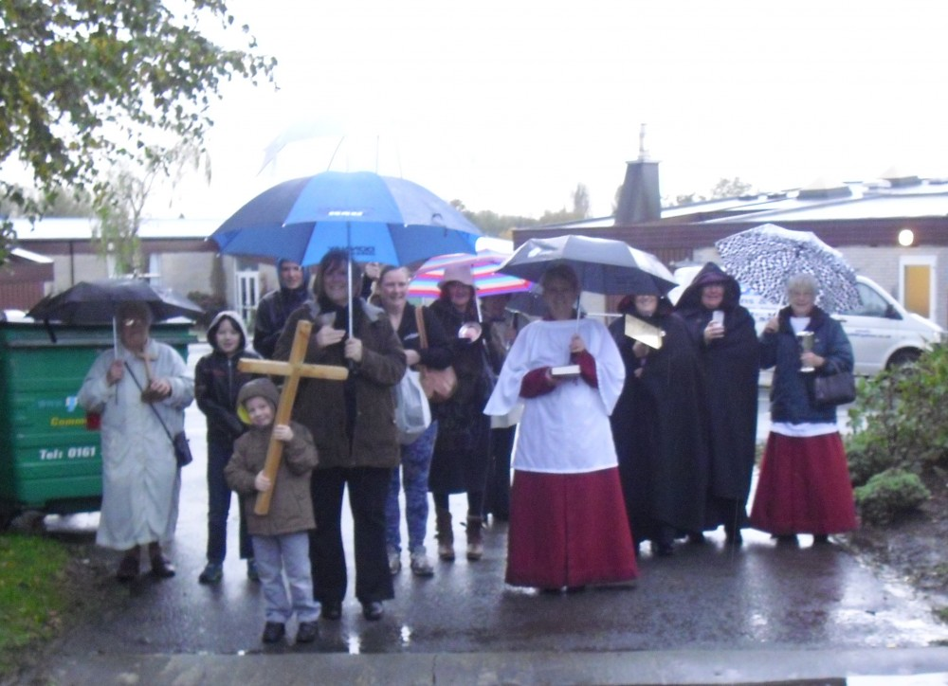
Leaving Greswell School for the journey back to Church
Wednesday 30th October 2013
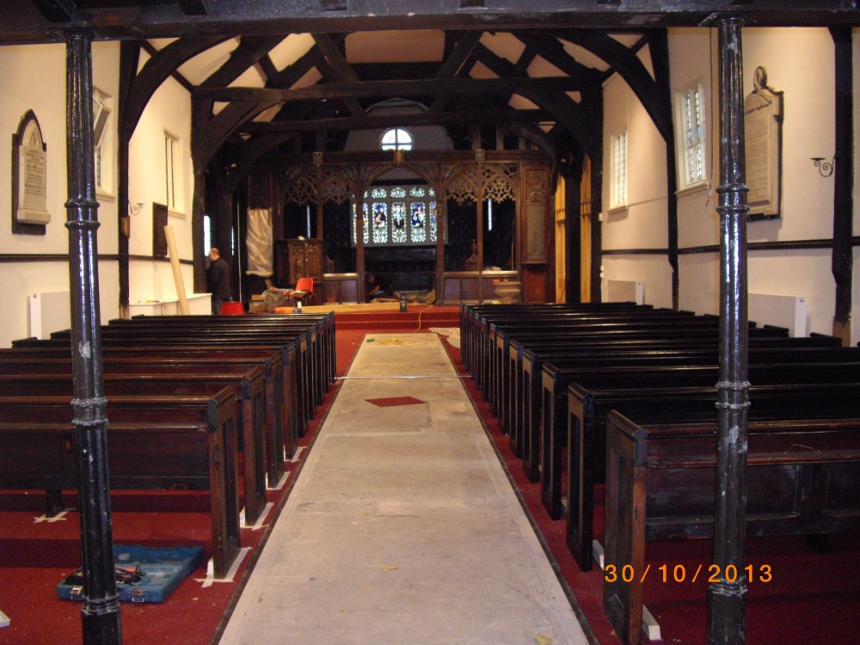
Church nearly ready to move back in
Thursday 24th October 2013
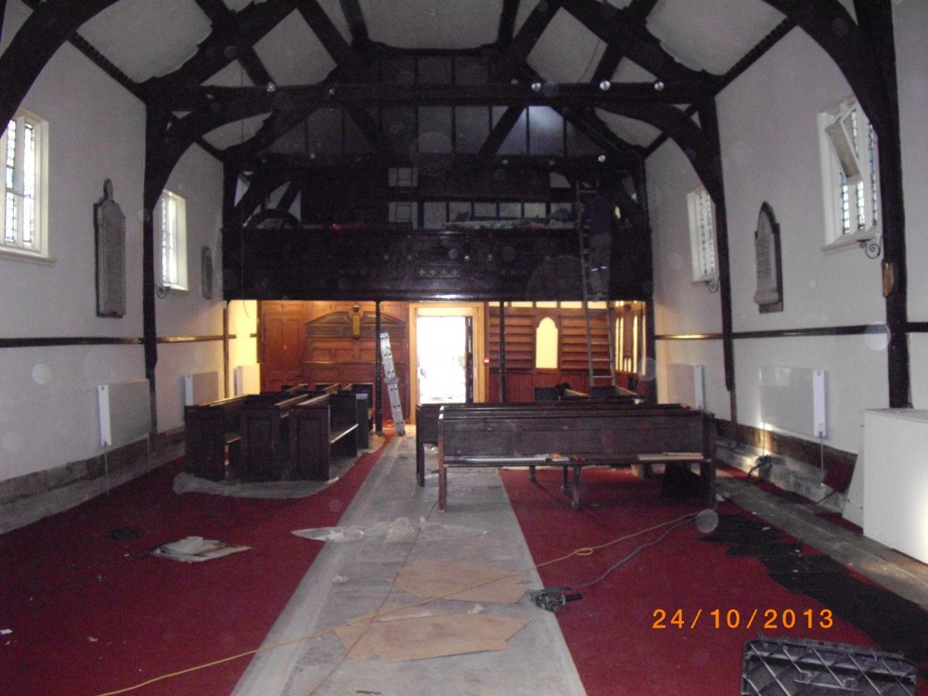
Pews going back in
Wednesday 16th October 2013
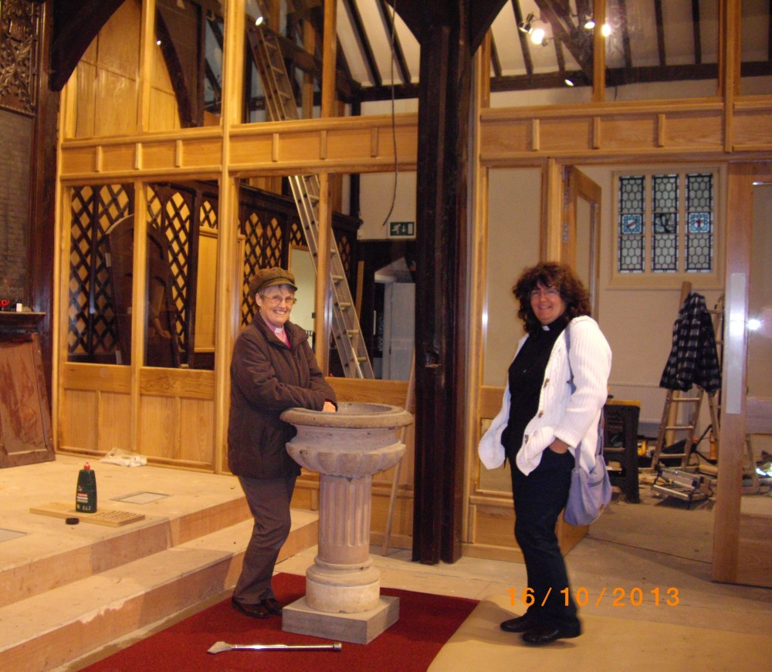
Around the font
Tuesday 15th October 2013
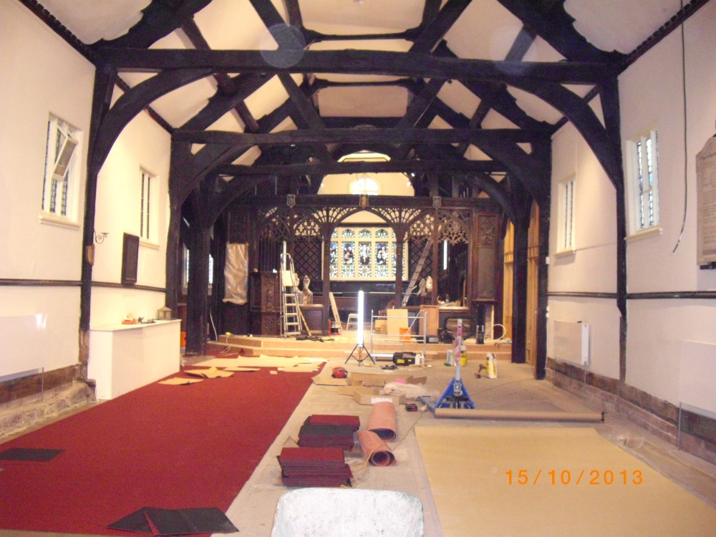
Floor tiles being laid
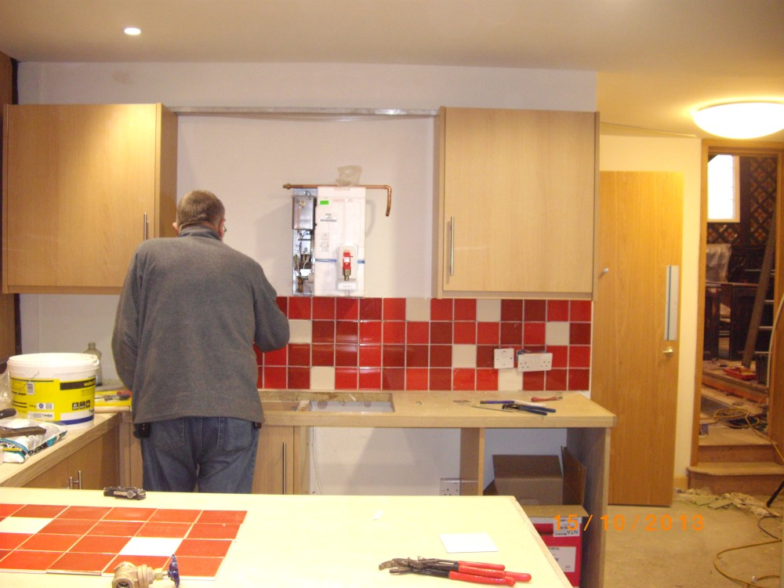
Servery tiles being applied
Monday 9th September 2013
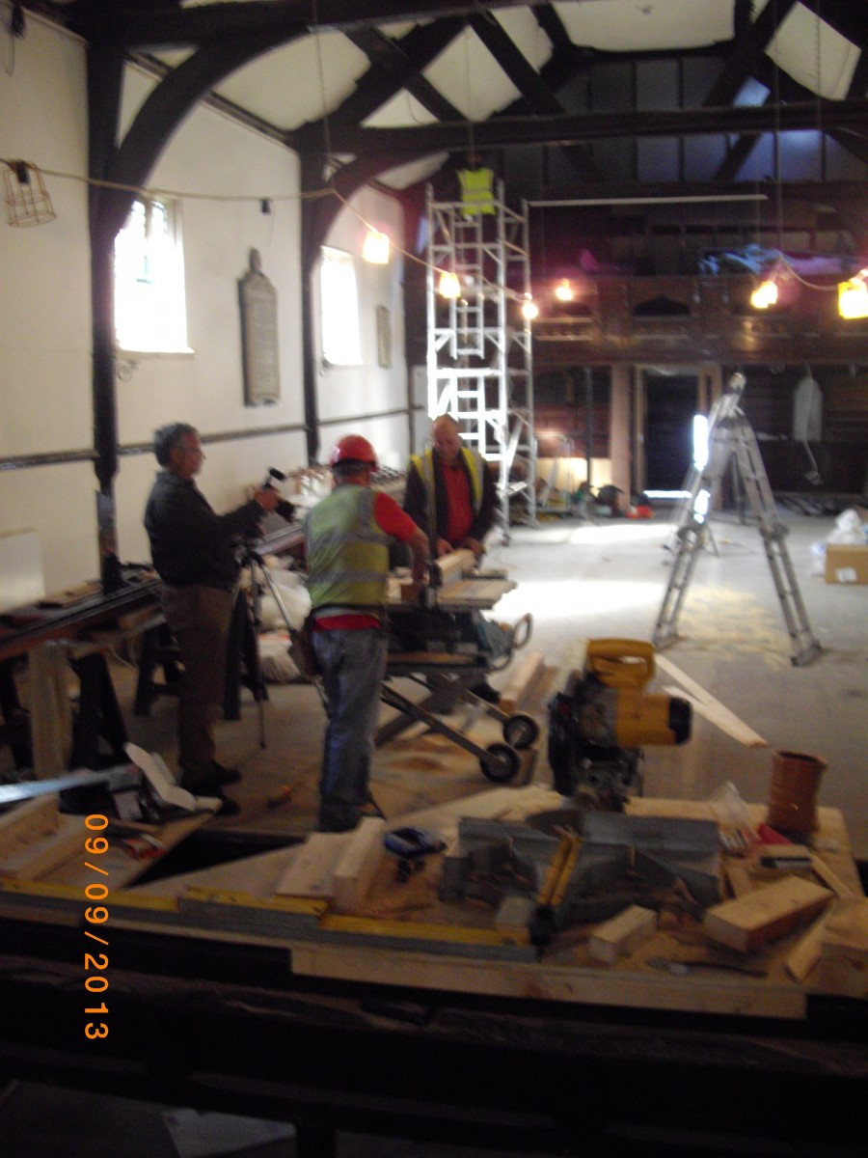
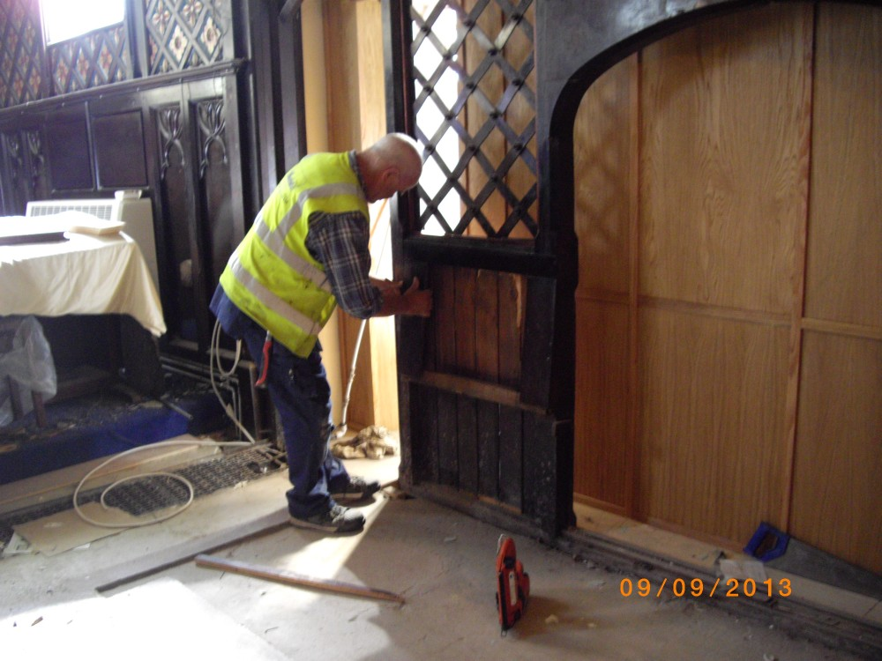
Work continues with the Reordering work
Friday 16th August 2013
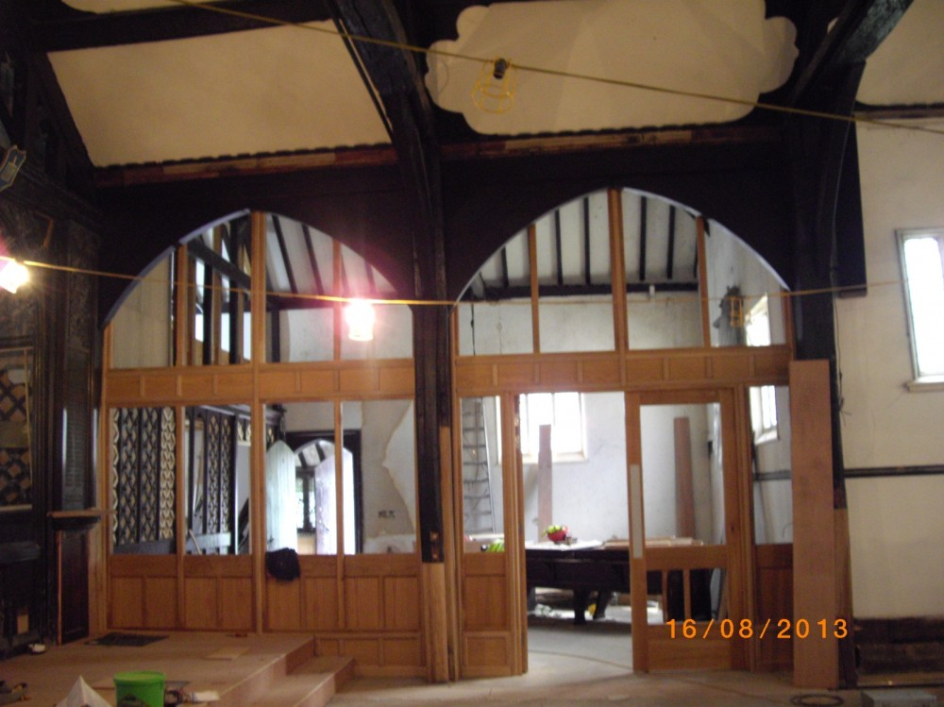
Looking into the Community Room
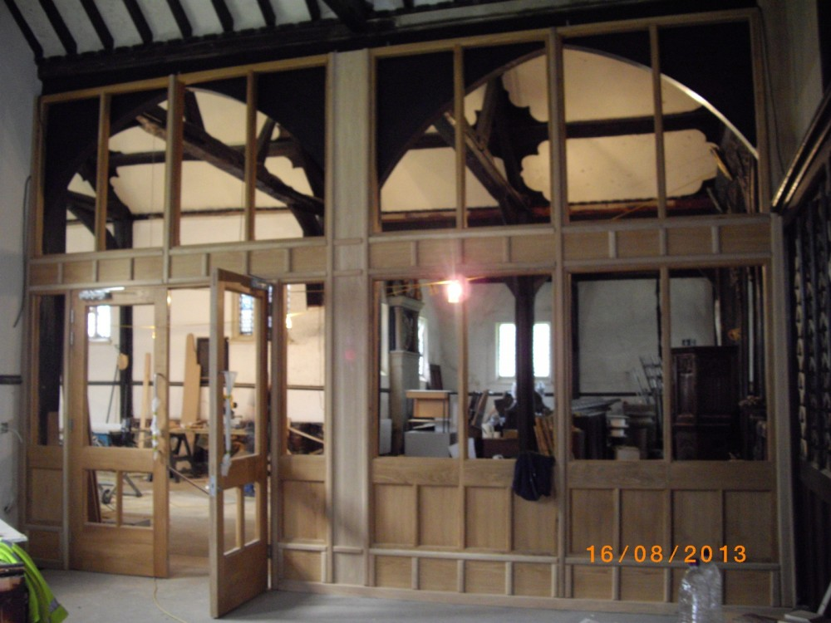
Looking out of the Community Room
Wednesday 7th August 2013
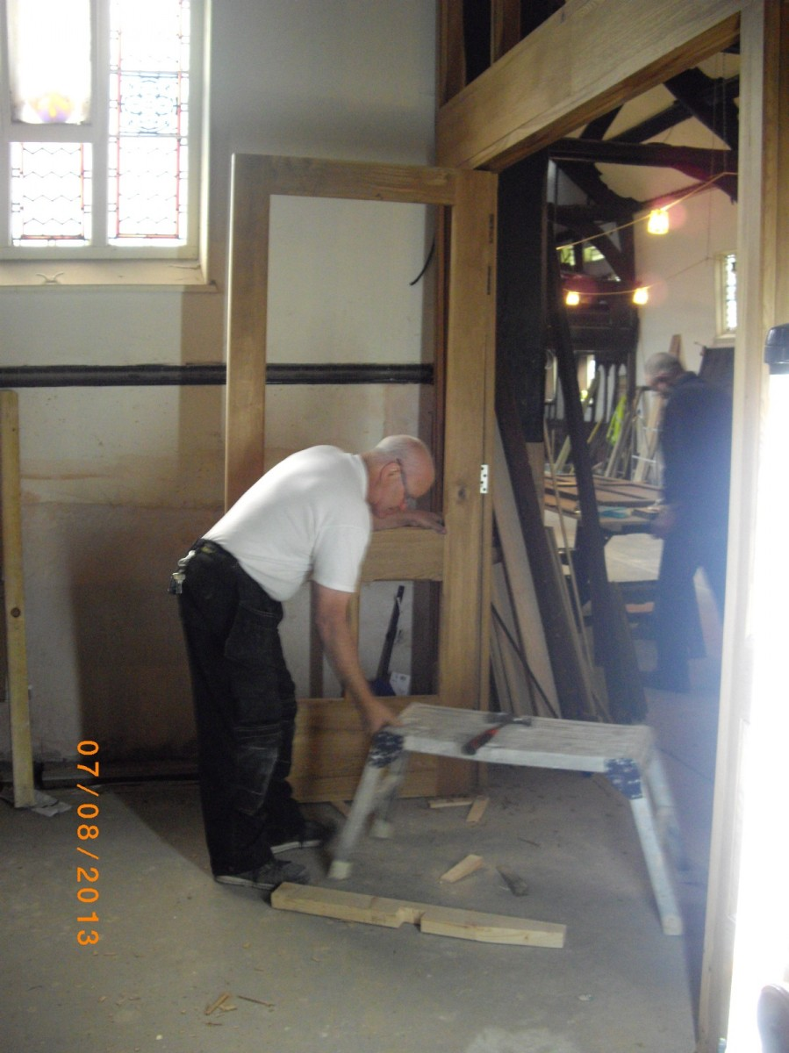
Doors for the Community space being installed
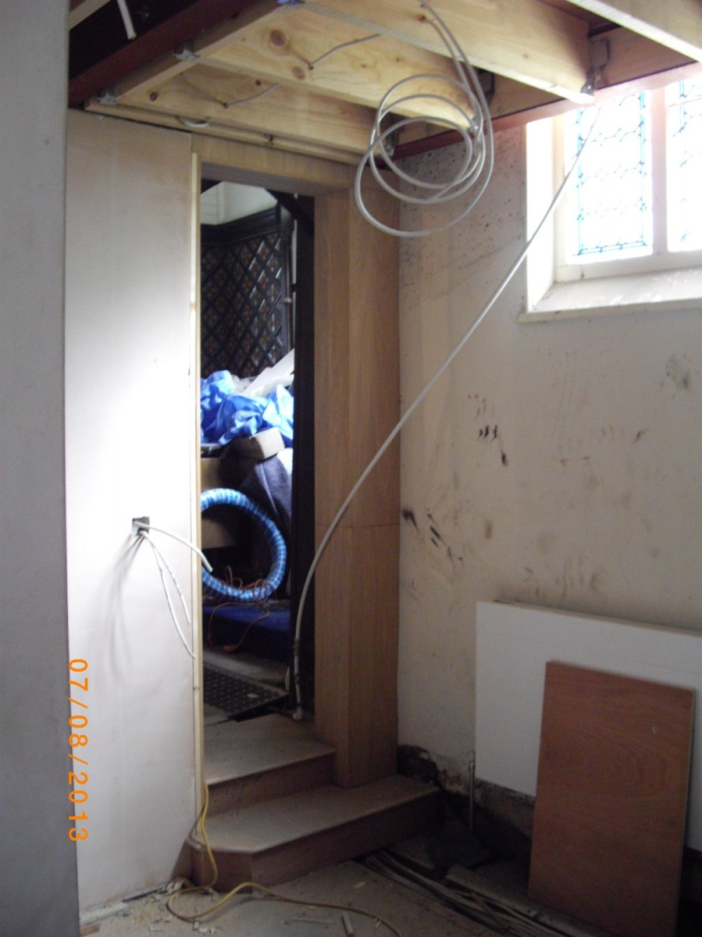
New steps from the Vestry into the Chancel
Thursday 1st August 2013
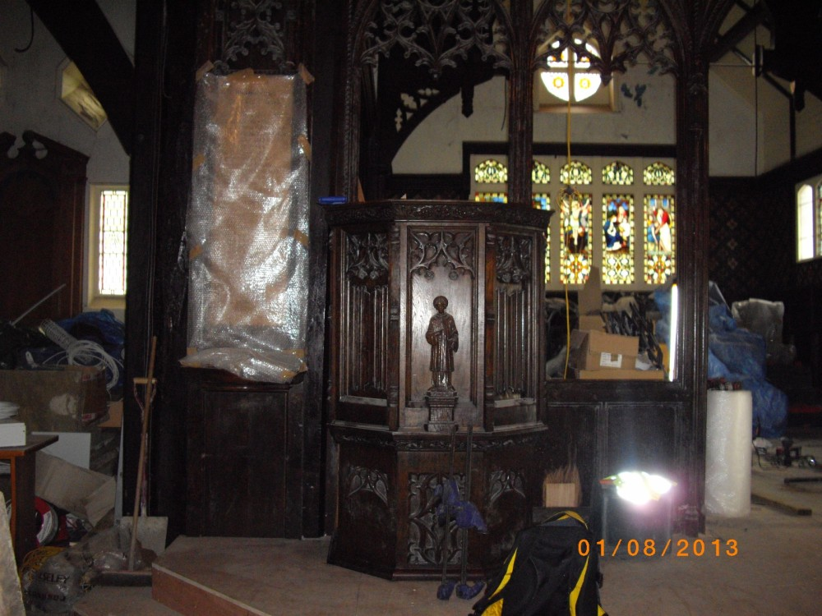
The Pulpit is put back in place
Monday 8th July 2013
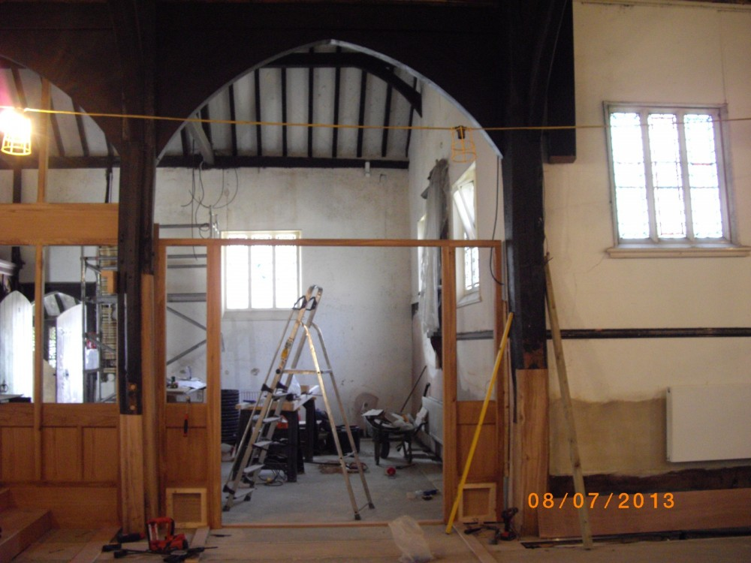
Work progresses on the Community space
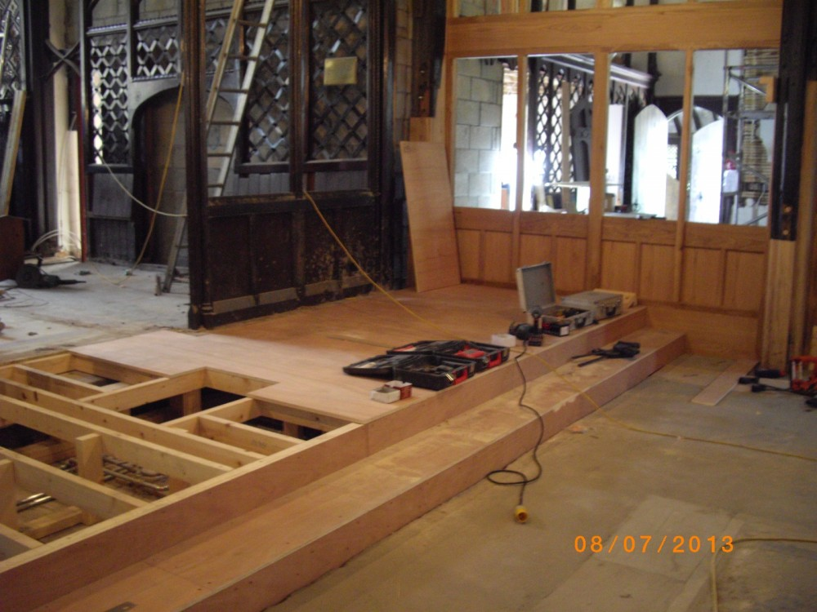
Work progresses on the Platform
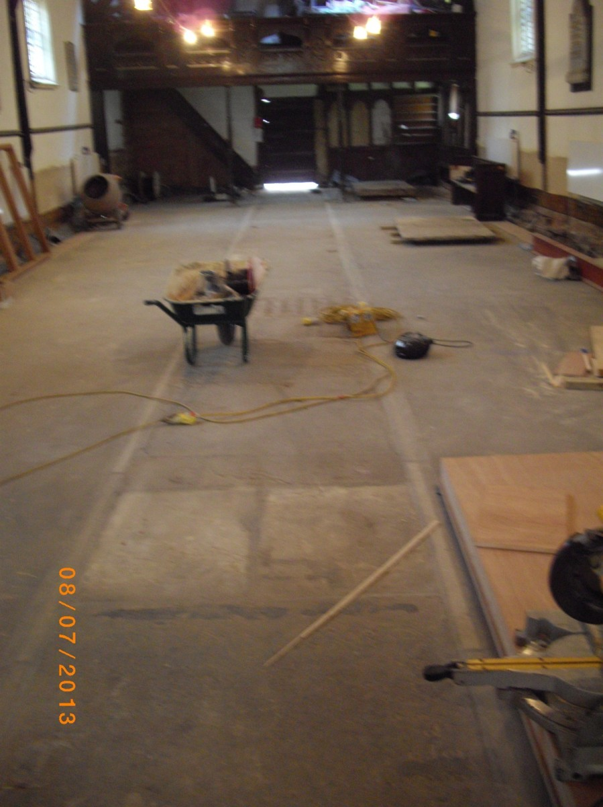
Work progressing inside Church
Saturday 22nd June 2013 (Open Day)
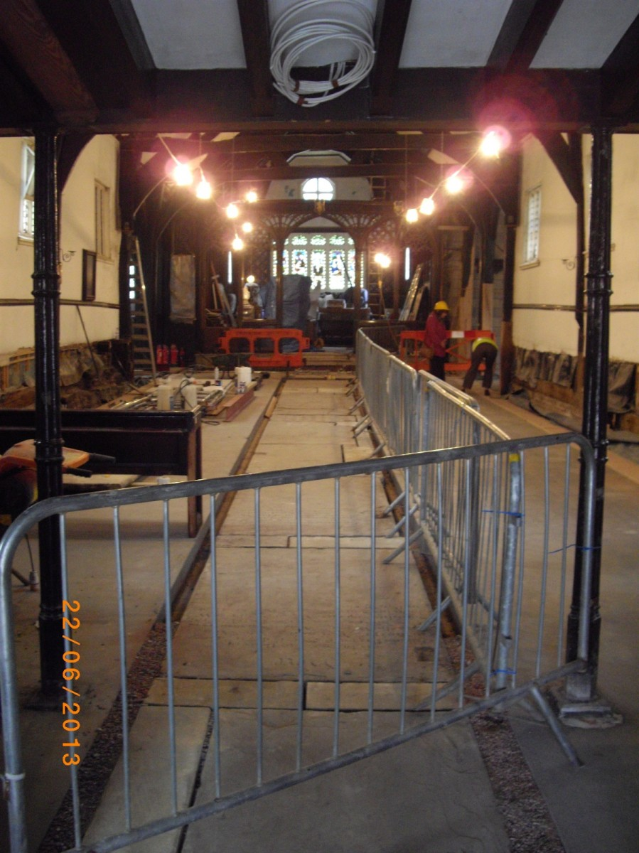
Work progressing on the aisle
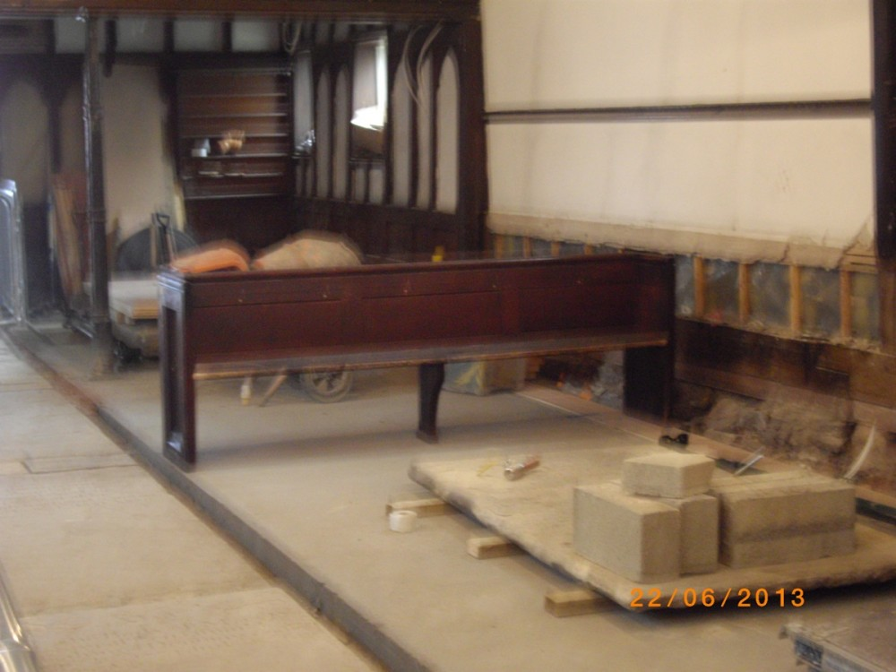
A refurbished pew
Thursday 13th June 2013
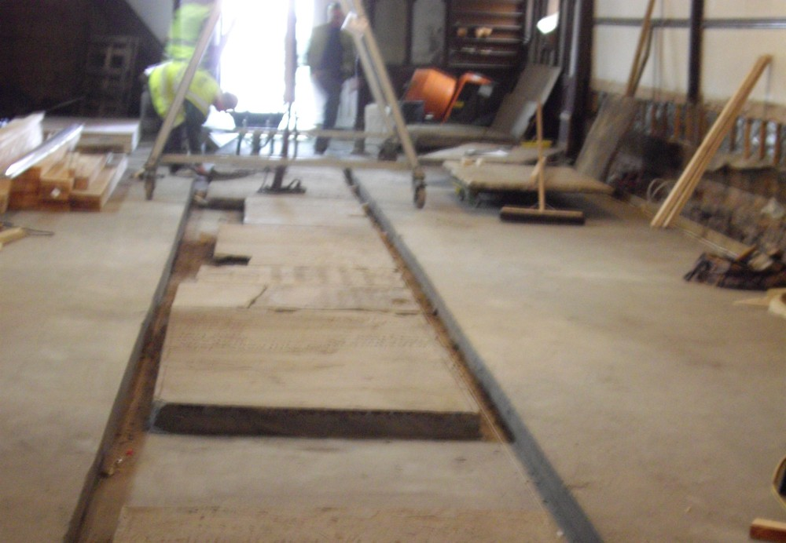
Memorial stones being set in the aisle
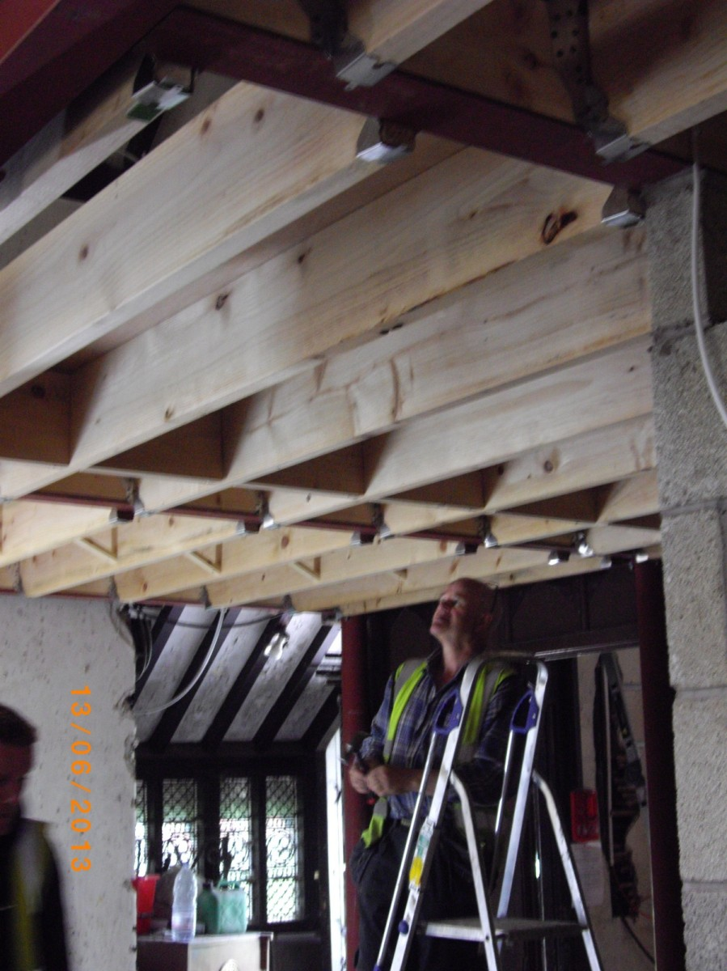
Floor of the first floor office
Wednesday 29th May 2013
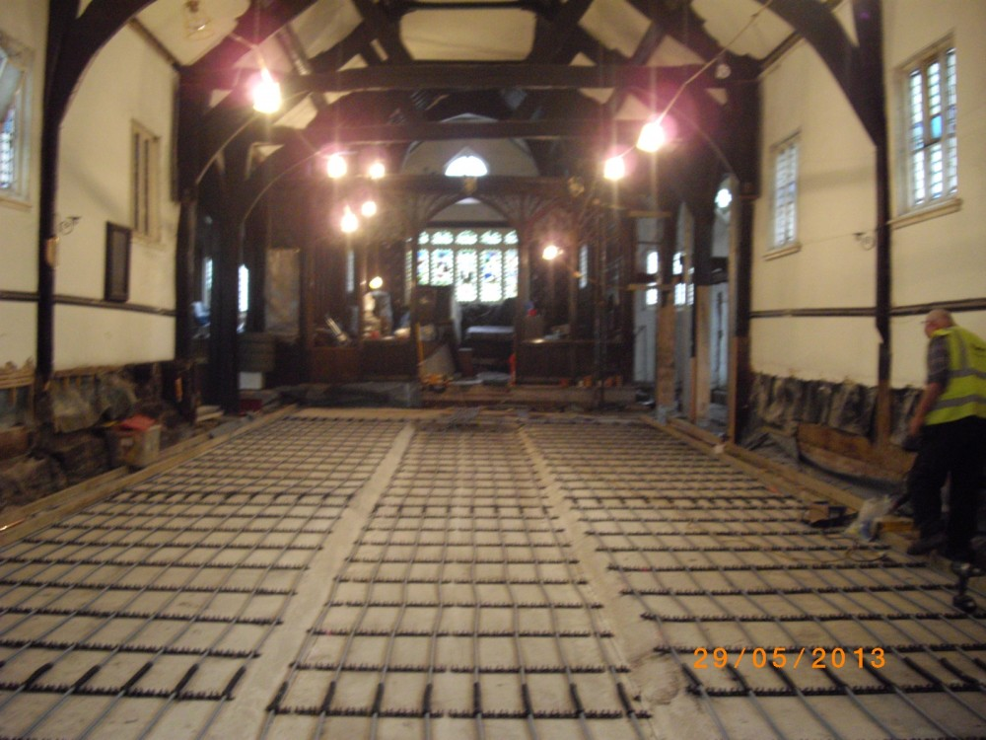
Under floor heating is installed
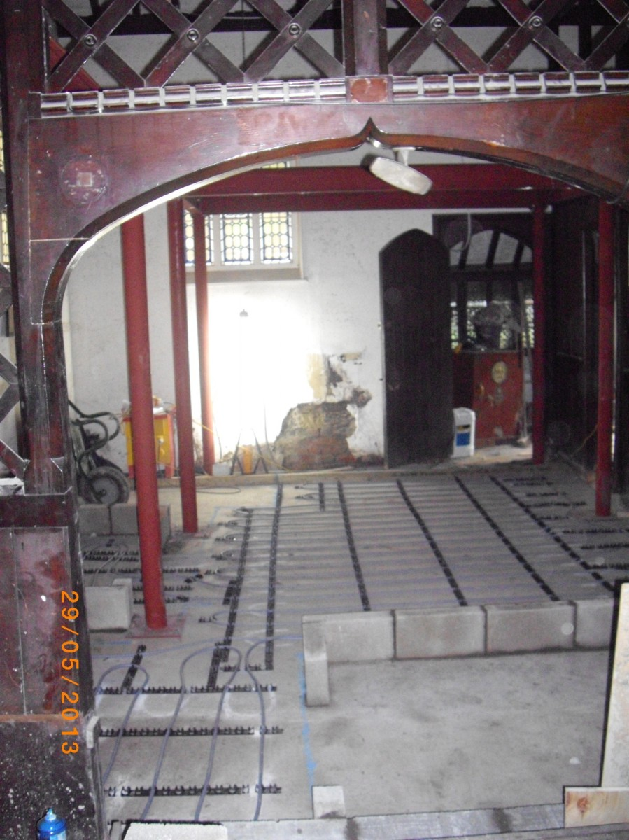
Area where Drinks Servery and Toilet will go
Wednesday 8th May 2013
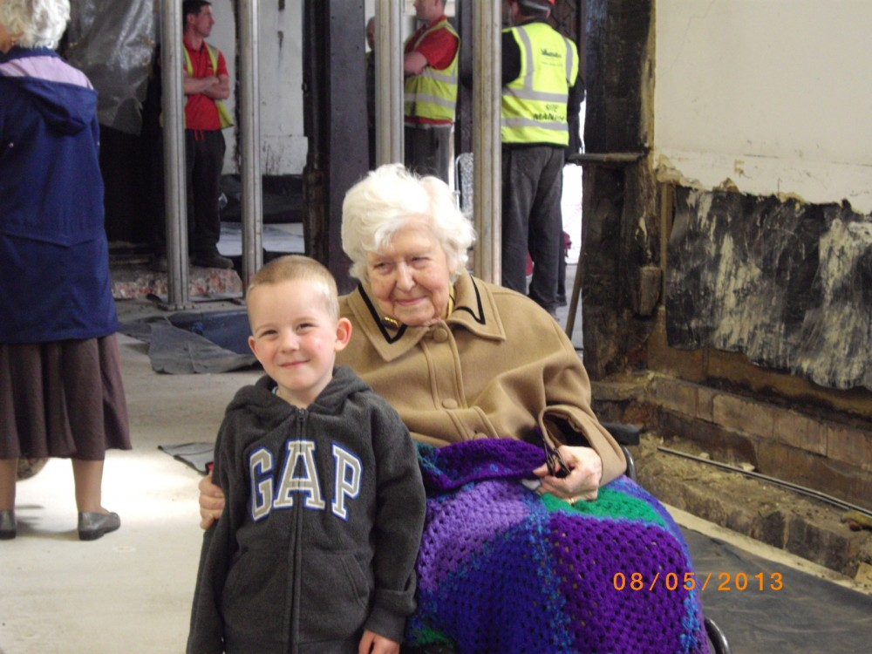
Alice and Leo survey the work!
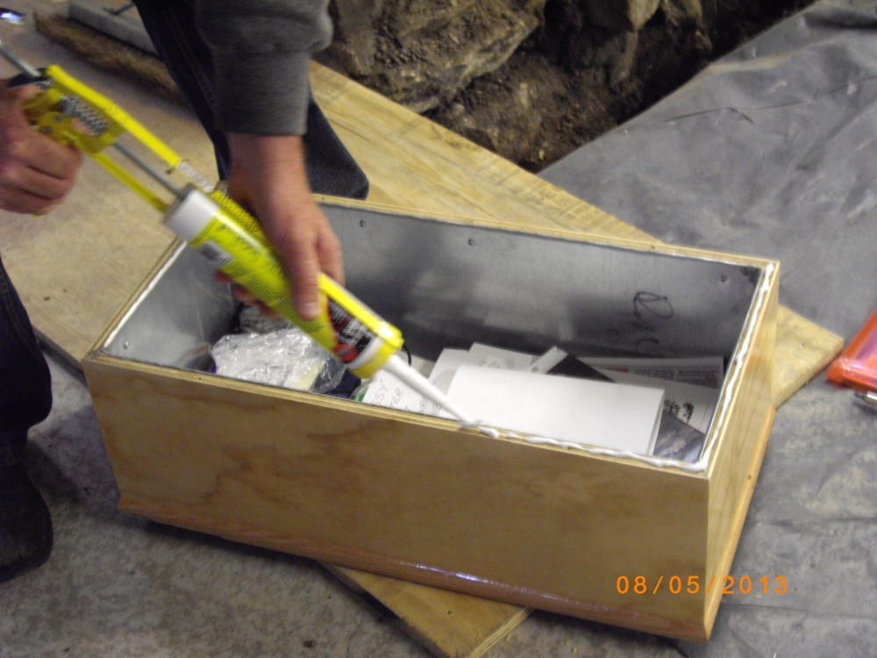
Time capsule being sealed
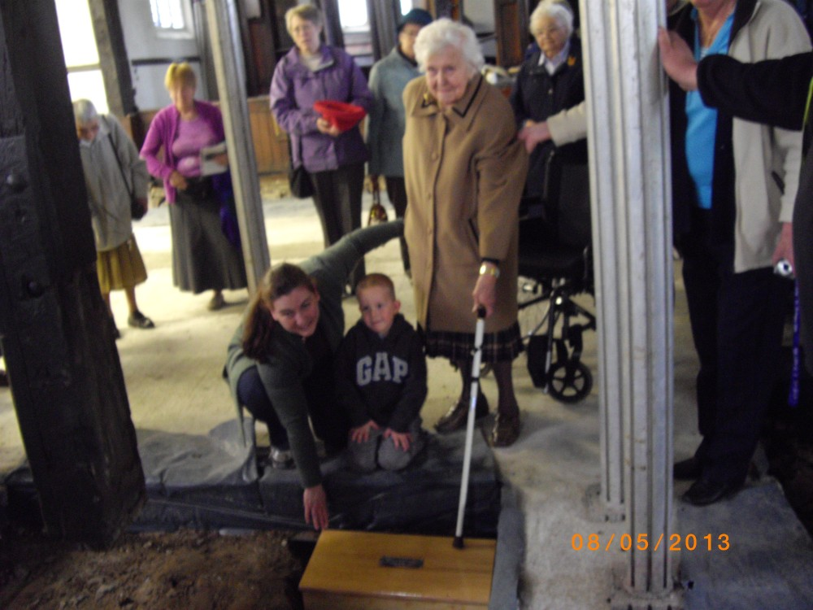
Time capsule being buried
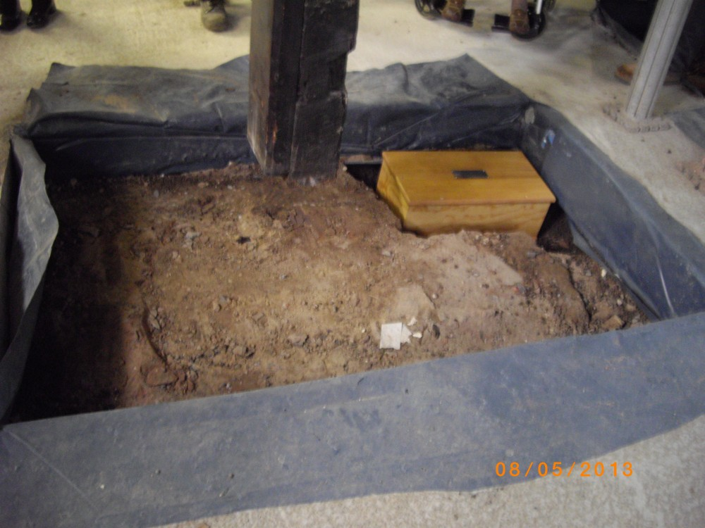
Time capsule in the ground

Friday 3rd May 2013
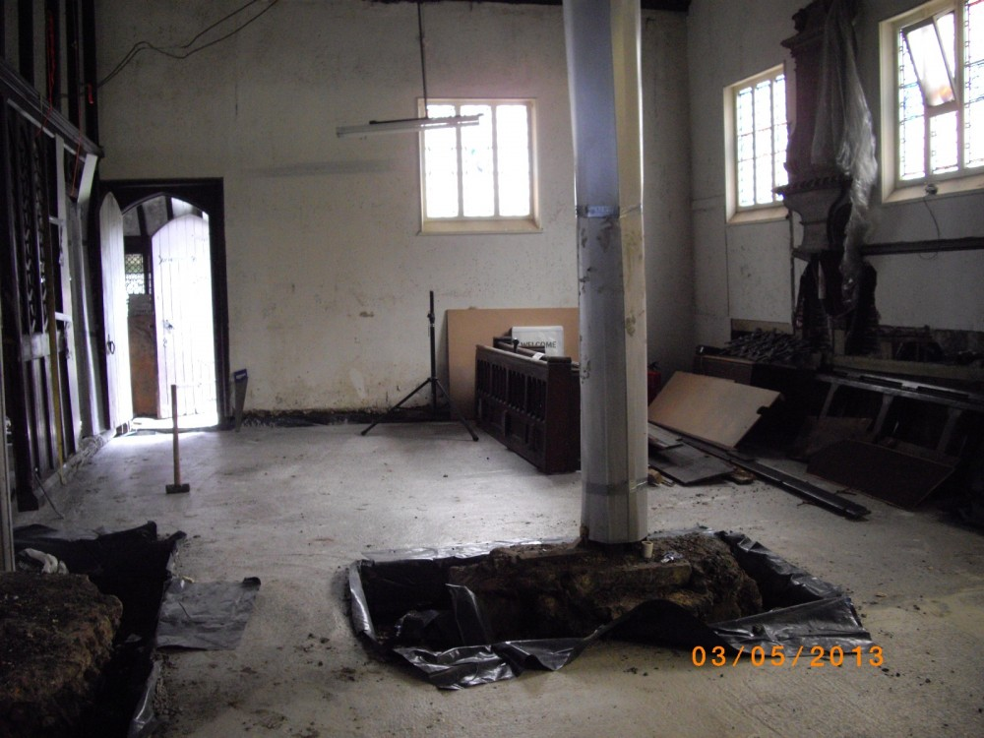
Community space taking shape
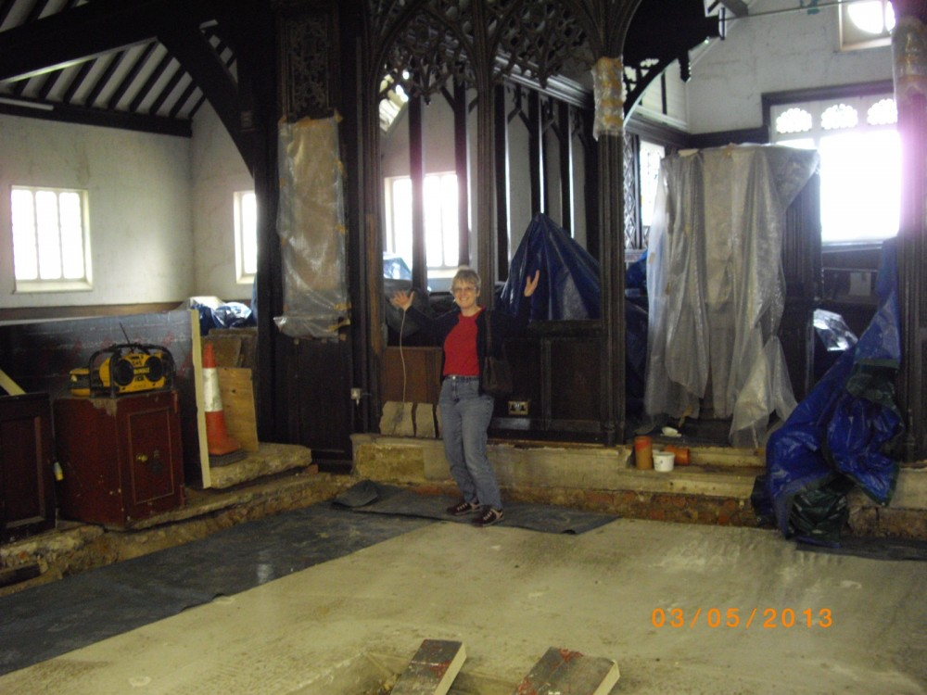
Rev Elizabeth Pope shows work in progress
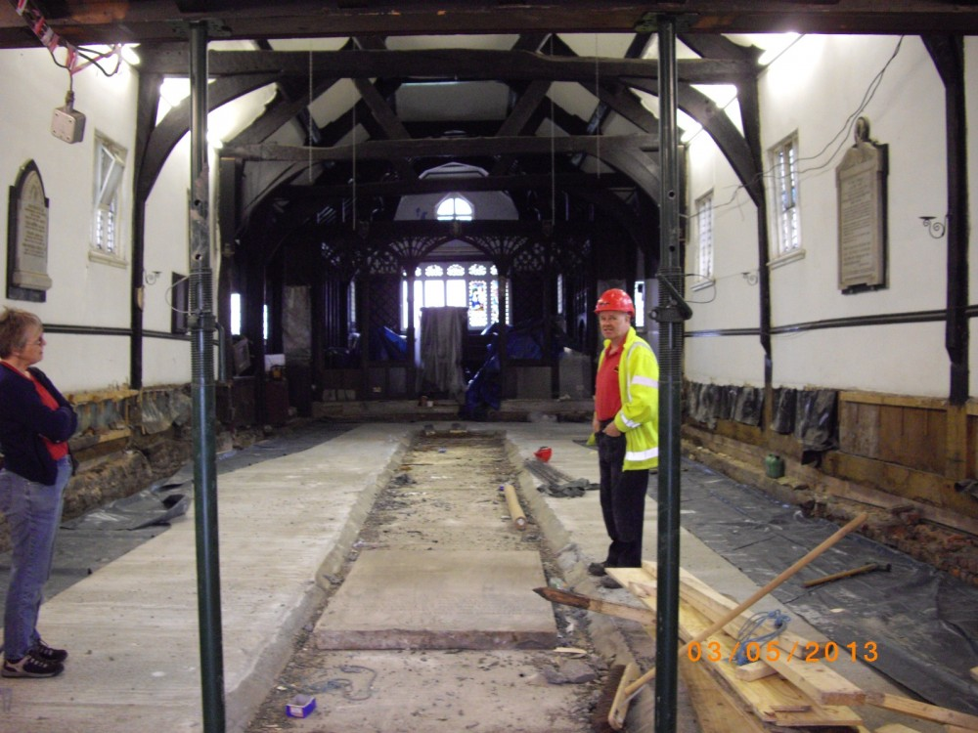
Looking in from the main door
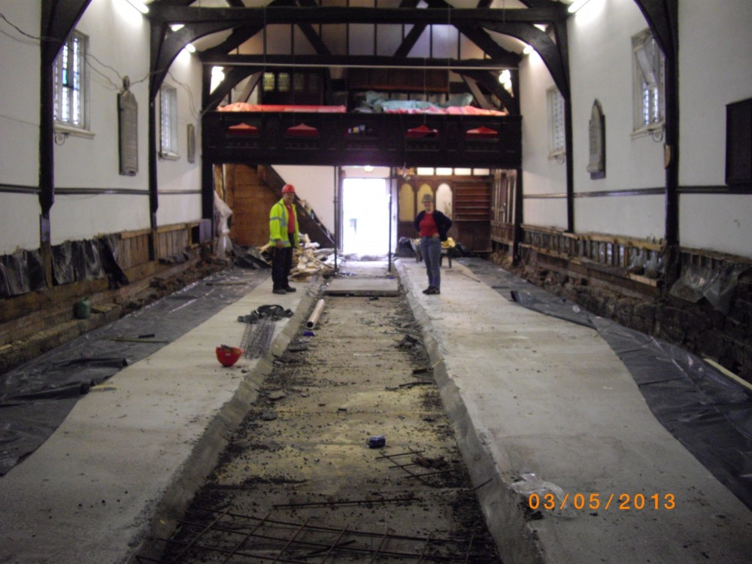
Looking back to the main door
Friday 3rd May 2013

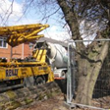 | 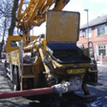 | Concrete is delivered
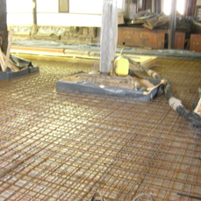 |  | Community space area ready for concreting
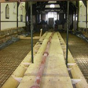 | 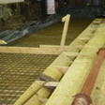 | Piping the concrete in
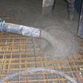 | 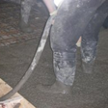 | Spreading the concrete
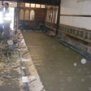 | 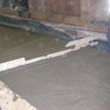 | Concrete applied

Tuesday 16th April 2013
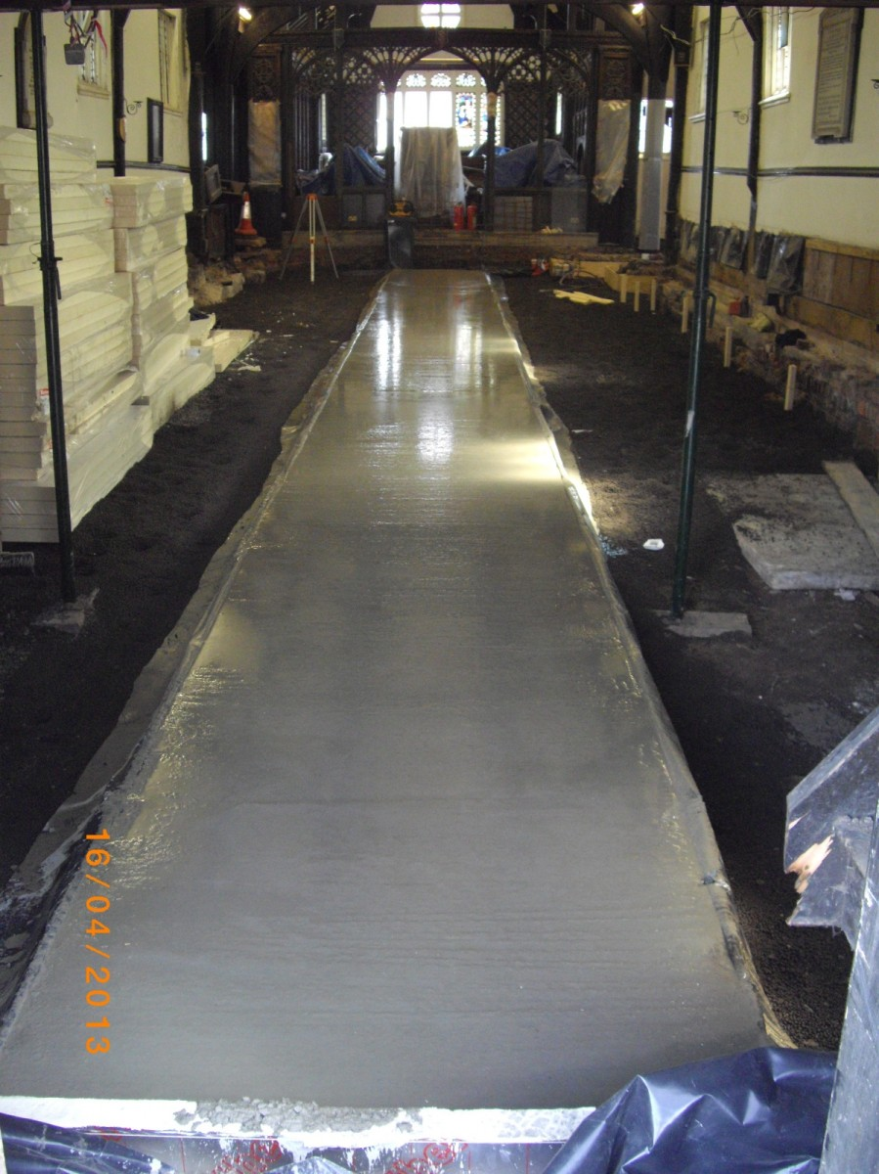
The new aisle begins to take shape
Thursday 28th March 2013
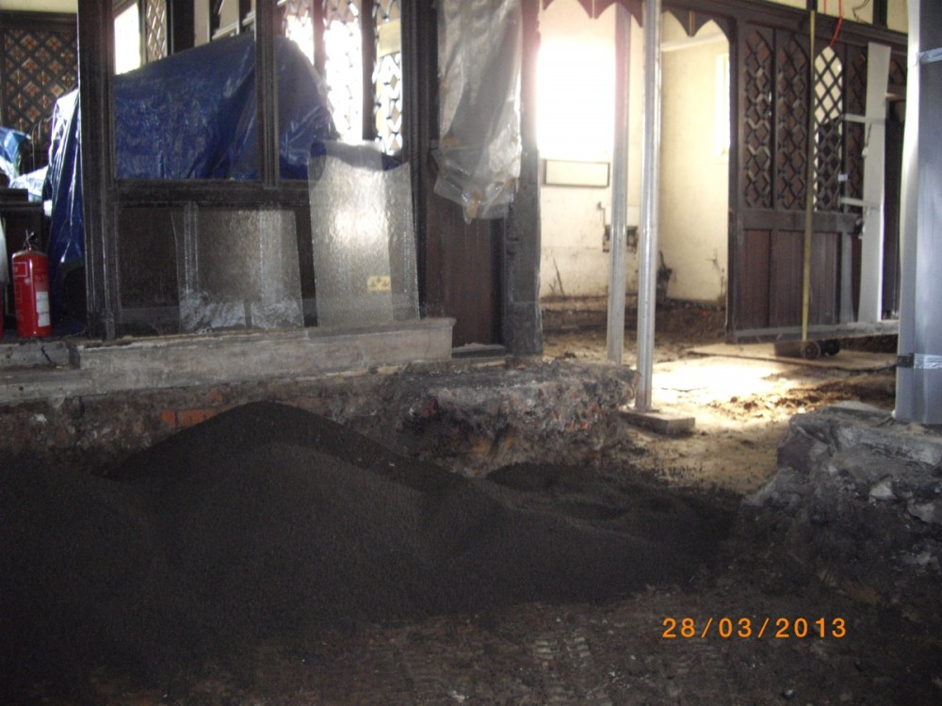
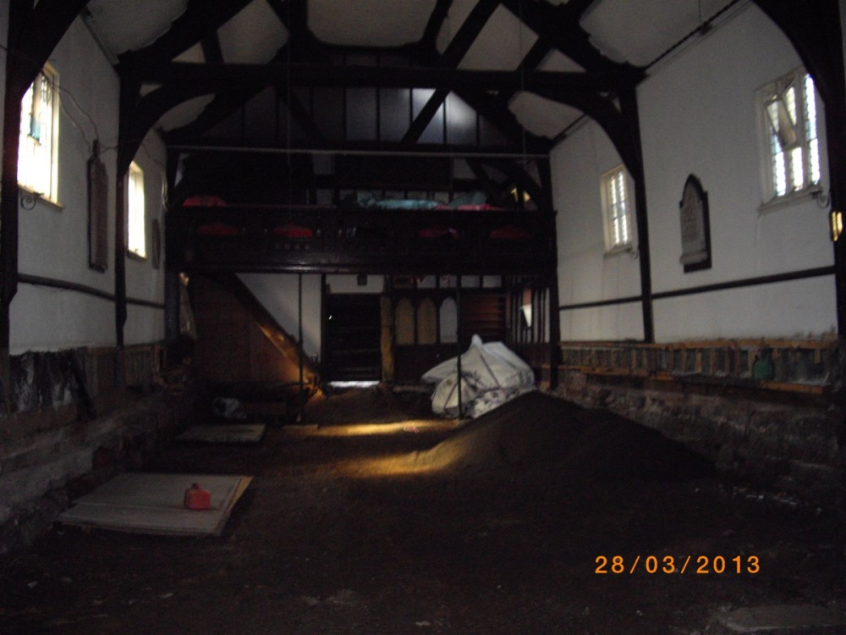
Work begins inside Church

Monday 25th March 2013
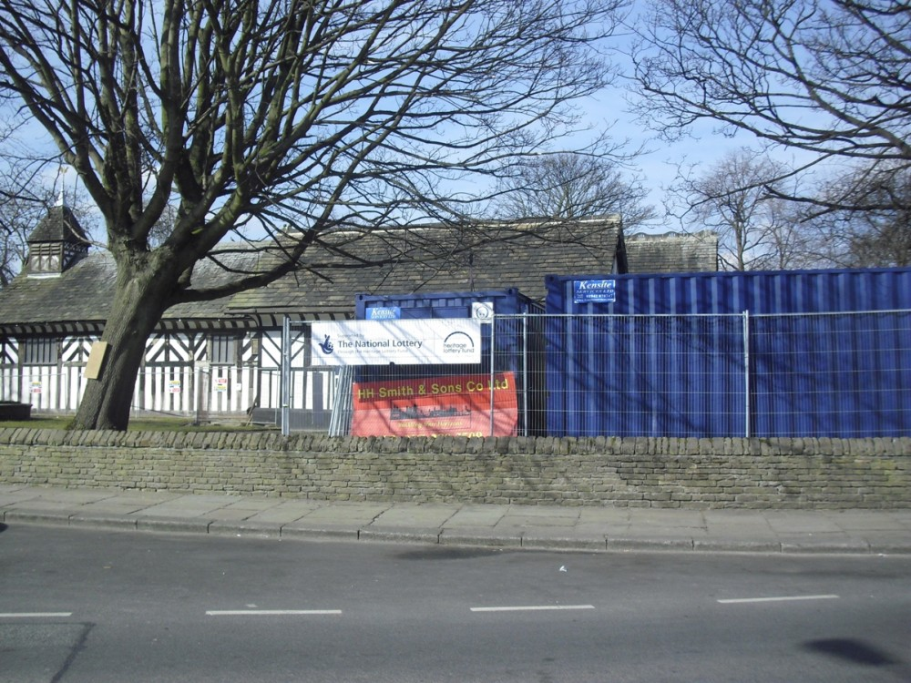The appointed contractors are HH Smith & Sons Co Ltd
Phase 2 work commences - scheduled to take 26 weeks

EVENTS PRIOR TO WORK STARTING
Friday 22nd February 2013
 | 22/02/13 BREAKING NEWS!
St Lawrence Church Community Project wins Heritage Lottery Fund support - £100,000.
Today, St Lawrence's Church, Denton, has been delighted to receive £100,000 from the Heritage Lottery Fund (HLF) for an exciting new Community Heritage Project.
For more details please click here.
The project was featured in the Manchester Evening News. To see the article please click here.
Tuesday 29th January 2013
Open meeting with the Architect to discuss the way forward for the project.
Mon 1st Oct to Sat 17th Nov 2012
Tokens were printed in the Manchester Evening News every day to collect for a share of £25,000.
Tuesday 10th October 2012
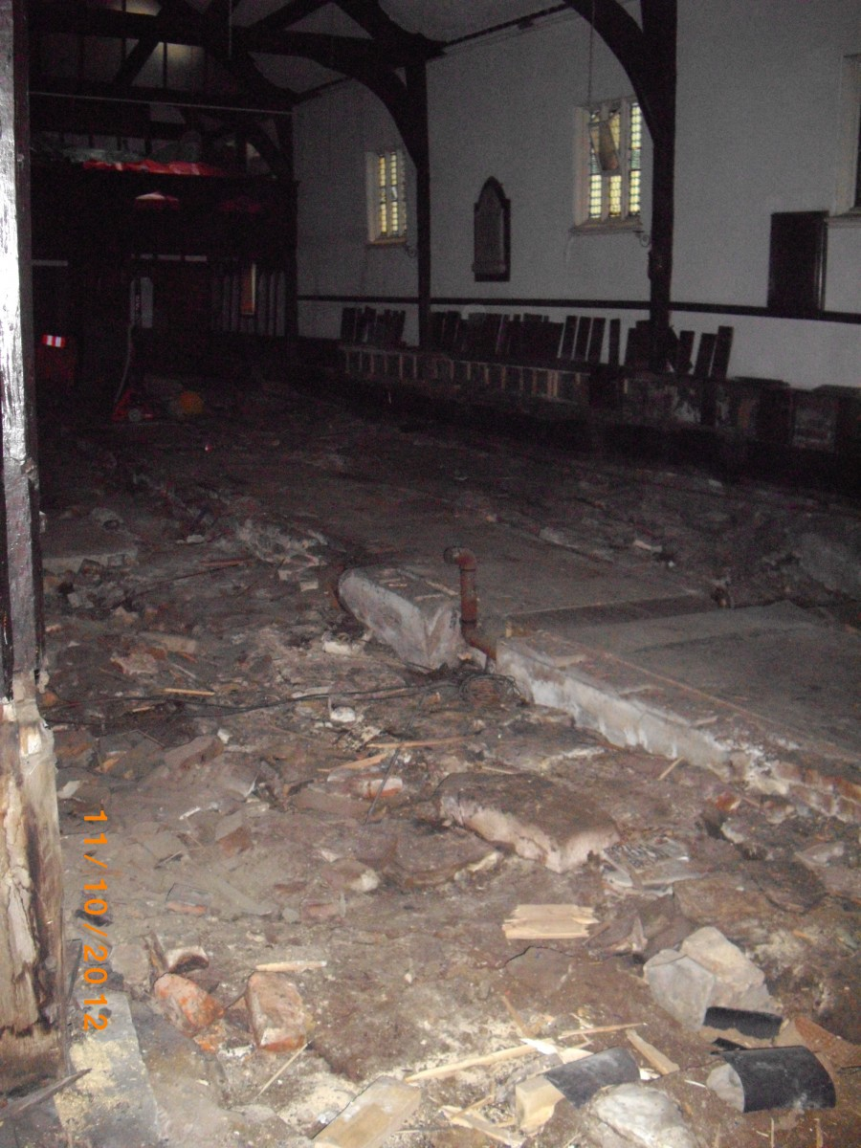
On site working for the 1st phase has commenced and is expected to take 6 weeks. As you can see removal work is well underway!
Wednesday 26th September 2012
The contract for the 1st phase of the reordering is signed with the contractor - Anelay. Planning and off site preparation is underway.
Monday 24th September 2012
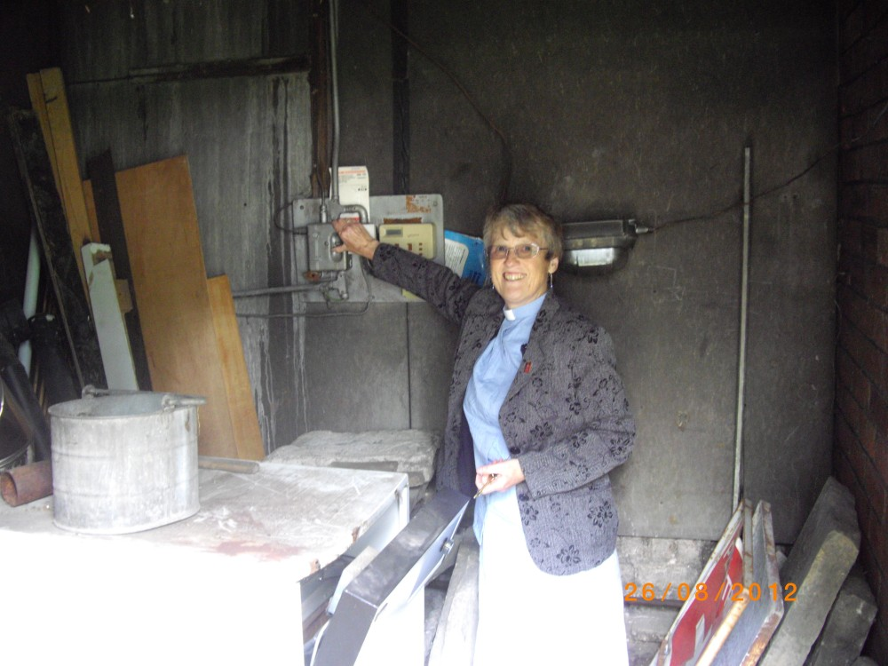
It gives Rev'd Elizabeth Pope great pleasure to finally turn off the ancient boiler that has served the Church for many years.
The Heating Service Engineer was also informed and he breathed a huge sigh of relief as it has taken all his skill and dedication to keep it working.
Wednesday 5th September 2012
The chancellor issued the faculty to enable work to proceed.
Sunday 2nd Sept 2012 at 10.45am
This will be our first service at Greswell School which will be our temporary home until the reordering work is completed. Directions to Greswell School can be found here.
Sunday 5th August 2012 at 10.30am
This will be the last service at St Lawrence's before we move out. It will be a joint service with our friends from our Mission Partnership churches.
There will be joint services at other Churches for the remainder of August.
Please note:
Vestry Hour/Enquirers drop in sessions on Monday evenings have ceased during the re-ordering project. If you have an enquiry about a Baptism or Wedding please contact the Rectory on 0161 320 4895 or email admin@stlawrencedenton.org.uk

