SUNDAY 7th June 2026.



Loving God and Loving our Neighbour


Although we are currently without a permanent Rector, services in the Benefice continue with the assistance of visiting clergy. Please do join us – you will be made very Welcome!! The post will continue to be advertised and further updates will be featured in the newsletter

Sunday 7th June Trinity 1
11.00am Watton Contemporary service.
11.00am Aston Prayer and Praise
11.00am Stapleford Prayer and Praise
11.00am Waterford Holy Communion

Sunday 14th June Trinity 2
9.30am Watton Holy Communion
11.00am Watton Contemporary service.
11.00am Aston Family service
11.15am Bramfield Holy Communion
11.15am Stapleford Prayer and Praise



MIDWEEK
Fortnightly MONDAY 2pm ASTON Bible Study Fellowship 3 Long Ridge Aston with tea and biscuits. All are welcome. Next meeting Monday 29th June Contact Pauline at pauline.manley1966@gmail.com

Alpha Course. Where: 85 Great Innings South, Watton at stone, SG14 3TF. Mondays at 10.00am. Please call Jane:07867016430 or email Richard@Takeawaychurch.com Alpha:uk@alphja.org

NIGHT PRAYER Alternate WEDNESDAYS at 7.30pm on ZOOM. Next meeting Wednesday 10th June. All welcome. Contact Tim Alexander for link tim_alexander3@hotmail.com

Sunday 14th June The Hertford Rotary club presents A Summer Musical Festival Bramfield village community hall, Bury Lane, SG14 2QL. 3.00pm to 7.00pm

Wednesday 17th June 2.30pm Stapleford village Tea afternoon in Church. All are welcome for tea, coffee cake and chat.

Sunday 6th September Waterford village FETE. Keep the date free.

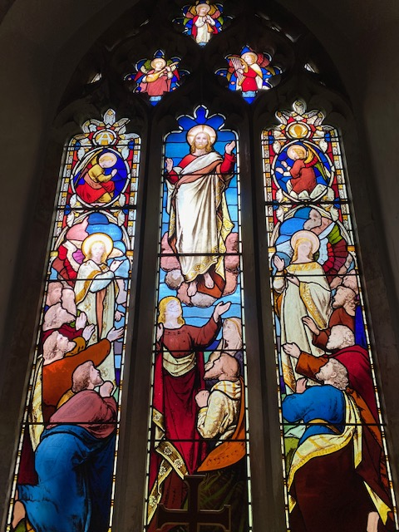
C0llect Prayer for Sunday 7th June Trinity 1. O God, the strength of all those who put their trust in you, mercifully accept our prayers and, because through the weakness of our mortal nature we can do no good thing without you, grant us the help of your grace, that in the keeping of your commandments we may please you both in will and deed; through Jesus Christ your Son our Lord, who is alive and reigns with you, in the unity of the Holy Spirit, one God, now and for ever. Amen

The east window in St Andrew’s Church, Bramfield behind the altar shows Jesus lifted up to heaven, the end of his earthly life, his return to God’s right hand on high

Hymn 163 HAM. Angel voices ever singing. Author: Francis Pott
Francis Pott studied at Brasenose College, Oxford, where he graduated B.A. in 1854, and M.A. in 1857. He was ordained Deacon in 1856, and Priest in 1857. He was Curate of Bishopsworth, Bristol, 1856; of Ardingly, Sussex, 1858; was appointed to Ticehurst in 1861
1 Angel voices ever singing  round Thy throne of light,  angel harps, forever ringing,  rest not day nor night;  thousands only live to bless Thee  and confess thee Lord of might.  2 Thou who art beyond the farthest  mortal eye can scan,  can it be that Thou regardest  songs of sinful man?  Can we feel that Thou art near us  and wilt hear us? Yea, we can. | 4 Here, great God, today we offer  of Thine own to Thee;  and for Thine acceptance proffer,  all unworthily,  hearts and minds and hands and voices  in our choicest melody.  5 Honour, glory, might, and merit  Thine shall ever be,  Father, Son, and Holy Spirit,  blessed Trinity:  of the best that Thou hast given  earth and heaven render Thee.

PRAY for PEACE in The Middle East, UKRAINE and all areas of conflict


Lord God, though peace seems humanly impossible,

We continue to pray for an end to violence and bloodshed. We pray your comfort for the fearful and broken – hearted.


Change the hearts of those set on revenge and destruction.

Give wisdom to world leaders as they respond to aggression.

Bless all who work for understanding, reconciliation and justice which alone bring lasting peace. Amen.

‘God give us peace that lasts, not through the fear of might, but through the force of love, and love of life and right’. Amen

We believe that responding to the climate crisis is an essential part of our responsibility to safeguard God's creation and achieve a just world. Climate change hits hardest the poorest countries and poorest people of the world. Meantime, the widespread destruction of the natural world is a crisis for creation.

Our Environment Programme exists to enable the whole Church to address this — in faith, practice and mission. This includes tackling our own carbon emissions (aiming for Net Zero Carbon by 2030) and our wider work. More information can be found using the following web-link: http://www.churchofengland.org/about/church-england-environment-programme#na

Energy Hub Funded by UK Government: Find out how to:

1. Save energy

2. Save money. Reduce energy bills

3. Reduce carbon. Improve energy footprint

4.Increase comfort

For useful resources and guidance on where to get started visit: linktr.ee/energy_hub


https://app.ecochurch.org/user/21703/summary

EcoChurch - EcoTip for May
Is your garden environmentally friendly? You've probably heard of no mow May. Could you have a dedicated wildflower area? If you buy potting compost, or plant feeds are they organic? Could you grow more of your own vegetables? If you just have windowsills, could you grow tomatoes, other veg, or herbs? (They taste SO much nicer than supermarket ones). Or, you could get an allotment - details and application on Stevenage council website.

NEW RECTOR RECRUITMENT UPDATE –

Vacancy re-advertised for the Beane valley Benefice. https://www.stalbansdiocese.org/vacancies/rector-for-the-beane-valley-benefice/ A huge thank you to Churchwardens, Readers, LLWs, volunteers and visiting clergy for the enormous amount of extra work needed to keep Sunday services and other church business going during the vacancy.

Good news. Downing Street has announced that the Rt Revd Dr Andrew Rumsey, currently Bishop of Ramsbury in the Diocese of Salisbury, is to be the next Bishop of St Albans. Bishop Andrew returns to the Diocese in which he was born and baptised, describing the appointment as “a homecoming” and saying he is thrilled to be joining a “fine team”

CARING for our CHURCHYARDS

TUESDAYS Waterford Working Parties – Contact Churchwarden Malcolm Wandrag to offer help m.t.wandrag@gmail.com
To help in Stapleford or Watton or Bramfield please contact the Churchwardens.ASTON church open Sundays 12.00-16.00 and Wednesdays 10.00 -17.00 Church and churchyard working parties first Tuesday of month 10am to 12 noon. Contact Churchwarden Sara wardenstmarys@gmail.com
All our churchyards are cared for by volunteers.
Donations and offers of help are welcomed.
To include a loved one in the Book of Remembrance contact the churchwardens

Prayer for Growth for Aston, Bramfield, Stapleford, Waterford and Watton at Stone
Jesus teaches us to pray for our churches to grow. Jesus says: ‘Ask the Lord of the harvest, therefore, to send out workers into his harvest field’ (Matthew 9:38). In ways we don’t understand, God uses all our prayers.

Heavenly Father, you call us to sow seeds of faith in our communities. We ask you to fill us with your Holy Spirit that our lives may show the joy and new life we have in you. Guide our speaking and actions that others may be drawn to know your love. Lord Jesus, bless our churches that we may grow in numbers, love and service. We ask this in your name. Amen.

We pray for others to know God’s love. Tie 5 knots in a piece of string - let each knot represent a friend or family member. Keep the string in your pocket and, as you feel the string, pray for those people to know God’s love. Set an alert on your phone to remind you to pray for those 5 people every day.

A prayer for those who seek to know God.
Lord Jesus, when your followers walked the Emmaus road wondering what was true and what was not, you came alongside them and revealed yourself in Scripture and in broken bread. Come alongside those we know and love who may wonder or seek at this time. Reveal yourself in your love and make us ready to walk alongside them too, until they see your face and know your presence. Amen.
Heavenly father we pray for guidance for our Beane valley benefice churches during the vacancy. Amen.
In Touch Age UK Hertfordshire
offer confidential, non-judgemental emotional and practical support on bereavement, physical & mental health issues, cancer, end of life, a partner with dementia or any other problem. Call 01992 634964/630623 or email intouch@ageukherts.org.uk Web page Age UK Hertfordshire | Our Services











Bereavement Support You can access online help at griefshare.org thebereavementjourney.org cruse.org.uk teardropgrief.co.uk ataloss.org
’s
afternoon
Tea

rty
at 64 Rivershill
Sunday 24th July 2.00-5.oopm

Bring & Buy <> Raffle <> Jams
Proceeds to Both

TAKE AWAY AVAILABLE

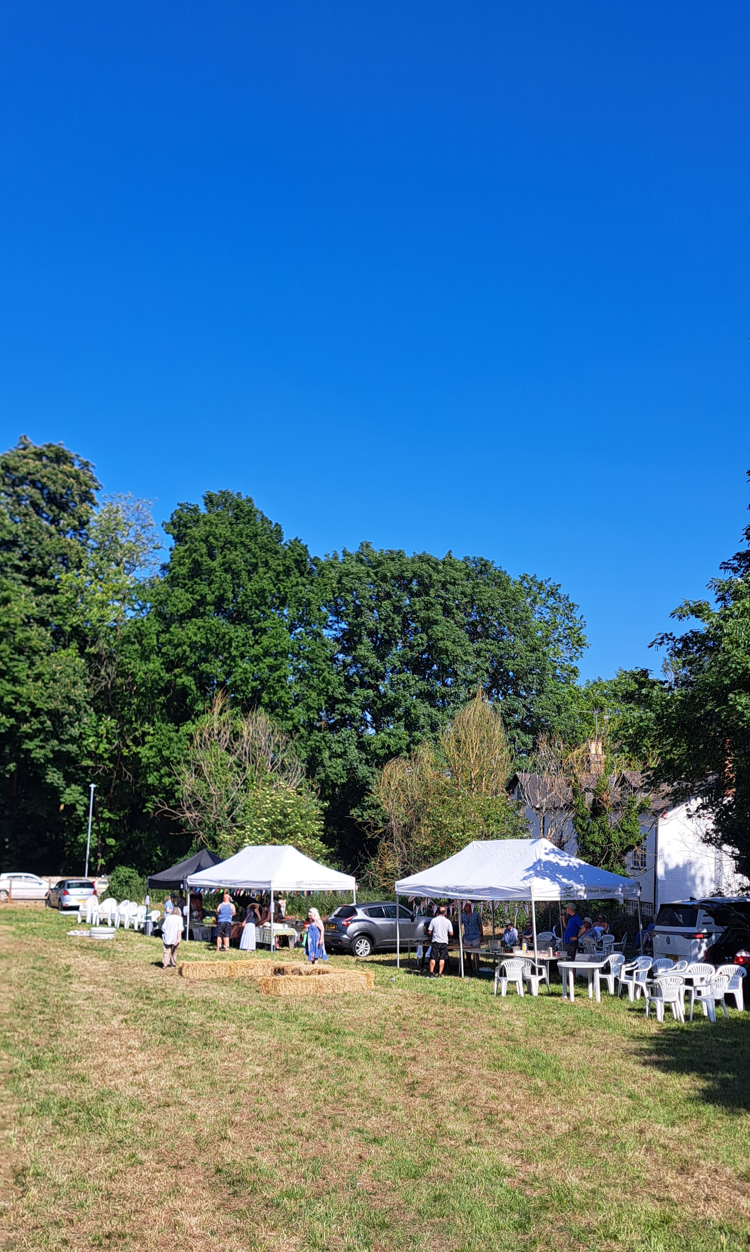
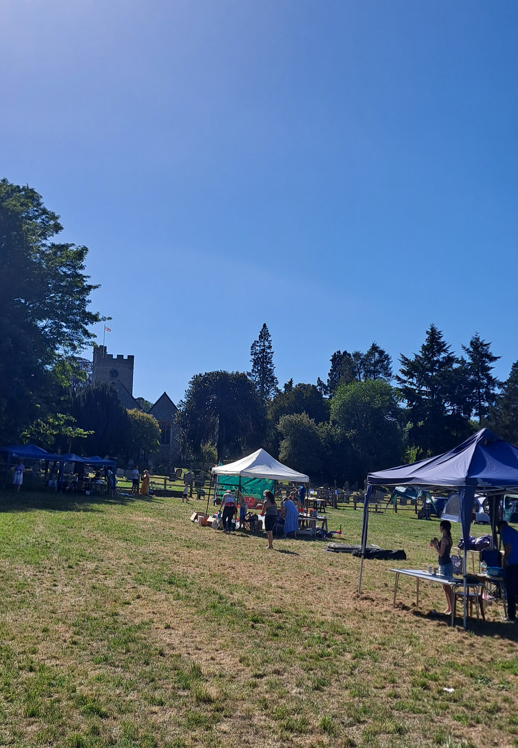


Watton Fete – Congratulations and thank you to everyone who helped organise and run a fantastic Fete. Also a wonderful community day

