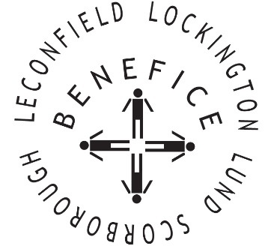

Church Services for
July 2026
Wherever you are from, you are welcome to join us for any of these services

Sunday 5th 9:30am Holy Communion St Leonard’s Scorborough

11:00am Morning Worship St Mary’s Lockington

Sunday 12th 9:30am Holy Communion St Catherine’s Leconfield

11:00am Morning Worship All Saint’s Lund

Wednesday 15th 9:30am Mid Week Service
With healing prayers St Catherine’s Leconfield

Friday 17th 7:00pm Songs of Praise St Catherine’s Leconfield

Sunday 19th 9:30am Holy Communion St Mary’s Lockington

Thursday 23rd 7:00pm Celtic Prayers St Catherine’s Leconfield

Sunday 26th 9:30am Holy Communion All Saints Lund

11:00am Contemporary Worship St Mary’s Lockington

Service times, events and Messenger can also be found at:
http://www.achurchnearyou.com for the four churches

