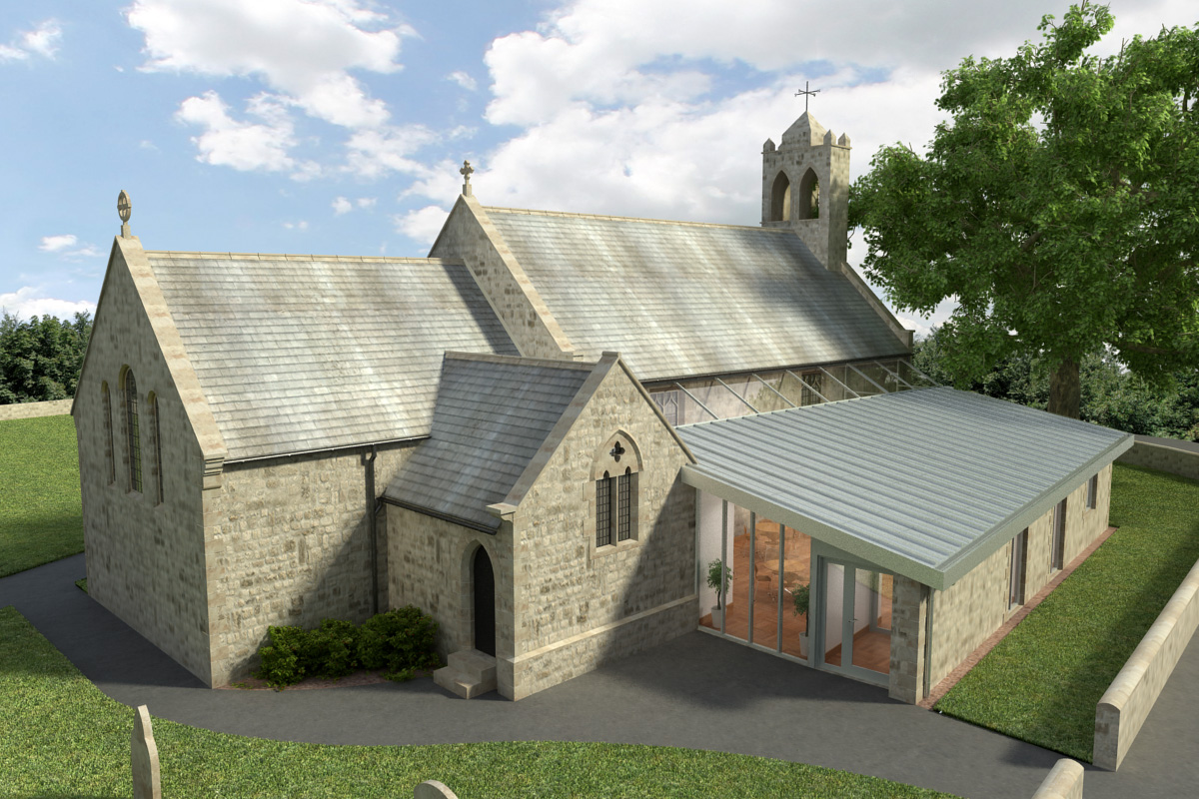
St Mary’s Parish Church, Longframlington

Welcome to our Sunday Morning Prayer. On Sunday 21 June, which is Third Sunday after Trinity, our Officiant will be Rev Gabby, and Tony playing the organ. Next week, Trinity Sunday 4, our Officiant will be Rev Rich, and Michael producing the music.
Coming up at St Mary’s and our sister parishes – Morning Prayer in St Mary’s – and on Zoom – usually every Wednesday morning at 9.30 am followed by coffee in the Community Room. The Link can be made using Meeting ID889 6133 2870, Password 093043. New people always welcome either on screen or in church.
Starting Rite is a five week free course continuing for parents with babies aged under 12 months. Tuesdays 2nd, 9th, 16th, 23rd and 30th June 10 am to 11.30 am at St Mary’s, a space to come together and play and wonder about God and faith. Contact Emma Townend at flowparishes@gmail.com for details.
Growing in Jesus – A six-week practical workshop course exploring how we love God, follow Jesus, and show his love to others today. In St Mary’s Community Room, Longframlington, Wednesdays starting 3 June 7 pm – 8 pm. Led by Robert Nunn of St Mary’s and Jan McCuin from Felton. Speak to them for further details.
Lifepath at Brinkburn Priory commences on Monday 22nd June using St Aidan’s lifepath with the theme of “Caring and Sharing”. The Priory is being prepared for the children this afternoon and anyone who wishes to help would be most welcome at 1 pm.
Giulio Tampalini and Daniele Fabio will perform in a concert at St Michael’s Felton on Sunday 28th June at 7.30 pm. Admission is £20 to include finger buffet and glass of wine. Tickets from Gallery 45 and St Michael’s.
4th July – Baptism of Luca at St Mary’s. Longframlington at 2 pm.
Our grateful thanks to Pat and Ian for running the Warm Hub Lunches for so many years. Sadly, June has been the last one, but we would like to express our appreciation for all they have done and friendships made.
Thank you for your giving to the life and work of our church. Our offering is taken during the third hymn, and there is a collection giving point at the back of the church for use after the service if you prefer. Regular giving by Standing Order with Gift Aid is particularly valuable to the church – speak to Audrey (01665 570 922) for more information and blank forms.
All our news and much more available on our Facebook page https:www.facebook.com/SMCLongfram/?ti=as and You Tube channel https:www.youtube.com/@stmichaelsfeltonstmaryslon.
Priest in Charge: Rev Rich Townend. Phone 01670 719470. Email:revrichtea@gmail.com. Regular day off is Monday.
For St Mary’s information contact Veronica Thomson (01665 570 807) or Audrey Truman (01665 570922).

