THE HISTORIC CHURCH of ST LAWRENCE, DENTON

founded 1531, extended 1872
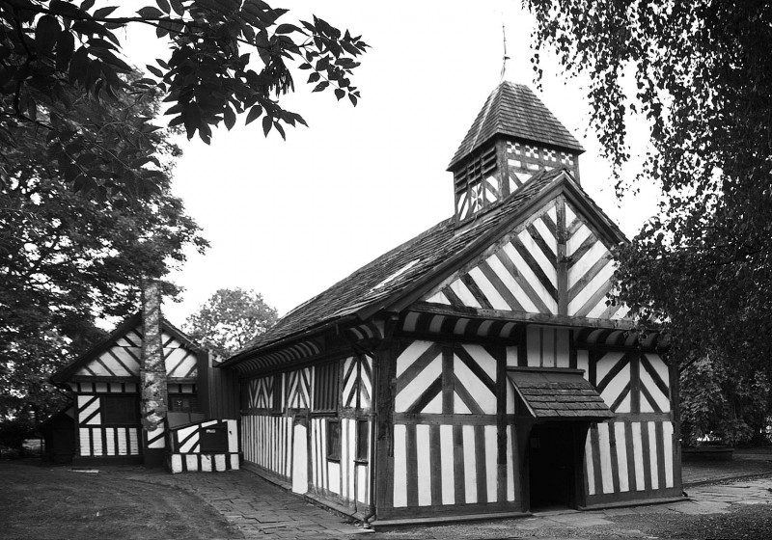
After standing for nearly 500 years from the Tudors to present day, this church remains as a symbol of the religious life of Denton, physically linking with the town's medieval past and local families who founded the chapel.

©Photo Bob Alston 2010

It is known locally as Th'owd Peg, because of the wooden pegs used to join the timbers
The black and white church for obvious reasons
There are extensive parish records available for those interested in genealogy further information is available from UK and Ireland Genealogy

Historical Development
St Lawrence's Church, Denton is a timber-framed building dating from 1531 at the most conservative estimate. Only 29 of this type of common medieval building remain in England and Wales. These are scattered from Kent in the South East to Lancashire in the North West. Originally the timber-framed structure was neither a parish church nor dedicated to St. Lawrence. It began as a chapel of ease (a type of half-way house) for the medieval manor of Denton within the Parish of Manchester, dedicated to St. James. It became a parish church under the name St. Lawrence in 1839. Story of St. Lawrence can be read by clicking this link.
When the chapel was built, its original benefactors, the Hollands and Hydes, were staunch Roman Catholics. It stood firm also through the upheavals of the Puritan Era, under the leadership of the much-persecuted Puritan leader, John Angier. A later notable pastor, William Parr Greswell, began the process of reshaping the chapel along more conventional liturgical lines, a process later accelerated in the era of the Tractarian Movement.
The Church was dedicated to St. Lawrence by Parr Greswell as a result of the discovery within the structure of fragments of glass depicting the martyrdom of St. Lawrence. These fragments are now incorporated into a window on the south side of the sanctuary.

Geography
The Church stands on the busy Ashton to Stockport Rd, and so is seen by many travellers. It is about a quarter of a mile from the Town Centre of Denton, at the centre of the parish of St. Lawrence.
Environmental Significance
The Church stands in one of the few open green spaces in the urban environments of Denton. The trees in the churchyard have Preservation Orders on them. Both the Parochial Church Council and the Local Authority are in total agreement that the openness of the site should not only be preserved but enhanced for the sake of the local community, and future generations.

Tour of the Exterior of the Church
Features of interest outside the Church
Pegs, not nails
The beams are held together with wooden pegs. These pegs gave the Church its original nickname 'Th'owd Peg'. In the restoration work carried out in 1995, traditional methods were followed, and new pegs put in to replace the old.
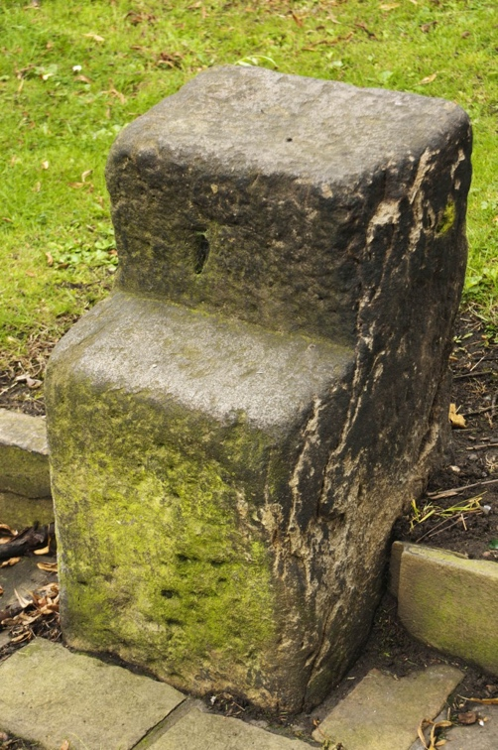
Mounting Block
In the south part of the churchyard, near the Memorial garden is a stone step or Mounting block, used to help people get on and off their horses as they arrived for worship. It probably stood somewhere near the Lych Gate.
©Photo Bob Alston 2010
The Graveyard
This was grassed over in 1965 when the former Denton Council took it over under the Open Spaces Act, and, in accordance with that Act the gravestone were either removed, covered over or broken up. A few gravestones remain, though probably not in their original locations. The most notable of these is that of Colonel Robert Dukinfield, (an updated version of an older one), a prominent combatant in the English Civil War, and buried somewhere in the graveyard.
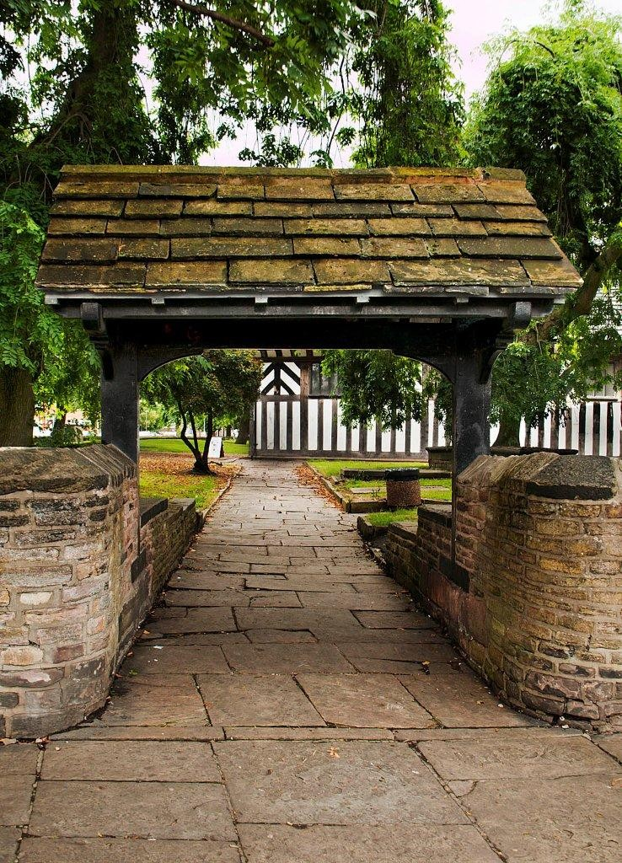
Lych Gate (from old Saxon meaning of death)

When people were brought to the Church for funerals only the coffins of those who could afford it were taken in Church The coffins of poorer people rested under the Lych Gate until burial after a service.
Nowadays it is very popular to have wedding photographs taken there.
©Photo Bob Alston 2010

Blue Plaques
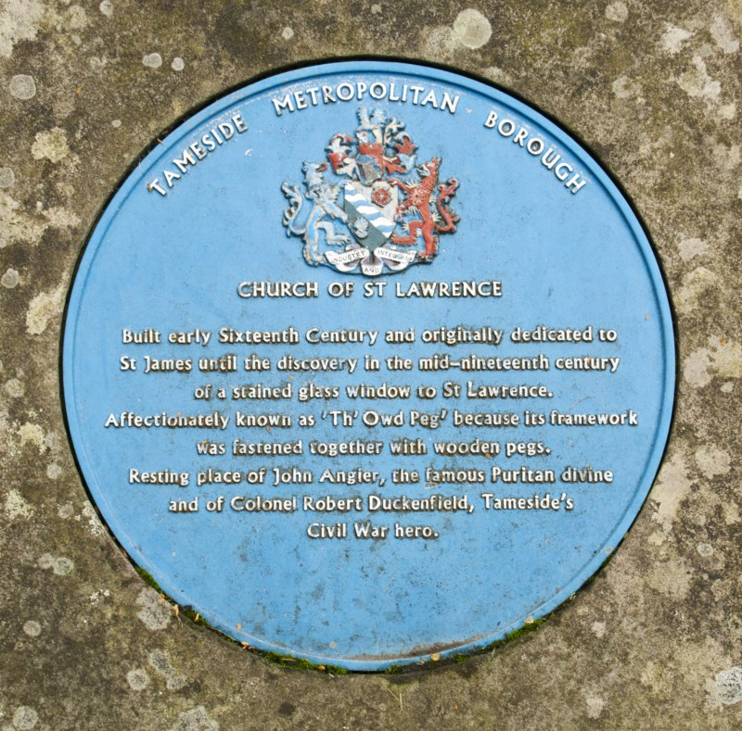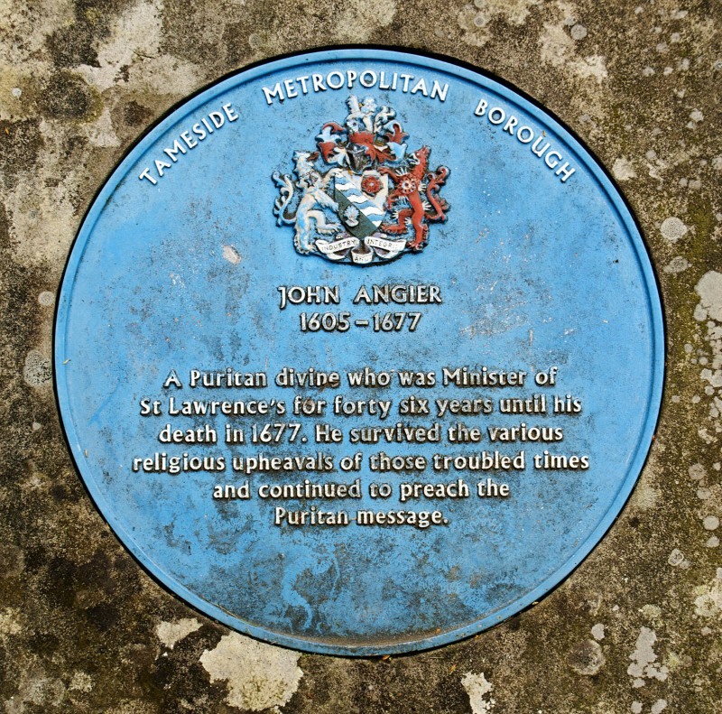
Two blue plaques stand on the East side of the building, one as a general reference to the Church, the other a memorial to the Rev John Angier, minister of the Church during the upheavals in the Puritan Era of the seventeenth Century.
©Photo Bob Alston 2010

Tour of the Church Interior
Features of Interest inside the Church Building

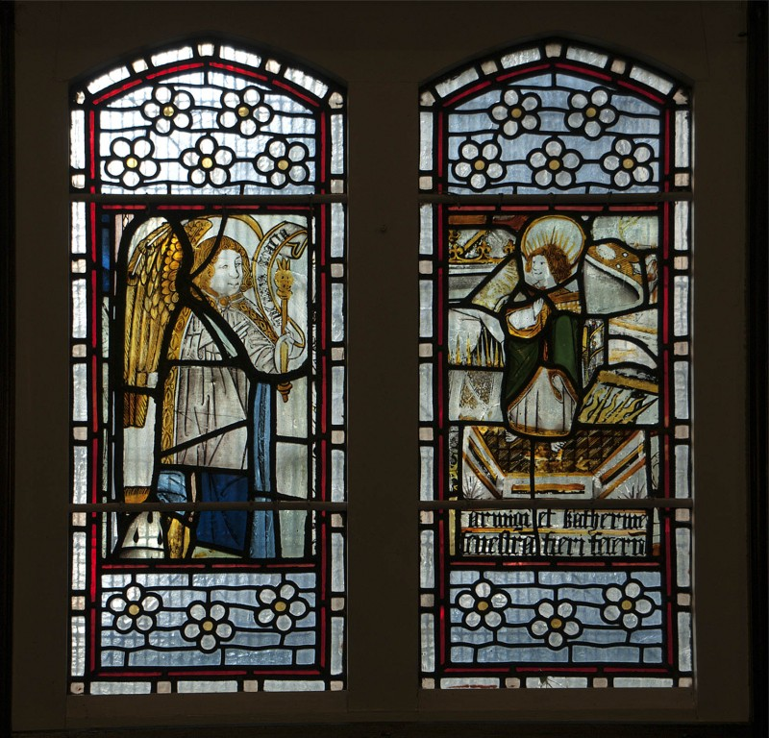
Window depicting the Martyrdom of St. Lawrence
On the right hand side in the Sanctuary is an ancient stained-glass window depicting the execution of St. Lawrence on a grid iron in Rome in 258 AD. It was the discovery of this window that caused the Church to be dedicated to him in 1854.
©Photo Bob Alston 2010
Memorial Crest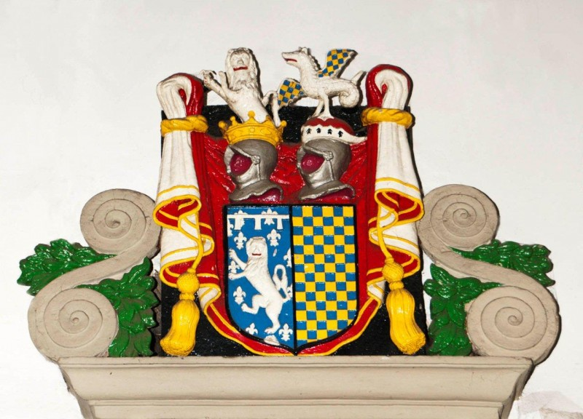
This colourful crest, located in the North Transept, is the memorial to the Holland family, one of the original benefactors of the Church.
©Photo Bob Alston 2010
Minstrel Gallery
At the west end of the Nave is the Minstrel gallery, one of the earliest additions to the interior, where the musicians and choir were located. As there was little light in that part of the Church, a small skylight was made on the north side of the gallery, and named the 'Psalm Singers' window', because it was designed to give the choir enough light to see by.
Victorian Extension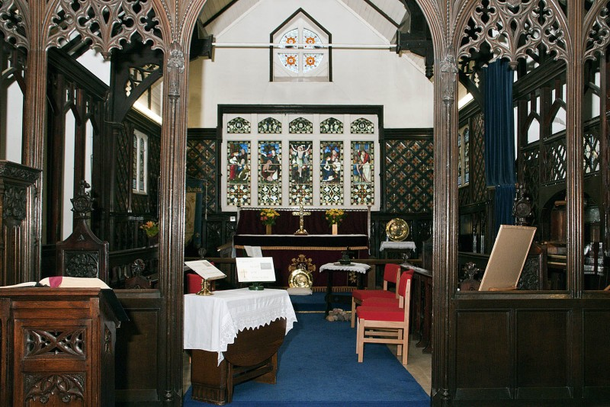
The two transepts (side rooms) were added in 1872 to cope with the expanding population of Denton, as was the Chancel, housing the choir pews and organ. The ornate screen was added only at the beginning of the last century (1926). ©Photo Bob Alston 2010
Two of the three blue shields fixed to the top of the screen bear the grid iron symbol of St. Lawrence, a symbol to be seen in many places within the church.
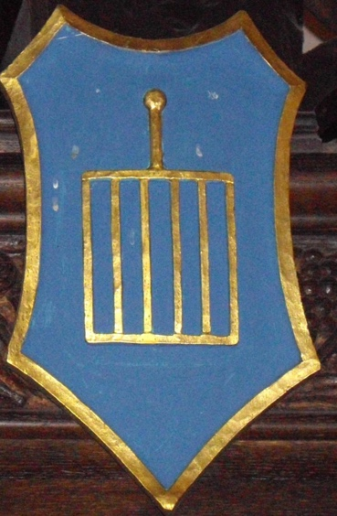

On the left of the screen is the pulpit and the List of Incumbents. Showing all the vicars, rectors, priests-in-charge starting with Sir Roger Ward in 1533.
©Photo Bob Alston 2010

