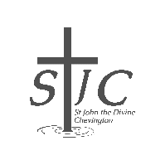

St John’s

Review

MAY 2026


Serving the villages of Hadston, Red Row and North and South Broomhill
Services May 2026

SUNDAY  3rd May | 9:00am  10.30am | Holy Communion  Holy Communion | St Cuthbert’s  St John’s
SUNDAY  10th May | 9:00am  10.30am  4:00pm | Holy Communion  Holy Communion  Café Church | St Cuthbert’s  St John’s  Coquet tea rooms  Amble
THURSDAY  14th May | 7:00pm | Holy communion for Ascension Day | St Cuthbert’s
SUNDAY  17th May | 9:00am  10.30am | Holy Communion  Holy Communion | St Cuthbert’s  St John’s
THURSDAY  21st May | 2:00pm | Third Thursday | St John’s
SUNDAY 24th May | 9:00am  10.30am | Holy Communion  Holy Communion | St Cuthbert’s  St John’s
SUNDAY 31st May | 10:00am | Holy Communion | St John’s  (joined by St Cuthbert’s)

FUNERALS April 2026

The funerals of Ken Bolton and Thomas Brennan took place in April.

Our love and condolences to their families and friends

Dear friends
I do hope that you had a good Easter and didn’t consume too much chocolate in celebration of the resurrection of Jesus. Sweet treats are always a joy, especially if you decided to observe Lent by giving them up. As I write this letter I am sitting, a little exhausted, and reflecting on the Holy Week and Easter we have recently experienced together.
In our churches of St Cuthbert’s and St John’s we had Easter Services that were decorated so very beautifully. After observing the ‘no flowers in church during Lent’ it is always such a delight to see colour and beauty adorning our lovely churches for the glory of God.

A massive thanks goes to all those who had a large or small part in making Holy Week and Easter so special. We rejoice in having people who have been sweeping and hoovering, polishing brass
candlesticks and crosses, washing and ironing linens, picking or buying flowers and collecting assorted greenery then creating gorgeous arrangements, playing the organ, moving furniture and
getting hymn books ready, baking and serving refreshments, creating services and preparing sermons.

We all have our talents and when we can see that playing to our individual strengths, as our offering to God and His people, then we are well on the way to serving each other in a loving Christian way. It is also so great to be part of a team of people who work well together. Thank you to all who made this time together special.

When I look at the way in which Jesus went about with his friends I can see that there were some key elements to how he spent his time. He spent time in prayer, always a necessary part in life. We
have so much to pray for both in thanksgiving and prayer needs for the world, don’t we? Jesus also took time to be with his close friends, eat meals with them and teach them. Quality time with our friends and family is important, so too is spending time with God. That can be in church as we worship together but also as we go about our daily lives, often in the beauty of nature. I think that we need to do both to have a healthy balance… be together with others as well as time on our own with God. The third thing that I see that Jesus did was to connect with large groups of people.
Jesus was in his communities and making a difference as he did that. Jesus cared for EVERYONE but he made a special focus to care for those no one else wanted to even talk to, let alone show
compassion to! This is the way that Christians are called to follow. Now, we don’t get this right all of the time, actually if we are honest we struggle to get it right some of the time. However, when we make a conscious effort to reflect the life of Jesus we DO make a difference.
In this Easter Season, as it still is for the moment, let us try to remember to PRAY, spend TIME with God and get involved with our COMMUNITIES, bringing the light and love of Jesus as we do
that. If you would like some help to do any of these things then do get in touch. In May I am looking forward to my first Puffin Festival in Amble so hopefully I will see you as I go out and about.

Rev Rachael



Some perks of getting old
Things you buy now won’t wear out.
You can eat supper at 4 pm.
You can sing along with lift music.
Your eyes won’t get much worse.
Your secrets are safe with your friends – because they can’t remember them either.

 | Wednesday 13th May in Druridge Bay Community Centre.  Everyone welcome!
Third Thursday - May  Everyone is welcome to Third Thursday, 21st May, at 2 pm in St John’s Church.  A short informal service enjoyed by all, led by Cynthia or Sheila.  Refreshments are served afterwards. | 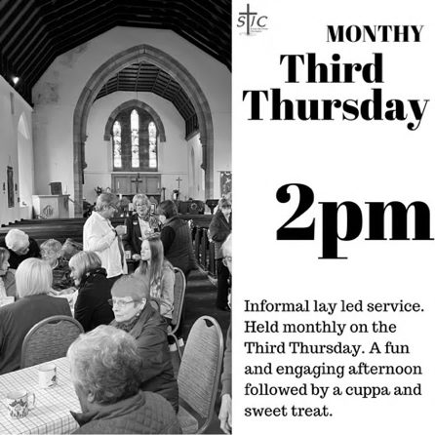
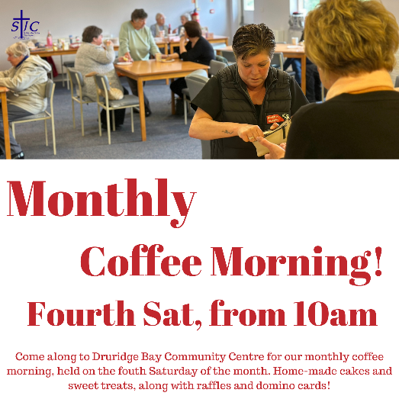 | Saturday 24th May from 10 am  in Druridge Bay Community Centre.
Crossword for May 2026

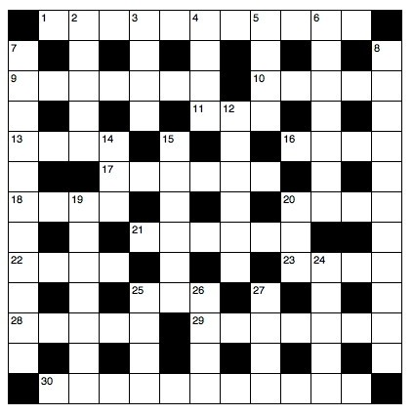

Across
1 Overpowered (Deuteronomy 11:4) (11)
9 ‘The — are mantled with corn’ (Psalm 65:13) (7)
10 ‘Each man—a sword to his side’ (Exodus 32:27) (5)
11 On the death of Jesus the curtain in the temple was torn from— to bottom (Matthew 27:51) (3)
13 Stagger (Isaiah 28:7) (4)
16 ‘Anyone, then, who knows the good he ought——and doesn’t do it, sins’ (James 4:17) (2,2)
17 Stir up or provoke (Acts13:50) (6)
18 Burden (Luke11:46) (4)
20 ‘As far as the east is from the—, so far has he removed our transgressions from us’ (Psalm 103:12) (4)
21 Sign (Luke23:38) (6)
22 ‘After that, Jesus poured water into a basin and began to—his disciples’ feet’ (John 13:5) (4)
23 The nature of the seven ears of corn which swallowed up the good ears in Pharaoh’s dream (Genesis 41:23) (4)
25 Has (anag.) (3)
28 ‘This is the account of Shem, Ham and Japheth, —sons’ (Genesis 10:1) (5)
29 ‘I will...make them drunk, so that they...sleep for—and— awake’ (Jeremiah 51:39) (4,3)
30 Paul said of him, ‘he often refreshes me and is not ashamed of my chains’ (2 Timothy 1:16) (11)

Down
2 Worth (Matthew 13:46) (5)
3 ‘A bruised — He will not break’ (Matthew 12:20) (4)
4 ‘Suddenly a great company of the heavenly — appeared with the angel’ (Luke 2:13) (4)
5 Slip (anag.) (4)
6 ‘Take an awl and push it through his — — into the door, and he will become your servant for life’ (Deuteronomy 15:17) (3,4)
7 Bountiful (2 Corinthians 8:2) (11)
8 ‘Therefore, as we have —, let us do good to all people’ (Galatians 6:10) (11)
12 Acquire (2 Timothy 2:10) (6)
14 Container cover (Numbers 19:15) (3)
15 ‘He...became obedient to death, even death on——!’ (Philippians 2:8) (1,5)
19 Refrain (1 Peter2:11) (7)
20 ‘She began to—his feet with her tears’ (Luke 7:38) (3)
24 One who worships Brahma, Vishnu or Shiva (5)
25 ‘Give to everyone who—you’ (Luke6:30) (4)
26 ‘I lift up my eyes to the hills; where does my—come from?’ (Psalm 121:1) (4)
27 One of those whom the Lord said would be taken from Jerusalem and Judah as judgment on them (Isaiah 3:2) (4)
Wordsearch for May

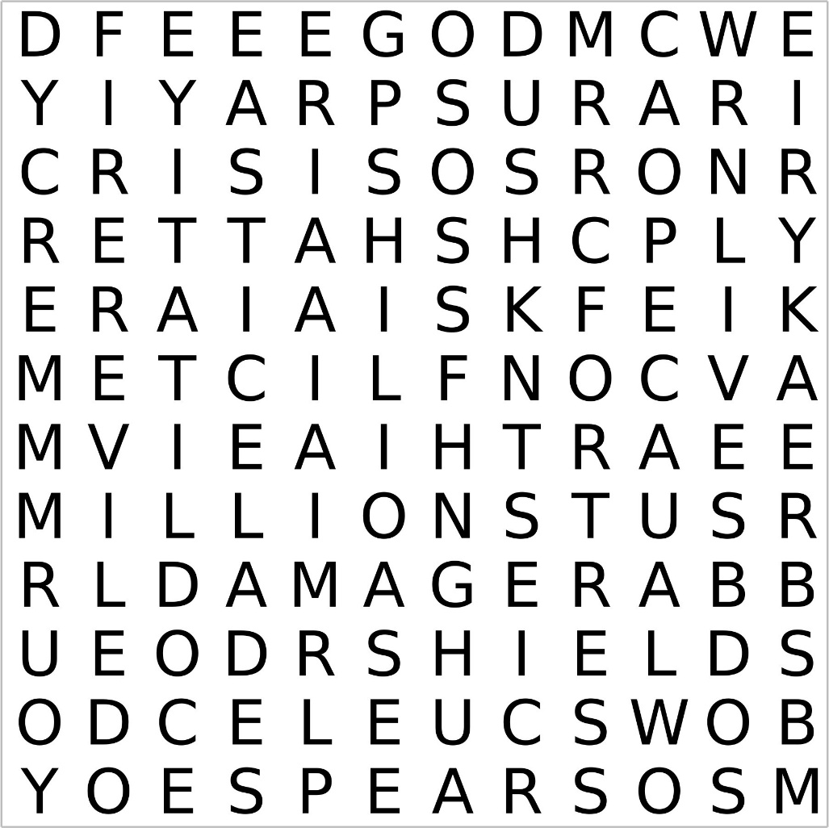

Middle | East | Conflict | Pray | Damage
War | Cease | Earth | Break | Bows
Shatter | Spears | Burn | Shields | Fire
Crisis | Many | Lives | Millions | Lord
Our | Rock | Fortress | Deliverer | Hope
Kyrie | In | You | Mercy

A prayer for the Middle East
Lord, we pray for the conflict in the Middle East, and how it is damaging the lives of so many millions of people. You, Lord, make wars cease to the end of the earth; You break bows, shatter spears, and burn shields with fire [Psalm 46:9]. Through Your Holy Spirit, move upon the leaders of the nations to de-escalate this crisis. We hear of wars and rumours of wars (Matt. 24:6], but You Lord are our rock, our fortress and our deliverer. Our hope is in You. Let Your name be exalted among the nations; may You be exalted in the earth [Psalm 46:10]. Kyrie eleison – Lord have mercy.

Poet’s Corner - by John Robertson

Weshing Day!

Weshing day arrives, mam’s full of gan!
Oot hoose ready, boiler filled, everything’s gan to plan.
Pit claes sorted, whites ready to boil; Claes horse oot!
Monday early morn, gotta be on her very best front foot.

Fire stoked up, bleezer on, and tea on constant flow,
She moves with grace and speed, with such get up and go, go!
Quick thinking skills, tea to prepare; hold your nerve Irene… be steady,
Dad’s in bed, that night shift sleep; everything’s more than ready.

The line fills up, Omo or Daz, it’s more than done the trick
‘Canny line of weshing Irene!’ Whites or colours? Tek your pick!
Hands on hips, pinny tied tight sometimes curlers in,
She’s in her stride, like some production line, such strength, she has within.

Pride runs deep when it comes to a ‘line of weshing!’
Are the whites white? No colours ran…just checking!
Wo-betide! Anyone’s sarcastic comments,
Weshing’s done, she quietly whispers, a cry and self-lament,
But tea’s to finish, and that bloody ironing awaits…Dammit!
The May Night Sky
Bright planets
Venus is very bright in the western sky after sunset. Watch for the crescent moon nearby on the evening of May 18th. Jupiter is also a prominent sight after sunset. The two planets continue to approach one another in the sky ahead of a conjunction in early June. Meanwhile, the planets Mars and Saturn have emerged from behind the Sun and might be seen low in the eastern sky before sunrise.

Phases of the moon

May 1 May 9 May 16 May 23 May 31

There are two full moons this month; the second full moon is popularly referred to as a blue moon.

Once in a Blue Moon: What does It really mean?
The phrase “once in a blue moon” has become a popular way of describing something rare. But in astronomy, a Blue Moon has a very specific meaning – and despite the name, it almost never looks blue.
Today, a Blue Moon usually means the second full Moon in a single calendar month. Because a full Moon occurs about every 29½ days, most months contain only one. Occasionally, however, the timing works out so that a month sneaks in two. When that happens, the second full Moon earns the title Blue Moon. On average, this occurs
roughly once every two to three years.

This modern definition goes back to the mid-20th century and was popularised through almanacs and astronomy magazines. In particular, the Maine Farmers’ Almanac played a role in spreading the term, although earlier meanings existed too.
Historically, a Blue Moon referred to something slightly different: the third full Moon in a season that contains four full Moons instead of the usual three. Astronomical seasons normally include three full Moons, but occasionally an extra one appears. Rather than
disrupt the naming of traditional Moons (like Harvest Moon), the “extra” Moon was called blue. Both definitions are still encountered, which can lead to confusion.
So why blue? Most of the time, the Moon looks exactly the same silvery white we’re used to. Very rarely, atmospheric conditions – such as smoke from wildfires or volcanic ash – can scatter light in a way that gives the Moon a bluish tint. But this has nothing to do with
the timing of a Blue Moon; it’s a coincidence when it happens.

From a scientific point of view, a Blue Moon is simply a quirk of our calendar. The Moon’s phases don’t line up neatly with months and seasons, so every so often we get an extra full Moon tucked in where we don’t expect it. The Moon itself doesn’t change – only our
way of counting does.

Still, Blue Moons offer a great excuse to step outside, look up, and enjoy a familiar sight made special by timing alone.

If you’d like to learn more about astronomy, then consider contacting your local astronomy club – the Northumberland Astronomical Society (NASTRO) – see www.nastro.org.uk for further details.

Dr Adrian Jannetta MSc CMath FRAS



Ascension Day – May 14th 2026
Join us at 7pm at St Cuthbert’s Amble as we celebrate this day.

Hail the day that sees him rise
To His throne above the skies;
Christ, a while to mortals given,
Reascends His native heaven. – Charles Wesley
Pentecost – May 24th 2026
The word means ’50 days after Easter’. It’s the celebration of the gift of the Holy Spirit and it’s the birthday of the Church. So far so good; but beyond this, things get a bit hazy for some of us. We are familiar with the idea of God the good Father, and we’ve heard and read of all that Jesus – God the Son – said and did. But the Holy Spirit?
The images used of the Holy Spirit in scripture can be a bit of a barrier to understanding. Words like ‘spirit’ ‘wind’ ‘flame’ ‘breath’ are all a bit elusive, and they possibly leave us with a feeling that in trying to understand the Holy Spirit we’re chasing rainbows. But we can see that these images speak of an unhindered force which can be powerful and yet gentle, cleansing and free.
The Bible is full of images of the Holy Spirit. There is ‘dove’, as seen on many Christmas cards and in stained glass windows. It’s usually white. A white dove image speaks of gentleness and purity, unfettered as it wings its way across the sky.
Then there’s the more difficult word ‘advocate’. Someone who speaks up for us, comes alongside us, someone to aid us in times of need. We could go on with different images which tell us more of the character of the Holy Spirit, but there are two key things to remember. Firstly, this is the spirit of Jesus. All that Jesus was in earthly form, the Holy Spirit is to us now. Jesus is no longer among us as He was two thousand years ago, but the Holy Spirit makes Him available to us now.
Which brings us to the second point; the Holy Spirit is given by the good Father to us, His children – giving us, as it were, an injection of Jesus’ personality, wisdom and holiness, enabling us to serve as Jesus did, enabling us, as Mother Teresa put it, ‘to do little things with great love’.
The first Pentecost set the young Church in Jerusalem off on a great adventure which culminated in today’s world where one in three people worldwide say they are Christians. It could be a great adventure for us as we ask God, the good Father, to gift us with the Spirit of Jesus. Let’s do it!


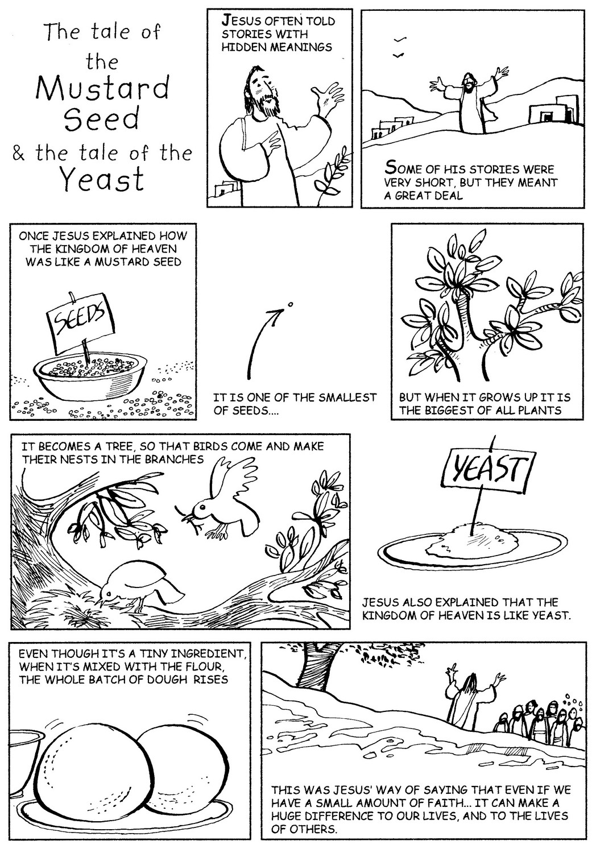

MEMORIAMS

ALSOP
Jim and Martha
Jim a loving Dad and Granda died 19th April 1980 and Martha a loving Mam, Nanna and Nanna Marr to all, died 2nd May 2001.
Tenderly we treasure the past, with memories that will always last.
Loved and missed by all the family.

BUTLER
Joan died 22nd May 2017. Beloved mother of Michael and David. You made the world a very special place just by being in it. You are still with me every heartbeat, keeping me on the right path, taking care and protecting me. Thank you for being so kind and cheerful and generous. I am missing you so much. I will love you forever Mum. Thank you for everything you have done for me. Goodbye Michael

BUTLER
Joan – 22.5.17 and Roy Keith – 22.6.05
Dad you gave me the greatest gift of all! “My Mum” called Joan. Your care, love and understanding will be with me for ever. Thank you for choosing to be “My Mum”. If memories bring us closer, we are never apart because Mum and Dad you are always in our thoughts and forever in our hearts.

DIXON
Ella Dixon. In loving memory of a dear mam, granma and great-granma died 16th May 2002. Our thoughts are with you every minute of every day. We love and miss you. Son Leslie, daughters Pamela, Wendy and late son Terry.

FAIRBAIRN
Jen died 5th May 2021. Treasured memories of a dear Mother, Grandma and Great Grandma. If roses grow in heaven, Lord pick a bunch for me, place them in my Mother’s arms and tell her they’re from me. Tell her I love her and miss her and when she turns to smile, place a kiss upon her cheek and hold her for a while. Remembering her is easy, I do it every day, but there’s an ache within my heart that will never go away. Never forgotten, always in our hearts Kevin, Julie, Christopher and Anthony.

Treasured memories of my dear friend Jen died 5th May 2021. It’s been a very lonely time since you left me and that will last until we meet again. I will never forget you. Jean

LITTLE
David Graham Little, 8th May 1999
Battled for years, fought till the end - we are so proud of you.
Michelle and all your grandchildren.

MONTGOMERY
Elizabeth Montgomery (Liz), died 01-05-2023
Forever in our hearts and thoughts Liz.
Love, Joan, Lynda and Janet xx

MORSE
In loving memory of my dear husband Jimmy died May 18th 2010. Thinking of you every day. Now that you’re gone may the angels take care of you ‘till we meet again. Thelma.

SMITH
Treasured memories of a much loved son Shaun Raymond Smith died 28th May 2006. The tears in my eyes I wipe away, but the pain in my heart is here to stay, so with aching heart I whisper low, God bless you son, I miss you so. Mam, Dad, Kimberley, Grandma Anne and all the family. Xx

STANTON
William George died 21st May 2012. Beautiful memories treasured for ever of the happy years spent together. Life is eternal, love will remain, in God’s own time we’ll meet again. Always in our thoughts, forever in our hearts. Loving wife Sylvia and family x

Memoriams are included free of charge
If you would like to remember a loved one in this way – and have not already done so – please confirm that via email to the editors on stjohnchevington@gmail.com Thank you.

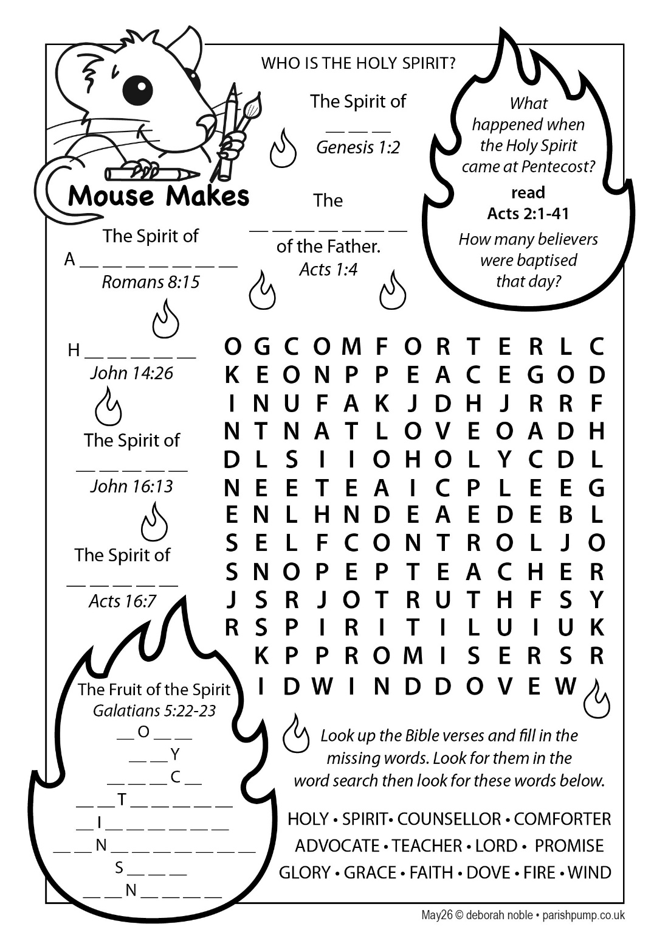
Stained glass windows
You may know the story of the little girl with her family during a guided tour around a cathedral. As the bright sun streamed through one of the windows, she asked the guide who were the people depicted there “Those are the saints,” he replied.
Later that evening the girl told her mummy, “I know who the saints are.” “Do you, dear? Who are they?” the mother asked. The little girl replied: “They are the people who let the light shine through.”

The afternoon sun sometimes shines in through St John’s south facing window depicting the Road to Emmaus. It shines through the figures and colours of the scene to bathe the chancel in a rainbow.
This window reminds us of the story of Jesus meeting two disciples as they walked from Jerusalem to Emmaus on the day of his resurrection. He brought the scriptures to life for them and they recognised him when he stayed to eat with them and shared bread.

Next time you are near St John’s, why not pop in and look at this window? It’s a beautiful image of that story and a memorial to two ladies who were members of our church family.

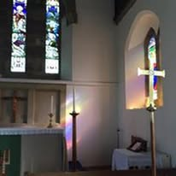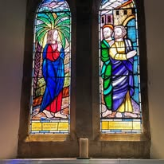

George Herbert has a poem that calls us to shine out like the church windows. It is easy, he says, to be “brittle crazy glass”, but in God’s good grace we can become like a window where colours and light, belief and life can combine and mingle to radiate out into the world.

All in the month of May
It was:
400 years ago, on 4th May 1626 that the Dutch explorer Peter Minuit arrived on the east coast of what is now the USA. He negotiated the purchase of Manhattan Island from the Lenape Native Americans for $24 worth of cloth and buttons. (Equal to about $1,150 today.)

300 years ago, on 25th May 1726 that the world’s first Circulating Library (lending library) was launched by Scottish poet and bookseller Allan Ramsay at his bookshop in Edinburgh.

250 years ago, on 4th May 1776 that Rhode Island became the first of the Thirteen Colonies to renounce allegiance to the British Crown and instead, to declare independence.

90 years ago, on 7th May 1936 that British aviator Amy Johnson made the fastest-ever (at that time) solo flight from England to Cape Town.

75 years ago, on 9th May 1951 that the Lake District National Park was established as Britain’s second national park.

70 years ago, on 24th May 1956 that the first Eurovision Song Contest was held in Lugano, Switzerland. It was won by Switzerland.

60 years ago, on 30th May 1966 that British racing driver Graham Hill won the 1966 Indianapolis 500. He was the only driver in history to win the ‘triple crown of motor racing’: the Formula One World Championship, the 24 Hours of Le Mans, and the Indianapolis 500.

40 years ago, on 9th May 1986 that Tenzing Norgay (Sherpa Tenzing), died. This Tibetan/Nepalese mountaineer had been with Sir Edmund Hillary of New Zealand when in 1953 they became the first people to reach the summit of Mount Everest.

10 years ago, on 31st May 2016 that Carla Lane, TV screenwriter, died. Best remembered for creating the sitcoms The Liver Birds, Butterflies, and Bread.

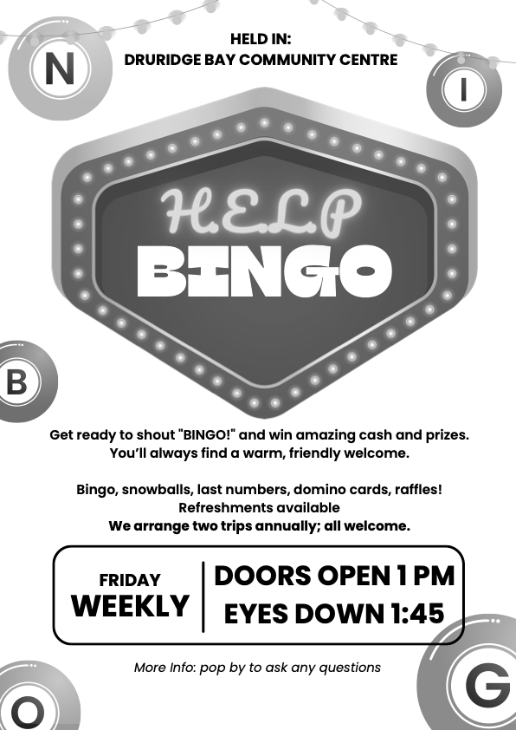

Gift Shop, Home Interiors, Painted Furniture, Furniture painting commissions & Frenchic Paint stockist.


10 The Precinct. Hadston. NE65 9YF

Facebook The Furniture Painter

Email keith.brooks2@btconnect.com Mobile 07437853665.




ADVERTISE HERE!

If you would like to advertise your business, please contact the editors via stjohnchevington@gmail.com for more
HADSTON NEWSAGENCY
PROPRIETOR – Stephen Paton

HADSTON SHOPPING CENTRE
Tel: 760233

Post Office Now in Shop
Newspapers Magazines
Stationery Cigarettes
Tobacco Alcohol
Pet Corner Household Goods
Groceries





T. DAWSON Ltd

ELECTRICAL CONTRACTOR

- Renewables
- EICR
- Domestic, Commercial, Industrial

T. Dawson Ltd
Bradley House
23 Togston Road
North Broomhill
NE65 9UZ

Tel: 01670 761921 / 07955 911720

Email: trevortoggy@icloud.com


John S Lunn & Sons  Artsmith, Blacksmith  Stephen Lunn  Est 1921  Tel: Red Row 01670 760246   | 


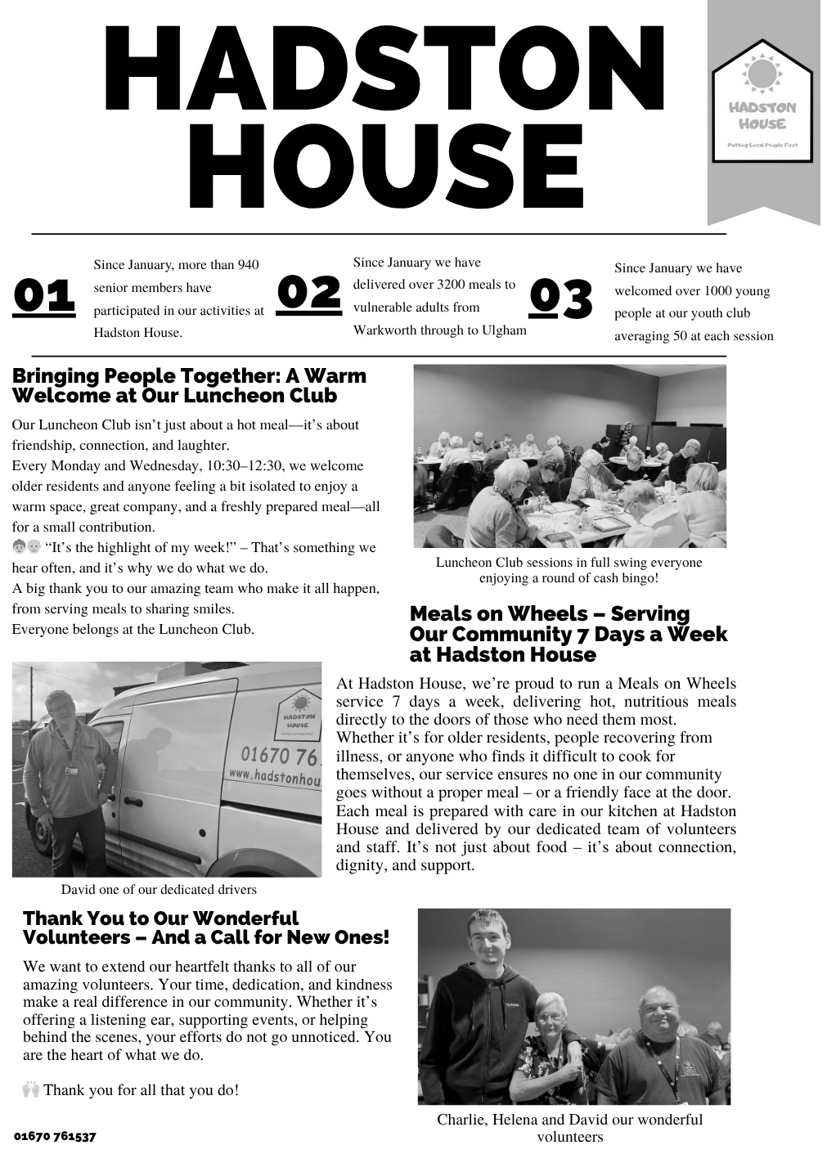
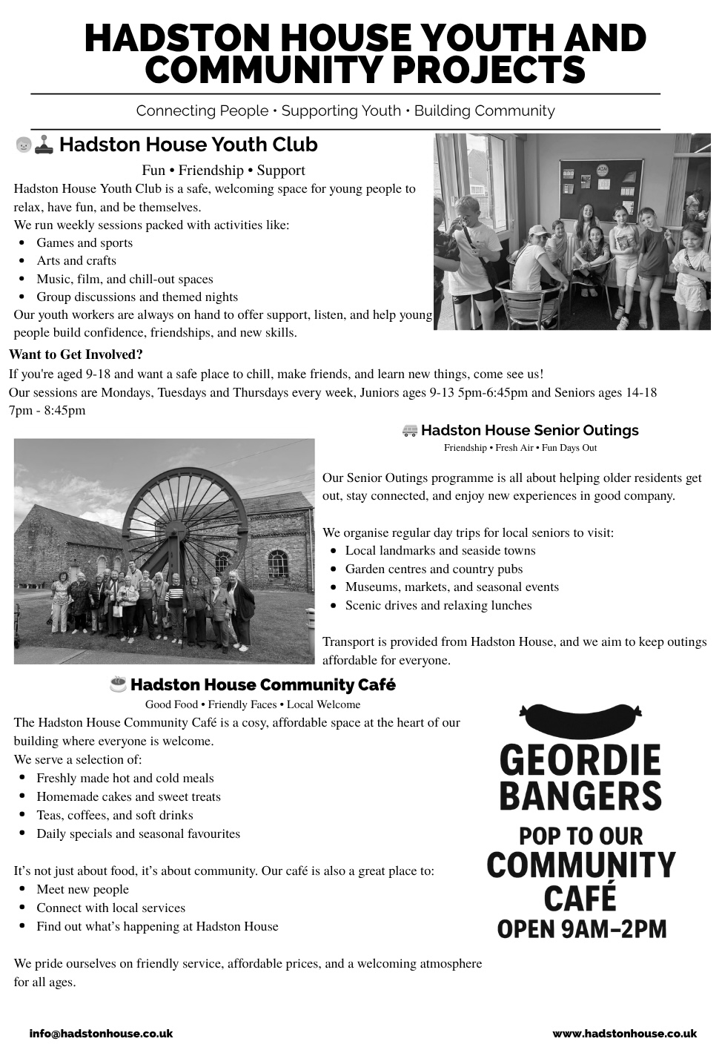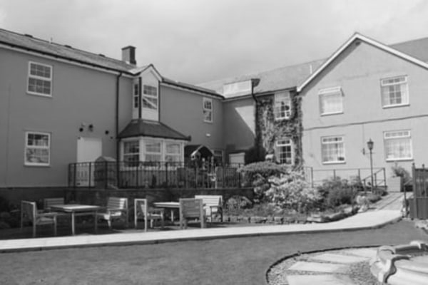
HEATHERDALE RESIDENTIAL
CARE HOME
Broomhill, Morpeth

01670 760796

Our aim is simply ‘Care Without Compromise’, which fundamentally means
we believe in Privacy, Dignity, Independence, Choice, Rights and Fulfilment
for the client. High standards of comfort, providing ‘First Class Quality Care’

Our home has:
- Ambience – “Truly a Hom, in the warmest sense.”
- Social Activities and Outings – “Daily with various outings”
- A Tip-top team – “Warm, cheerful, reassuring and caring”
- Virtually all single rooms, the majority of which are en-suite.
- Lovely Gardens, which have won Britain in Bloom Competitions
- Excellent Home Cooking - Great choice – 5 Star”
- Qualified Staff – “Training from day one”
Call any time for a brochure
Helpline | Phone | Cost
Samaritans | 116 123  Open 24/7  jo@samaritans.org | Free
Mind Mental health support | 0300 123 3393 Open 9am-6pm except bank holidays.  Text 86463  info@mind.org.uk | Local rates from landline  Mobile charges vary
FRANK  Need advice about drugs – talk to Frank | 0300 123 6600 Open 24/7  Text 82111  frank@talktofrank.com | Local rates from landline  Mobile charges vary
Alcoholics Anonymous | 0800 9177 650  help@aamail.org | Free
Rape Crisis | 0808 802 9999  12noon-2.30 & 7-9.30 daily | Free
Switchboard LGBT+ helpline | 0300 330 0630  10am-10pm daily  chris@switchboard.lgbt | Local rates from landline  Mobile charges vary
National Domestic Violence  Run by Women’s Aid and refuge | 0808 2000 247 Open 24/7  0808 801 0327 Male advice & enquiry  0808 802 4040 Helpline for men worried they may be harming someone else | Free
ManKind Initiative domestic abuse helpline for men | 01823 334244 weekdays 10am to 4pm | Local rates from landline  Mobile charges vary
Farming Community Network | 03000 111 999  7am-11pm every day of the year  chris@fon.org.uk | Local rates from landline  Mobile charges vary
Dementia Helpline | 0800 888 6678  Open 9am-9pm Mon-Fri  helpline@dimentiauk | Free
Silver Line  Helpline for older people | 0800 470 80 90  Open 24/7 | Free
Action for Elder Abuse | 0808 808 8141  Open 9am-5pm Mon-Fri | Free
Childline | 0800 1111 open 24/7 | Free

PARISH CONTACTS
Priest in Charge: Rev’d Rachael Dines, 07763 211901
revd.rachael.dines@gmail.com
Churchwardens: Sheila Orgill (07484 825203)
Magazine Editors: email stjohnchevington@gmail.com
Safeguarding Officer Sheila Orgill

Please contact Rev’d Rachael Dines, 07763 211901 / 01665 497631
or email stjohnchevington@gmail.com with any enquiries about baptisms, weddings and funerals or if there is anything St John’s can do to help you.

Find us on Facebook  - St John the Divine, Chevington
Also: A Church Near You website https:/www.achurchnearyou

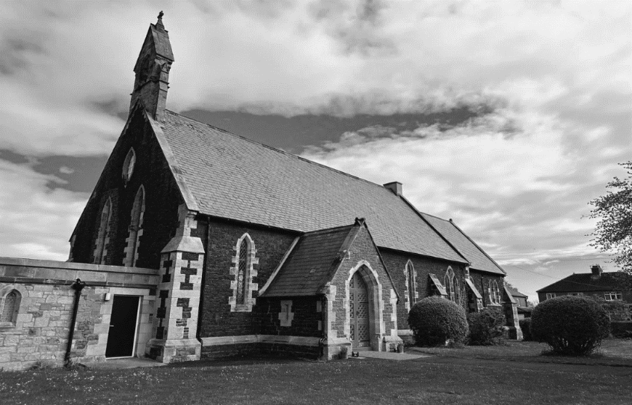

Dates and times are correct at the time of going to press.
Copies of this magazine can be obtained from St John’s Church or by contacting the magazine secretary

The magazine editors are not responsible for the content of articles submitted and also reserves the right to exercise editorial discretion.

