Dear All,
In school collective worship the other week I showed this picture and asked the children what they could see. I was expecting two answers, but they came up with a long list of answers including many options I have never even considered as I know the picture too well. Their fresh insight reminded me that the narrow ways in which we sometimes view things, due to past learning or experiences, can stop us from seeing things in a different, fresh way. On occasions we are prevented from seeing things in the way that God wishes us to, through eyes of love, grace and compassion.

I find that no matter how many times I read a passage from the Bible, there is always something new that I will see or learn from it. Being able to look at situations in new ways is something that is important to do. Last June I was given a voucher for a flight in a Gyrocopter by Martin and Jane as an Ordination gift; as an opportunity to view our Parish from a different perspective.

I took my flight the other week. It was a beautiful sunny, clear afternoon. Simon, Lottie, Sophie and Martin waved me off from Rufforth airfield as Jim, my instructor, and I took off. It was amazing to see the Parish from a bird’s eye view. The familiar countryside now seen as a beautiful patchwork of brown and green fields, and red rooftops. Our villages look so small from the air, in comparison with the countryside around them, and the people walking and waving at us below, even smaller!

The timing of this flight was perfect. Having served as curate in Marston Moor for nearly a year, I have settled into a rhythm of life which I love and am very comfortable with. However, if I’m honest, I’ve started taking for granted the beauty of our parish and people in it. This fresh perspective reminded me how blessed and fortunate I am to be working with and helping Martin serve you all. It also reminded me that despite us being small and “insignificant” we are so precious and loved by God who chose to create each one of us. So precious that he knows how many hairs are on each of our heads and is with us in all that we are going through.

When we’re going about our everyday lives we can get so lost in the busyness or difficulties of life, that we fail to see beauty in the familiar. Children are good at helping us do this as they notice the small but important things; the colours in a beautiful sunset, the number of spots on a ladybird’s wings, the beautiful shapes of leaves. Next time you are out and about, stop and look around to see the surrounding beauty. Think about seeing things from a different perspective but, also remember to focus not just on the things on earth but on God. As it says in Colossians 3:2 in the Bible, “set your minds on things that are above, not on things that are on earth.”

If we focus on God as we journey through our lives, we start to be changed and able to see the world from a fresh perspective. This renewal isn’t just about changing our actions; it involves a complete transformation of how we view our situations and our relationships. The more we spend time with God, whether in prayer, reading the Bible, or connecting with him in other ways, we develop a deeper understanding of how God sees things. We are more able to embrace challenges with faith and joy; recognise and celebrate the extraordinary in ordinary situations.

As I prepare for ordination as Priest at the end of June, I am praying that we will all continue to grow with God and remember to see things through his eyes. It would be lovely if you are able to join me for my ordination at Selby Abbey at 6pm on Sunday 28th June at Selby Abbey and/or on Wednesday 1st July when I celebrate my first Eucharist at 5pm in Tockwith Church.

Karen

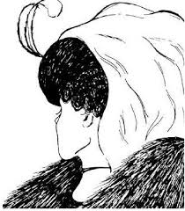
Pic to go near the first paragraph please.

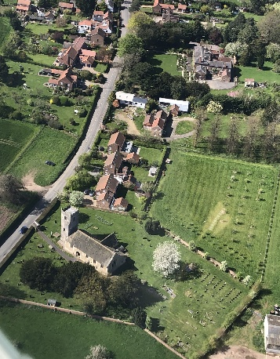
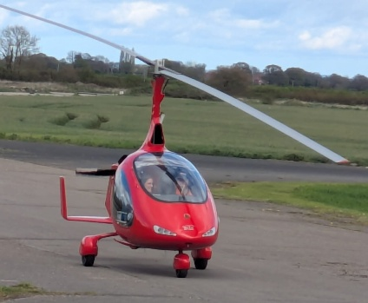
Pics for the bottom of the article (space permitting)

