Sharnbrook Church, floor above the bells - Statement of Needs

Background

The existing ring of bells at St Peter’s Church, Sharnbrook, is based on a ring of six installed in an eight-bell frame in 1924. Two new trebles, completing the current ring of eight, were installed in the existing frame in 2004.

The modern-style frame is of cast-iron, low-side frame members, mounted on a grillage of steel, I-section beams, embedded into the walls on all four sides. The frame head sits approximately 5.2m below the base of the spire, level with the cills of the large bell-chamber openings. In 1999 the bell-chamber openings in the tower were partially closed with concrete block, both to prevent rain water blowing into the chamber, but primarily to reduce the sound level in the local area, as a result of some noise complaints.

However, the bell chamber is completely open to the remaining tower, and spire above. Over the years the bell installation and internal structure of the tower has suffered the following damage as a result of water ingress through the tower and spire openings:

- In 1982, cracks were found in two of the cast-iron frame sides. This was caused by the rusting, and subsequent expansion, of steel shims placed under their feet. Additionally, the floor beneath the bells, which was supported on the upper foundation beams lower flanges, was determined to be rotten. The moisture in the wood had also caused corrosion in the foundation beams.

- In 1983, the bell-wheel soles and shrouds were found to be rotten, due to the effects of prolonged, regular soaking.

- In 1988, the clock-room floor below the bell chamber was determined to be unsafe due to beetle and fungal infestation, primarily brought about by the damp environment.

Additionally, due to the natural erosion of the internal walls of the tower and spire, the bell installation is constantly exposed to falling masonry grit and dust which, overtime, can cause wear and deterioration to moving parts (i.e. bearings). Also, although not gaining access, birds sitting on the spire openings mesh, allow their droppings to fall onto the bells and fittings, further adding to the risk of corrosion and rot (this is particularly evident during the period that ripe elderberries are available, as the installation is covered in purple spots).

Solution

The proposed solution to this issue is a new floor to be positioned above the bells, just below the base of the spire (see attached quotation and drawing). This will have a water-proof surface which will contain any water ingress, bird droppings and the majority of the masonry debris, and prevent it from descending onto the bells, frame or floor, and allow the water to evaporate off naturally.

Additionally, access to the door to the parapet at the base of the spire is via a vertical ladder against the internal south wall, attached to the frame head and some 5.2m high. The new floor, combined with the proposed addition of a ladder safety cage, will provide safer access to the parapet door.

P J S Albon
March 2024.

Sharnbrook Church, platform at base of vertical ladder - Statement of Needs

Background

Having submitted the above document for consideration by the DAC, a response was received requesting that consideration should be given to the provision of a landing platform, at the base of the vertical ladder, in accordance with BS4211.

The vertical ladder was installed in 1924 along with the current bell installation, and it descends onto the bell frame, over the 3rd bell pit. This presented us with a number of issues:

- A fixed platform would obstruct the swinging of the 3rd bell.
- A removeable platform would need to be manhandled over or around the 3rd bell which is highly undesirable from a safety point of view.
- Similarly, a simple hinged platform at the base of the ladder would require the operator to climb over or around the 3rd bell, and also would be difficult to support adequately.

Solution

The proposed solution was assembled as shown in the following photos, using non-intrusive fixings to demonstrate the concept.

A framework had been assembled utilising steel Unistrut beams, around the 3rd bell. A platform of 22mm plywood, sealed with a non-slip coating and supported on further Unistrut beams is attached, by hinges, to the frame at the door end of the 3rd pit. The platform, when not in use, is secured (by a hasp and padlock) in the vertical position (figures 3 & 4) and all framework remains well clear of the swinging bells.

When access to the ladder is required, once the padlock has been removed, the platform may be lowered by the rope from the doorway end (negating the need to clamber over the bell / frame). Once in position (figures 1 & 2), the platform is supported at both ends by the framework and additionally, in the middle where it rests on the 3rd headstock. A handrail around two sides of the platform provides further security to those accessing the ladder.

On completion of use, again the platform may be raised to the stowage position by the rope from the doorway side.

PJSA
April 25.

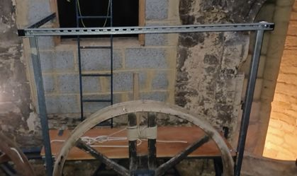
Figure 1. Platfrom in lowered position

Figure 2. Platform in lowered position

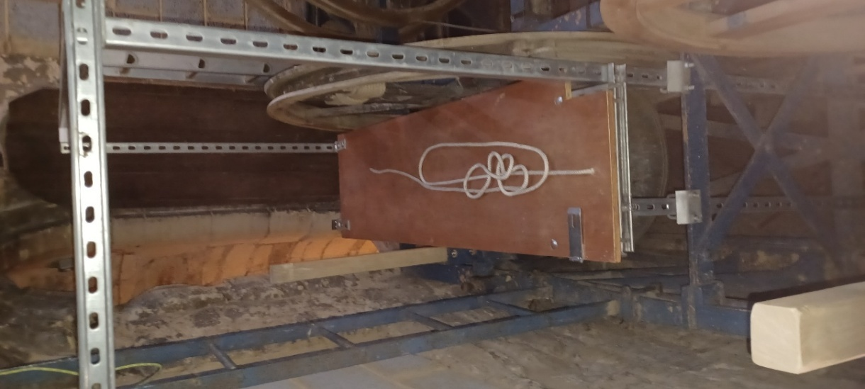
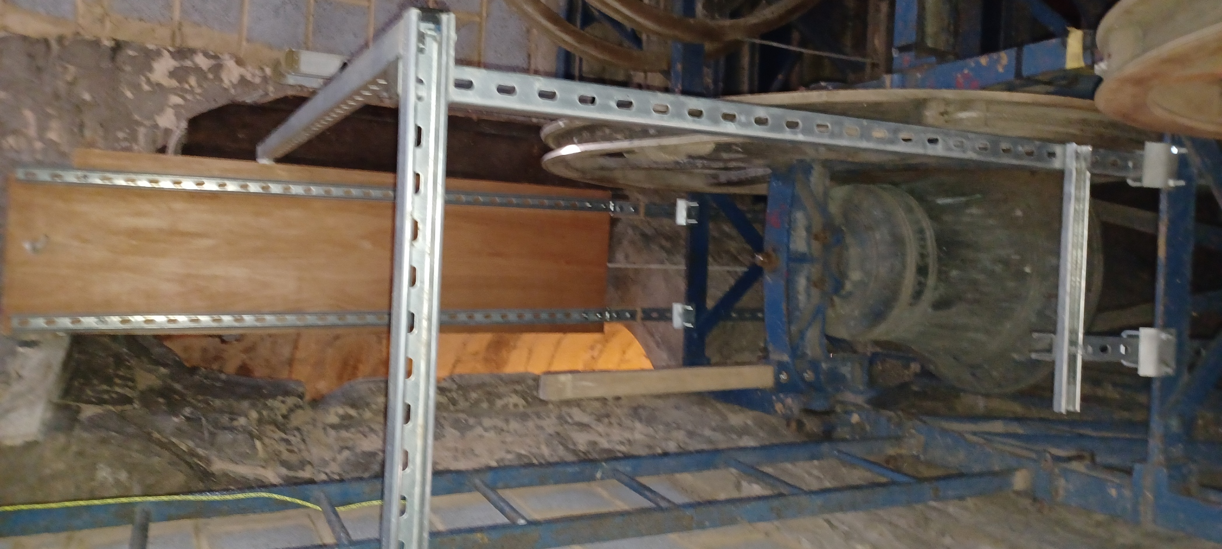
Figure 3. Platform in raised position

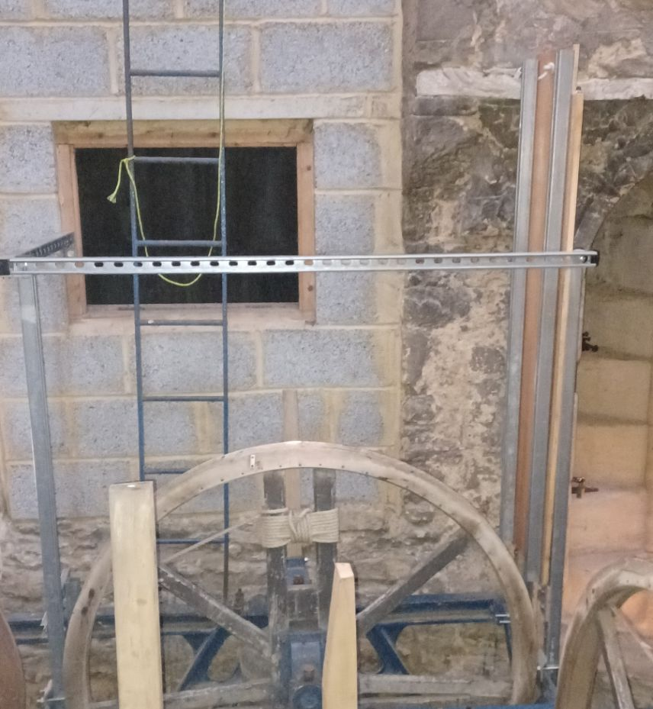
Figure 4. Platform in raised position
COMMENTS FROM ARCHITECT

From: davidllewellyn@prioryheritage.co.uk <davidllewellyn@prioryheritage.co.uk>
Sent: 18 August 2025 09:29
To: 'patrickalbon' <patrickalbon@gmail.com>
Subject: RE: Sharnbrook Church roof over bells

Hi Patrick

Thanks for your message which was received but unfortunately the reply had slipped my attention
I had thought the upper floor was protection against water ingress but if the volume of water is low / not causing a significant problem at present then I agree getting overly concerned about the weathering detail around the edge is probably unnecessary. If the company erecting the floor with the revised quote / specification are happy the timber structure is achievable and adequate then I have no objections.

The landing stage is not exactly how I would have detailed it / choice of materials but it is functional and I expect a useful improvement to safety.

Regards
David Llewellyn
Mobile 07849740365

Priory Heritage Historic Buildings Consultants
Lt Staughton, Bedfordshire, MK442BX
Telephone (01234) 376866 / (01767) 631293

