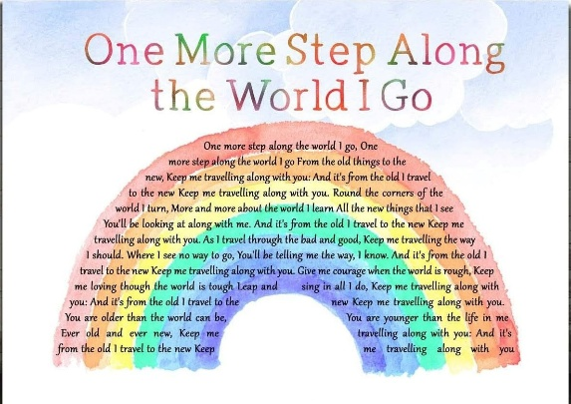
The Rector's Ramblings

Last weekend I had the joy of officiating at the first of six weddings in the parish this year (with two booked for next year already). I love weddings, because although they take a lot of work and time to organise, they are always such joyful and uplifting occasions and I leave the church with a spring in my step and usually the last hymn we’ve sung going round and round in my head, and last Saturday was no exception.
When I meet with the couple to plan the day, it is always interesting to find out what readings they have chosen, and especially which hymns. There are, of course, the classics such as Jerusalem, Love Divine all Loves Excelling and The Lord’s My Shepherd, but one that is becoming increasingly popular is One More Step Along the World I Go, mainly because of the chorus – ‘And it’s from the old I travel to the new, keep me travelling along with you’, and because it is a very catchy tune. For a couple getting married, it doesn’t matter if they have been together for six months or six years. It doesn’t matter if they already have a family. Getting married changes everything and they are, when they leave the church, travelling from the old into the new. Their new life together, their new future together, and although the hymn is obviously written for and to God, for a couple who have just exchanged vows to love through better or worse it carries a special and wonderful message to each other – ‘As I travel through the bad and good…where I see no way to go, you’ll be telling me the way I know’. They trust that the person they have just committed their life to will be with them, helping them, guiding them, supporting them, every step of the way, every new day.
As I drove home after the service (it was at West Dean in case you think I was incredibly lazy and drove just around the corner to Singleton Church) I was singing One More Step and it got me thinking that actually I should probably sing, or say, it to myself every morning, because every day is new, every morning I am leaving the old, the past, behind and taking one step at a time into a new day, into a new world. Now I know we don’t, we can’t, leave the past behind us every new day, because our past, our countries past, what happened 2000 years ago in Jerusalem, has shaped us into who we are, and continues to shape us, but we can learn from it without reliving it. As we start each new day we can do so in hope and expectation, or in despair and doubt. We can travel into the new day rejoicing in our blessings, or we can carry with us all our problems, all our disappointments, all our failures, from the day, week, month, before.
In The Lord’s Prayer, Jesus tells us to ask for our daily bread, not because we shouldn’t plan for the future, shop for the future, but because we should focus on today, we shouldn’t let today get lost in our plans, and anxieties, about what tomorrow will bring, what next week, next month, next year, will bring. My to-do list for this weekend is long, and getting longer, but I have a choice. I can get hung up on what I have to do tomorrow, what I have to do next week, or I can add it to the list, know that it needs to be done, but focus on today. Enjoy today, knowing that, as it says in the hymn, God will give me courage when the world is rough, and keep me loving though the world is tough, and that he is travelling along with me as I step into each new day. He is there to guide, support, encourage, and love all day, every day.
(Oh, and as a follow up from last week - my book shelves are now no longer groaning as there are 3 boxes of religious books ready to head into the second hand section of St Olav's after a very productive, and therapeutic, Bank Holiday Monday))
Rev Sarah
Worship in the Valley Parish
10th May
Holy Communion
10am Singleton
Bishop Martin retires at the end of May, and as a diocesan family we are beginning the search for his successor. Have your say in the appointment at tinyurl.com/next-bishop It will take only a few minutes to complete, and it is open until May 26th. We welcome responses from everyone.

Dates for your diaries
Annual Parochial Church Meeting  Wednesday 27th May @ 7pm  West Dean Church  Open to all residents and congregation, a meeting to elect Churchwardens, PCC members, and a review of last year, together with our plans for the year ahead.  This is a tough time for churches and church communities, please come and find out what you can do to help keep worship alive in the Valley parish. | Tuesday 30th June @ 7pm  Singleton Village Hall  From Stagecoach to Stagecoach -  300 years of travel in the Lavant  Valley  This illustrated talk by local historian Alan Green explores the importance of the Lavant Valley as a transport link north from Chichester towards London.  Tickets will be £10 each – more details on how to book to follow.  Raising funds for Standing the  Test of Time Buildings Appeal

Rev Sarah Manouch
07468 854864 priestvalleyparish@gmail.com Please note that I am part-time. My principal working days are Friday and Saturday as well as Sunday. I am not available on a Thursday.

