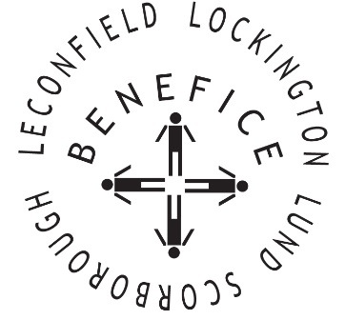

Church Services for
June 2026
Wherever you are from, you are welcome to join us for any of these services

Sunday 7th 9:30am Holy Communion St Catherine’s Leconfield
No Service at Scorborough this month

11:00am Morning Worship St Mary’s Lockington

Sunday 14th 9:30am Holy Communion St Mary’s Lockington

11:00am Morning Worship All Saint’s Lund

Wednesday 21st 9:30am Mid Week Service
With healing prayers St Catherine’s Leconfield

Sunday 21st 9:30am Holy Communion St Mary’s Lockington

7:30am Deanery Encounter
Prayer & Praise Evening All Saints, Lund

Thursday 25th 7:00pm Celtic Evening Prayers St Catherine’s Leconfield

Sunday 28th 9:30am Holy Communion All Saints Lund

11:00am Contemporary Worship St Mary’s Lockington

Service times, events and Messenger can also be found at:
http://www.achurchnearyou.com for the four churches

