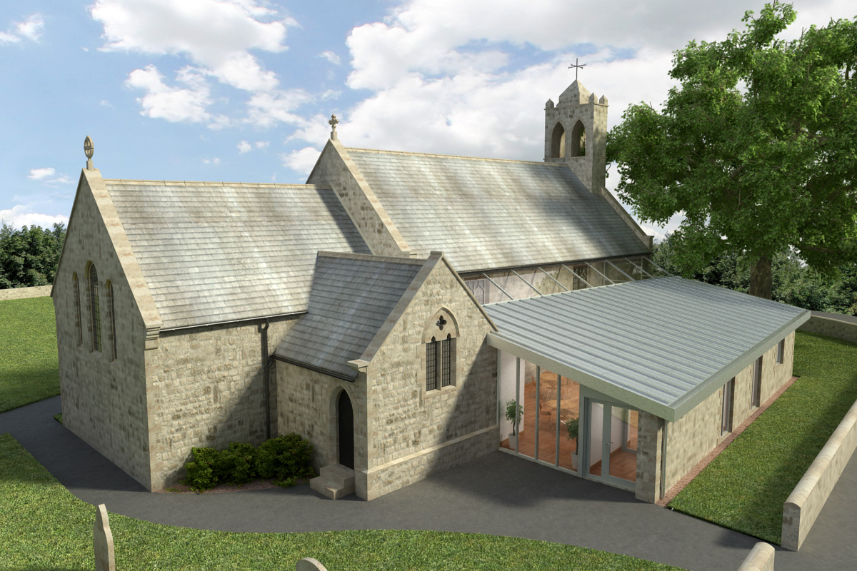
St Mary’s Parish Church, Longframlington

Welcome to our Sunday Morning Prayer. On Sunday 10 May, which is Sixth Sunday of Easter, when our Officiant will be Rev Rich and Tony playing the organ. Next week, Sunday after Ascension (Easter 7) our Officiant will be Rev Michael and Steve playing the organ. Ascension Day service at Brinkburn Priory, Thursday 14 May at 7 pm with the Area Dean and the Bridge Singers. All welcome.
Coming up at St Mary’s and our sister parishes+- Morning Prayer in St Mary’s – and on Zoom – usually every Wednesday morning at 9.30 am followed by coffee in the Community Room. The Link can be made using Meeting ID889 6133 2870, Password 093043. New people always welcome either on screen or in church.
URC Clearance Items – Please get in touch with Aileen on norskwood.aileen@gmail.com or Pat, telephone 01665 570 820. Various items include tables, chairs, bookshelves, electronic piano/organ, large White board, hymn books varied, crockery, cutlery, wine glasses, and many more. From church, kitchen and hall. Still ongoing.
URC Domino Drive – Friday 15th May at 7 pm in the Community Room.
URC Spring Coffee Morning – This will be held on Saturday 23rd May 10.30 am – 12 Noon in St Mary’s Community Room. All welcome.
A meeting of the new PCC will be held in the Community Room on Wednesday 13th May at 7 pm led by the Rev Rich. Welcome to new members.
Thy Kingdom Come – a week of prayer begins 14 May until Pentecost. Booklet available at the back of the church. Also a leaflet of events that St Michael are arranging.
Other Notices – these are available in the shared Pew Sheets and on posters in and around the church please note them.
Thank you for your giving to the life and work of our church. Our offering is taken during the third hymn, and there is a collection giving point at the back of the church for use after the service if you prefer. Regular giving by Standing Order with Gift Aid is particularly valuable to the church – speak to Audrey (01665 570 922) for more information and blank forms. All our news and much more available on our Facebook page https:www.facebook.com/SMCLongfram/?ti=as and You Tubechannelhttps:www.youtube.com/@stmichaelsfeltonstmaryslonPriest in Charge: Rev Rich Townend Phone 01670 719470 Email:revrichtea@gmail.com Regular day off is Monday, for St Mary’s information contact Veronica Thomson (01665 570 807) or Audrey Truman (01665 570922).

