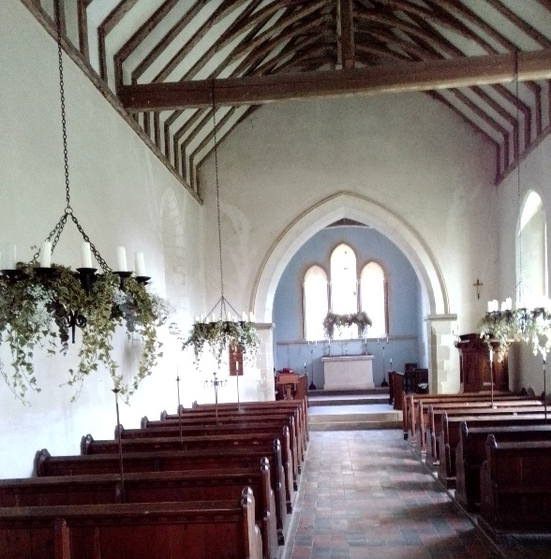
The Friends Of St. Leonard’s Church, South Stoke

Established in 2023
Our aim is to preserve this beautiful church building, inside and out, for all future generations .
To encourage everyone, whether they worship or not, in nearby Arundel and beyond, to support the preservation of the building.

The Purpose of The Friends Of
St Leonard’s Church South Stoke :

Is to raise funds solely to support the cost of repairs and maintenance to the fabric of the church building.
Initially, we are concentrating on the essential reroofing of the church.
Along with this, there will always be future repairs needed to keep the entire fabric of the building, inside and out, in a good state.
Unforeseen emergency repair work will also be required as time goes by.
By becoming a Friend, you will help to ensure that the building is preserved and enhanced for future generations.
There will also be an opportunity to enjoy future fundraising events for St. Leonard’s Church.
If you become a Friend, you might also be able to offer some of your time and expertise towards looking after this beautiful building, should you wish.

Please Consider Becoming A Friend .
It will help us to achieve our aim.
We ask that you pay a minimum of £10 per person, per year.
Please complete the Friends Membership Application Form below, and return it to :

The Friends Of St. Leonard’s Church, South Stoke,
c/o Tarrant House,
42 Tarrant Street,
Arundel, BN18 9DN

Alternatively: Complete the Membership Application Form below, scan it and email it to :
Diana Hawkins at : oliveranddiana@gmail.com

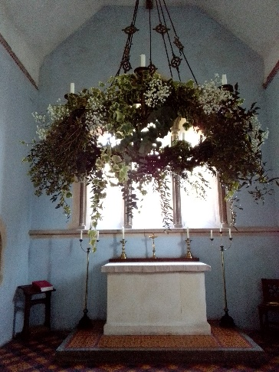

Friends Of St. Leonard’s Church Membership Application Form

I/We would like to become a Friend Of St. Leonard’s Church, South Stoke

Please Print

Name(s) :…………………………………………………………………………………………………..

Address :……………………………………………………………………..

……………………………………………………………………………………

……………………………………………………………………………………

Post Code:…………………………………………………………………..

Email Address :

…………………………………………………………………………………..

Date :………………………………………………..

Please Insert The Amount Of Annual Subscription
You would Like To Pay Below

£……………………

Single Membership : £10 minimum, per person

Gift Aid Declaration
Please treat all of my subscriptions and
Donations to The Friends Of St. Leonard’s
Church, South Stoke as Gift Aid Donations.
I confirm that I pay Income Tax
and/or Capital Gains Tax.

Signature……………………………………………………………..

Data Protection Act :
I/We agree to my membership details being held on a database by The Friends Of St. Leonard’s Church, South Stoke.

Signed:………………………………………………………………………………………

Membership Payment Options

CHEQUES: Please make out your cheque to : PCC SOUTH STOKE and send it, along with the Membership Application to :

The Friends Of St. Leonard’s Church, South Stoke
c/o Tarrant House
42 Tarrant Street,
Arundel, BN18 9DN

BANK TRANSFER : To pay via your Online Bank Account, using “Faster Payments” (FP) or BACS – Our Bank Details Are :

Business Account Name : PCC South Stoke
Sort Code : 60-01-18
Account number : 96048565
Reference : FSL (Then Your Surname)

STANDING ORDER :
Please complete your Standing Order Instruction via your Online Bank Account, or your Branch, using our Bank Details above.
You will have the option there to pay your Friends Membership annually.

Our Sincere Thanks For Your Support

