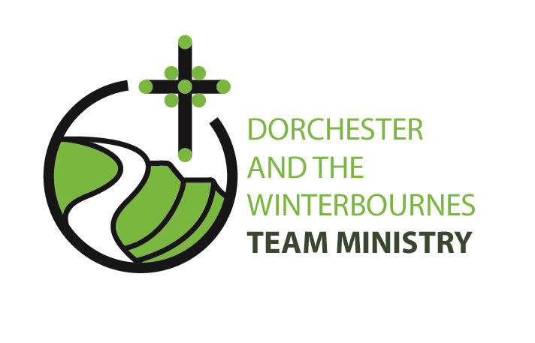Safeguarding

Policy and Procedure

Table of Contents

Introduction 3
Agreement 4
Procedures to identify, respond to and report concerns 5
1. Who is vulnerable and why? 5
2. What do we do? 5
Vulnerable Adults: 5
Children: 6
Events – External/Internal 6
3. How do we implement safeguarding practice? 7
4. Who requires DBS clearance? 9
5.Reporting Concerns: 9
6. Supporting documents: 11
Appendix A - Safeguarding Representatives contact list 12
Appendix B - Safeguarding Risk Assessment 13
What is the hazard and who might be harmed? 13
What is already being done? 13
What is the hazard? 13
What is the remaining risk? 14
What further action is needed? 14
Who is responsible for doing it and by when? 14
Example safeguarding risk assessment 15
Risk-benefit assessment form - Advent Craft Day 15
Appendix C – Regulated Activity Decision Making Flowchart 16
Appendix D - Data Protection Act 1998 (Summary) 17
Data Protection Act 1998 17
Security 17
Appendix E - Safeguarding Flowchart: What to do, by whom and by when 20
Appendix F - Safeguarding Risk Assessment Form 22

Dorchester and the Winterbournes Team Ministry

Safeguarding Policy

Introduction
Safeguarding is creating an environment which is safe physically, emotionally and spiritually and which has the welfare and well being of children and vulnerable adults at its heart.
We have produced this local policy guidance based on the needs and work of the Dorchester and The Winterbournes Team Ministry and to implement the safeguarding policy of the Church of England ‘Promoting a Safer Church’.
We asked: Who is vulnerable and why?
What do we do in our Team?
How do we implement safeguarding practice?
Who requires DBS clearance?
How are concerns reported?

These five questions form the basis for the policy.
It is important to note that this policy will be reviewed annually and updated if necessary according to the needs of the Dorchester and The Winterbournes Team Ministry.

Agreement

Dorchester and The Winterbournes Team Ministry
Policy on the Safeguarding of Children and Vulnerable Adults
in the Church
In drawing up this policy we have followed the safeguarding guidelines of the Church of England and commit ourselves to promoting safe practice by those in positions of trust.
We undertake to exercise proper care in the appointment and selection of those who will work with people who may be vulnerable – in both paid and voluntary posts.
The Team PCCs will continue to support, resource, train and regularly review those who undertake work with people who may be vulnerable.
Each person who works with vulnerable people will agree to abide by these recommendations and the guidelines established by this church.
This policy is reviewed each year by the Team Ministry Safeguarding Review Group and presented to the Team PCCs.
The PCCs appoint a safeguarding representative for each church who will work with the Dorchester Team Ministry’s safeguarding representative. (See Appendix A ‘Key Contacts’ for detail.)

Keith Magee
Team Rector: .........................................................................
26.11.24
Date: ..................................................................................

Procedures to identify, respond to and report concerns
Risk to be balanced against practicalities

1. Who is vulnerable and why?
Vulnerability is considered to be something anyone might experience whenever they are in a situation where another person can exercise power, in the form of legitimate authority, over them. (Safeguarding Vulnerable Group Act 2006) (Disability Discrimination Acts 1995 & 2005)
- Vulnerable adult. Any adult aged 18 years or over who, by reason of mental ill-health, a learning disability, age, physical disability or other illness is permanently or for the time being unable to take care of him or herself, or unable to protect him or herself against significant harm or exploitation.
- Children. In the Children’s Acts 1989 and 2004 a child is anyone who has not reached their 18th birthday.

2. What do we do?
- Church Services
  - Online meetings and services
- Home Visits
- Cell groups (home groups, Lent groups, discussion groups)
- Events (external/internal)
- Flowers and cleaning
- Bell ringing
- Transport
- Music in church
- Children’s Groups
All Church activities carried out are subject to risk assessment procedures. For the purposes of this policy (i.e. Safeguarding) only activities deemed to be Regulated Activities are considered.

Vulnerable Adults:
- A normal Church Service is not a regulated activity.
- Transportation of a vulnerable adult is a regulated activity but transport to and from Church does not require DBS clearance.
“The volunteers who are part of the rota to bring church members who would otherwise be unable to attend church, are NOT engaging in Regulated Activity as Church services are not covered by the Protection of Freedoms Act - unless they collect Care Home residents, in which case they would be in Regulated Activity.”
However... “A church worker who is part of a group of volunteers that drive church members to their GP surgery or hospital appointments is working in Regulated Activity.”
- A Cell Group (Home Groups) is not a regulated activity. Checks are required if the group consists mainly of vulnerable adults meeting “weekly, or 4 or more days in a 30 day period...”
- Lunch Clubs are not a regulated activity, unless... ”they are giving professional counselling/health care or personal care to adults”
- A Home Visit is a Regulated activity. Clearance required... ”A church worker who visits housebound people and on occasions is asked by the homeowner to do some shopping or pay a bill on their behalf is engaging in Regulated Activity.”
A record should be kept of all home visits and of any gifts received: “Any gifts received should be disclosed to a supervisor or colleague where it should be decided whether they could be accepted”
‘Frequently’ for the purpose of Regulated Activity only is once a week or more
‘Intensively’ is four or more days in a 30 day period or overnight.
‘Personal Care’ is defined as those who provide or prompt an adult with physical assistance with eating, drinking, toileting, washing or bathing, dressing, oral care or care of skin, hair or nails due to the adult’s age, illness or disability, these would be in Regulated Activity (except in circumstances where a hairdresser or a person cuts the hair of an adult)

Children:
Eligibility is different with children – if the worker is not in regulated activity then as long as they are a Trustee of a charity that works with children or the applicant works with children more than occasionally (on a rota or intensively—overnight or 4 or more days in a 30 day period) then they would still be eligible for an enhanced disclosure but without a check of the barred list.
Source – CCPAS (The Churches’ Child Protection Advisory Service), C of E Promoting a Safe Church

Events – External/Internal
- Every event organiser must do a risk assessment of the proposed event (using the form in Appendix B).
- As well as the event itself, the site should also be assessed.
NB most public buildings should already have a risk assessment available for users.
- Using the regulated activity decision-making flowchart (Appendix C), determine whether the person running the event must hold the appropriate level of DBS clearance e.g. enhanced DBS Check with barred list check for those working with children or vulnerable adults.
- Once completed, a copy of the risk assessment must be given to the Parish Safeguarding Representative.
Children’s Events (e.g. Advent Craft Day)
- Note the recommended ratio of adult helpers to children
- Information forms to be completed by parents/carers giving contact information, dietary requirements.
- Permission forms needed e.g. for emergency medical intervention, photographs/video of the event.
- First aid arrangements
Anyone carrying out any of the following must have DBS clearance
Personal Care – Child (any frequency - Regulated Activity)
- Physical help with eating or drinking for reasons of illness or disability
- Physical help with toileting, washing, bathing or dressing for reasons of age, illness or disability
- Prompting together with supervision when a child is otherwise unable to decide for themselves in relation to any of the above personal care activities
- Training or advice given to a child in relation to any of the above personal care activities.
Personal Care – Adult (any frequency – Regulated Activity)
- Physical assistance with eating or drinking, toileting, washing or bathing, dressing, oral care or care of the skin, hair or nails provided for reasons of age, illness or disability.
- Prompting together with supervision when an adult for reason of age, illness or disability is otherwise unable to decide for themselves in relation to any of the above personal care activities.
- Training, instruction, advice or guidance given to an adult for reasons of age, illness or disability in relation to any of the above personal care activities.

3. How do we implement safeguarding practice?
Health and safety should be managed as part of all activities and each church shall keep an accident logbook, first aid kit and one person from each church shall have attended an approved first aid course.
- Identify procedures/roles.
What is the function and the roles involved in carrying it out? Use the regulated activity decision-making flowchart (Appendix C).
- Safeguarding Risk assessment
  - each role and task involved with the event to be assessed;
  - a risk assessment should be in place for all new and existing regulated activities both one off and regular events and renewed at least annually (Appendix B).
The completed safeguarding assessment to be approved and lodged with the safeguarding representative.
Responsible Adults – For each activity there must be a nominated responsible adult. (Use the regulated activity decision-making flow chart (Appendix C) to determine whether DBS clearance is required).
Training and guidelines
Individuals needs to be aware of their safeguarding responsibilities.
Specific role descriptions to determine training needs can be found in the Team Office and on the Training and DBS section of the Safeguarding area of the diocesan website
Data and data protection – safe keeping of personal data. Data Protection Act 1998 (Appendix D).

4. Who requires DBS clearance?
Role | DBS | Notes
Bellringer | No | Unless in a supervisory/teaching role with junior bell ringers
Children’s worker | Yes | Unsupervised, personal care.
Choir Leader | Yes | If supervising/teaching children or supervising those who do.
Choir member | No | Unless also has chaperone/teaching role with junior choir members
Churchwarden | No | Unless circumstances dictate – see the Regulated Activity Flow Chart at Appendix C
Coffee/tea servers | No | -
Driver of Adults at Risk | Yes | For ‘social/health/personal ‘care. Not visits to church.
Driver of Children | Yes | -
Flower Arranger | No | -
House Group | No | -
Home Visitor | Yes | -
Clergy/Lay Ministers | Yes | All clergy holding the Bishop’s licence and all licensed and authorised Lay Ministers
Organist | No | Unless also has chaperone/teaching role with junior choir members
Pastoral Worker | Yes | -
PCC Member | Yes | -
Prayer Team Member | No | Unless regularly praying unsupervised with children
Server | No | Unless in a supervisory/teaching role with junior servers
Steward/Sides person | No | Unless specifically designated to supervise/toilet children
Tower Captain | Yes | If supervising/teaching children or supervising those who do
Church Safeguarding Officers | Yes | -
Volunteers | Yes | Where deemed necessary following risk assessment procedures – see the Regulated Activity Flow Chart at Appendix C
Vergers | Yes | -

N.B Refer to updated guidance on the diocesan website using the following link:
http://www.salisbury.anglican.org/parishes/safeguarding/what-DBS-or-safeguarding-by-role

5.Reporting Concerns:
- Reporting procedures
In accordance with Diocesan guidelines all event leaders to be aware of who to contact in the first instance. Contact details for the Team Safeguarding Representative and the Church safeguarding officers are displayed in each church. (See Appendix A for contacts.)
If the person is at immediate risk of physical harm, or needs medical attention, dial 999 to contact the Ambulance Service and/or the Police. Follow any advice given. (Appendix E)

6. Supporting documents:
Promoting a Safer Church:
https://www.churchofengland.org/media/3896819/cofe-policy-statement.pdf
Domestic Abuse:
http://www.salisbury.anglican.org/parishes/safeguarding/domestic-abuse
Safer Recruitment Practice Guidance:
http://www.salisbury.anglican.org/resources-library/parishes/safeguarding1/parish-resources/recruitment/2016-safer-recruitment-practice-guidance/view?searchterm=safer%20recruiting
Data Protection Act 1998
https://ico.org.uk/for-organisations/guide-to-data-protection/key-definitions/
(Also see Appendix D for a summary of the Act)
GDPR (General Data Protection Regulation)
https://www.salisbury.anglican.org/resources-library/parishes/data-protection

Acknowledgements:
House of Bishops – Protecting All God’s Children
Church of England – Promoting a Safe Church
CCPAS – The Churches’ Child Protection Advisory Service

Appendix A - Safeguarding Representatives contact list

Team Safeguarding Officer:

Diocesan Safeguarding Advisor:

Suzie Futcher 07500664800
Jem Carter 07469857888
Tracie Hancock 07557 422387 (Mon -Wed)
Both: safeguarding@salisbury.anglican.org

Church Safeguarding Representatives:

St George’s, Fordington – Vacancy
St Andrew’s, West Stafford – Linda Purr (0791968674)
St Peter’s, Dorchester – Jane Pryce (01305 269937)
St Simon and St Jude, Winterborne Monkton – Peter Vojak (01305 265994)
St Mary’s, Dorchester - Peter Vojak (as above)
The Winterbournes (St Martin’s, Martinstown, St Michael’s, Winterbourne Steepleton, St Mary’s, Winterbourne Abbas) –
St Thomas a Becket, Compton Valence –
DBS verification: Judy Cowling (judy.cowling@gmail.com)

Appendix B - Safeguarding Risk Assessment

What is the hazard and who might be harmed?
Think about the people who use the venue. They might include adults, small children, teenagers and people with disabilities. The risks will be different for different groups. Consider the developmental level stages of children and young people. Think about how people of different sizes, mobility or level of understanding may be affected differently by the potential hazards in the environment.
Complete the blank Safeguarding Risk Assessment Form (Appendix F) taking into account the following considerations. (See the below example for guidance)

What is already being done?
Refer to the existing risk assessment for the general use of the venue.
It is worth thinking about all the things you are already doing to make the venue safer. This might include physical things, like lighting, notices, ramps, handrails or it could be procedures.

What is the hazard?
Think about the physical environment, the activities and equipment.
The physical environment might include:
- Roads
- Car park area
- Steps and stairs
- Uneven surfaces
- Windows
- Cupboards
- High ceilings
- Seasonal changes e.g. snow and ice, fallen leaves, dark nights etc.
The activities that take place might include:
- Services (indoor and outdoor)
- Cleaning
- Flower arranging
- Catering
- Transport
- Moving and handling
- Visiting parishioners
- Special events e.g. children’s activities, concerts, home groups, lunches etc.
- Outside maintenance
Equipment might include:
- Ladders
- Electrical equipment
- Flower stands and vases.
- Stored objects
Possible types of accident could include:
- Slips, trips and falls
- Electric shocks
- Accidents involving broken glass or other sharp objects
- Fire

What is the remaining risk?
After you have taken your existing safeguarding measures into account, you need to prioritise the remaining risk. For each risk (before and after), select a number one to four, to indicate the likelihood of a particular accident happening. A score of one would mean that the risk was ‘unlikely’ to occur, with two being ‘fairly unlikely’, three being ‘fairly likely’ and four being ‘very likely’.
The impact of the risk and its severity should also be considered and it may be appropriate to ‘score’ the impact by selecting a number from one to three as follows: one would mean that there is ‘minor impact’ on the individual, with two being ‘fairly serious impact’ and three serious being ‘very serious impact’.
Multiply these two numbers together to give the remaining score.
Multiply these two numbers together to give the remaining risk a score, and note this on the form. The higher the score, the greater the priority that you need to give to dealing with that risk.

What further action is needed?
List the things that you are not already doing but that you are going to do to manage the risk effectively.

Who is responsible for doing it and by when?
Write the name of the person responsible. Insert a realistic date for completing the things that need to be done.

Example safeguarding risk assessment

Risk-benefit assessment form - Advent Craft Day

Type of event/description:
Craft activities, pub visit, service. Event over a 5-hour period. 30 children. Activities in church, lunch at pub. All children 5+

Identified Risks:
Wandering off, toileting, hygiene, minor injuries, journey to pub

Hazard observed | Existing measures and risk level | Persons at risk | Control measures | Remaining risk level | Who is responsible and by when.
Supervision of 30 children | 1 adult to 3 children. High | Children | 1:3. No child to be left with one adult. 3 Church DBS + 3 add | Low | DCW/AC
Toileting | Helpers houses. High | Children/Adult | 2 adults (or more depending on no’s) | Low | DCW/RD
Lunch. Escorting children to pub along roadside | Walking to pub, traffic, straying children. High | Children | Children to assemble together and process in crocodile formation. Marshall at front rear and sides (min 4 escorts) | Moderate | DCW
Photographing and data | Publishing of photo’s. Data. Low | Children, parent | Written parental permission. Data to be stored for one year | Low | DCW
Hygiene, first aid, emergencies | Accident, child ‘crisis’ | Children | Hand washing. ‘Quiet’ supervised quiet area | ? | ?

Do any of the activities planned come under the DBS category or Regulated Activity and require DBS clearance?

1. Are there any vulnerable adults? No
2. Are there any unaccompanied children? Yes
(If ‘Yes’ to either of the above please state in the form what safeguards are in place.)

Sufficient DBS checked and other adults to supervise – see control measure above.

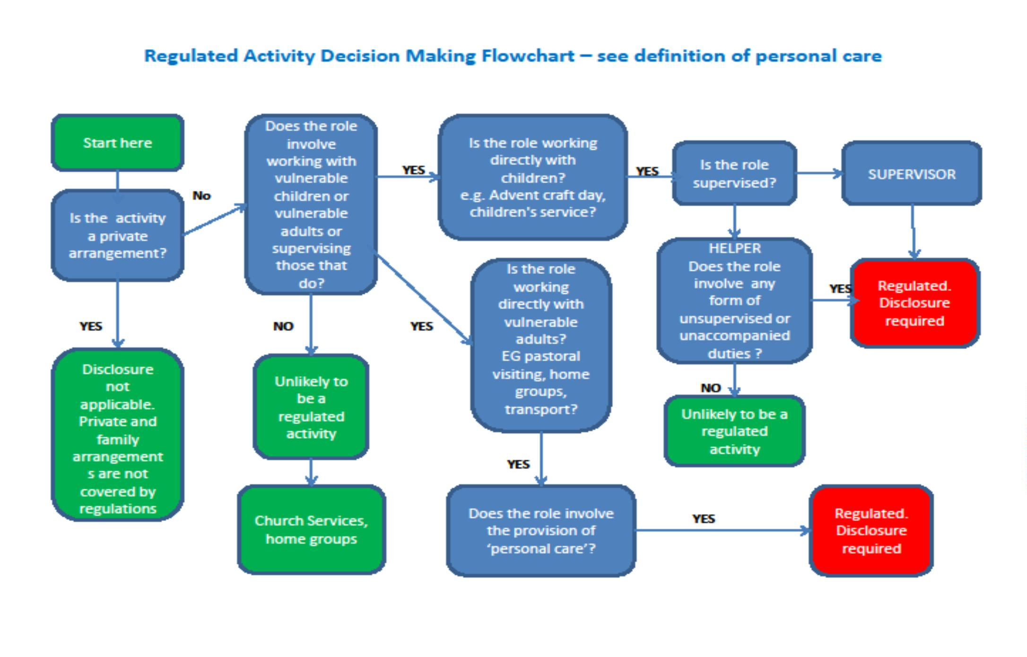
Appendix C – Regulated Activity Decision Making Flowchart

Appendix D - Data Protection Act 1998 (Summary)

Data Protection Act 1998
The Data Protection Act makes provision for the regulation of the processing of information relating to individuals, including the obtaining, holding, use or disclosure of personal information.
Personal data means data which relate to a living individual who can be identified:
- from those data, or
- from those data and other information which is in the possession of, or is likely to come into the possession of, the data controller and includes any expression of opinion about the individual (e.g. assessment and opinion of an employee’s performance ) and any indication of the intentions of the data controller or any other person in respect of the individual.
Sensitive personal data means personal data consisting of information as to:
- the racial or ethnic origin of the data subject,
- their political opinions,
- their religious beliefs or other beliefs of a similar nature,
- whether they are a member of a trade union,
- their physical or mental health or condition,
- their sexual life,
- the commission or alleged commission by them of any offence, or
- any proceedings for any offence committed or alleged to have been committed by them, the disposal of such proceedings or the sentence of any court in such proceedings.
For further information use the following link to the Information Commissioner’s website:
https://www.gov.uk/government/organisations/information-commissioner-s-office

Security
- Restrict hard copy and e-mail
- Shred additional copies of sensitive material – keep the original
- Keep one record and signpost to where other records are kept. All sensitive information can be held in the secure cabinet in the Team Office
- Password protect files
- Only the roles in the church/diocese as agreed should have access
- Don’t put sensitive information in e-mails
- Don’t leave sensitive information in voicemail messages
N.B. The General Data Protection Regulation governs the processing of personal data. Further information is available from the Diocesan website document Data Protection and the Parish Guidelines (November 2018)

Appendix E - Safeguarding Flowchart: What to do, by whom and by when
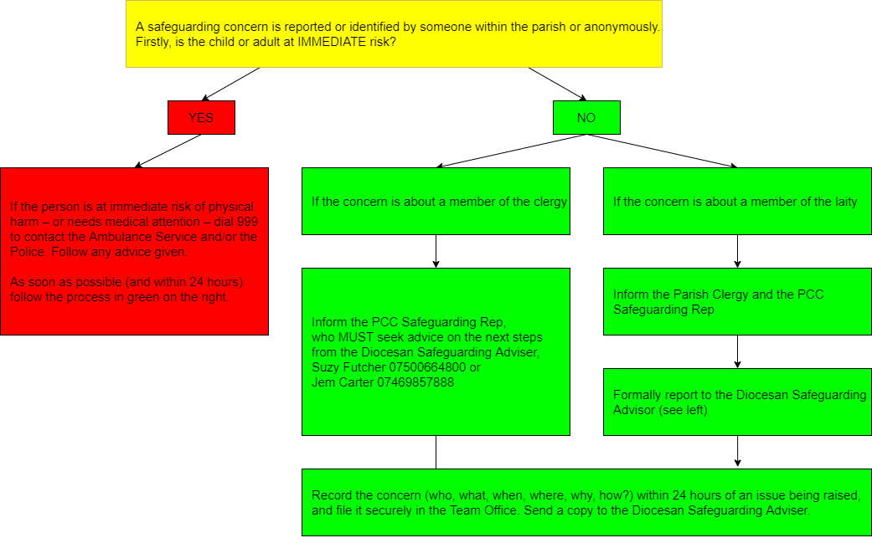

Appendix F - Safeguarding Risk Assessment Form
(when completed please send to your Church Safeguarding Representative)
Type of event:

Identified Risks:

Hazard observed | Existing measures and risk level | Persons at risk | Control measures | Remaining risk level | Who is responsible and by when.

Do any of the activities planned come under the DBS category or Regulated Activity and require DBS clearance?
1. Are there any vulnerable adults? Yes/No
2. Are there any unaccompanied children? Yes/No
(If ‘Yes’ to either of the above please state in the form what safeguards are in place.)

