SUNDAY 31st May 2026.



Loving God and Loving our Neighbour


Although we are currently without a permanent Rector, services in the Benefice continue with the assistance of visiting clergy. Please do join us – you will be made very Welcome!! The post will continue to be advertised and further updates will be featured in the newsletter

Sunday 31st May Trinity Sunday
10.00am Watton Holy Communion. Benefice service.
No service at Aston, Bramfield, Stapleford or Waterford.
11.15am Watton Contemporary Service

Sunday 7th June Trinity 1
11.00am Watton Contemporary service.
11.00am Aston Prayer and Praise
11.00am Stapleford Prayer and Praise
11.00am Waterford Holy Communion



MIDWEEK
Fortnightly MONDAY 2pm ASTON Bible Study Fellowship 3 Long Ridge Aston with tea and biscuits. All are welcome. Next meeting Monday 1st June Contact Pauline at pauline.manley1966@gmail.com

Alpha Course. Where: 85 Great Innings South, Watton at stone, SG14 3TF. Mondays at 10.00am. Please call Jane:07867016430 or email Richard@Takeawaychurch.com Alpha:uk@alphja.org

NIGHT PRAYER Alternate WEDNESDAYS at 7.30pm on ZOOM. Next meeting Wednesday 10th June. All welcome. Contact Tim Alexander for link tim_alexander3@hotmail.com

Saturday 30th May 2pm Waterford live Music day. Tickets £10. Contact Sarahbaldwin59@hotmail.com

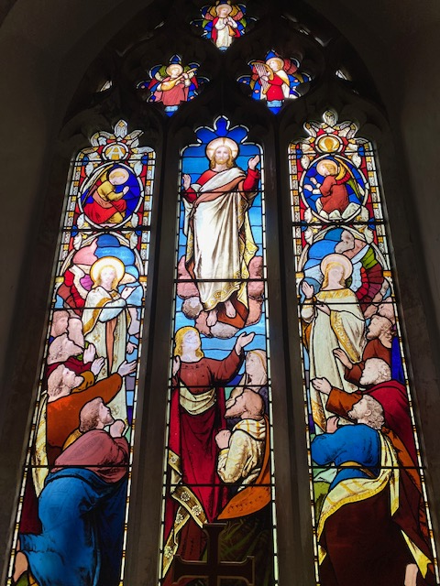
C0llect Prayer for Sunday 31st May Trinity Sunday. Almighty and everlasting God, you have given us your servants grace, by the confession of a true faith, to acknowledge the glory of the eternal Trinity and in the power of the divine majesty to worship the Unity: keep us steadfast in this faith, that we may evermore be defended from all adversities; through Jesus Christ your Son our Lord, who is alive and reigns with you, in the unity of the Holy Spirit, one God, now and for ever. Amen

The east window in St Andrew’s Church, Bramfield behind the altar shows Jesus lifted up to heaven, the end of his earthly life, his return to God’s right hand on high


Hymn 33 Mission Praise. And can it be. Author: Charles Wesley
Charles Wesley, M.A. was the great hymn-writer of the Wesley family, perhaps, taking quantity and quality into consideration, the great hymn-writer of all ages. Charles Wesley was the youngest son and 18th child of Samuel and Susanna Wesley, and was born at Epworth Rectory, Dec. 18, 1707.
1 And can it be that I should gain  An interest in the Saviour's blood?  Died He for me, who caused His pain?  For me, who Him to death pursued?  Amazing love! how can it be  That Thou, my God, should die for me?  2 'Tis mystery all! The immortal dies!  Who can explore His strange design?  In vain the firstborn seraph tries  To sound the depths of love divine!  'Tis mercy all! let earth adore,  Let angel minds inquire no more. [Refrain] | 4 Long my imprisoned spirit lay  Fast bound in sin and nature's night;  Thine eye diffused a quickening ray,  I woke, the dungeon flamed with light;  My chains fell off, my heart was free;  I rose, went forth and followed Thee. [Refrain]  5 No condemnation now I dread;  Jesus, and all in Him is mine!  Alive in Him, my living Head,  And clothed in righteousness divine,  Bold I approach the eternal throne,  And claim the crown, through Christ my own. [Refrain]

PRAY for PEACE in The Middle East, UKRAINE and all areas of conflict


Lord God, though peace seems humanly impossible,

We continue to pray for an end to violence and bloodshed. We pray your comfort for the fearful and broken – hearted.


Change the hearts of those set on revenge and destruction.

Give wisdom to world leaders as they respond to aggression.

Bless all who work for understanding, reconciliation and justice which alone bring lasting peace. Amen.

‘God give us peace that lasts, not through the fear of might, but through the force of love, and love of life and right’. Amen

We believe that responding to the climate crisis is an essential part of our responsibility to safeguard God's creation and achieve a just world. Climate change hits hardest the poorest countries and poorest people of the world. Meantime, the widespread destruction of the natural world is a crisis for creation.

Our Environment Programme exists to enable the whole Church to address this — in faith, practice and mission. This includes tackling our own carbon emissions (aiming for Net Zero Carbon by 2030) and our wider work. More information can be found using the following web-link: http://www.churchofengland.org/about/church-england-environment-programme#na

Energy Hub Funded by UK Government: Find out how to:

1. Save energy

2. Save money. Reduce energy bills

3. Reduce carbon. Improve energy footprint

4.Increase comfort

For useful resources and guidance on where to get started visit: linktr.ee/energy_hub


https://app.ecochurch.org/user/21703/summary

EcoChurch - EcoTip for May
Is your garden environmentally friendly? You've probably heard of no mow May. Could you have a dedicated wildflower area? If you buy potting compost, or plant feeds are they organic? Could you grow more of your own vegetables? If you just have windowsills, could you grow tomatoes, other veg, or herbs? (They taste SO much nicer than supermarket ones). Or, you could get an allotment - details and application on Stevenage council website.

NEW RECTOR RECRUITMENT UPDATE –

Sadly there have been no applicants this time. The vacancy will have to be re advertised. A huge thank you to Churchwardens, Readers, LLWs, volunteers and visiting clergy for the enormous amount of extra work needed to keep Sunday services and other church business going.

Good news. Downing Street has announced that the Rt Revd Dr Andrew Rumsey, currently Bishop of Ramsbury in the Diocese of Salisbury, is to be the next Bishop of St Albans. Bishop Andrew returns to the Diocese in which he was born and baptised, describing the appointment as “a homecoming” and saying he is thrilled to be joining a “fine team”

CARING for our CHURCHYARDS

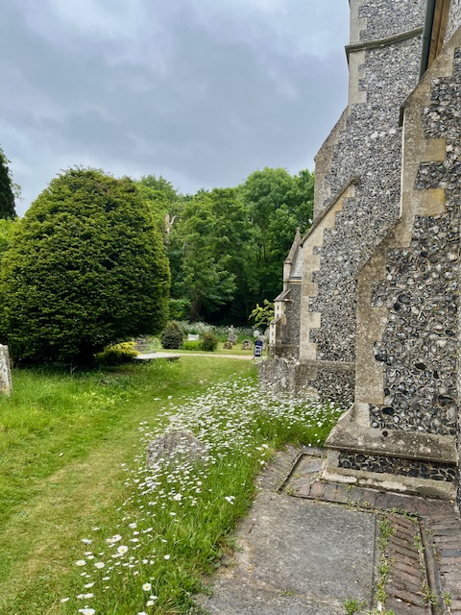
TUESDAYS Waterford Working Parties – Contact Churchwarden Malcolm Wandrag to offer help m.t.wandrag@gmail.com
To help in Stapleford or Watton or Bramfield please contact the Churchwardens.ASTON church open Sundays 12.00-16.00 and Wednesdays 10.00 -17.00 Church and churchyard working parties first Tuesday of month 10am to 12 noon. Contact Churchwarden Sara wardenstmarys@gmail.com
All our churchyards are cared for by volunteers.
Donations and offers of help are welcomed.
To include a loved one in the Book of Remembrance contact the churchwardens

Prayer for Growth for Aston, Bramfield, Stapleford, Waterford and Watton at Stone
Jesus teaches us to pray for our churches to grow. Jesus says: ‘Ask the Lord of the harvest, therefore, to send out workers into his harvest field’ (Matthew 9:38). In ways we don’t understand, God uses all our prayers.

Heavenly Father, you call us to sow seeds of faith in our communities. We ask you to fill us with your Holy Spirit that our lives may show the joy and new life we have in you. Guide our speaking and actions that others may be drawn to know your love. Lord Jesus, bless our churches that we may grow in numbers, love and service. We ask this in your name. Amen.

We pray for others to know God’s love. Tie 5 knots in a piece of string - let each knot represent a friend or family member. Keep the string in your pocket and, as you feel the string, pray for those people to know God’s love. Set an alert on your phone to remind you to pray for those 5 people every day.
A prayer for those who seek to know God.
Lord Jesus, when your followers walked the Emmaus road wondering what was true and what was not, you came alongside them and revealed yourself in Scripture and in broken bread. Come alongside those we know and love who may wonder or seek at this time. Reveal yourself in your love and make us ready to walk alongside them too, until they see your face and know your presence. Amen.
Heavenly father we pray for guidance for our Beane valley benefice churches during the vacancy. Amen.
In Touch Age UK Hertfordshire
offer confidential, non-judgemental emotional and practical support on bereavement, physical & mental health issues, cancer, end of life, a partner with dementia or any other problem. Call 01992 634964/630623 or email intouch@ageukherts.org.uk Web page Age UK Hertfordshire | Our Services











Bereavement Support You can access online help at griefshare.org thebereavementjourney.org cruse.org.uk teardropgrief.co.uk ataloss.org
’s
afternoon
Tea

rty
at 64 Rivershill
Sunday 24th July 2.00-5.oopm

Bring & Buy <> Raffle <> Jams
Proceeds to Both

TAKE AWAY AVAILABLE

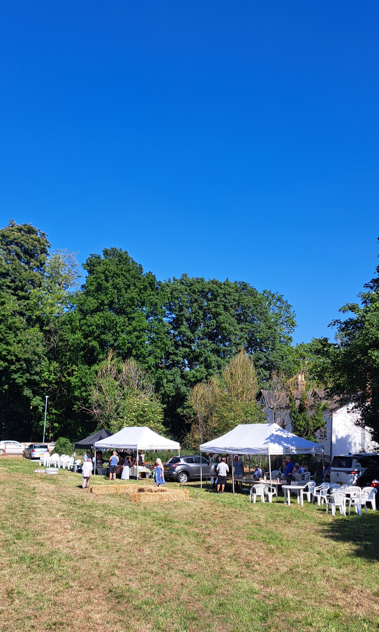
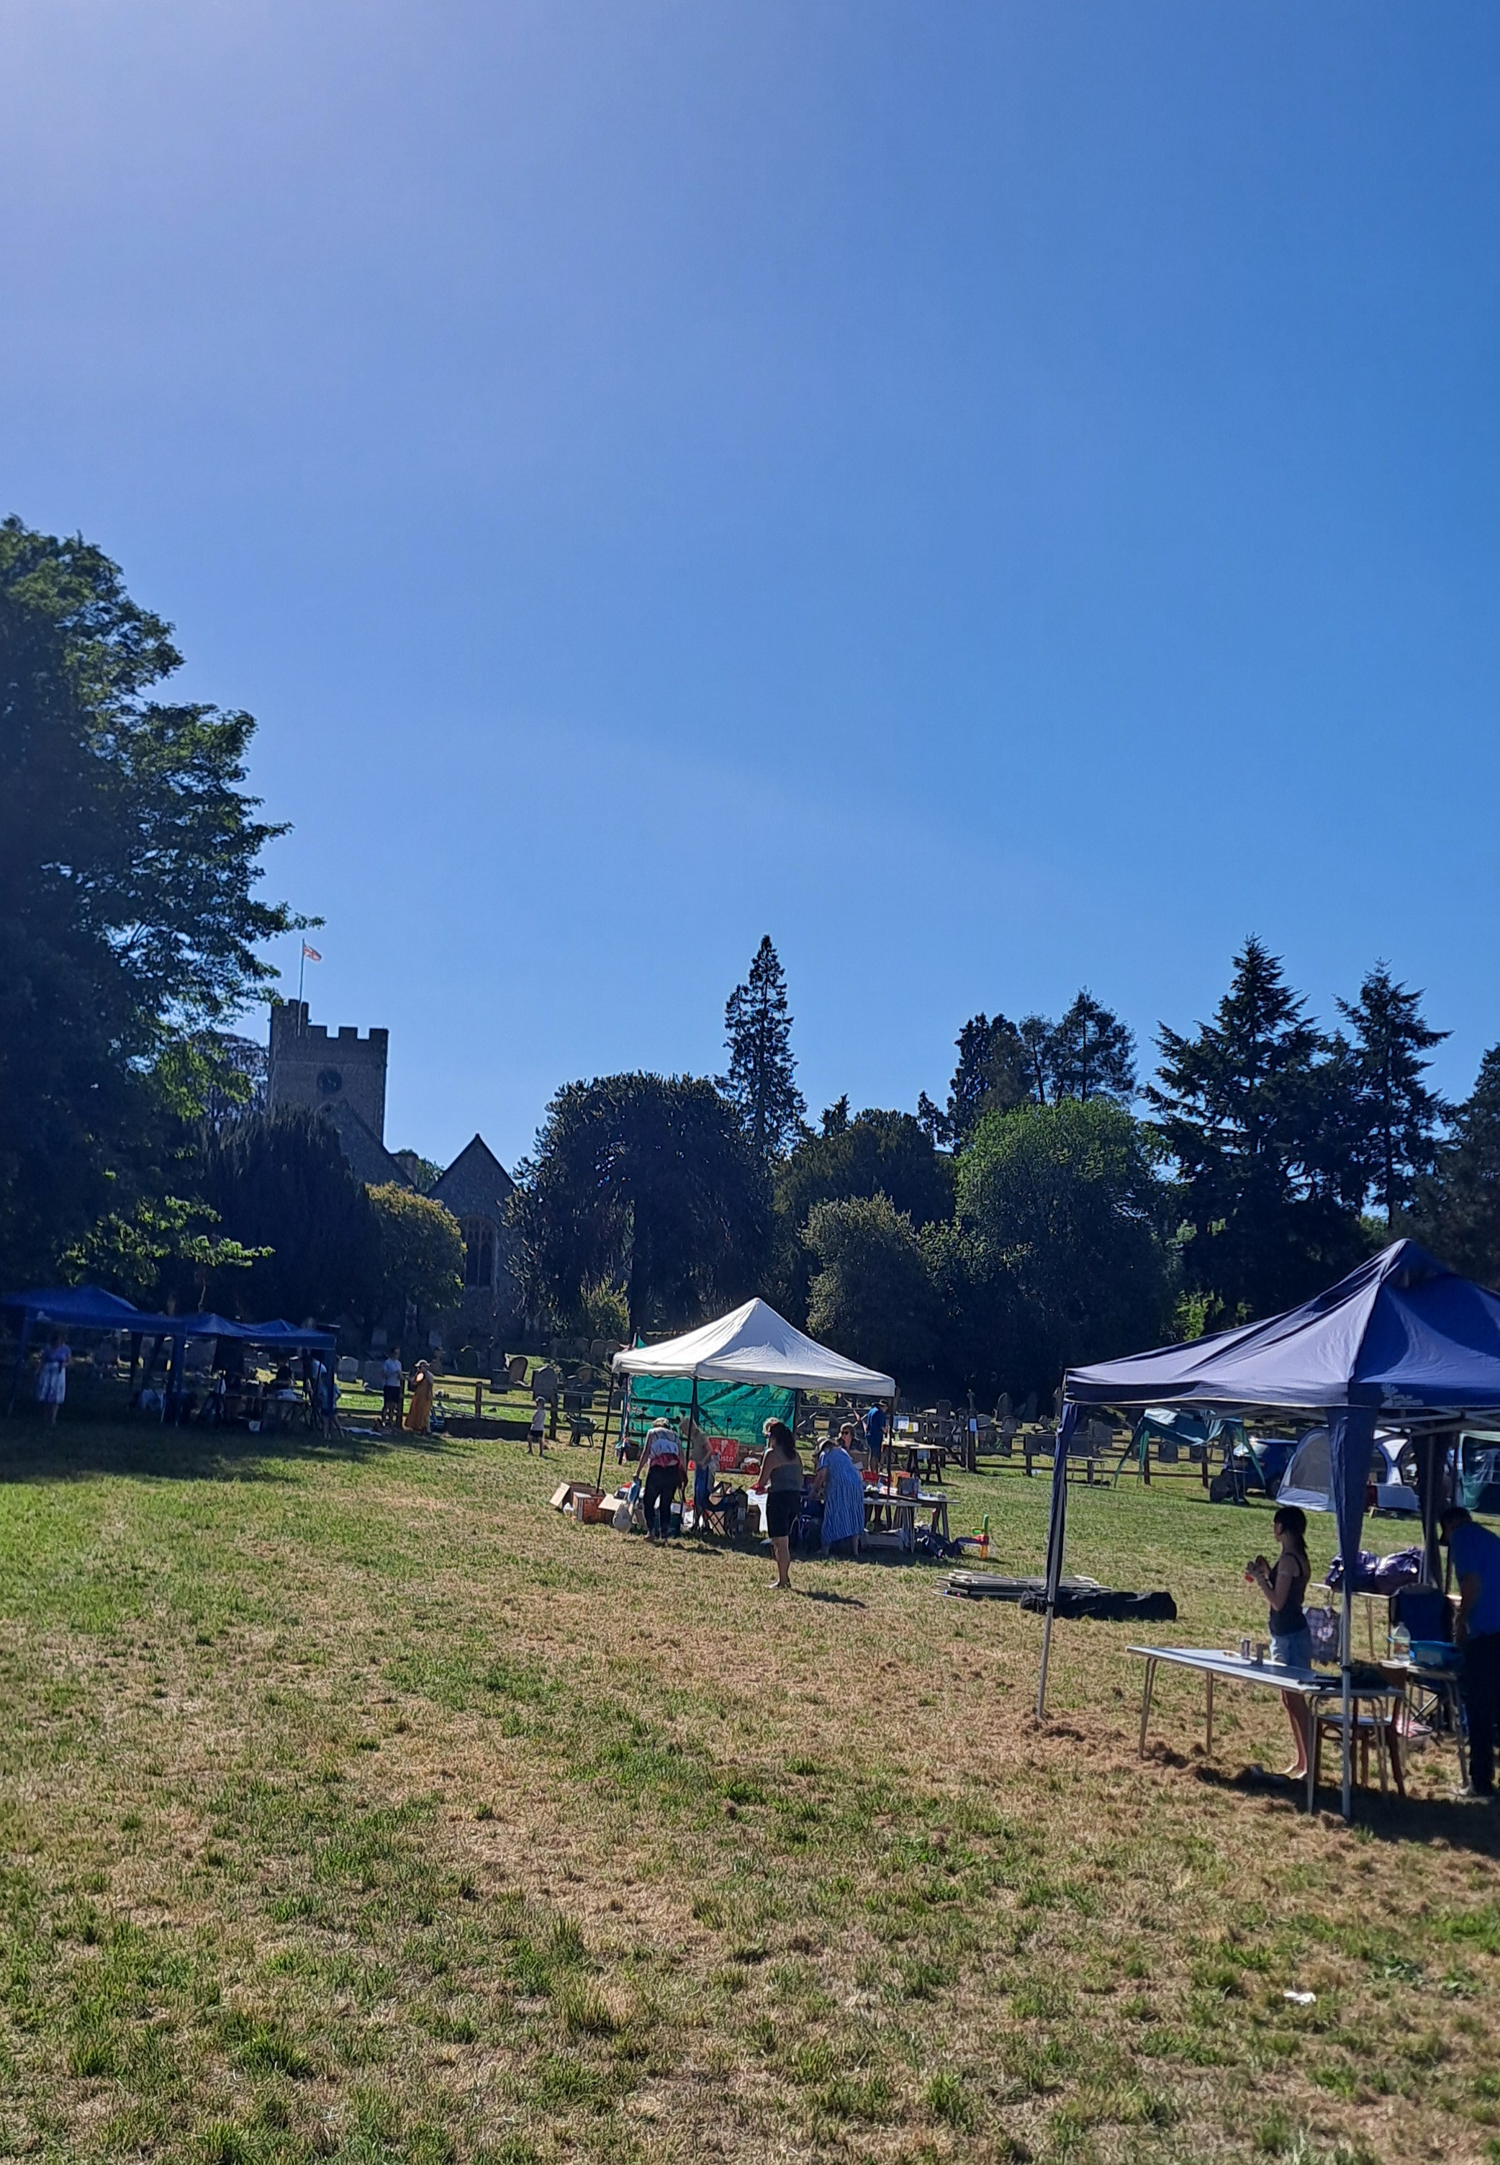
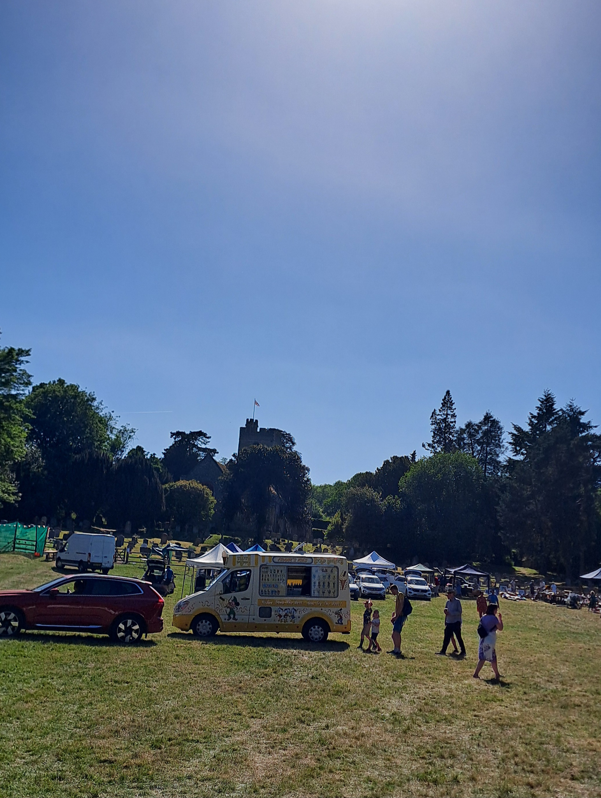
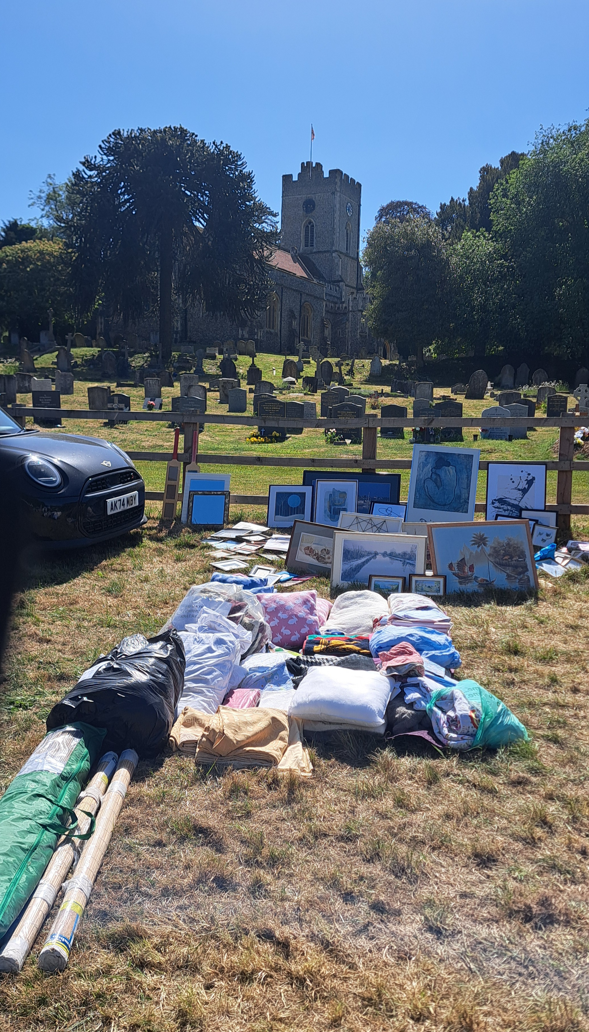
Watton Fete – Congratulations and thank you to everyone who helped organise and run a fantastic Fete. Also a wonderful community day

