Dorchester and the Winterbournes Team Ministry – Safeguarding Domestic Abuse Policy

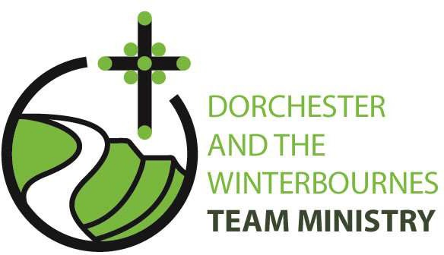

Safeguarding Domestic Abuse Policy

Version 1.2 November 2024 1



Diocese of Salisbury Domestic Abuse Policy

All forms of domestic abuse are wrong and must stop. We are committed to promoting and supporting safer environments which:
- ensure that all people feel welcomed, respected and safe from abuse;
- work to protect those experiencing domestic abuse;
- recognise equality amongst people and within relationships;
- refuse to condone any form of abuse;
- enable and encourage concerns to be raised and responded to openly and consistently.

We recognise that:
- all forms of domestic abuse cause damage to the survivor and express an imbalance of power in the relationship;
- all survivors (regardless of age, disability, gender, racial heritage, religious belief, sexual orientation or identity) have the right to equal protection from all types of harm or abuse;
- domestic abuse can occur in all communities;
- domestic abuse may be a single incident, but is usually a systematic repeated pattern which escalates in severity and frequency;
- domestic abuse, if witnessed or overheard by a child, is a form of abuse by the perpetrator of the abusive behaviour;
- working in partnership with children, adults and other agencies is essential in promoting the welfare of any child or adult suffering abuse.

We will respond to domestic abuse:
In all our activities by –
- valuing, listening to and respecting both survivors and alleged or known perpetrators of domestic abuse, whilst appreciating the need to ensure a distance is kept between the two and refusing to condone the perpetration or continuation of any form of abuse.

In our publicity by –
- raising awareness about other agencies, support services, resources and expertise, through providing information in public and women-only areas of relevance to survivors, children and alleged or known perpetrators of domestic abuse.

When concerns are raised by –
- ensuring that those who have experienced abuse can find safety and informed help;

- working with the appropriate statutory bodies during an investigation into domestic abuse, including when allegations are made against a member of the church community.

In our care by –
- ensuring that informed and appropriate pastoral care is offered to any child, young person or adult who has suffered abuse;
- identifying and outlining the appropriate relationship of those with pastoral care responsibilities with both survivors and alleged or known perpetrators of domestic abuse.
We are committed to reviewing our policy and procedures regularly.

Owner: Safeguarding

Date of Approval: 25 April 2017

Approved by: DSMG

Date of last review: November 2024

Due for review: November 2025

Dorchester and the Winterbournes Team Ministry – Safeguarding Domestic Abuse Policy

Agreement

Dorchester and the Winterbournes Team Ministry Domestic Abuse Policy

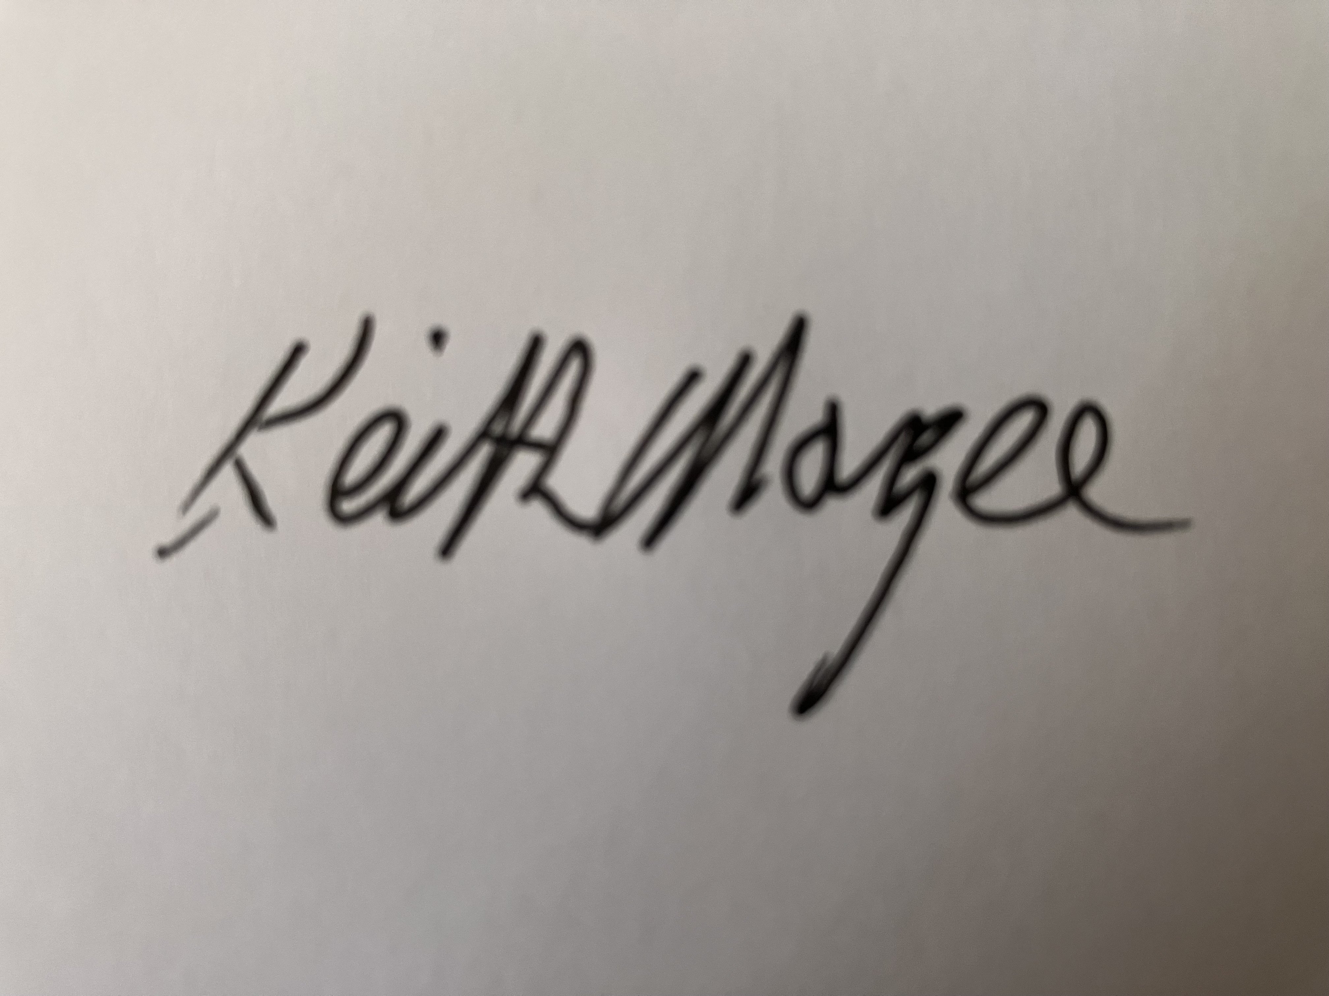
Adopted by Dorchester and the Winterbournes Team Ministry

Team Rector: .........................................................................

Date: ……26th November 2024 ............................................................................

Version 1.2 November 2024 2

