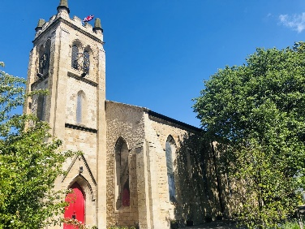


Holy Trinity Church Photography Policy Statement

The safety of all children, young people and adults must be maintained at all times. If a child,
young person or adult is in immediate danger or requires medical attention call the emergency
service on 999. Do not delay.
Photography in Holy Trinity Church, Seaton Carew
Holy Trinity Church is a place of worship and pilgrimage, and also the heart of Seaton Carew.
We recognise those who visit do so for many different reasons and may wish to take photos to remind them of their visit.
The Clergy and PCC, governing body of the Church, has adopted the following policy on photography including the inside and outside of the Church building:
- Visitors and regular worshippers are encouraged to take respectful non-flash photos for personal use inside Holy Trinity Church, Seaton Carew.

- Photography is not permitted during services, unless stated otherwise (e.g. permission is granted, for example during baptisms and Weddings etc.)

- Photos can be taken freely outside of the church building including Church building itself, and Graveyard, however, please be cautious and respect the privacy of people outside of the Church building.

If you see someone acting unusually or taking photographs/recordings that they should not be doing inform someone immediately. Safeguarding all children, young people and adults are a priority.

Please respect these rules when taking photos:
- Photos for personal use taken on ordinary handheld cameras and/or mobile phones is encouraged.

- Don’t use flash when taking photos, as it can be disruptive to other visitors/worshippers.

- Please respect the privacy of other visitors/worshippers, especially during services.

- No photos of children are permitted unless they are part of your party, for safeguarding reasons.

- Photos of School children are not permitted, unless taken by the school themselves.

- Visitors/regular worshippers are not permitted to climb any areas of the Church.

- Selfie sticks, tripods and monopods are not allowed as they can be disruptive and hazardous to other people (unless this has been booked through a professional business).

- People who have a disability which affects their photography, making it hard to hold a camera, may use tripods or monopods inside the Church. If possible, please get in touch with us beforehand through our ‘Contact us’ page on our website.

Safeguarding is everyone’s responsibility

As a working church, we must limit photos in some cases:
- Given that Holy Trinity Church above all else a place of worship, please do not take offence if you are asked to refrain from taking photos at any time.

- The Prayer corner, located in the North Isle of the Church and can be used for private prayer. Photos are prohibited when people are worshipping/praying to protect their privacy.

- The Nave, Chancel and South Isle of the Church are also areas of Prayer and worship. Photos are prohibited when people are worshipping/praying to protect their privacy unless permission is granted.

- Taking photos and making recordings is strictly prohibited during services (unless granted permission e.g. Baptisms, Weddings, Funerals)

The Clergy and PCC governing body of Holy Trinity Church, Seaton Carew reserves the right to deny or withdraw photography permissions at any time.

Reporting a Safeguarding Concern
Holy Trinity Church, Seaton Carew Safeguarding Officer – Jackie Hamilton can be contacted on 07922922824 to discuss or report a safeguarding concern or incident (please note this number is not answered 24hrs a day, 7 days a week).

Further Safeguarding contact details can be found on the ‘Safeguarding’ page on our website.
Last updated 28/04/26

