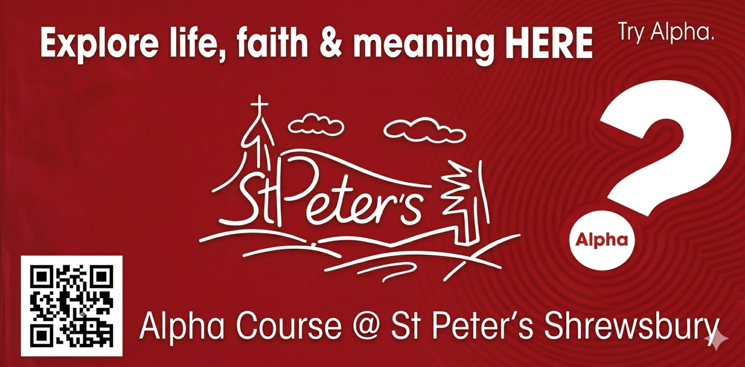

Our next Alpha Course begins on
Monday 22nd June 2026
6.45pm – 9.00pm
Here at St Peter’s Shrewsbury
With Refreshments

More details – https://alpha.org.uk
Contact Paul & Bernice
on 07511 646456 to book your place

